

Cooperative Extension Livestock and
Natural Resources Advisor
Mendocino and Lake Counties, California

Position Overview
The University of California, Agriculture and Natural Resources (UC ANR) invites applications for a UC Cooperative Extension (UCCE) Livestock and Natural Resources Advisor at the Assistant rank. The successful candidate will implement an extension education and applied problem-solving research program in livestock production systems and range management on both private and public lands for Mendocino and Lake Counties. The advisor will conduct a locally based extension, education, and applied research program to address high priority issues with a focus on livestock production practices, rangeland management and marketing.

UCCE Advisors are responsible for applied research and extension of knowledge. Research activities are applied, needs-based, mission-oriented, and focused on addressing our communities' challenges. Extension activities are the educational practices Advisors use to share research results directly with clientele and communities to increase their knowledge and understanding of science-based research results to support and promote the adoption of practices and technologies to solve problems. Extension methods may include individual consultations, presentations, organization of educational workshops and short courses, field demonstrations, farm calls, and site visits. Information may also be disseminated via radio outreach, webinars, fact sheets, policy briefs, news blogs, and social media. Publications are expected in various formats, such as newsletters, articles for the popular press, curricula, conference proceedings, and peer-reviewed publications. Successful research and extension programs result in new information that improves knowledge or understanding and adoption of new skills, practices, changed attitudes, policies, and improved environmental, health, agricultural, economic, and/or social conditions. UCCE Advisors are evaluated through an academic advancement system based on four criteria: extending knowledge, applied research and creative activity, professional competence and activity, and University and public service. There is an expectation that advisors will evolve and grow across their careers and respond to changes in the industry, clientele, and organizational change.
Location Headquarters: University of California Cooperative Extension Office in Mendocino County Office, 890 N. Bush St., Ukiah, CA

Position Details
The Livestock and Natural Resources Advisor will serve clientele in the Mendocino and Lake Counties with a general focus on livestock production systems including grazing management, pasture management, livestock nutrition, herd health, animal husbandry, genetic selection, reproduction, harvesting/processing, and marketing. Rangeland livestock production is the primary land use in the region and continues to be one of the leading agricultural commodities. Cattle is the largest segment of the local livestock industry, but goats, sheep, poultry, and swine are also present and are growing in numbers. Nearly all the cattle produced in the region come from cow/calf operations that operate on a complex and diverse mix of private and public land. Rangeland management issues are important in the two-county area, with fuels management, a significant consideration. Historically as well as recently, the region has had some of the largest and most destructive wildfires in California’s history.
The advisor is expected to implement a variety of extension activities to address local needs. This information can be disseminated through workshops, seminars, field days, short courses, newsletters, and lay publications, in coordination with local public agencies. This is an exciting opportunity to do research and provide research-based education on livestock management practices to enhance production efficiency, ranch profitability and the ecosystem services associated with rangeland livestock production. Managing ecosystems is an area where UC is well positioned to provide leadership and generate success. Key clientele groups include livestock producers, public resource management agencies (NRCS, California Fish and Wildlife, US Forest Service, Bureau of Land Management, and RCDs), nonprofit conservation organizations (such as The Nature Conservancy, fire safe councils, local watershed councils, land trusts and other non-government organizations) tribes and youth groups (4-H, FFA, and Grange). Collaboration with these groups will identify issues and opportunities for extension of livestock and land management information using the methods outlined above

Applied research and creative activity are expected to be aligned with the position description and determined by clientele needs, and include collaboration on projects, securing grant funding from public agencies, private foundations, and commodity groups, and publications in relevant topical journals. Research will be synthesized and popularized in ANR publications, academic journals, the internet, and other outlets as appropriate. The Livestock and Natural Resources Advisor, collaborating with other CE advisors and specialists, AES faculty, and clientele will help implement management practices that improve livestock production in the region and will address production, animal health, food safety, meat processing and marketing, rangeland management and improvements, water quality, soil quality, and ecosystem health.

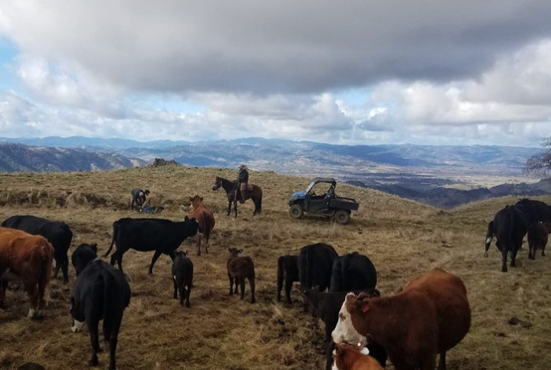
Counties of Responsibility: This position will serve Mendocino and Lake Counties.

Reporting Relationship: The Cooperative Extension advisor serves under the administrative guidance of the University of California Cooperative Extension County Director for Mendocino and Lake Counties. It is not a remote position; the candidate must be available to work onsite at the headquarters location and travel to and be present in other counties with programmatic responsibilities. Specific expectations for maintaining office hours and fieldwork in the geographic area covered by this position will be outlined upon hire by the respective directors and supervisors.

Qualifications and Skills Required

Required Qualifications
Education: The successful applicant will have a minimum of a master’s degree in animal science, range management or a closely related field and coursework or a degree in agricultural economics is required at time of appointment. In lieu of a range management degree the applicant would have the minimum coursework to be a Certified Rangeland Manager. (https://calpacsrm.org/certified-rangeland-managers)

Key Qualifications:
- Coursework or a degree in agricultural economics.
- Certified Rangeland Manager license or minimum coursework to obtain license as a Certified Rangeland Manager
- Ability and means to travel on a flexible schedule as needed, proof of liability and property damage insurance on vehicle used is required. Must possess valid California Driver's License to drive a County or University vehicle.
- Extension experience and demonstrated excellence in the areas of applied research is desired.
- Coursework and experience in range management, livestock production including small and large ruminants, fuels management, and natural resource management.
- Training and experience in interdisciplinary and multi-disciplinary research and collaboration is preferred.
- Familiarity with California’s natural resources will be beneficial.
- Knowledge and demonstrated use of remote methods of conducting outreach and delivery are a benefit.

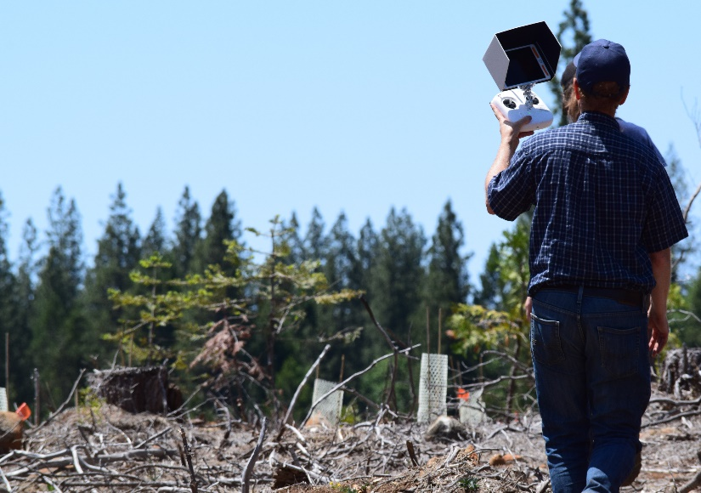
Additional Skills Required
- Interest in and a desire to pursue a career in UC Cooperative Extension
- Technical Competence and Impact: The candidate should understand key concepts to optimize engagement and development and be able to design and implement a program that leads to positive changes and impact within the community and beyond.
- Communication: Demonstrated excellence in written, oral, interpersonal and information technology communication skills.
- Collaboration, Teamwork and Flexibility: The candidate should demonstrate the ability to work collaboratively as a team member with key external stakeholders and county-based staff, as well as with other colleagues within UC ANR.
- Lifelong Learning: There is an expectation that Advisors evolve and grow across their career and respond to changes in the industry, clientele, and organizational change.

Learn more about Skills and Areas of Programmatic Review
(including Professional Competence, University and Public Service, and Affirmative Action and DEI) at: https://ucanr.edu/sites/anrstaff/files/319460.pdf

About UC ANR
UC ANR is a division of the University of California (UC) system that bridges the gap between local issues and the expertise of the UC system by providing research-based information, educational programs, and technical expertise to the public in areas such as agriculture, natural resources, nutrition, and youth development. UC ANR is part of a nationwide Cooperative Extension network, which began in the early 20th century to connect research from land-grant universities with the everyday needs of people in communities across the United States. Today, we collaborate with farmers, ranchers, diverse communities, youth and adult educators, and policymakers to address local and statewide issues related to food systems, water, climate change, and sustainable agriculture through a statewide network of campus-based researchers, county-based Advisors, and community educators. Our mission is to cultivate thriving communities, sustainable agriculture, resilient ecosystems, and economic prosperity in California and globally through equitable generation and sharing of collaborative, science-based solutions. Over 180 UCCE Advisors conduct applied research and extension education from county-based UCCE offices serving all 58 counties from 70+ locations. By working and living among those we serve, UC ANR expands the University of California’s reach to engage all people and communities in California, ensuring equal access to the resources UC has to offer. Our vision is that UC ANR will be valued in every California community for meaningful engagement and making a positive difference in people’s lives.

About Mendocino and Lake Counties
At 3,878 square miles (10,040 km2), of which 3,506 square miles (9,080 km2) is land and 372
square miles (960 km2) (9.6%) is water, Mendocino County is substantially larger than Marin, Sonoma and Napa Counties combined. Lake County has total area of 1,329square miles (3,440 km2), of which 1,256 square miles (3,250 km2) is land and 73 square miles (190 km2) (5.5%) is water. The economies of both counties have historically been and continues to be resource-based, including ranching, forest products, vineyards, orchards, and legal and illegal marijuana cultivation. Rangeland livestock production is the primary land use in the region and continues to be one of the leading agricultural commodities. In addition, the Hopland Research & Extension Center is in Mendocino and has range livestock and natural resources for more intensive research and educational opportunities.

Mendocino County has nine Indigenous tribes located within its borders, the fourth most of any county in the United States. Lake County has six tribes. Culturally, livestock production is important to many of them. Cattle is the largest segment of the livestock industry, but goats, sheep, poultry, and swine are also present and are growing in numbers. Nearly all the cattle produced in the region come from cow/calf operations that operate on a complex and diverse land ownership basis. Livestock production on annual and coastal rangelands accounts for 735,000 acres in Mendocino County and 90,000 acres in Lake County. Most of this land is in private ownership that is either owner operated or leased. There is an additional small amount of public rangeland in both counties.

Learn more about
- UC ANR and UC ANR Mission Statement.

- UC ANR administers Statewide Programs and Institutes that focus research and extension on solving priority problems that engage ANR academics and UC faculty in integrated teams
- UC ANR Strategic Initiatives help unify, communicate, and advocate for the work we do.
- UC ANR UC ANR uses seven Public Value statements to communicate how our work makes a difference to the public.
- UC ANR academics are expected to share and exhibit UC ANR’s commitment to UC ANR’s Affirmative Action policy
- UC ANR academics are expected to share and exhibit UC ANR’s commitment to Diversity, Equity and Inclusion he University of California Agriculture and Natural Resources is committed to attracting and retaining a diverse workforce and will honor your experiences, perspectives, and unique identity. We encourage applications from members of historically underrepresented racial/ethnic groups, women, individuals with disabilities, veterans, LGBTQ+ community members, and others who demonstrate the ability to help us create and maintain working and learning environments that are inclusive, equitable and welcoming.
- As a condition of employment, the finalist will be required to disclose if they are subject to any final administrative or judicial decisions within the last seven years determining that they committed any misconduct, are currently being investigated for misconduct, left a position during an investigation for alleged misconduct, or have filed an appeal with a previous employer.
“Misconduct” means any violation of the policies or laws governing conduct at the applicant’s previous place of employment, including, but not limited to, violations of policies or laws prohibiting sexual harassment, sexual assault, or other forms of harassment, discrimination, dishonesty, or unethical conduct, as defined by the employer.
UC Sexual Violence and Sexual Harassment Policy
UC Anti-Discrimination Policy for Employees, Students and Third Parties
APM - 035: Affirmative Action and Nondiscrimination in Employment

Salary & Benefits
Salary: The salary range for this Cooperative Extension Advisor position is Assistant Rank, Step I ($82,900) to Step VI ($105,200). Step placement in the Advisor series is based on applicable experience and professional qualifications.

This position is eligible for indefinite status following three successful reviews and subject to terms noted in UC ANR Policy and Procedure Manual, Section 315 of the ANR Policy and Procedure Manual (PPM).

If the successful candidate is currently a UCCE Advisor, the candidate will be offered the position without change to the candidate’s current rank, step, salary and/or appointment terms; and if applicable, is eligible to retain indefinite status.

Benefits: The University of California offers comprehensive benefits including health insurance, retirement plans, two days per month paid vacation, one day per month paid sick leave, and paid holidays. This position is eligible for sabbatical leave privileges as per the terms of the University policy. For more information, refer to the UC Benefits website at: https://ucnet.universityofcalifornia.edu/compensation-and-benefits/index.html

How to Apply
If interested in this position, please visit: https://recruit.ucanr.edu/ and choose “applicants” (refer to position #24-20). An in-person finalist interview may be required as part of the search process.

Closing Date:
To ensure full consideration, complete application packets must be received by March 28, 2025 (open until filled).

Questions?
Contact Mikyla Perez, email: mikperez@ucanr.edu

Applicants may wish to explore the UC Davis Services for International Students and Scholars web page at https://siss.ucdavis.edu/ as a resource.
University of California Cooperative Extension
As a University employee, you will be required to comply with all applicable University policies and/or collective bargaining agreements, as may be amended from time to time. Federal, state, or local government directives may impose additional requirements.

The University of California is an Equal Opportunity/Affirmative Action Employer. All qualified applicants will receive consideration for employment without regard to race, color, religion, sex, sexual orientation, gender identity, national origin, disability, age, protected veteran status or other protected categories covered by the UC nondiscrimination policy.

As of January 1, 2014, ANR is a smoke- and tobacco-free environment in which smoking, the use of smokeless tobacco products, and the use of unregulated nicotine products (e-cigarettes), is strictly prohibited.

