Southwest Arizona Refuge Complex

We are recruiting for the Complex Refuge Manager (Fish and Wildlife Administrator), GS-0480-14. https://www.usajobs.gov/GetJob/ViewDetails/824661800

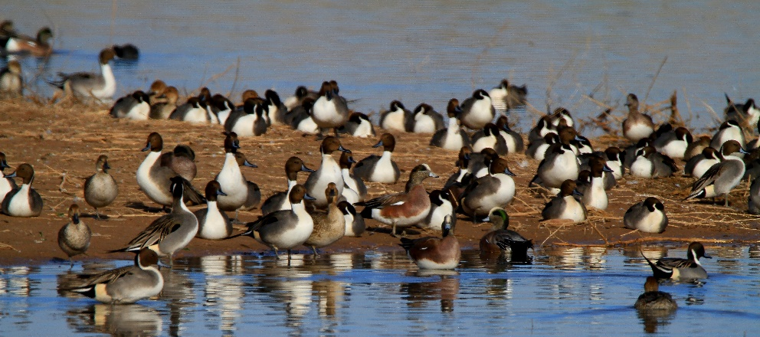
The Southwest Arizona Refuge Complex is comprised of the Cibola, Imperial, and Kofa National Wildlife Refuges. The Complex office is located in Yuma, AZ. The Cibola and Imperial NWRs are located along the Lower Colorado River, while Kofa NWR is a strictly desert refuge.
Cibola National Wildlife Refuge

The 18,444-acre Cibola NWR was established in 1964 as mitigation for the channelization of the river. The 25,768-acre Imperial NWR protects 30 miles of wildlife habitat along the lower Colorado River and was established in 1941. The refuge includes the last un-channelized section of the river before it enters Mexico and has more than 15,000 acres of designated wilderness. The 666,641-acre Kofa NWR was established in 1939 for the protection of desert bighorn sheep. Until the 1970’s, the refuge was co-managed by the Fish and Wildlife Service and the Bureau of Land Management. Like the Imperial NWR, Kofa has designated wilderness, over 545,000-acres.

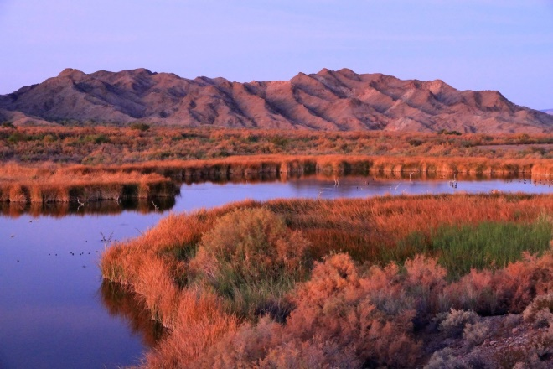
The Project Leader supervises a GS-9 Administrative Officer, a GS-11 Supervisory Facility Operations Specialist, and a GS-13 Deputy Project Leader. The Deputy Project Leader supervises the individual Refuge Managers and serves as the Refuge Manager for the Kofa NWR. Each Refuge in the Complex also supports a strong and active volunteer program during the fall and winter months. A part of the Arizona Fire Zone is based out of the Imperial NWR and assists the Complex on various projects on the refuges. The Project Leader works closely with other federal agencies, particularly with the Bureau of Reclamation on the Multi-Species Conservation Program; the Arizona Game and Fish Department; and various NGOs.
Imperial National Wildlife Refuge

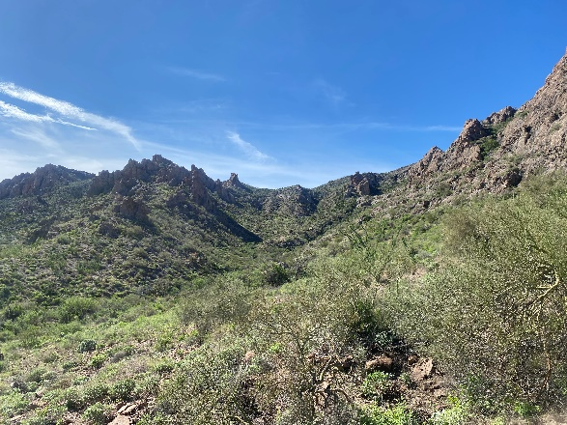
This is a challenging position with the various refuges and variety of work that takes place on each, from river restoration projects on Cibola and Imperial NWRs to bighorn sheep translocation efforts working with Arizona Game and Fish and the Department of the Army’s Yuma Proving Grounds on Kofa NWR.
Kofa National Wildlife Refuge

Contact Ronnie Sanchez, Arizona/New Mexico Refuge Supervisor, Southwest Region (ronnie_sanchez@fws.gov , 907.306.2361) for further information.

