
www.uaztierraseca.org
Nov 26, 2024
Called to Order: 5:16pm

Meetings:
Sept 3rd
Sept. 17th
Oct. 1st
Oct. 15th
Oct. 29th
Nov. 12th
Nov. 26th
Dec. 10th
….Last Meeting TBD

Every other Tuesday @ 5:15-6:00pm, ENR2 N350

Attendance:
Fonzo Tryillo, Dakota Baden, Brian Muha, Matt Meyer, Doan Goolsby, Philly Montierth, Ezra Schneider, Maddie Terlap, Noah Sygrove (10)

Meeting Minutes:
“We are Better Ag For A Better Future”
Our club aims to Forster Education and Innovation, Cultivate Professional Growth and Leadership Champion Inclusions and Diversity, and Inspire Action for a Sustainable Future.
How?
With access to research, tech, hands-on experiences, and exposure/networking/collaborating with professionals, alumni, peers, and the community, we aim to promote practices that ensure the health and resilience of rangelands for generations to come.

SRM Participants Should Apply for the Ogden Scholarship

YPC- Young Producers Conclave
Reached out asking about what we want to see for merch.

Recommend taking these Fall 2024 Courses specially if going to SRM (Society of Range Management Annual Meeting): (can be taken a second time for preceptor credit) (can be taken a second time for preceptor credit)
- RAM 389 Principles of Range Management (URME Test prep) Wed. 4-5:45pm
- RAM/PLS 370 Wildland Plants of North America (Plant ID prep)Thur. 4-5:45pm
- URME Study Group with Elena , meeting time Tuesdays at 6:15 pm

Plant ID and URME Study Sessions:
(Talk to Doan if you want to join sessions)
Team Captains: Plant ID: Dakota (Have learned half of the plants so far)
URME: Doan
Extemporaneous Speaking: Noah
Range Cup: Seth
(reach out to captains if questions)

Upcoming Speakers

TBD: NRCS guest speaker (will potentially speak about pathways positions, recent grad jobs, and RMS job series) Recent grad jobs opened up with NRCS on Oct. 16th.

(Let us know if you have ideas for other guest speakers.)

Upcoming Events
(Sign up for events on the Tierra Seca website)

FFA Event
February 28, 2025 7:00 am-1:00 pm
Youth involvement in the field of range management, Flavie Audoin needs help from Tierra Seca for event set up, tear down, and grading of the Plant ID competition. Great opportunity to get some experience with outreach and youth education. If interested, signup is on the Tierra Seca website. For further questions contact Flavie Audoin at faudoin@arizona.edu

National Grazing Lands Coalition Conference at Hilton El Conquistador
December 4-6
Conference with numerous producers and range professionals, requesting volunteers to aid in set-up. Dress business casual.

Golf Tournament
Dec 15th- 9am
More info to come…
Table to sell merchandise
Fun and easy way to support and make the club $$.
Will need to wear a polo…potential club fund if you need one.

Field Tech Assistant Position with PhD student Maddie Wallace
Working with/in the Rachel Mitchell Lab.
Data collection, transect and plant counts. Will get plant ecology, plant ID, fieldwork experience and independent project credit. Potential payment in the future.
Where/When: Satant Rita Experimental Range 7am-4pm.
Contact: maddiewallace@arizona.edu for more info.

Ashley Hall- Tonto Monitoring Project
Opportunity to aid with monitoring, specifically plant frequency, dry
weight rank, and ground cover. Ashley Hall has 45-50 sites that TS can assist on. Multiple sites across Arizona including locations near Globe, Cave Creek, Mesa, and Payson. Potential for the club to earn up to $1500 for our volunteering. Valuable plant ID practice and opportunity for professional connections. Flexibility in weekday and potential long weekend schedules for
volunteers. Ashley Hall will send dates that they are planning on going out and TS can figure out what days work for us. If you are interested and need information on logistics email Maddie Terlap: mterlap@arizona.edu Ashley Hall: ashleys3@arizona.edu

50/50 Raffle Competition with Fish and Wildlife Club
From now until Dec. 10
Tickets are $1 for 1 and $5 for 6. Whichever club makes more money, wins the competition. Loser may be getting a tattoo?! Need first and last name and phone number for every ticket sold, bring sold tickets and money to Philly.

Farther out/In-the-Works Events

Steer Raffle
Steer Raffle is set up, we will start selling tickets soon. Potentially going to split the cow into four parts for more even distribution and ease of collection.

Society of Range Management Annual Meeting prep
Feb. 8th-14th
Where: Spokane, Washington
Flights: Feb 9th and 14th.
Bringing 12ppl. We will have a finalized list by Dec. 18th.
Read and Sign the SRM contracts emailed to you. Sign by Oct. 29th

Fundraising Committee and Banquet Committee
We need people to sign up!
The Fundraising Committee helps ideas actually get set up and can vote for fundraising events the club will actually pursue. (check groupchat for meeting times)
The Banquet Committee will focus on the End of the Year BBQ Banquet.
Being on the committee will give you more of a say of what the club does. (Meets in Bio Sci East building 124 12/12:15)

End of the year BBQ Banquet
This is a big goal for this year. We want this to become an annual event.
Date: TBD either May 17th or 18th (graduation is the 16th..)
Reach out to 4 ranchers. They will bring their meat. We can prepare and serve it to guests while the ranchers talk about their ranch/product. Live auction/prizes from local businesses, Live music, bags/games. We will do shout outs/thank yous to ranchers, sponsors, faculty, mentors, advisors, SRM awards, student and teacher of the year. Invite ranchers, families, club members, Pima County, agencies… that’s the idea.
Currently figuring out venues (Seth and Noah recently did a walk through and got estimates for Mission Gardens) Also currently trying to secure a liquor license (cash bar)
Let us know if you know anyone who would want to auction something.

SNRE (School of Natural Resources and the Environment) 50th Anniversary
We will keep an eye out for events throughout the year.

Miscellaneous Ideas??? Share Your Ideas!
Have a pint night at Mavericks to Line Dance./Bag Tournament, Bars with Pool tables for Tournaments. Either 10% goes to the club or every pint sale goes to the club. Sell Merch and/or do a 50/50 raffle..??? Contact CALES Alumni, Arizona Cattlemen, Cow Bells, any Rangeland Organizations, Rodeo Club, Young Farmers and Ranchers, Animal Science Club. Find Sponsors/businesses. Ask like Chipotle for a Tierra Seca Night. Donate 10% to the club.
(this is what we brainstorm and try to finalize during Fundraiser Committee Meetings)


Previous Event

Cornhole Tournament with Fish and Wildlife Club
Rescheduled (New Date TBD) ~5pm
Location: Reid Park (specific location TBD)
Tierra Seca sponsored cornhole tournament, BYOB, prize will be any one item from the merch (excluding the field shirt, Carhartt shirt, or sweater). Social event

Rangeland Forage Clinic at Bar V Ranch
November 10 7:00 am-1:00 pm, 16901 Charolais Rd, Vail, AZ
Interactive learning about rangeland nutrition at the Bar V ranch. “Hands-on experience with forage plants, invasive species, water resources, and grazing practices.” RSVP on the website by Nov 8 to secure your spot.

RISE (Research Insights in Semi-Arid Ecosystems)
Nov. 9th- 8:30am-3:30pm
This is an Academic conference. There will be speakers and posters and interesting research. W Gultch and SRER conference. We will table and serve coffee and pastries. We’ll tell people what we are and what we do. (You have to register online FREE get your name in if you want to go to the conference)

Elkhorn Monitoring
November 1st- 7am-3pm
Where: 27000 W Elk Horn Ranch Rd, Tucson, AZ 85736, USA
This is the Annual Elkhorn ranch monitoring event with the Altar Valley Conservation Alliance. We will be doing Photo Imaging Monitoring (photo points). We will be getting Dean's excuses for anyone missing classes. We will meet and drive together to the ranch. Very cool and great experience for the club to meet AVCA and NRCS people, and this may lead to continued partnering and work for the club with AVCA . (Fundraising Opportunity)

SNRE (School of Natural Resources and the Environment) 50th Anniversary Breakfast Homecoming
October 19- 8:30-10:30 am
Deadline for volunteering (for setup/cleanup) has passed however everyone is welcome to join us to socialize and network. (we will get an extra $500 from AgriLife for volunteering)

Tierra Seca Pint Night
October 4th- 4pm-8pm
Where: Borderlands Brewing Company, 119 E Toole Ave, Tucson, AZ 85701, USA
Fundraising event Downtown. Every beer sold contributed $1 to the club, merch was also sold. Got ~$300 in merch and some donations. Still need to get ahold of how much $ through pints.

Open House Even at Bar V Ranch
October 5th- 2pm-6pm
Where: Bar V Ranch, 16901 Charolais Rd, Vail, AZ 85641, USA
Community Outreach Open House Event. Hosted by County and Pima Extension.
A ranch tour, range, conservation and wildlife-related demonstration tables, picnic dinner, and barn dance. It was fun. Good food, good people, good music, good dancing. TS will work with Jess in the future.

Range Day (Burning Range!!)
Oct 12, 2024, 5:00 AM – Oct 13, 2024, 3:00 PM
Where: Santa Rita Experimental Range Sahuarita, AZ 85629, USA
Get hands-on inventorying and monitoring experience as you help student range technicians run transects (sampling methods for production: point ground, frequency, DWR (dry weight rank), canopy cover). Worked, learned, ate, swam, fire, cards, good time.

BIOBLITZ (Sept. 20th-22nd)
This was a Fish and Wildlife Society club event that some Tierra Seca members went to to participate and/or assist in driving ect. Saw and/or caught scorpions, snakes, lizards, insects, bats, birds, and a lot of grass, trees, forbes, ect. Camped out and traversed around the Santa Rita Experimental Range.

_______________________________________________________________________

Merch Orders Available
We have merch!
www.uaztierraseca.org/merch
Give us your ideas, wants, and desires…
No large bags. No using U of A block A.

Jobs/Internships
I will add to this, emails, and the group chat for opportunities when they come. __________________________________________________

Doing any cool and interesting RANGE-related activities?
Take pictures and send them to officers, with a little description so we can do a spotlight post on instagram.

Webinar Series
Doan is doing a webinar series on aspects of range management and club spotlights!!

Officers
President: Seth
Vice President: Maddie
Secretary: Ezra
Treasurer-Fundraising Chair: Philly

Dues can be paid in cash, PayPal (uofatierraseca), or Venmo
Club Dues: $15/semester or $30/year
Balance: $4,130.97
Connect with Us!
Email: uofatierraseca@gmail.com
GroupMe: https://groupme.com/join_group/38156015/nWJ5vk
Website: https://www.uaztierraseca.org/donatecontact
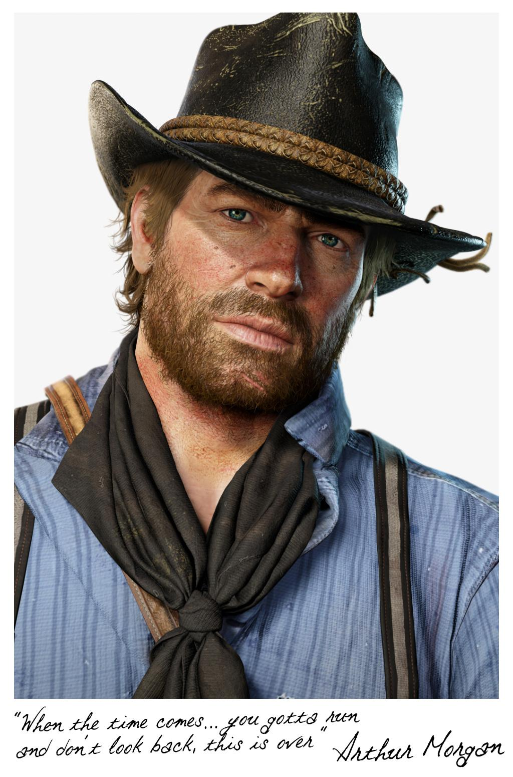
Instagram: https://www.instagram.com/uatierraseca/?hl=en (@uatierraseca) Meeting Closed: 5:40 PM

