Nineteenth Annual Symposium

RISE
Research Insights in
Semiarid Ecosystems
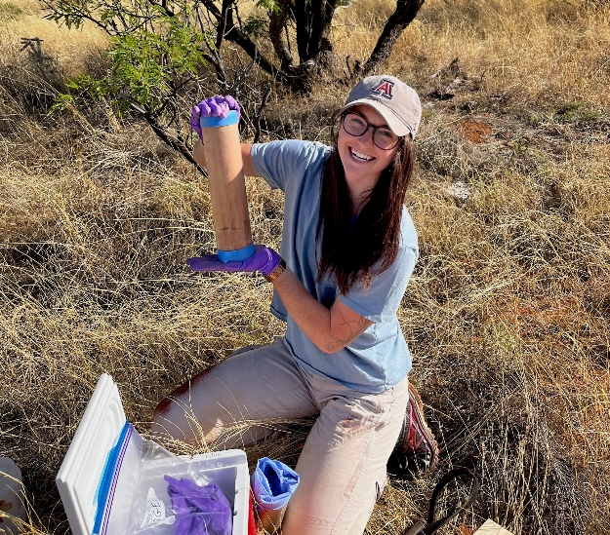

Highlights of recent research at the
USDA-ARS Walnut Gulch Experimental Watershed (WGEW),
the University of Arizona Santa Rita Experimental Range (SRER),
and the Region

Call for Posters and Registration
including Student Poster Contest

Saturday, 21 October 2023, 8:30 AM to 3:30 PM

Marley Building Rm. 230, University of Arizona, Tucson,
Lunch and Poster Session, 11:35-1:15 PM


Purpose: Share recent results of scientific research at WGEW and SRER, encourage future research activities at the WGEW and the SRER, and promote the WGEW and the SRER as outdoor scientific laboratories.

Registration, Poster Submission, and Program
are available at http://www.tucson.ars.ag.gov/rise/

