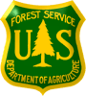
White River National Forest

OUTREACH NOTICE
GS-0454-7/9/11
GS-0455-7/8/9
GS-0401-7/9/11
Rangeland Management Specialist
120 Day Detail/Temporary Promotion

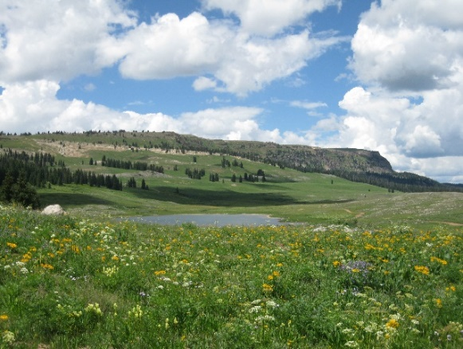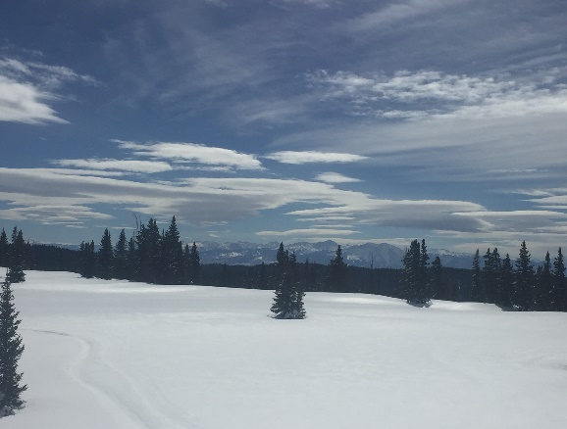

Rifle Ranger District
Rifle, CO
Respond By Friday June 30, 2023

If you are looking for a rewarding professional opportunity and enjoy the wide range of recreational pursuits found in Colorado’s high country, the White River National Forest (WRNF) is a perfect place for you. The Rifle Ranger District will be filling a Range Management Specialist detail while we work to fill the permanent position. The purpose of this Outreach Notice is to inform the pool of potential applicants about this detail/Temporary Promotion opportunity and determine interest.

This position works on a as the District Range Management Specialist as part of a cooperative team that includes a district range technician, zone invasive weed coordinator, a team of range specialists across the forest and other resource specialists on the district. The position will report to the District Ranger in Rifle, CO.

What an idyllic place to ride the range here in the uplands of western Colorado!

MAJOR DUTIES:

This position will be expected to provide leadership, technical expertise, and implementation to the district range and noxious weed programs. Development of the range program of work, facilitation of cooperative range management projects, maintaining and operating equipment, and annual target reporting. This position will assist with hiring, supervising, and training seasonal workforce, managing partnerships including our County and BLM counterparts, applying for and administering grants and agreements, working with fuels, fire, botany, wildlife, recreation and other resources to manage range vegetation, while leading and fostering the rangeland ecology program throughout the district in integration with other resource programs.

Incumbent will work with the Forest Range Program Manager and administer the district range program, including administration of grazing permits, conducting annual spring meetings with term grazing permittees, developing annual operating plans, range billing and authorized use, allotment and pasture inspections, trend and condition vegetation monitoring in upland and riparian settings, annual utilization monitoring, and documentation of allotment visits and conversations with permittees. Effective communication with grazing permittees is a critical component of this position in successful development of annual operating instructions and managing a responsible integrated grazing program. The incumbent will provide recommendations on range improvement projects, order range betterment materials, and ensure projects are planned and completed to Forest Service standards. Additionally, the incumbent will plan NEPA documents for range ecology and vegetation projects, allotment NEPA and analysis, and other district range project priorities.

This position will be integral to working with the District stock program. Utilizing the equine to support rangeland work and contributing to other resource needs such as pack and saddle support in our wilderness areas. Including all facets of equine needs via horse pasture maintenance, veterinary and farrier care and coordination, feeding routines and logistics etc. Horsemanship skills are encouraged but not required for the detail, but will need to be a continuous development as part of the permanent position.

DESIRED QUALITIES:
The person in this position will frequently work in the field, sometimes alone, driving unpaved roads and often hiking or riding ATVs or horses to inspect remote locations. To be successful in this job you must be a self-starter, a team player, and able to work without day-to-day direction. The incumbent must be an excellent communicator, extremely professional, and ready to work with internal staff and external partners to accomplish shared goals. Additionally, you must be prepared to operate in a dynamic work environment that can be challenging, yet incredibly rewarding.

RIFLE RANGER DISTRICT: The Rifle Ranger District is approximately 300,000 acres and stretches from the Colorado River Valley north to the Flat Tops Wilderness and south to the Battlements and Grand Mesa. District elevations range from 5,000 to 11,000 feet and the predominant vegetation ranges from sagebrush and pinion-juniper in the lower elevations to lodgepole pine, Engelmann spruce and aspen at the higher elevations. District programs focus on developed and dispersed summer and winter recreation (including snowmobiling and cross-country ski trails), timber, grazing, oil and gas development, and special uses.
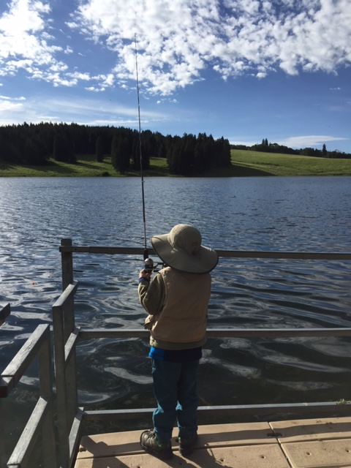
Recreation opportunities on the Rifle Ranger District include almost 200 miles of hiking and horse trails, 30+ miles of mountain bike trails, and 150 miles of groomed snowmobile and winter sport trails. Hunting and fishing are popular throughout the district and the White River National Forest. Also on the district are two campgrounds and the Cayton Guard Station National Historic Register Site. We have a well-developed network of partners who contribute thousands of hours of volunteer service every year!

THE WHITE RIVER NATIONAL FOREST: The Forest was established in 1891 as the White River Plateau Timber Reserve, the second such reserve to be named in the United States. It was one of the initial land reserves that started the public land system in America. But long before this designation, the Forest was home to the Ute Indians who followed herds of elk and bison on their seasonal migrations.

Today the Forest embodies the spirit of multiple-use management with more than 9 million visitors per year, making the White River the #1 Forest for recreation in the country. In addition to world-class recreation and abundant wildlife populations, the White River hosts activities such as grazing, logging, mining, and oil and gas development that are crucial to the economies of western Colorado.

The White River National Forest spans 2.3 million acres in Eagle, Garfield, Pitkin, Summit, Gunnison, Mesa, Moffat, Rio Blanco and Routt counties in Colorado. In addition, the Forest serves as a playground for Denver and the rest of the Front Range.

Community Information-Rifle: Located in western Colorado, Rifle is situated on the banks of the Colorado River. The “Bookcliffs”, named for lines of sediment and shale that resemble the pages of a book, provide a dramatic backdrop for the town. Recreation opportunities in the area include hunting for elk and deer, fishing, camping, horseback riding, hiking, and mountain biking. Rifle Gap and Rifle Falls State Park are just north of Rifle, as is Rifle Mountain St Park, are known for world-class climbing, and are located just north of Rifle. Additionally, there is downhill and cross-country skiing, snowshoeing, ice-fishing, snowmobiling, kayaking, and rafting.
Rifle has a population of about 10,000 people and is a full-service community. There are several smaller communities in the area, including Parachute, Silt, and New Castle. The city of Glenwood Springs (10,000) is about 25 miles to the east and Grand Junction (60,000+), the largest city on the Western Slope, is about 65 miles west of Rifle. Rentals range from $1500 to $2500 per month for a 2-3 bedroom home. The median home price in Rifle is $450,000.

For more information about the area, check out: https://www.rifleco.org/ and http://www.fs.fed.us/r2/whiteriver/.

HOW TO EXPRESS INTEREST: This outreach effort will help the gauge interest in this detail and permanent position. Please complete and return the response form with resume to Joseph Fazzi; Acting Rifle District Ranger (Joseph.Fazzi@usda.gov, 970-200-6449).
Please respond by Friday June 30, 2023.

Rangeland Management Specialist GS-0454 7/9/11, 0455 7/8/9, 0401 7/9/11
120 Day detail/Temporary Promotion
Rifle, CO, White River National Forest
USDA Forest Service, R2-Rocky Mountain Region
If you have questions regarding this position, please contact Joseph Fazzi at joseph.fazzi@usda.gov
970-230-2663

Please return this completed form and resume via email by Friday June 30, 2022 to:
Joseph Fazzi, joseph.fazzi@usda.gov

Name: |  | Phone W:
Email: |  | Phone H:
 |  | Phone C:

Indicate Interest
Detail/Promotional Opp. |  | Permanent

Current Employer
USDA FS Unit:
Other:
Location:

If Federal Employee, Type of Appointment
Permanent |  | Temporary |  | Student/  Intern |  | Contractor |  | Other
Current Position Title: |  |  |  |  | Series/Grade:

How did you hear about this position?
Agency Contact:
Other:

If not a current permanent employee, are you eligible to be hired under any of the following special authorities?
☐ Schedule A (persons with disabilities)
☐ Veterans Recruitment Act (ARA)
☐ Veterans with 30% Compensable Disability
☐ Veterans Employment Opportunities Act (VEOA) of 1998
☐ Former Peace Corps Volunteer
☐ Pathways Program (Students, Interns and Recent Graduates)
☐ Public Land Corps (PLC)
☐ Land Management Workforce Flexibility Act (Temporary/Term Land Management Agency Employees)
☐ Other: <please elaborate>

