USDA Forest Service

Rocky Mountain Region
_______________________________________________________
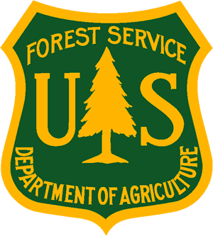
Outreach Notice
Region 2
Medicine Bow-Routt National Forests
& Thunder Basin National Grassland
______________________________________________________________

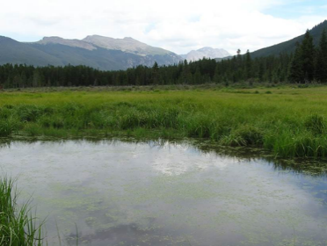 | 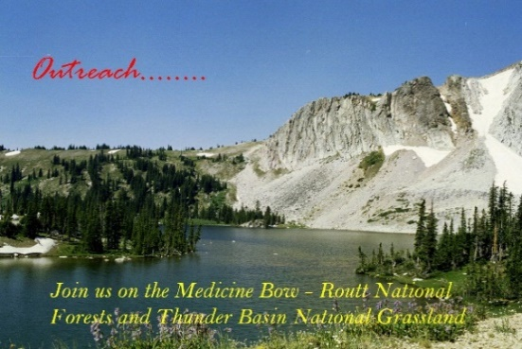 |  | 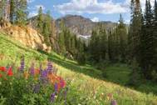
______________________________________________________________
Outreach - Interest Notice/Detail Opportunity
PLEASE RESPOND BY MAY 19, 2023

Rangeland Management Specialist
GS-0454-7/9
Brush Creek/Hayden Ranger District
Saratoga, WY

The Medicine Bow-Routt National Forests & Thunder Basin National Grassland (MBRTB) anticipates filling a permanent Rangeland Management Specialist, GS-0454-7/9 position in Saratoga, Wyoming. This outreach is to determine interest in a Detail/Temporary Promotion (NTE 120 Days) as well as the permanent position.
This notification is being circulated to inform those interested of this upcoming opportunity. To respond to this outreach, complete the Outreach Response Form below, include your resume and return by May 19, 2023, to Brad Weatherd at bradley.weatherd@usda.gov

ABOUT THE POSITION:
MAJOR DUTIES:

The incumbent has responsibility for the administration of grazing permits on the Brush Creek/Hayden Ranger District. The district consists of 33 active allotments, 26 of which are grazed by cattle, 6 by sheep, and 1 by both cattle and sheep. This position will support the noxious weeds program, which includes planning, treatment, mapping, and monitoring. The district administers about 545,000 acres of National Forest System lands with an elevation range of approximately 7,000 to 12,000 feet.

Field Work: The selected individual will perform field work that may include permit administration, monitoring, improvement inspections and other duties as assigned. They will assist in the treatment and inventory of noxious weeds. They will be expected to utilize 4x4 pickups, flatbed trailers, ATV/UTV and hiking as means of access.
Data Management: We are seeking applicants with strong verbal and written communication skills. Experience with all Microsoft programs, ArcGIS, Avenza, FieldMaps, and Survey 123 is desired.
Supervision: This position is non-supervisory but may be responsible for day-to-day guidance to seasonal field crews.

Gov’t housing options may be available for candidate and family.
For additional information, please contact:
Brad Weatherd | 307-330-6752 | bradley.weatherd@usda.gov

ABOUT THE FORESTS AND GRASSLAND:
The Medicine Bow-Routt National Forests & Thunder Basin National Grassland - Home (usda.gov) dates back to May 22, 1902, with the establishment of the Medicine Bow Forest Reserve by President Theodore Roosevelt. The Medicine Bow contains 1,665,721 acres of National Forest System land within its boundaries. It consists of three Ranger districts: Brush Creek/Hayden Ranger District in Saratoga, Laramie Ranger District in Laramie, and the Douglas Ranger District / Thunder Basin National Grassland in Douglas.
The Routt National Forest is located in northern Colorado. It now consists of three Ranger Districts: Hahn’s Peak-Bears Ears Ranger District in Steamboat Springs, Parks Ranger District in Walden, and Yampa Ranger District in Yampa. Elevations on the Forest range from about 5,000 feet to over 12,000 feet. Vegetation varies from sage brush-grasslands at the lower elevations to mixed conifer forests of pine, spruce, fir and aspen in the upper elevations. Wildlife is abundant, with antelope, elk, moose, mule deer, and white-tailed deer being the most common larger species. Major resource programs on the Forest include fire and fuel management, range, timber and other vegetation management, wildlife, minerals and recreation.
ABOUT SARATOGA, WY
The Platte Valley, which includes Saratoga, Encampment, and Riverside, boasts spectacular mountain scenery, miles of blue-ribbon trout fishing, and abundant wildlife.
Saratoga has all the charm, authenticity, and tranquility that most folks associate with Western towns. Situated on the banks of the North Platte River, the city offers first class amenities and a thriving economic community. There is an interesting variety of restaurants, hotels, shops, art galleries, hardware stores, farm and ranch stores, a brewpub, grocery, pharmacy, laundromat, gas/service stations, and 2 banks. High-speed internet, several TV choices, a radio station, and a weekly paper keep us connected to each other and the rest of the world. Daycare facilities are available. A gorgeous community center complex serves as host to local theater, meetings and other events, and indoor recreation. There are also numerous local festivals, sporting events, and hands-on museums for every interest. Perhaps not surprisingly, Saratoga often places high on “best places to live/recreate lists” and was named the 2012 Outdoor Life Magazine 10th best hunting and fishing town in America.
Ranching and outfitter/guide services cater to visitors year-round, with a corresponding contribution to the local economy. Local and federal governments, plus traditional and renewable energy industries, are among the area’s largest employers.
The small towns of Encampment and Riverside, about 20 miles south of Saratoga, provide easy access to prime mountain and wilderness country. The adjacent Encampment River offers excellent kayaking and rafting, as well as public access points. The Grand Encampment Museum is a real GEM, recounting the area’s copper mining boom of the early 1900s, as well as the ranching and timber heritage of the Valley.
Over 500 total K-12 students are enrolled in the Saratoga and Encampment school systems. Both school districts offer a variety of programs, including Gifted & Talented, Honor Society, music, speech, FFA, 4H, basketball, football, volleyball, track, cross-country, and wrestling. A county library is located in Saratoga. In addition to school activities, there are numerous churches, fraternal organizations, and youth programs.
RECREATION
District recreational opportunities include hiking, including a section of the Continental Divide National Scenic Trail, mountain biking, rafting, canoeing, swimming, horseback riding, camping, 2 Wildernesses, and several scenic drives. Lake and river fishing are excellent throughout the year, along with hunting for all of Wyoming's big game species. Deer, elk, antelope, bald eagles, and sage grouse are plentiful. There are also bear, moose, and big horn sheep in the area. The local elk herds number over 14,000 animals. One mile north of town, Saratoga Lake offers open water fishing, ice fishing, boating, and water skiing. A National fish hatchery is just outside town.
Over 150 miles of groomed snowmobile trails and 15 miles of groomed cross-country ski and snowshoe trails, plus nearly endless ungroomed opportunities, provide bountiful winter recreation choices as well. Snowy Range and Steamboat Springs Ski areas are both about 2 hours away. Regardless of the activity chosen, the free mineral hot springs in Saratoga is a popular way to relax and warm up with friends afterwards.
Snowy Range Highway (WY-130), 20 miles east of Saratoga, was the second "National Scenic Byway" in the United States and is a photographer’s delight. The Battle Mountain Highway, WY-70, was also recently designated as a National Scenic Byway.
AVERAGE WEATHER CONDITIONS
The Platte Valley climate is probably best described as mild in all seasons, with limited rain and abundant wind. Spring generally arrives in mid- to late April; summers are long and warm; autumn extends well into November on the valley floor; and winters are snowy (but only a foot or two in town) but, almost always, above zero – the perfect place for those that relish 4 distinct seasons.

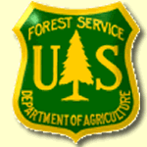
OUTREACH RESPONSE FORM

Medicine Bow-Routt NFs and Thunder Basin NG
Brush Creek/Hayden Ranger District, Saratoga, WY

RESPONSE TO OUTREACH
Rangeland Management Specialist/GS-0454-7/9

NAME:

E-MAIL ADDRESS:

MAILING ADDRESS:

TELEPHONE NUMBER:
 | USFS |  | BLM |  | OTHER

AGENCY EMPLOYED WITH:

 | PERMANENT |  | TEMPORARY |  | TERM
TYPE OF APPOINTMENT:

 | VRA |  | PWD |  | OTHER

 | REGION |  | FOREST

CURRENT:
DISTRICT

 | SERIES |  | GRADE

CURRENT:
POSITION TITLE

CURRENT:

If not a current permanent employee, are you eligible to be hired under any of the following special authorities?
☐ Schedule A (persons with disabilities)
☐ Veterans Recruitment Act (VRA)
☐ Veterans with 30% Compensable Disability
☐ Veterans Employment Opportunities Act (VEOA) of 1998
☐ Former Peace Corps Volunteer
☐ Pathways Program (Students, Interns and Recent Graduates)
☐ Public Land Corps (PLC)
☐ Land Management Workforce Flexibility Act (Temporary/Term Land Management Agency Employees)
☐ Other: <please elaborate>

HOW DID YOU FIND OUT ABOUT THIS OUTREACH NOTICE?

Use the space below to identify special qualifications, interest, or additional information:

Respond by COB May 19, 2023. Email this completed form and resume to bradley.weatherd@usda.gov
Thank you for your interest in this vacancy!

