

March 28, 2023

Called to Order: 5:35PM

Spring 2023 Meetings Schedule:
Every other Tuesday at 5:30pm in ENR2 N350
January 17
January 31
Feb 7 (SRM info meeting)
February 28th
March 14th
March 28th
April 11th
April 25th

Attendance:
Bailie Wynbelt, Ashley Gomez, Philly Montierth, Riley Gallagher, Ava Hamstead, Genna Smith, Maxwell Eller, Andres Martinez, Davin Jorgensen, Parker Brown, Noah Sygrove, Dakota Baden, Flavie Audoin, Idelfonzo Trujillo, Doan Goolsby, Isabel DiNardo

Meeting Minutes:
- Sheep Shearing
  - Who: Dennis Moroney and the 47 Ranch
  - What: Sheeeeeep!!
  - Where: McNeal, AZ
  - When: All day Monday April 10th
  - Sign Up Sheet: https://docs.google.com/spreadsheets/d/16R4ovgN8GhTMplcd6I4iOYzVyC1BhUjTvT9YBpJ60NI/edit?usp=sharing
  - There is limited parking space – PLEASE CARPOOL

- Upcoming summer classes: PLS/RNR 400: Noxious/Invasive Plants of AZ w/ Dr. Larry Howery (5 weeks, fully online/asynchronous)
  - Good option for your PLS credit!
  - 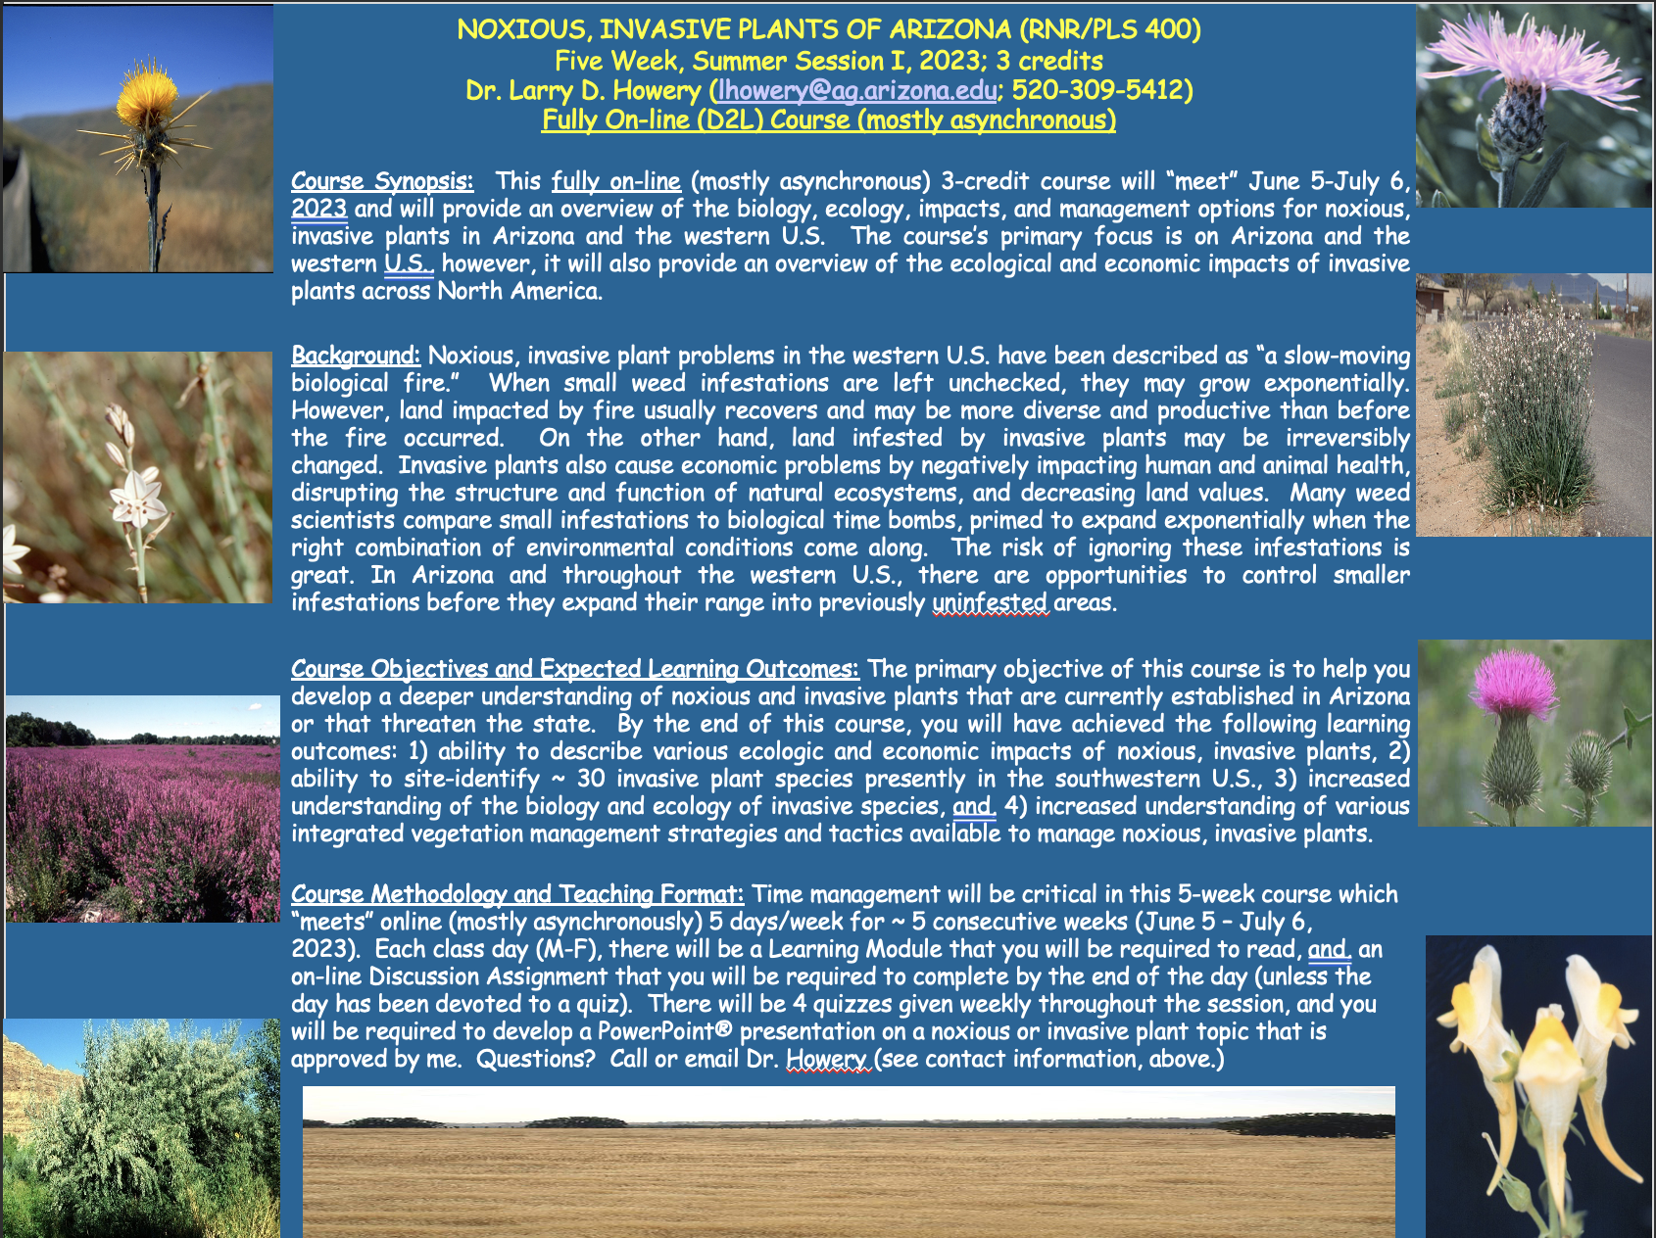
Budget:
Checking: $4,927.63
Club dues: $15/semester or $30/year
Dues can be paid in cash, PayPal (uofatierraseca), or Venmo (@TierraSeca)

Connect with Us!
Email: uofatierraseca@gmail.com
GroupMe: https://groupme.com/join_group/38156015/nWJ5vk
Website: https://uofatierraseca.wixsite.com/website
Instagram: https://www.instagram.com/uatierraseca/?hl=en (@uatierraseca)

Meeting Closed: 6:16 PM

