

March 14, 2023

Called to Order: 5:31PM

Spring 2023 Meetings Schedule:
Every other Tuesday at 5:30pm in ENR2 N350
January 17
January 31
Feb 7 (SRM info meeting)
February 28th
March 14th
March 28th
April 11th
April 25th

Attendance:
Kaitlyn Tyler, Bailie Wynbelt, Robin Bradley, Ashley Gomez, Parker Brown, Noah Sygrove, Dakota Baden, Maxwell Eller, Doan Goolsby, Davin Jorgensen, Philly Montierth, Riley Gallagher, Ava Hamstead, Brandon Mayer, Brandi Obregon, Idelfonzo Trujillo, Sarah Noelle, Matt Mayer, Isabel DiNardo, Tanner Skaare, Davin Jorgensen, Andres Martinez, Aaron Lien, Eamonn Mazur

Meeting Minutes:
- Guest Speaker: John Hall with the BLM Wild Horse and Burro Program
- Sheep Shearing
  - Who: Dennis Moroney and the 47 Ranch
  - What: Sheeeeeep!!
  - Where: McNeal, AZ
  - When: All day Monday April 10th
  - Sign Up Sheet: https://docs.google.com/spreadsheets/d/16R4ovgN8GhTMplcd6I4iOYzVyC1BhUjTvT9YBpJ60NI/edit?usp=sharing
  - If you want a Dean’s excuse you must sign up by SUNDAY 3/19
- Upcoming Workshops:
  - 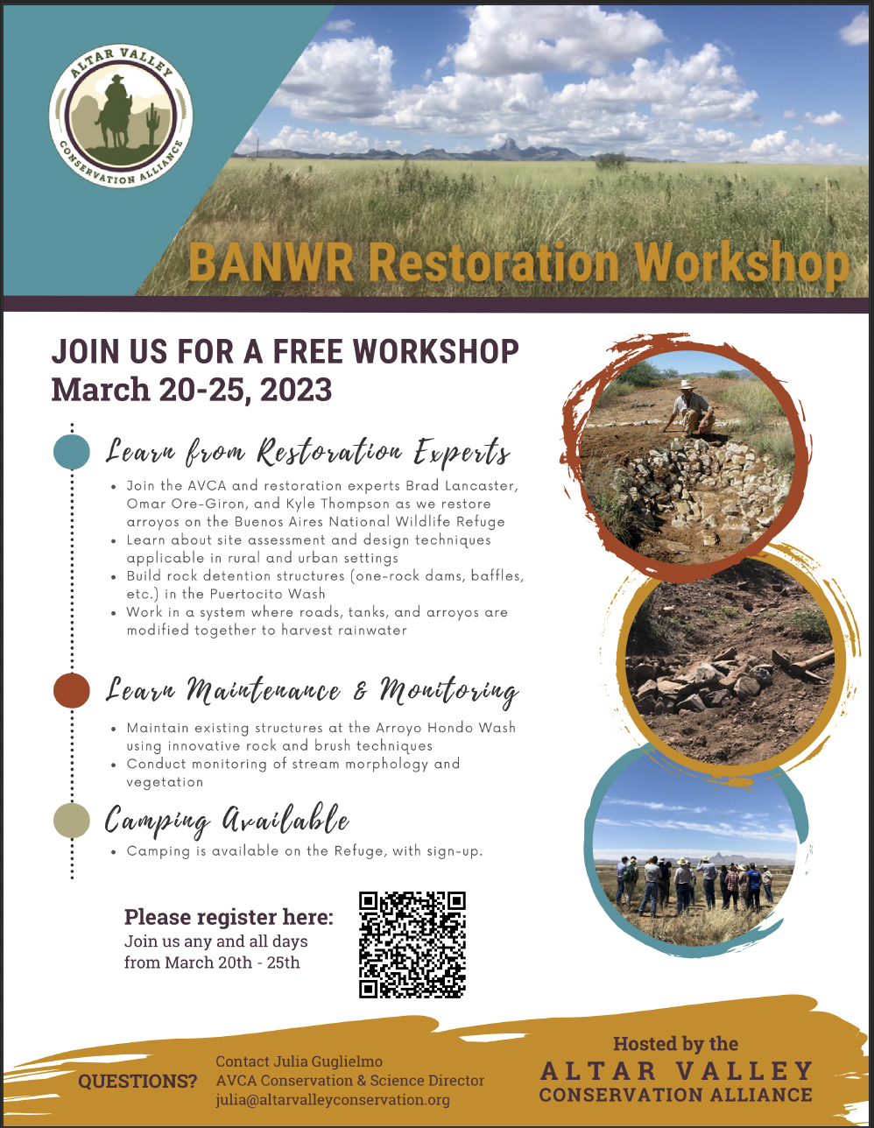

- Upcoming summer classes: PLS/RNR 400: Noxious/Invasive Plants of AZ w/ Dr. Larry Howery (5 weeks, fully online/asynchronous)
  - Good option for your PLS credit!
  - 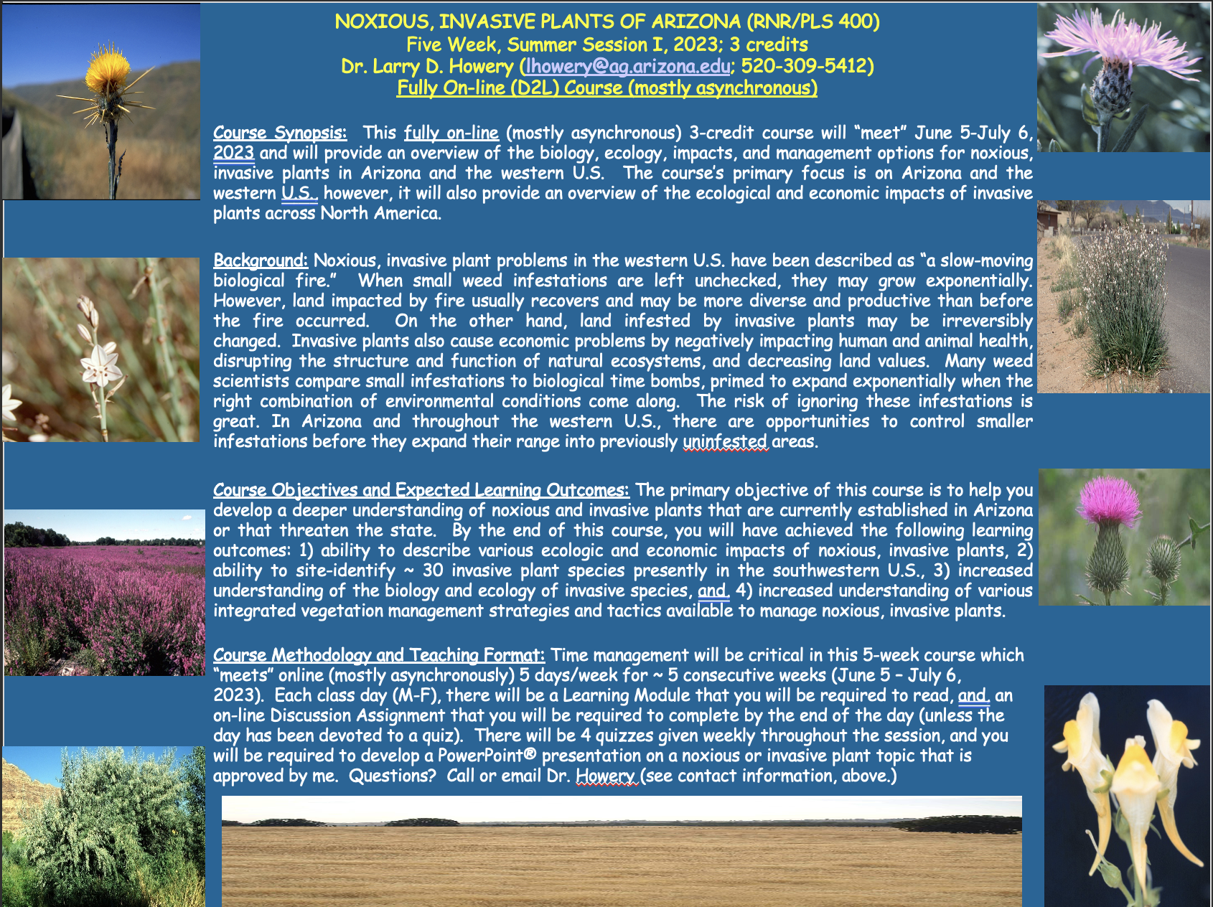
- Scholarships
  - 2023-2024 CALS scholarships (due Apr 1)
    - Who: All degree-seeking CALS students are eligible. Undergraduate and graduate, all majors, all campuses, all academic levels (including incoming First-Year and transfer students), all GPAs.
    - What: Over $1.1 million available for 2023-2024.
    - By When: Deadline to apply is 11:59pm, April 1, 2023.
    - How: We have an efficient, two-step process that starts with Scholarship Universe (SU) and ends with a Qualtrics survey. When you are ready to apply, be absolutely sure to follow the CALS How-To-Apply Guide. This guide contains specific steps and a walkthrough video to help you maximize your CALS scholarship eligibility. For more information on our scholarships in general, visit the scholarships page on the CALS website.
    - Very easy application that applies for 60+ scholarships at once
    - Questions: Contact Camille Andersen at camilleandersen@arizona.edu.

- Officer Elections for 2023-24
  - President
    - Dakota Baden
  - Vice President
    - Noah Sygrove
  - Secretary
    - Maxwell Eller
  - Treasurer
    - Philly Montierth
  - Historian
    - Doan Goolsby

Budget:
Checking: $4,927.63
Club dues: $15/semester or $30/year
Dues can be paid in cash, PayPal (uofatierraseca), or Venmo (@TierraSeca)

Connect with Us!
Email: uofatierraseca@gmail.com
GroupMe: https://groupme.com/join_group/38156015/nWJ5vk
Website: https://uofatierraseca.wixsite.com/website
Instagram: https://www.instagram.com/uatierraseca/?hl=en (@uatierraseca)

Meeting Closed: 6:32 PM

