

February 28, 2023

Called to Order: 5:31PM

Spring 2023 Meetings Schedule:
Every other Tuesday at 5:30pm in ENR2 N350
January 17
January 31
Feb 7 (SRM info meeting)
February 28th
March 14th
March 28th
April 11th
April 25th

Attendance:
Kaitlyn Tyler, Bailie Wynbelt, Robin Bradley, Parker Brown, Noah Sygrove, Dakota Baden, Maxwell Eller, Doan Goolsby, Davin Jorgensen, Philly Montierth, Riley Gallagher, Ava Hamstead, Brandon Mayer, Brandi Obregon, Idelfonzo Trujillo, Sarah Noelle, Matt Mayer, Isabel DiNardo, Tanner Skaare, Jacob Brown, Rakeen Abdali, Sebastien Sagel, Ethan Smook

Meeting Minutes:
- SRM Wrap-up
  - URME Team: Congratulations to Philly, Kaitlyn, Robin, Doan, Davin, Andres, Dakota, Isabel, Brandi, Ashley, Fonzo, Ava, Noah, Brian, Parker and Max for competing!! And thank you to Elena for coaching!
    - Congratulations to Robin for a 3rd Place in the Individual Undergraduate Range Management Exam
  - Plant ID: Congratulations to Philly, Kaitlyn, Robin, Doan, Davin, Andres, Dakota, Brandi, Ashley, Fonzo, Ava, Noah, Brian, and Max for competing!! Thank you to Sarah and Brandon for coaching!
  - Range Cup: Congratulations to Brandi, Noah, and Parker on taking 2nd place in the Range Cup competition! Thank you to Dr. Aaron Lien for coaching and Brandon Mayer, Kelsey Landreville, and Noah’s mom for edits
  - Next year: Reno!
- Upcoming Workshops:
  - 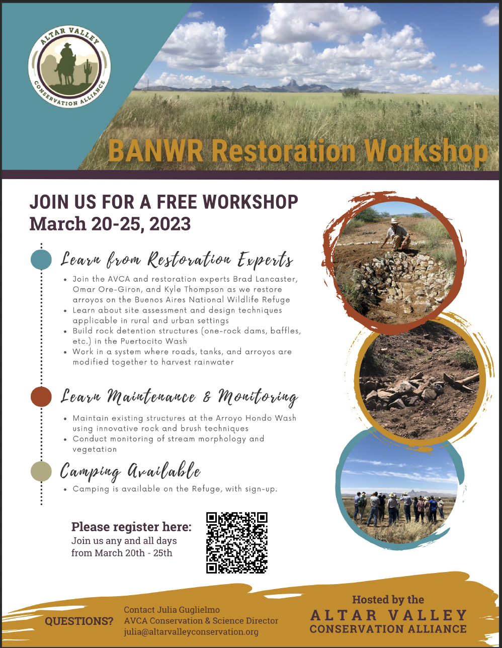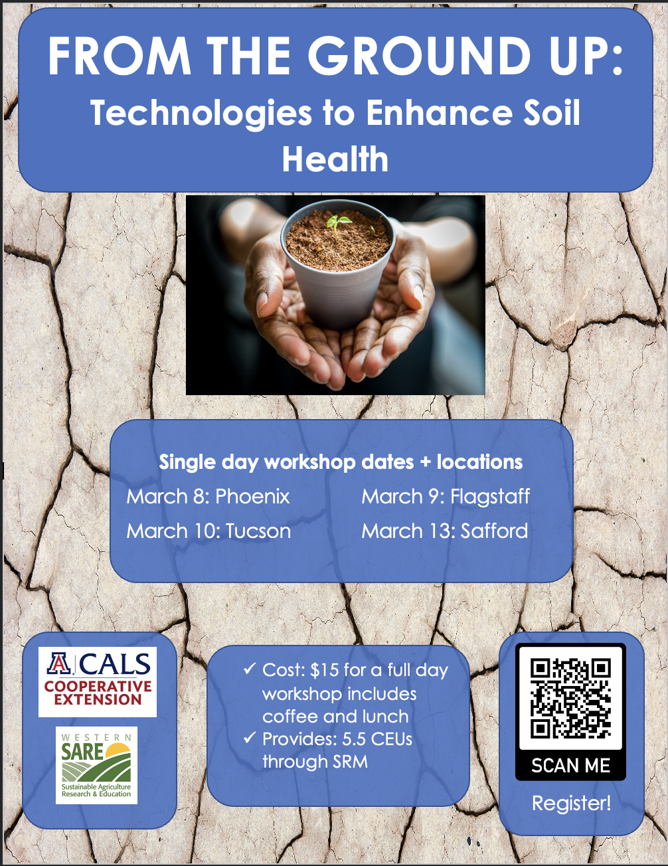

- Upcoming summer classes: PLS/RNR 400: Noxious/Invasive Plants of AZ w/ Dr. Larry Howery (5 weeks, fully online/asynchronous)
  - Good option for your PLS credit!
  - 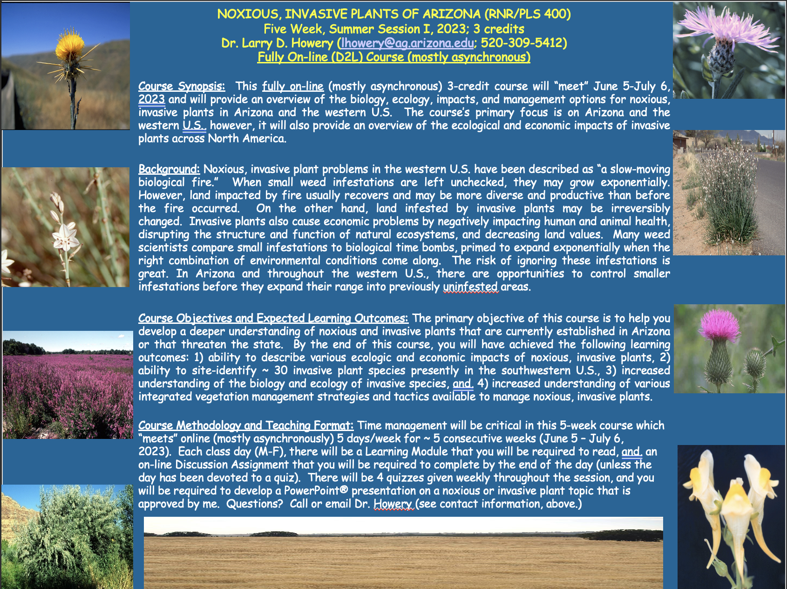
- Scholarships
  - 2023-2024 CALS scholarships (due Apr 1)
    - Who: All degree-seeking CALS students are eligible. Undergraduate and graduate, all majors, all campuses, all academic levels (including incoming First-Year and transfer students), all GPAs.
    - What: Over $1.1 million available for 2023-2024.
    - By When: Deadline to apply is 11:59pm, April 1, 2023.
    - How: We have an efficient, two-step process that starts with Scholarship Universe (SU) and ends with a Qualtrics survey. When you are ready to apply, be absolutely sure to follow the CALS How-To-Apply Guide. This guide contains specific steps and a walkthrough video to help you maximize your CALS scholarship eligibility. For more information on our scholarships in general, visit the scholarships page on the CALS website.
    - Very easy application that applies for 60+ scholarships at once
    - Questions: Contact Camille Andersen at camilleandersen@arizona.edu.

- Officer Nominations - Elections set for 3/14/2023 meeting
  - President
    - Noah Sygrove
    - Dakota Baden
    - Ashley Gomez
    - Parker Brown
    - Brian Muha
  - Vice President
    - Ava Hamstead
    - Dakota Baden
    - Brandi Obregon
    - Brian Muha
  - Secretary
    - Fonzo Trujillo
    - Philly Montierth
    - Ava Hamstead
    - Brian Muha
  - Treasurer
    - Kaitlyn Tyler
    - Ava Hamstead
    - Noah Sygrove
    - Brandi Obregon
    - Brian Muha
  - Historian
    - Doan Goolsby
  - Message us if you want to nominate anyone else (including yourself)

- Plant ID Debrief and Class
  - Email Brandon and Sarah with feedback
  - Class will be Tu/Th evenings next semester
  - Do not have to be in the class to participate in Plant ID

Budget:
Checking: $4,927.63
Club dues: $15/semester or $30/year
Dues can be paid in cash, PayPal (uofatierraseca), or Venmo (@TierraSeca)

Connect with Us!
Email: uofatierraseca@gmail.com
GroupMe: https://groupme.com/join_group/38156015/nWJ5vk
Website: https://uofatierraseca.wixsite.com/website
Instagram: https://www.instagram.com/uatierraseca/?hl=en (@uatierraseca)

Meeting Closed: 6:35 PM

