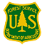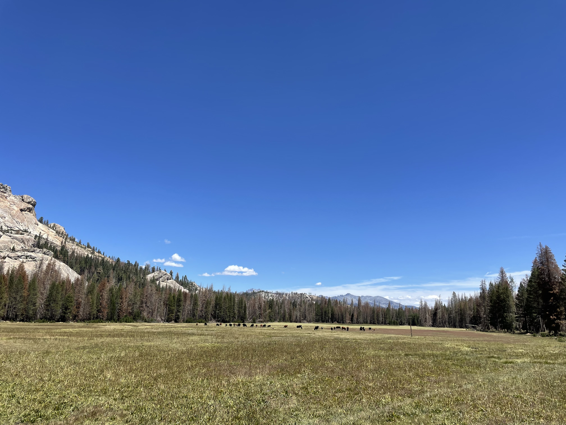

Student Trainee (Range Management) ♣ Series: 0499 ♣ Entry Grades: 03/04/05 ♣ Planned conversion full performance level: Not to exceed GS-09. ♣ Available Duty Locations:
- Inyo National Forest – Bishop, CA or Mammoth Lakes, CA / Contact: Nathan Sill nathan.sill@usda.gov (626) 698-8996
Rangeland Management Specialist ♣ Series 0454 ♣ Entry Grade: GS-07/09 ♣ Full Performance level: GS-11 ♣ Available Duty Locations:
- Los Padres National Forest – Santa Maria, CA (Michael Papa michael.papa@usda.gov ), Frazier Park, CA (Karina Medina karina.medina@usda.gov) and King City, CA (Fin Eifert john.eifert@usda.gov)
- Inyo National Forest – Lee Vining, CA or Mammoth Lakes, CA / Contact: Nathan Sills nathan.sill@usda.gov (626) 698-8996
- Mendocino National Forest – Upper Lake, CA / Contact: Frank Aebly frank.aebly@usda.gov (707) 489-2786
- Modoc National Forest – 2 positions: Adin, CA or Alturas, CA & Cedarville, CA or Alturas, CA
- Contact: Garrett Noles garrett.noles@usda.gov (530) 667-8630 / Jenny Jayo jennifer.jayo@usda.gov (530) 640-5398
- Six Rivers National Forest – Mad River, CA or Eureka, CA / Contact: Kristen Lark kristen.lark@usda.gov (707) 382-8427
- Tahoe National Forest – Sierraville, CA / Contact: Rachel Hutchinson rachel.hutchinson@usda.gov (530) 562-7517
Rangeland Management Specialist ♣ Series 0454 ♣ Entry Grade: GS-05/07 ♣ Full Performance level: GS-09 ♣ Available Duty Locations:
- Sierra National Forest – North Fork, CA and Prather, CA / Contact: Aimee Cox aimee.cox@usda.gov (559) 317-7482 and Cinda Mattrocce cinda.mattocce2@usda.gov (559) 706-3716
Range Technician ♣ Series: 0455 ♣ Entry Grade: GS-04/05 ♣ Full Performance Level: GS-07 Available Duty Locations:
- Los Padres National Forest – Santa Maria, CA (Michael Papa michael.papa@usda.gov ), Frazier Park, CA (Karina Medina karina.medina@usda.gov ) and King City, CA (Fin Eifert john.eifert@usda.gov )
- Modoc National Forest - Adin, CA or Alturas, CA / Contact: Garrett Noles garrett.noles@usda.gov (530) 667-8630 / Jenny Jayo jennifer.jayo@usda.gov (530) 640-5398
- Shasta-Trinity National Forest – Redding, CA / Contact: Ashley Knight ashley.knight@usda.gov (530) 440-8942
- Sierra National Forest – North Fork, CA and Prather, CA /Contact: Aimee Cox aimee.cox@usda.gov (559) 317-7482 and Cinda Mattrocce cinda.mattocce2@usda.gov (559) 706-3716

