
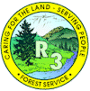
Prescott National Forest
Southwest Region (R3)
Two Permanent, Full-Time
Rangeland Management Technicians, GS-0455-05/06/07
If interested, please complete the outreach reply form below.

The Prescott National Forest is outreaching for two Rangeland Management Technicians,
GS-0455-06/07, one to be located at the Verde Ranger District in Camp Verde, AZ and one to be located at the Chino Valley Ranger District in Chino Valley, AZ. These positions are advertised as merit and recent graduates as eligable candidates, so please ensure all required documentation is submitted. The districts emphasizes watershed, wildlife and range management, dispersed recreation, and fuel wood programs.

The Prescott NF covers an area of approximately 1.2 million acres in west Central Arizona. At the lowest elevation, the landscape is dominated by the lower Sonoran desert ecosystem. As the land gains elevation, chaparral and desert grassland becomes common, followed by pinon-pine and juniper. Above that, Ponderosa Pine is the dominant ecosystem. Elevation on the Forest ranges from approximately 2,600 – 7,900 feet.

The Prescott National Forest Range Program is divided into two zones. The Bradshaw and Chino Valley Ranger Districts are known as the West Zone, and the Verde Ranger District is known as the East Zone. The program is comprised of a Forest Range Program Manager, two GS-11 Range Management Specialists one on each zone (East and West), one GS-09 Range Management Specialist (West Zone), and two GS-07 Range Technicians, one on each zone. Seasonal employees are located out of the district offices to help support the range program.

Permit administration on the Prescott National Forest includes 58 active allotments. The Forest is also very progressive regarding restoration activities and timber sale work, which encompasses several resource areas working together.
MAJOR DUTIES AND RESPONSIBILITIES
- Conduct short and long-term monitoring on assigned grazing allotments, which includes both upland and riparian monitoring.
- Gather and assemble data concerning rangeland health, trends and ecological status of vegetation communities.
- Utilization of GPS, computers, the ability to create maps, work within the NRM computer system.
- Make recommendations for improved rangeland and livestock administration and provides input into the development of subsequent rangeland and livestock management decisions.
- Assist in the administration of grazing permits by consulting, coordinating and cooperating with permittees and other rangeland users.
- Inspect rangeland improvements over rough and uneven terrain for permit compliance
- Prepare rangeland improvement maintenance schedules and keep records of existing and proposed improvements, maintenance needs, and accomplishments.
- Maintain range allotment inspection books, livestock management strategies/practices, and compile actual use information for various grazing areas.
- Investigate unauthorized livestock uses and take direct action for removal of unauthorized/trespass livestock. Work closely with permittees and other livestock owners to prevent further unauthorized use.
This is a great opportunity to work with a dynamic team. This position will be supervised by the local GS-11 Rangeland Management Specialist. For additional job information, please contact Seth Ratering (seth.ratering@usda.gov) or John Kava (john.kava@usda.gov).
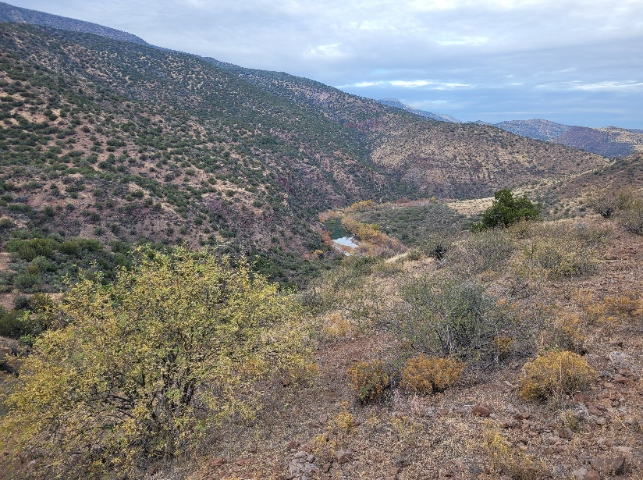
Camp Verde is located one and a half hours from the Phoenix metropolitan area, one hour from Flagstaff, Prescott, Payson, and 30 minutes from Sedona. Chino Valley is about 30 minutes north of Prescott on highway 89.

Common to both zones, the winding Verde River creates habitat for bald eagles, hawks, blue heron, beavers, otters, and many others. Surrounded by the Bradshaw Mountains and the Black Hills, there’s spectacular scenery in every direction.
The weather in Central Arizona is hard to beat, offering all four seasons, with sunny spring-time weather, warm summers, gorgeous fall colors, and seasonably cool winters with only occasional snow. The area is rich with history and there are activities for everyone from golfing, exploring nature, hiking, mountain biking, camping, hunting, fishing, exploring back roads, mining, great restaurants, local art, and many different types of events and entertainment.
Other Community Information:
Visit Prescott: www.visit-prescott.com
Visit Camp Verde: https://visitcampverde.com
Visit Chino Valley: Tourism (chinovalley.org)

Outreach Notice Reply Form
One permanent, full time Rangeland Management Technician, GS-0455-06/07, located at the Verde Ranger District in Camp Verde, AZ.

One permanent, full time Rangeland Management Technician, GS-0455-06/07, located at the Chino Valley Ranger District in Chino Valley, AZ

If you are interested please complete this form and attach your resume and email the documents to seth.ratering@usda.gov and john.kava@usda.gov. Notification will be provided to you when the online job application is available. Thank you for your interest in these important positions.

NAME: ___________________________________________________________________

E-MAIL ADDRESS:___________________________________________________________

MAILING ADDRESS: _________________________________________________________

Location Preference:________________________________________________________

TELEPHONE NUMBER(S): ____________________________________________________

AGENCY EMPLOYED WITH: _____USFS _____BLM OTHER________________________

TYPE OF APPOINTMENT: _____PERMANENT _____ TEMPORARY ______ TERM
_____VRA _____ PWD _____ OTHER

CURRENT REGION/FOREST/DISTRICT: _________________________________________

CURRENT SERIES AND GRADE: _______________________________________________

CURRENT POSITION TITLE: __________________________________________________

IF NOT A CURRENT PERMANENT (CAREER OR CAREER CONDITIONAL) EMPLOYEE
ARE YOU ELIGIBLE TO BE HIRED UNDER ANY OF THE FOLLOWING SPECIAL
AUTHORITIES?
______ PERSON WITH DISABILITIES
______ VETERANS READJUSTMENT
______ DISABLED VETERANS W/30% COMPENSABLE DISABILITY
______ VETERANS EMPLOYMENT OPPORTUNITIES ACT OF 1998
______ FORMER PEACE CORPS VOLUNTEER
______ PATHWAYS PROGRAM
______ PUBLIC LANDS CORPS (PLC)
______ OTHER ____________________________________________________________

