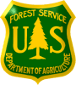
White River National Forest
Blanco Ranger District

OUTREACH NOTICE
Rangeland Management SPECIALIST GS-0454-5/7/9
natural resource specialist gs-0401-7/9

position will open in usa jobs february 15 – 27, 2023

White River National Forest, Blanco Ranger District
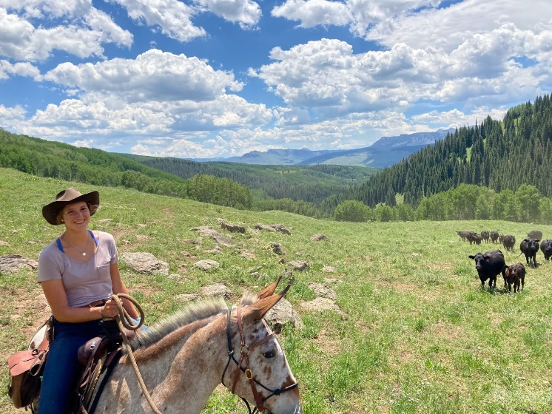
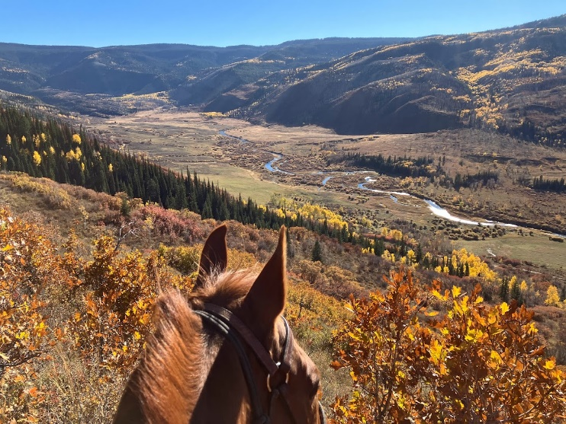
Meeker, Colorado

The White River National Forest will soon be advertising to fill a permanent Rangeland Management Specialist GS-454-5/7/9 for the Blanco Ranger District. The duty station is in Meeker, Colorado. The responses to this outreach will help determine who will be eligible to apply to the vacancy when it is advertised.

THE POSITION
This is an exciting and challenging opportunity to work on a district with a large, complex range program. This position serves as the rangeland management specialist responsible for assisting in managing, planning, scheduling, coordinating, reviewing, and reporting on an ecosystem-based rangeland management program. This position is supervised by a Supervisory Rangeland Management Specialist

This position will assist in the management of 34 active allotments with a mix of sheep and cattle while working with 16 permittees. This position will be expected to acquire and have a willingness to learn thorough knowledge of the field, range management and permit administration from which to develop management recommendations for the District Ranger.

We are looking for a person who:
- Has strong interpersonal skills
- Is a good communicator, both written and oral
- Is technically competent with a solid foundation in range management
- Is a team player who enjoys working with others to accomplish a common goal
- Is a self-starter, enjoys a challenge and has excellent problem-solving skills
- Has the ability to cope well with changing direction, multiple priorities, and a fast-paced work environment
- Has the ability to work well with diverse groups of people
- Horseback riding and pack stock skills are preferred

MAJOR DUTIES
Assist in developing an overall ecosystem-based rangeland management program utilizing Forest Plan guidance and rangeland project decisions as necessary to implement actions that help achieve plan goals and objectives.

Assist in coordinates the district noxious weed program including ongoing coordination with counties and other cooperators.

Consults, coordinates, and cooperates with all affected users, interested publics, and private interests. Assists in advising permittees on principles of rangeland management and laws, regulations, and policies governing management of range resources.

Assist in the completion of documentation with permittees such as billing, compliance reviews, and permit modifications. Works to ensure permittee compliance and takes necessary action to address compliance issues.

Assist in planning and implements rangeland improvement projects.

Aids in conducting annual monitoring of rangeland resource and activities to document condition and trend of plant communities, upland and riparian resources. Assesses and determines the effectiveness of on-going management actions and possible alternatives in management practices to achieve land management goals and objectives more effectively.

Participates as a member of interdisciplinary teams, accomplishing field work and preparing specialist reports and other documentation as needed for NEPA documents.

Other desired abilities include knowledge of identification of plants, knowledge of ArcGIS, GPS units, construction/maintenance of range improvements; proficiency with ATV/UTV, 4-wheel drive vehicles, and horsemanship skills. The ability to communicate and maintain good working relationships with internal and external partners is very important for this position.

BLANCO RANGER DISTRICT
The Blanco Ranger District Office is in Meeker, Colorado approximately 4 hours west from Denver and 2 hours from Aspen and Grand Junction, Colorado. The District is co-located with the Bureau of Land Management’s White River Field Office.
The Blanco District is a traditional ranger district in the sense that dispersed recreation and livestock grazing are the main drivers of the district. Elk hunting season is the busiest time of the year for the district and the area. The district offers something for everyone from back country hiking and horseback riding to an amazing OHV trail system.
The district manages approximately 350,000 acres of the White River National Forest including the majority of the historic Flat Tops Wilderness, which encompasses approximately 235,000 acres and includes Trappers Lake and the ‘Cradle of Wilderness’. District elevation ranges from 6,500’ to 12,000’.
The Blanco Ranger District provides access to a wide range of recreational opportunities. The Wagon Wheel OHV trail system connects the community of Meeker with Blanco district trails and BLM lands. The area is well known for outstanding hunting with one of the largest elk herds in North America.

THE WHITE RIVER NATIONAL FOREST
The Forest was established in 1891 as the White River Plateau Timber Reserve, the second such reserve to be named in the United States. It was one of the initial land reserves that started the public land system in America. But long before this designation, the Forest was home to the Ute Indians who followed herds of elk and bison on their seasonal migrations.

Today the Forest embodies the spirit of multiple-use management with more than 9 million visitors per year, making the White River the number one forest for recreation in the country. In addition to world-class recreation and abundant wildlife populations, the White River hosts activities such as grazing, logging, mining, and oil and gas development that are crucial to the economies of western Colorado.

The White River National Forest spans 2.3 million acres and is located in Eagle, Garfield, Pitkin, Summit, Gunnison, Mesa, Moffat, Rio Blanco and Routt counties in Colorado. In addition, the Forest serves as a playground for Denver and the rest of the Front Range.

MEEKER, COLORADO
The duty station of this position is in Meeker, Colorado.
At the west end of the Flat Tops Trail Scenic Byway, the community of Meeker is a quiet complement to the White River’s resort based districts. Meeker, in eastern Rio Blanco County, is a predominantly agricultural town of approximately 2,500 people. Meeker is centrally located between the White River Field Office’s BLM lands and the White River and Routt National Forests. Approximately 75% of Rio Blanco County’s lands are federally owned, offering diverse landscapes and recreation opportunities.
Meeker School District has one elementary school (k-5), one middle school (6-8) and a new high school (9-12). Class sizes are small which allows for better teacher/student interaction. Meeker has a modern recreation center with an year round indoor pool, an airport (EEO), acres of parks and miles of trails connecting to adjacent public land. Pioneers Medical Center is an 87,000 square-foot medical facility for family and pediatric care, emergency care, and a nursing home. Pioneers recently opened up a new orthopedic surgical facility with top notch physicians.
Meeker hosts the Range Call, the oldest annual rodeo in Colorado, OHV and Enduro-Race activities, a free summer concert series and the Meeker Classic Sheepdog Championship Trials.
Like all small communities, housing in Meeker can be challenging. The real estate market is currently very active. Rentals may be difficult to find. The cost of living in towns adjacent to the White River National Forest is very high. Meeker’s cost of living is not as high as other towns. Several realtors are available to assist with finding housing.
IF INTERSTED IN THIS POSITION
Respond to the Employment Outreach Database (https://fsoutreach.gdcii.com/Outreach/)

Complete the Outreach Response form below
Email the completed form along with your Resume to: Aaron Grimes, Acting District Ranger (aaron.grimes@usda.gov) 970-878-6007

Outreach Response Form –
Range Management Specialist GS-5/7/9
Meeker, CO, White River National Forest
USDA Forest Service, R2-Rocky Mountain Region
Please respond with a Resume and the attached form by February 21, 2023 to:
Aaron Grimes, Acting District Ranger (aaron.grimes@usda.gov)

Personal Information/Interest Form
Name: Date: / /
Address: Phone: ( ) -
E-Mail:

Are you currently a Federal employee: Yes No
If a Federal Employee, type of appointment you are currently under:
Career Career-Conditional
Excepted-ANILCA Excepted VRA
Other

Information on Current Position:
POSITION TITLE

 | REGION |  | FOREST

LOCATION:
DISTRICT

 | SERIES |  | GRADE

HOW DID YOU FIND OUT ABOUT THIS OUTREACH NOTICE?
Briefly describe why you will be a quality candidate for this position: (Optional)

