
FROM THE GROUND UP: Technologies to Enhance Soil Health Workshop
FROM THE GROUND UP: Technologies to Enhance Soil Health

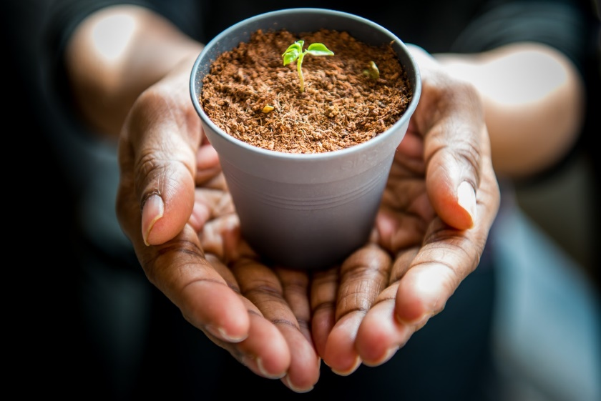

Single day workshop dates + locations
March 8: Phoenix March 9: Flagstaff
March 10: Tucson March 13: Safford

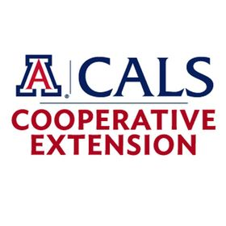
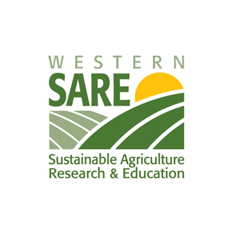

Register!
- Cost: $15 for a full day workshop includes coffee and lunch
- Provides: 5.5 CEUs through SRM

