Bighorn National Forest Vacancy Outreach Notice

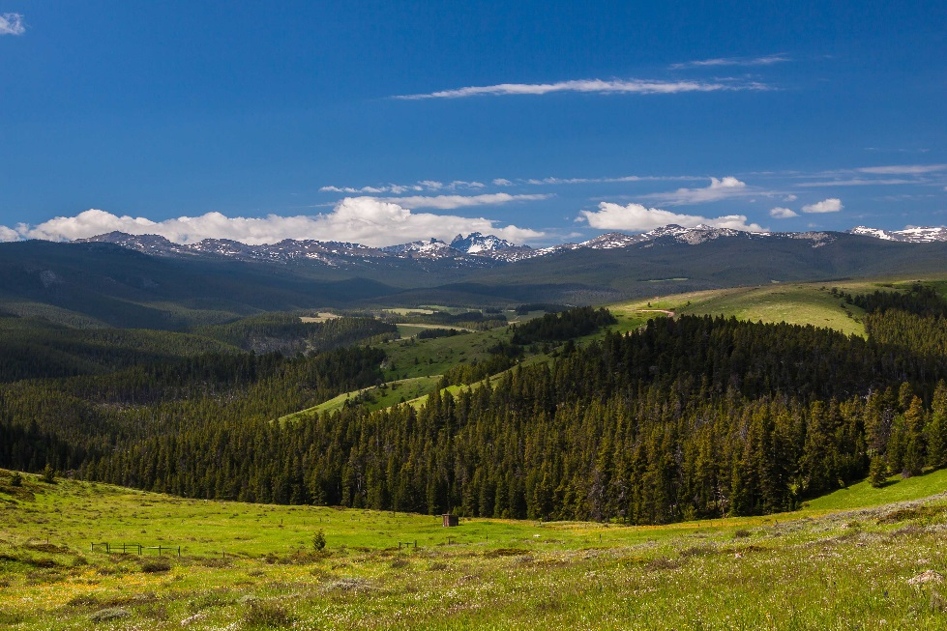
  - Rangeland Management Specialist
MERIT, RECENT GRADUATE, and INTERN opportunities
Permanent Position Opportunity
  - Bighorn National Forest in Sheridan, Greybull, and Buffalo Wyoming
  - Apply by

The Bighorn National Forest is looking to fill permanent Rangeland Management Specialist positions on the Tongue River, Medicine Wheel Ranger, and Power River Ranger Districts, with a duty station at Sheridan, Greybull, and Buffalo Wyoming respectively. These three positions are expected to be advertised at the National Society for Range Management hiring event occurring February 12-16, 2023 (https://www.fs.usda.gov/working-with-us/jobs/events/srm) through the Pathways Student- Recent Graduate Program, Internship, and Merit promotion opportunity. The successful applicants may be hired at a GS-3,4,5, or 7 level, with the position’s full promotional potential being a GS-9. Recent graduates and Interns who meet the minimum education requirements are encouraged to apply.
How and when to apply:
The vacancy announcement for this position will be posted on USAJOBS, the U.S. Government’s official website for employment opportunities at https://www.usajobs.gov. This position is expected to be available for application via USAJOBS February 12-16, 2023. However, this timeframe may change. Through USAJOBS, you can save a search and set up alerts, so you don’t miss this or other similar opportunities.

About the position:
This position serves as a Rangeland Management Specialist on one of three ranger districts, supervised by the Supervisory Rangeland Management Specialist.

Specific Tasks may include:
  - Gathering, compiling, and analyzing data to determine rangeland health requirements and participates by monitoring, gathering, analyzing, interpreting, and evaluating data to determine if land management, economic, and social goals and objectives identified for the land involved are being achieved
  - Conducts short and long term monitoring of plant community change, trends, grazing impacts; precipitation; soil erosion hazards; and correlates other rangeland resource activities and uses.
  - Individually, or as a team member, plans and carries out systematic ecosystem based rangeland surveys and inventories to identify and assess rangeland characteristics, amounts, types, values, and susceptibility of various land areas to specific land uses.
  - Prepares assigned portions of environmental assessments as a member of an interdisciplinary team.
  - Prepares environmental analysis reports in assigned functional areas
  - Makes recommendations for improved rangeland and livestock administration and provides input into the development of subsequent rangeland and livestock management decisions
  - Participates in the development, implementation, and evaluation of rangeland projects including determining the need for plant community and watershed improvements.
  - Prepares livestock management plans, determines location and proper stocking, and locates, prescribes, designs, and schedules rangeland improvement projects such as fences, pipelines, cattleguards, plant community changes, or prescribed burning.
  - Maintains continuing liaison with permittee, affected groups and others to ensure compliance with agreed upon plans and desired quality of work, and to advise rangeland users of various activities affecting their use of specific rangeland areas.
Assists in the administration of grazing permits by consulting, coordinating, and cooperating with permittees and other rangeland users.
  - Prepares and/or revises annual rangeland user instructions.
  - Receives, reviews, and acts on all livestock grazing applications. Provides information and guidance on the availability and eligibility of Federal cost share range improvement programs, assisting landowners with their applications, and following up to ensure compliance with cost share program requirements.
  - Determines permittee compliance with permits and makes recommendations to correct discrepancies.
  - Investigates unauthorized livestock uses and takes direct action for removal of unauthorized/trespass livestock.

Desired Strengths:
Strong candidates will demonstrate or be able to quickly gain knowledge, skills, or abilities related to:
- Verbal and written communication (technical and conversational), and interpersonal skills
- Field data collection for monitoring rangeland health
- Understanding physical and biological interrelationships that influence wildlife habit
- Use of mobile data collection services like ArcGIS Collector or Survey123
- Horsemanship is desired but not required.

Requirements:
- Some of this position’s duties will include considerable walking, bending, and climbing, often with a backpack or other gear over rough, uneven surfaces or mountainous terrain.
- Some of this position’s duties also include working on a computer for extended periods of time requiring the use of computer screens and sitting or standing in a traditional office or telework setting.
The Locations
BUFFALO, WYOMING: Buffalo is the county seat of Johnson County and located at the base of the Bighorn Mountains. It is conveniently located at the intersections of Interstates 25 and 90. The main street has more than a dozen historic buildings and just a short drive provides many other historical sites to explore. Buffalo has a population of about 4,600. Rental housing costs range from $700 to $1500 per month. Median house value is $300,000.
Buffalo is just a short drive to skiing, boating, camping, hunting, fishing, guest ranches, lakes, streams, and mountains. It is a sportsman’s paradise with an abundance of spectacular scenery, wildlife, fascinating frontier heritage and outdoor recreation. Health care, dental care, motels, banks, hardwarestore, lumber yard, grocery store, service stations, and a variety of dining options are all locally available.
The Buffalo City Park boasts outdoor swimming pool, tennis courts and playgrounds. Along with baseball fields, there is an excellent track, soccer fields, football field, a full-service YMCA, plus a 24-hour fitness center. Buffalo also has a walking/bike pathway along Clear Creek which connects by non-motorized trail to the Bighorn National Forest. Check out the Buffalo Area Chamber of Commerce at www.buffalowyo.com. The Johnson County School District has K-12 grades located in Buffalo (www.jcsd1.us). Sheridan College and Sheridan College Technical Center are in Sheridan, 35 miles to the north, and there is a Johnson County campus in Buffalo. Billings, Montana, is located 165 miles northwest of Buffalo via I-90. Casper, Wyoming, is 110 miles south of Buffalo via I-25. Gillette, Wyoming, is located 70 miles east of Buffalo via I-90. The northern Black Hills communities of Spearfish, Deadwood, Sturgis, and Rapid City are easily accessed in 3 hours.
GREYBULL, WYOMING: Greybull, Wyoming is home to 1,853 residents. The town sits adjacent to the Big Horn River and has a three mile developed river walk. Midway Golf Club is located just south of town. The nearest hospital is five miles south of town at the South Big Horn County Hospital. Greybull has elementary, middle, and high schools. Health care, dental care, motels, banks, hardware store, lumber yard, grocery store, service stations, and dining are all locally available. Nearby towns include Basin (8 miles), Cody (53 miles), Lovell (32 miles), Powell (48 miles), Shell (15 miles), and Worland (38 miles). The average house for sale in Greybull is $200,000 and houses for rent are around $800.
The town of Greybull is surrounded by public lands; year-round access to the Bighorn National Forest and east to Sheridan via Highway 14 allows for many recreational opportunities including fishing, hiking, hunting, sightseeing, snowshoeing, snowmobiling, exciting paleontology, and geology. Yellowstone National Park is two hours to the west. Antelope Butte Mountain Recreation Area is located 45 minutes away. Sleeping Giant Ski Hill and Meadowlark Ski Hill are both about 90 minutes away from Greybull.
The weather in Greybull is somewhat typical for the northern Rockies region, with fairly cold winters and warm summers. Wintertime highs average in the mid-30's, with occasional cold snaps dropping the mercury below zero. Summertime highs range from the mid-80 to mid-90, cooling off considerably at night. Greybull is at 3,789 feet in elevation (relatively low for Wyoming), and generally does not receive the winds that other parts of the State experience. Precipitation averages about 7 inches per year with most falling in the form of rain. Annual snow accumulation is usually less than 12 inches.
The main industries in the Greybull area are bentonite mining, farming, oil field production, railroad transportation, and ranching. Sales tax in Big Horn County is 5%, with NO State or local income tax. For more information about Greybull, visit http://townofgreybull.com/ or www.greybull.com/.
SHERIDAN, WYOMING: A full-service community of around 18,000 residents, Sheridan is situated in the eastern foothills of the Bighorn Mountains. Sheridan has an excellent school system including five elementary schools, one junior high school, one high school, and Sheridan College, a two-year college offering credit and non-credit classes. Health care is provided by numerous physicians, dentists, mental health specialists, and Sheridan Memorial Hospital.
The city offers recreational activities such as football, baseball, volleyball, ice hockey, softball, polo, and a multi-use trail system along Goose Creek. A large YMCA is very popular with local residents. The
Sheridan County Fulmer Library is excellent. Year-round access to the Bighorn National Forest allows recreational opportunities including fishing, hiking, hunting, sightseeing, snowshoeing, camping, rock climbing, and snowmobiling. Yellowstone National Park is about five hours to the west.
Housing costs range from $600 to $1,500 per month for rentals. Most three-bedroom homes are priced over $280,000. Sheridan County plus state sales tax is 6 percent; Wyoming does not levy state income tax.
The climate is typical for the northern Rockies. Wintertime highs average in the mid-30s with occasional cold spells below zero. Summertime highs generally range from the 80s to 90s, cooling off considerably after sundown. Sheridan is located at 3,700 feet in elevation. Precipitation averages about 15 inches per year with about 72 inches of snow on average. The average growing season is 119 days. For more information about Sheridan, visit www.sheridanwyomingchamber.org/.

Bighorn National Forest
The Bighorn National Forest is located in north-central Wyoming, about halfway between Mt. Rushmore and Yellowstone National Park. It is 80 miles long, 30 miles wide, and covers 1.1 million acres. The forest includes over 300 miles of groomed snowmobile trails, 30 campgrounds, over 1,500 miles of trails, and eight lodges/resorts.
Three scenic byways traverse the forest, which includes the 189,000-acre Cloud Peak Wilderness. Wildlife are abundant in the Bighorns, with moose, elk, bighorn sheep, deer, black bear, mountain lion, and smaller creatures such as pike, marmot, and various songbirds.
The forest is administered from three ranger districts and one supervisor’s office: Medicine Wheel Ranger District in Greybull, Powder River Ranger District in Buffalo, and Tongue Ranger District and supervisor’s office in Sheridan.
The forest is staffed by 86 permanent employees.
Learn more about the Bighorn National Forest at www.fs.usda.gov/bighorn/.

How to respond
If you would like to receive notification when the vacancy is available on USAJOBS, complete the reply form at the end of this outreach notice and send it by February 1, 2023, to
Cordell Perkins
Range Program Lead
Bighorn National Forest
cordell.perkins@usda.gov

For more information
For more information about the position or the community, contact Cordell Perkins via mobile phone (406) 740-1781 or by email at cordell.perkins@usda.gov

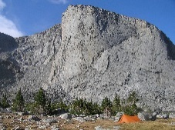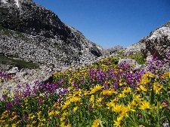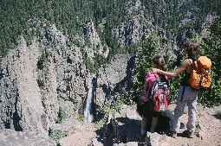

OUTREACH RESPONSE FORM
Bighorn National Forest
Rangeland Management Specialist/STUD TR (NATRL RES MGMT & BIO SCI).
GS-0454-05, 07, 09 / GS-0499-03, 04, 05, 07, 09
NAME:
E-MAIL ADDRESS:
MAILING ADDRESS:
TELEPHONE NUMBER:

AGENCY CURRENTLY EMPLOYED WITH: USFS BLM OTHER

TYPE OF APPOINTMENT: PERMANENT TEMPORARY TERM
VRA SCHEDULE A OTHER

IF CURRENT USFS EMPLOYEE, PROVIDE UNIT INFORMATION (REGION, FOREST, DISTRICT):

CURRENT SERIES: CURRENT GRADE:
CURRENT POSITION TITLE:

HOW DID YOU FIND OUT ABOUT THIS OUTREACH NOTICE?
CONFIRM THAT EDUCATIONAL REQUIREMENTS HAVE BEEN MET: YES NO

ARE YOU ELIGIBLE TO BE HIRED UNDER ANY OF THE FOLLOWING SPECIAL AUTHORITIES?

SCHEDULE A (PERSON WITH DISABILITIES)

VRA

DISABLED VETERANS W/30% COMPENSABLE DISABILITY

VETERANS EMPLOYMENT OPPORTUNITIES ACT OF 1998

FORMER PEACE CORPS VOLUNTEER

PATHWAYS PROGRAM (STUDENTS AND RECENT GRADUATES)

PUBLIC LAND CORPS

LAND MANAGEMENT WORKFORCE ACT (LONG-TERM TEMPORARY EMPLOYEE)

Submission of this form is voluntary — Thank you for your interest

