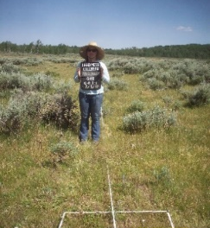
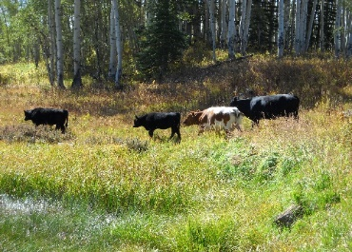
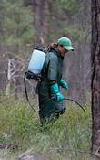
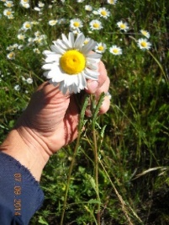

Student Trainee (Natural Resources Management and Biological Sciences)
GS-0499 03/04/05
Grand Mesa, Uncompahgre and Gunnison National Forests
Grand Valley Ranger District, Grand Junction, CO

The Grand Valley Ranger District of the Grand Mesa, Uncompahgre and Gunnison National Forests is seeking a candidate for the newly advertised GS-0499 03/04/05 Natural Resources Management and Biological Sciences Student Trainee. This open vacancy announcement 22-NPT-SUM-NR-345-NTE is available via www.usajobs.gov January 5th, 2023 through January 27th, 2023
The start date for this position is negotiable with a desire to have someone in place by June 5th , 2023.

Duties Associated with this Position
The Grand Valley Ranger District is located in the beautiful western slope community of Grand Junction, Colorado. The Range program of the Grand Valley Ranger District is a well rounded complex department that encompasses the administration and management of 22 seasonal grazing allotments on the Grand Mesa and Uncompahgre Plateau with 72 permitted livestock producers as well as the inventory and management of the areas invasive species.

This is position will afford an employee the opportunity to develop and hone their rangeland management and natural resources skills alongside experienced and diverse Forest Service Range Managers.

Duties that will be developed and assigned include but are not limited to:
- Short and Long-term Vegetation Trend Monitoring and analysis
- Range Infrastructure inspection, development and construction
- Invasive Species monitoring and herbicide application
- Compliance inspections and Allotment Spot checks.
- Backcountry travel via hiking, horseback riding and/or atv travel
- Other Duties as assigned

The ideal candidate is between their sophomore and junior years of university and pursuing a Rangeland Management or similar degree that will qualify them for the 0454 series upon graduation. Candidates should commit to working 2 summers and 1 semester prior to graduation. Upon successful completion of the program, the candidate may be non-competitively hired as a Rangeland Management Specialist for the US Forest Service.

We are excited and looking forward to hearing from you and reviewing all qualified interested applicants! For additional position information, please feel free to contact Rangeland Management Specialist Justin Bennett at justin.c.bennett@usda.gov or call (970)216-6481.

