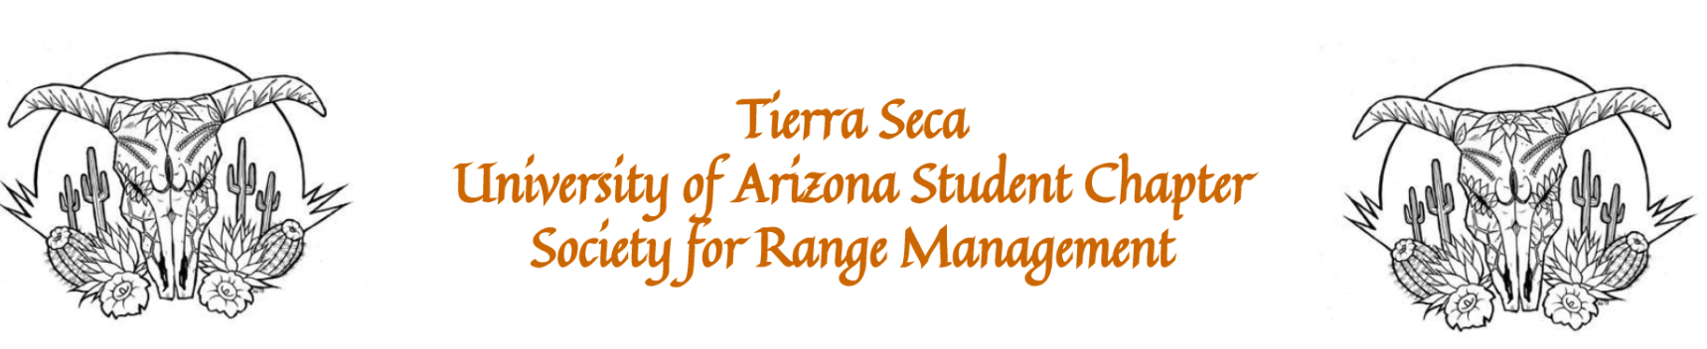

December 6, 2022

Called to Order: 5:39PM

Fall 2022 Meetings Schedule:
Every other Tuesday at 5:30pm in ENR2 N350
August 30
September 13
September 27
October 11
October 25
November 11
November 22
December 6

Attendance:
Robin Bradley, Bailie Wynbelt, Dakota Baden, Ashley Gomez, Philly Montierth, Doan Goolsby, Ava Hamstead, Brandi Obregon, Idelfonzo Trujillo, Noah Sygrove, Andres Martinez, Brian Muha, Davin Jorgenson, Eamonn Mazur, Maxwell Eller, Sydney Ingham, Parker Brown, Isabel DiNardo

Meeting Minutes:

- Steer Raffle Update
  - We have raffle tickets!!
  - One Quarter (~125 LBS): $20 each or 5 for $100
  - Steer provided by Dennis and Debra Moroney (The 47 Ranch)
    - Local beef producer from Bisbee AZ
    - Sustainable production, Grass raised and finished!
  - Drawing on February 7th, 2023.
  - Share with friends, family, and everyone else!
  - Link to steer raffle webpage: https://uofatierraseca.wixsite.com/website/steer-raffle-and-donations

- SRM Updates
  - Bailie and Robin secured Agrilife funding
  - Please fill out Ogden Scholarship ASAP
  - We are continuing to work on funding, and will be booking travel and hotels soon

- Last Call: Range Cup!
  - The topic this year is to identify a climate change issue affecting North American rangelands (can be region-specific) and then identify one or more solutions to this problem drawing on data from places outside of North America
  - More info here: https://rangelands.org/wp-content/uploads/2022/11/2023-Rangeland-Cup_Guidelines.pdf
  - Dr. Aaron Lien offered to coach again this year!
  - 1st-3rd place wins a cash prize, and this looks great on a resume
  - Let us know if you are interested

- Ogden Scholarship – Please fill out ASAP
  - Scholarship for students to use for SRM
  - Fill out the application (survey form) in email form Katie Hughes
    - Link to form here: https://forms.gle/UiztcRKGfr6BfZRb6
  - Must be filled out by individual students
  - High likelihood of receiving money to support travel
  - Deadline is Dec 10th!

Budget:
Checking: $6,711.46
Club dues: $15/semester or $30/year
Dues can be paid in cash, PayPal (uofatierraseca), or Venmo (@TierraSeca)

Connect with Us!
Email: uofatierraseca@gmail.com
GroupMe: https://groupme.com/join_group/38156015/nWJ5vk
Website: https://uofatierraseca.wixsite.com/website
Instagram: https://www.instagram.com/uatierraseca/?hl=en (@uatierraseca)

Meeting Closed: 6:16PM

