

November 8, 2022

Called to Order: 5:36PM

Fall 2022 Meetings Schedule:
Every other Tuesday at 5:30pm in ENR2 N350
August 30
September 13
September 27
October 11
October 25
November 11
November 22
December 6

Attendance:
Parker Brown, Robin Bradley, Bailie Wynbelt, Dakota Baden, Ashley Gomez, Philly Montierth, Doan Goolsby, Maxwell Eller, Ava Hamstead, Brandi Obregon, Idelfonzo Trujillo, Noah Sygrove, Andres Martinez, Brian Muha, Davin Jorgenson

Meeting Minutes:
- NRCDP Internship Presentation
  - Email us if you want the post-session email with more details!

- Steer Raffle Update
  - We have raffle tickets!!
  - One Quarter (~125 LBS): $20 each or 5 for $100
  - Steer provided by Dennis and Debra Moroney (The 47 Ranch)
    - Local beef producer from Bisbee AZ
    - Sustainable production, Grass raised and finished!
  - Drawing on February 7th, 2023.
  - Share with friends, family, and everyone else!

- AZSRM Bar V Workshop
  - Who: Cooperative Extension + AZSRM
  - What: Producer oriented workshop
  - Where: Vail, AZ
  - When: November 30th, 2022 8:30 - 3:00 PM
  - Dean’s Excuse info due by Tuesday November 8th. Student ID + Full Name emailed to club.
  - Sign Up: https://docs.google.com/spreadsheets/d/1gO911fPmsCxOQNzQTR9UGNn7z9rOmoBqCiS7mk-P8Eo/edit?usp=sharing
  - 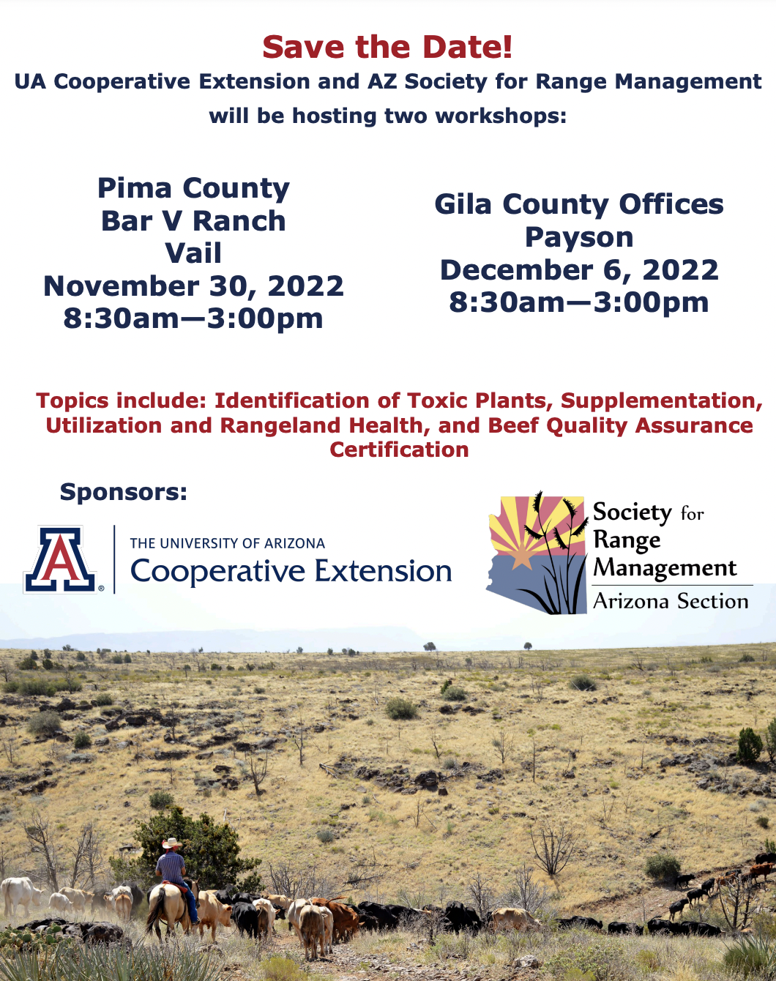

- Watershed clean-up! Corazón project
  - When: Saturday, November 19, 2022 from 8 am - 12 pm
  - Where: West of I-10 along N Silverbell Road
  - Additional information: There will be a 20’ long garbage rollout available and, depending on volunteer turn out, some parking space (although we strongly encourage carpooling).
  - Email: Wynbeltb@arizona.edu or Rhianyon@arizona.edu for more information and to be added
  - Scan QR code to sign up!! :)
  - 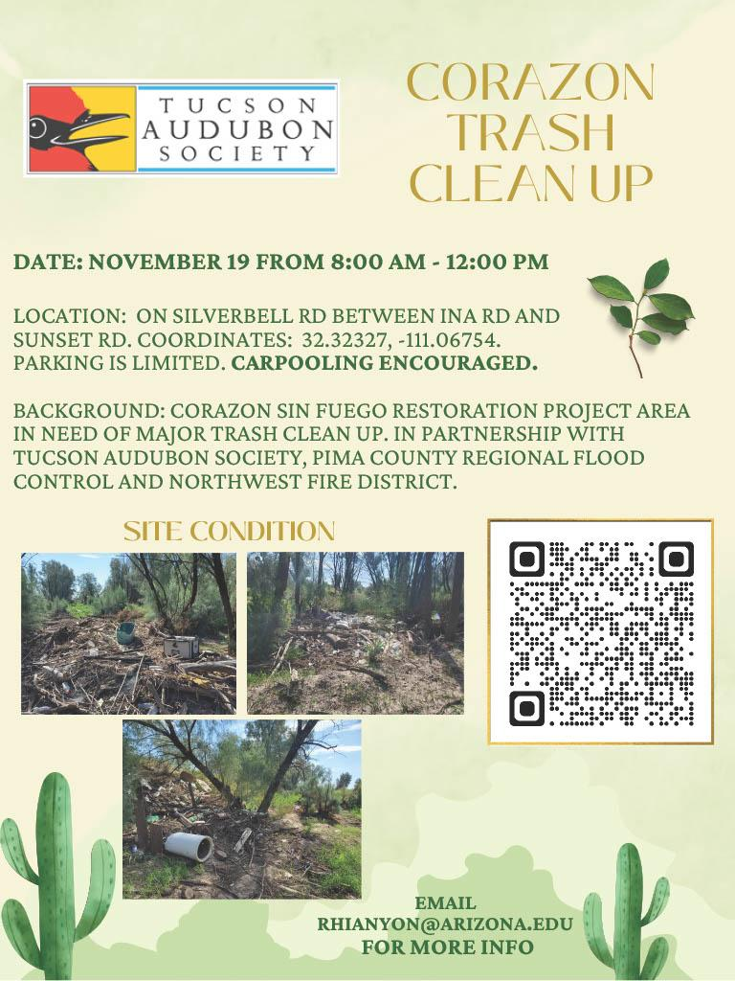

- Review of Range Classes for Next Semester
  - Plant Communities (RAM 384 Spring)
    - TuTh 11:00AM - 11:50AM
  - Grazing Ecology (RAM 436 Spring)
    - TuTh 10:00AM - 10:50AM
  - Wildland Restoration (RAM 446 Spring)
    - MoWeFr 10:00AM - 10:50AM
  - Rangeland Planning (RAM 487 Odd Spring)
    - We 2:00PM - 4:50PM
  - Field Safety and Professionalism Workshop (RNR 496B, Section 2, Spring 2023)
    - 7W1, M 12:00-1:50PM
  - Calving Management (ACBS 397A Spring)
    - We 8:00AM - 10:00AM
  - Beef Resource Management (ACBS 477 Spring)
    - TuTh 8:00AM - 9:15AM
  - Course Checklist and OPM:
    - https://nature.arizona.edu/undergraduate/ecology-management-restoration-rangelands

- Announcement: Please pay your dues! Paying dues is required to go to SRM.

Budget:
Checking: $6,437.12
Club dues: $15/semester or $30/year
Dues can be paid in cash, PayPal (uofatierraseca), or Venmo (@TierraSeca)

Connect with Us!
Email: uofatierraseca@gmail.com
GroupMe: https://groupme.com/join_group/38156015/nWJ5vk
Website: https://uofatierraseca.wixsite.com/website
Instagram: https://www.instagram.com/uatierraseca/?hl=en (@uatierraseca)

Meeting Closed: 6:36PM

