

October 25, 2022

Called to Order: 5:31PM

Fall 2022 Meetings Schedule:
Every other Tuesday at 5:30pm in ENR2 N350
August 30
September 13
September 27
October 11
October 25
November 11
November 22
December 6

Attendance:
Parker Brown, Robin Bradley, Kaitlyn Tyler, Bailie Wynbelt, Dakota Baden, Ashley Gomez, Genna Smith, Philly Montierth, Doan Goolsby, Maxwell Eller, Ava Hamstead, Brandi Obregon, Idelfonzo Trujillo, Noah Sygrove, Andres Martinez, Mano Tainatongo, Brian Muha, Rakeen Abdali

Meeting Minutes:
- Guest Speaker - Josh Grace, AZ State Lands Department and AZSRM President
  - Get involved in AZSRM, there are openings in many of the committees for students to get involved, especially the Young Professionals Committee
  - The winter meeting will be in Phoenix this year - early February

- Events Recap
  - Tierra Seca vs. Fish and Wildlife Kickball Game
  - Elkhorn Monitoring
  - Arroyo Chico Wash Cleanup
  - BLM Monitoring

- Steer Raffle Updates
  - We have raffle tickets!!
    - One Quarter (~125 LBS): $25 each or 5 for $100
    - One Eighth (~60 LBS): $15 each
      - Can fit in household fridge!
  - Steer provided by Dennis and Debra Moroney (The 47 Ranch)
    - Local beef producer from Bisbee AZ
    - Sustainable production, Grass raised and finished!
  - Drawing on February 7th, 2023.
  - Share with family, friends, and everyone else!
  - Please see flier attached to meeting minutes email

- Steer Raffle Tabling Event
  - Who: 3-4 Tierra Seca Members
  - What: Raffle Ticket Sales + Rangeland Education
  - Where: Rock Solid Climbing + Fitness (Marana, AZ)
  - When: November 3rd, 5:30 - 7:30
  - Sign Up: https://docs.google.com/spreadsheets/d/1OdNET-bNZwrQLnNMCNJDY6IR6pm4flTNDGutr5Yg7hY/edit?usp=sharing

- AZSRM Bar V Workshops
  - Who: Cooperative Extension + AZSRM
  - What: Producer oriented workshops - Identification of Toxic Plants, supplementation, utilization and rangeland health, beef quality assurance certification
  - Where: Vail, AZ
  - When: November 30th, 2022 8:30 - 3:00 PM
  - Dean’s Excuse info due by Tuesday November 8th. Student ID + Full Name emailed to club.
  - Sign Up: https://docs.google.com/spreadsheets/d/1gO911fPmsCxOQNzQTR9UGNn7z9rOmoBqCiS7mk-P8Eo/edit?usp=sharing

- Volunteer Events
  - RISE Symposium
    - Who: RISE (Research Insights in Semi-Arid Ecosystems) Symposium
    - What: Making breakfast for the event, can attend the rest of the symposium to learn about research in our area! Lots of cool speakers and posters.
    - Where: UofA Campus, Marley Building (next to Yavapai Dorm)
    - When: Saturday, November 5th. Meet at BSE 124 at 7:30am.
    - Conference Website: https://www.tucson.ars.ag.gov/rise/
    - Sign Up:
    - https://docs.google.com/spreadsheets/d/1rjGl_fmoJXjulY0ujYhDuasgFlsQdzVVxu39p-MEhDE/edit?usp=sharing

  - Watershed clean-up! Corazón project
    - When: Saturday, November 19, 2022 from 8 am - 12 pm
    - Where: West of I-10 along N Silverbell Road
    - Additional information: There will be a 20’ long garbage rollout available and, depending on volunteer turn out, some parking space (although we strongly encourage carpooling).
    - Email: Wynbeltb@arizona.edu or Rhianyon@arizona.edu for more information and to be added
    - Scan QR code to sign up!! :)
    - 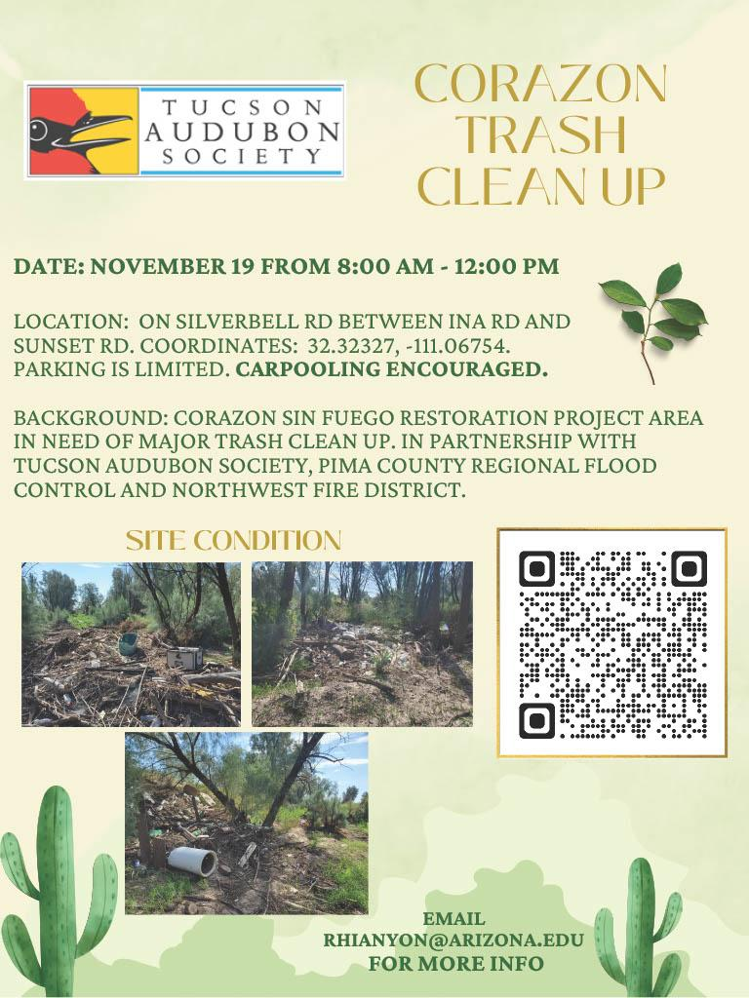

  - Bio/Diversity Project
    - 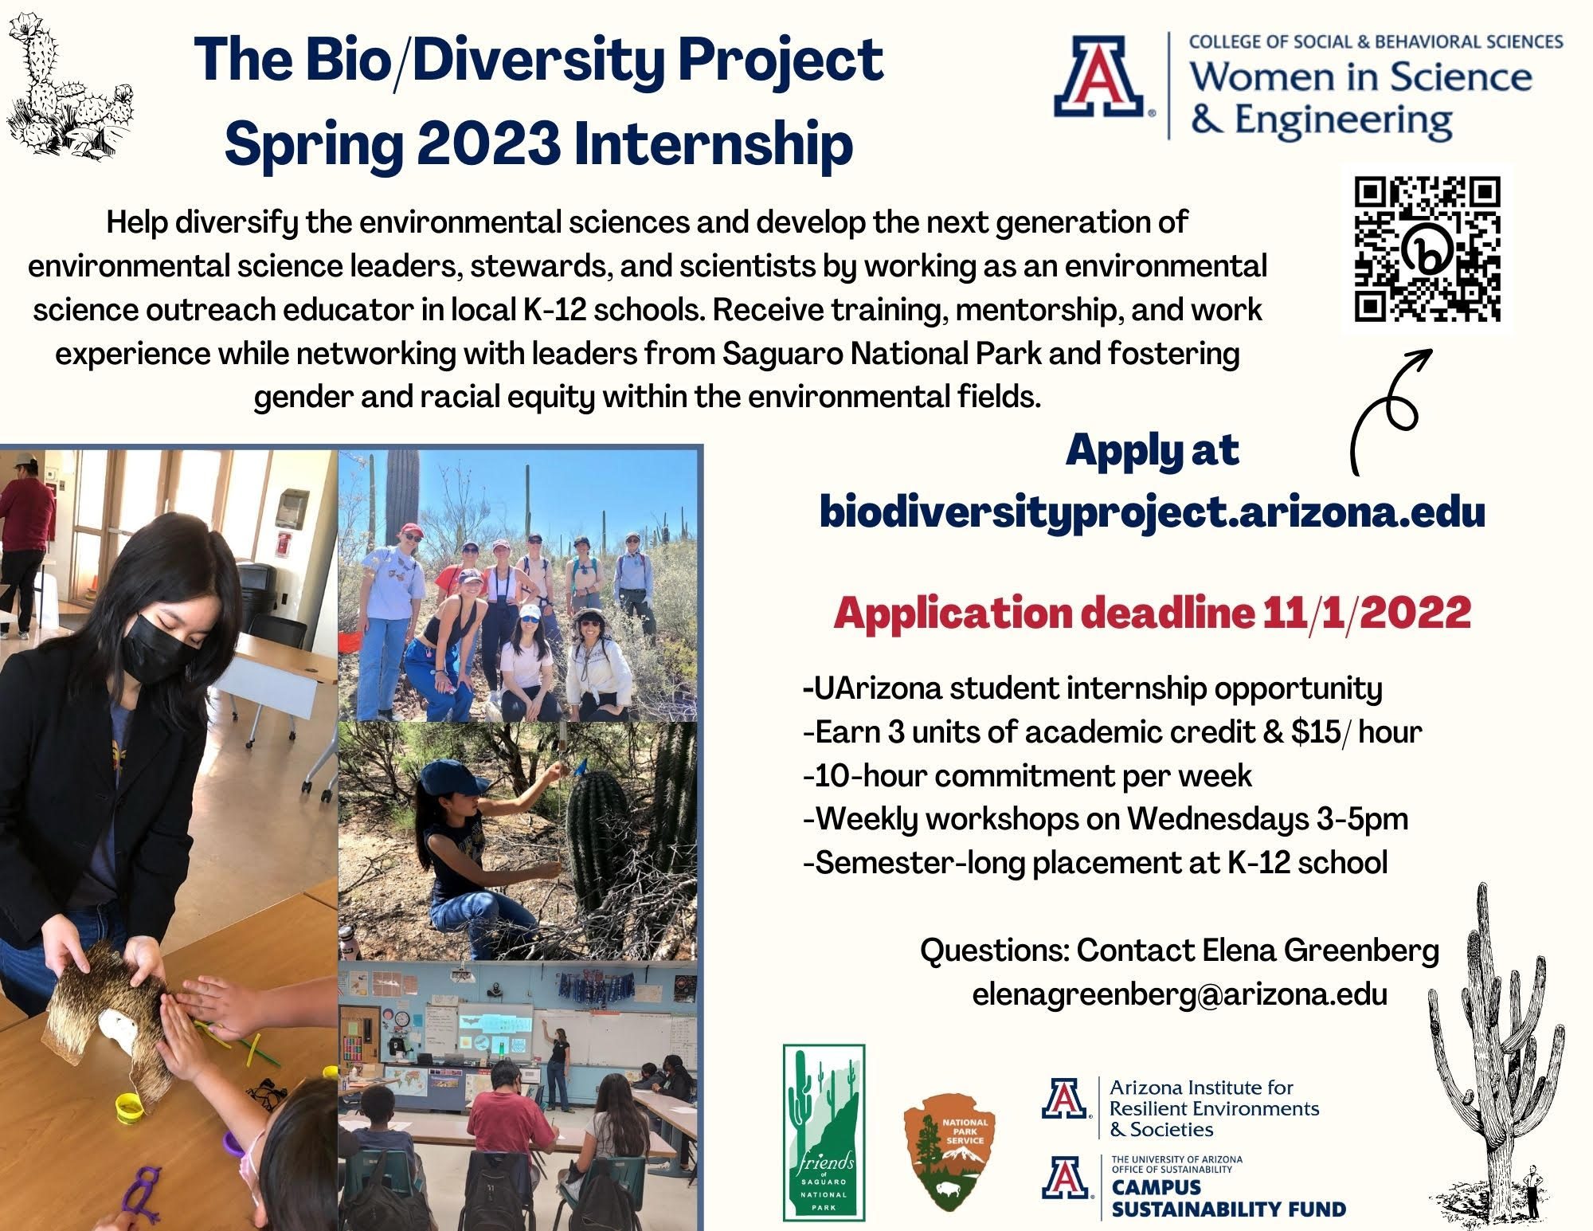

- Job Opportunities - NRCS Pathways Internship
  - https://www.usajobs.gov/job/682594600
  - Who: NRCS
  - What: Pathways Internship
  - Where: Tucson, AZ and other locations, look at job posting
  - When: Application Closes on October 28th!

- Society for Ecological Restoration Southwest Chapter Virtual Meeting
  - 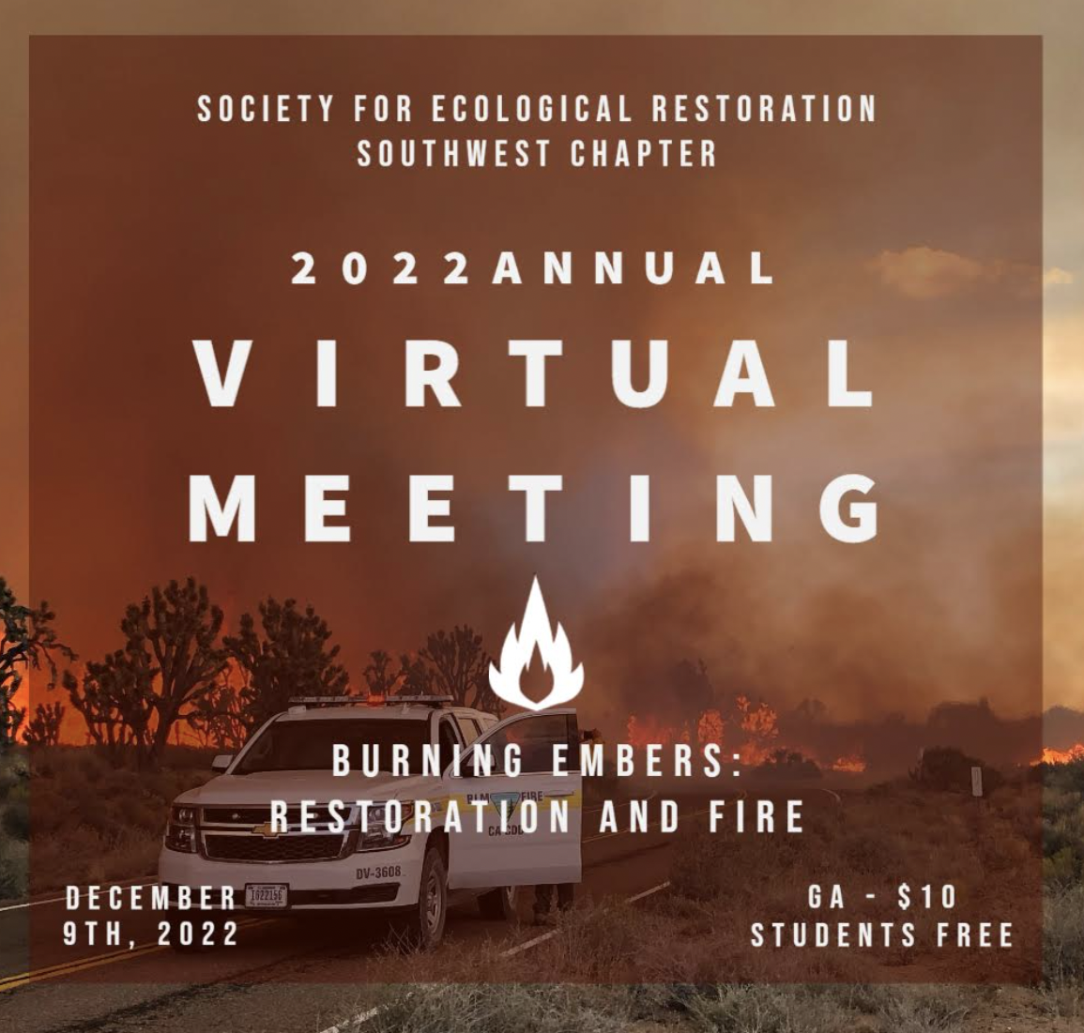
  - Registration free for students!!
  - Link: https://sersw2019.wixsite.com/main

- Review of Range Classes for Next Semester
  - Plant Communities (RAM 384 Spring)
    - TuTh 11:00AM - 11:50AM
  - Grazing Ecology (RAM 436 Spring)
    - TuTh 10:00AM - 10:50AM
  - Wildland Restoration (RAM 446 Spring)
    - MoWeFr 10:00AM - 10:50AM
  - Rangeland Planning (RAM 487 Odd Spring)
    - We 2:00PM - 4:50PM
  - Field Safety and Professionalism Workshop (RNR 496B, Section 2, Spring 2023)
    - 7W1, M 12:00-1:50PM
  - Calving Management (ACBS 397A Spring)
    - We 8:00AM - 10:00AM
  - Beef Resource Management (ACBS 477 Spring)
    - TuTh 8:00AM - 9:15AM
  - Course Checklist and OPM:
    - https://nature.arizona.edu/undergraduate/ecology-management-restoration-rangelands

- Announcement: Please pay your dues! Paying dues is required to go to SRM.

Budget:
Checking: $5,826.78
Club dues: $15/semester or $30/year
Dues can be paid in cash, PayPal (uofatierraseca), or Venmo (@TierraSeca)

Connect with Us!
Email: uofatierraseca@gmail.com
GroupMe: https://groupme.com/join_group/38156015/nWJ5vk
Website: https://uofatierraseca.wixsite.com/website

Meeting Closed: 6:36PM

