US Fish and Wildlife Service  Needs Volunteers For:  Trash Cleanup at the Gila River Waterfowl Area  @ The intersection of S El Mirage Rd and the Gila River  September 2nd and September 16th  8:00 AM – 2:00 PM  The USFWS is looking for volunteers to help with a trash cleanup effort at federal lands along the Gila River prior to beginning a large restoration project at these lands.  Work will begin at 8:00 AM at the intersection of S El Mirage Rd and the Gila River (just north-west of the Phoenix Raceway).  All cleanup supplies will be provided, please bring yourself, lunch, sunscreen, and clothes that provide sun protection. | 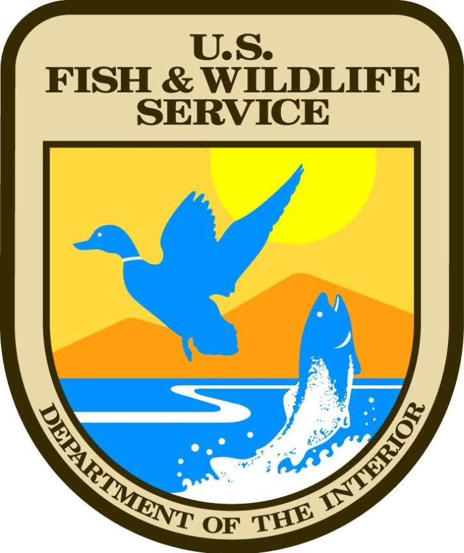

With Questions or to Sign up:
Reese Crebbin
Reese_crebbin@fws.gov
541-944-0543

