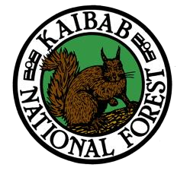
OUTREACH NOTICE
Region 3 KAIBAB NATIONAL FOREST
South Zone

Williams, Arizona
RANGE TECHNICIAN
GS-0455-05/06/07
Please Respond to the Outreach By August 26th, 2022
Primary Contact: shai.schendel@usda.gov
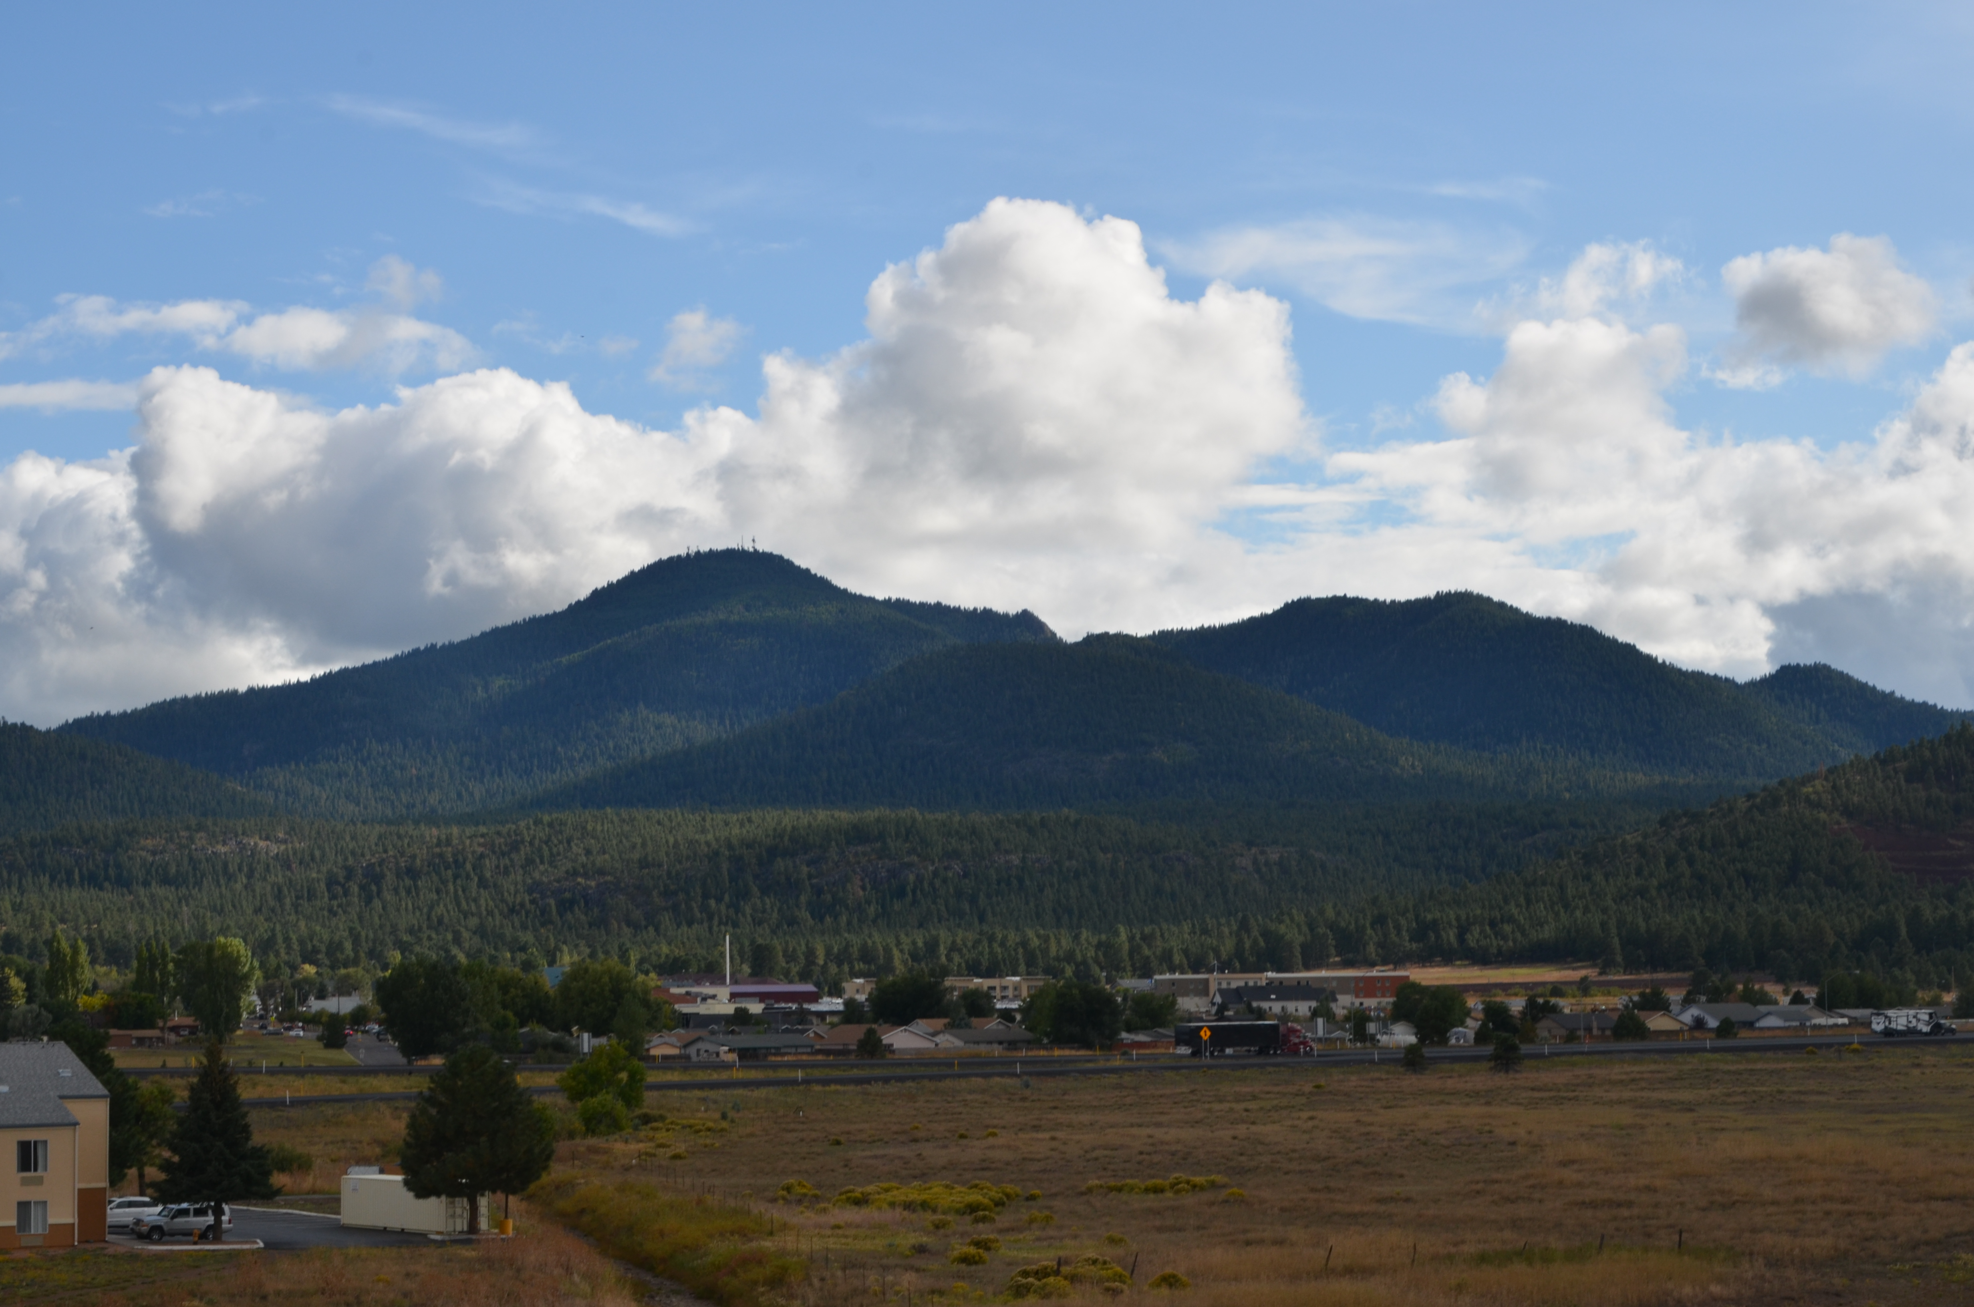
The South Zone of the Kaibab National Forest is seeking to fill a position for a GS-0455-05/06/07 Range Technician, located in Williams, AZ.
Brief Description of Duties for the GS-0455-05/06/07 Range Technician:
This position is located on a Forest Service unit where incumbent performs technical work in support of the range function.
Participates in range capacity studies such as allotment analysis and production utilization.

Monitors both the short and long-range plans for compliance. Makes recommendations for amendments or additions necessary to the plan. Answers questions of permittees concerning range management principles and how the plan is developed.

Through personal contacts with permittees and Forest users, ensures that the range management plans are implemented on the ground.

Takes initial corrective action for trespass violation by notifying the offender and gathering evidence to sustain the charges. Follows up on such action by checking for continued trespass violations. Compiles the complete report on trespass cases for supervisor to make a determination on more severe corrective measures. Serves as a witness in court as necessary.

Provides technical direction to crews, which may be under contract or seasonal employees, in various projects for range and wildlife.

Plans and sees to the accomplishment of a wide variety of range and wildlife resource related projects such as revegetation, fencing, slash disposal, spring development, range inspections, etc.
Schedules and executes a variety of rangeland management support assignments related to range conservation programs.
Assists in range capacity studies such as allotment analysis and production utilization studies. Using accepted indicator plants, determines range readiness dates. Conducts routine forage production studies, based on air-dry weight of vegetation.
Monitors both short and long-range plans for compliance with range management goals and objectives. Assists in planning a wide variety of range-related projects such as revegetation, fencing, spring developments, cattle guard placement, and erosion control procedures. Makes recommendations for amendments to range management plans.
Gathers rangeland management data exercising initiative and resourcefulness.
Works with permittees in preparing preliminary designs and plans for a variety of standardized revegetation project.
Key Focus Areas for the Kaibab National Forest
- Restoration
- Sustainable Recreation
- Partnerships
- Workforce
Kaibab National Forest Vision:
- Creation and maintenance of healthy, resilient landscapes.
- A cohesive team of employees who are motivated, passionate and customer service oriented.
- Interdependent forests, communities, industries and economies.
- Kaibab employees connect the public to their lands through recreation opportunities, shared stewardship and education and interpretation.
Desirable Attributes and Characteristics:
- Possesses an entrepreneurial spirit and business sense regarding the feasibility and delivery of new activities and new approaches for accomplishing landscape scale restoration Has the drive and commitment to deliver on those opportunities and be a change agent. (Sees Opportunity)
- Has a strong passion for recreation and for connecting ALL people to their public lands (Builds Community)
- Uses innovation, creativity and critical thinking in development of partnerships and volunteer opportunities to support restoration, recreation, education, and science activities. (Sees Opportunity)
- Engages with partners, volunteers, Tribes, and the public to form, tend, grow, and foster stronger relationships between the Forest and neighboring communities. (Shares Leadership & Builds Community)
- Possesses strong communication and collaboration skills (Builds Community)
- Contributes to positive Forest Leadership Team dynamics (Stewards the Whole Place)
- Leads zoned organizations and multi-Forest projects through shared leadership (Stewards the Whole Place)
- Skilled in large scale, long-term strategic planning and has the ability to meet major milestones (Stewards the Whole Place)
- Creates a cohesive work environment that is safe, inclusive and inspiring (Builds Community)
About Kaibab National Forest: The Forest has 3 Ranger Districts; Williams Ranger District,
Tusayan Ranger District and the North Kaibab Ranger District. The Supervisor’s Office and the Williams Ranger District Office are located in Williams, Arizona, and the Tusayan Ranger District is located 50 miles north in Tusayan, Arizona. The Williams and Tusayan Districts are referred to as the South Zone. The North Zone is located north of the Grand Canyon and includes the North Kaibab Ranger District.
Forest Information: Kaibab National Forest is part of the largest contiguous ponderosa pine forest in North America. Bordering both the north and south rims of the Grand Canyon, the 1.6 million acres of the Kaibab National Forest have the distinction of being divided by one of Nature’s greatest attractions. Elevations vary on the forest from 5,500 feet in the southwest corner to 10,418 feet at the summit of Kendrick Peak, one of the Kaibab’s “sky islands.” All the way from north-central Arizona into Utah, the Kaibab National Forest offers breathtaking views, outstanding forest scenery, unusual geologic formations and more.
Vegetation varies from desert-like conditions at the lower canyon elevations to pinyon-juniper woodlands, the ponderosa pine belt, and mixed conifer forests of pine, spruce and aspen at the upper mountain elevations. Wildlife is abundant and includes elk, deer, pronghorn antelope, turkey, coyote, black bear and mountain lion. Summer temperatures average from lows of 50F at night to highs of 85F during the day. Winter temperatures average from 20F to 45F, with snow being common. The cool monsoon season in July and August offers relief from the heat but can bring brief but violent thunderstorms across the Forest. For additional information on the Kaibab National Forest, please visit any of the following sites: www.fs.usda.gov/kaibab, www.flickr.com/kaibabnationalforest, www.twitter.com/KaibabNF
Local Communities: Williams is a small, mountain community with a population of about 3,500. It was founded in 1882 and named after the famous trapper and "mountain man" Bill Williams. Historic Route 66 runs through downtown Williams, and the Grand Canyon Railway makes its daily run from Williams to Grand Canyon and back. Williams is 50 miles south of the Grand Canyon and 30 miles west of Flagstaff. Williams District employees generally live in the Williams, Flagstaff, Parks, and Ash Fork communities.

Recreation opportunities include many hunting opportunities for both small and large game such as deer, trophy elk, turkey, squirrel and many others. Small lakes stocked annually with trout and some other species provide fishing opportunities in the immediate area of Flagstaff and Williams. However, within a 2-4 hour drive of the district you can find trophy trout fishing, crappie and bass fishing. Other recreation activities include mountain biking, downhill and cross-country skiing, camping, wildlife viewing, and hiking.

Qualification Requirement:
Those who are interested must meet the qualification requirements for the GS-0455-05/06/07.
They are covered by the U. S. Office of Personnel Management (OPM) Qualification Standards for Group Coverage Qualification Standards for Clerical and Administrative Support Positions. The OPM Qualification Standards Handbook Manual is available for review at any federal personnel office or on the Internet at: www.opm.gov/policy-data-oversight/classification-qualifications/classifyinggeneral-schedule-positions/#url=Standards

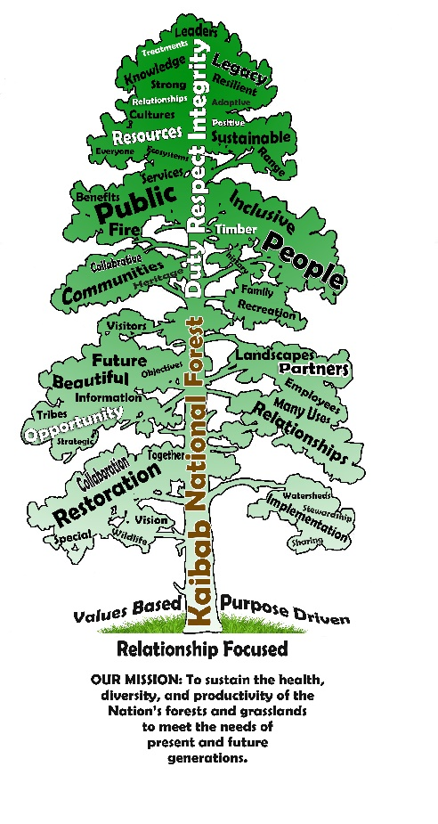

USDA Non-Discrimination Statement Revised 6/8/2005
“The U.S. Department of Agriculture (USDA) prohibits discrimination in all its programs and activities on the basis of race, color, national origin, age, disability, and where applicable, sex, marital status, familial status, parental status, religion, sexual orientation, genetic information, political beliefs, reprisal, or because all or part of an individual’s income is derived from any public assistance program. (Not all prohibited bases apply to all programs.) Persons with disabilities who require alternative means for communication of program information (Braille, large print, audiotape, etc.) should contact USDA’s TARGET Center at (202)720-2600 (voice and TDD). To file a complaint of discrimination, write to USDA, Director, Office of Civil Rights, 1400 Independence Avenue, S.W., Washington, DC 20250-9410, or call (800) 795-3272 (voice) or (202) 720-6382 (TDD). USDA is an equal opportunity provider and employer.”

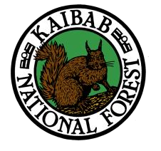
OUTREACH NOTICE
Region 3 KAIBAB NATIONAL FOREST
South Zone
Williams, Arizona
RANGE TECHNICIAN
GS-0455-05/06/07
120-Day Detail/Temp Promotion Opportunity
Please Reply By: August 26th, 2022
If you are interested in this position, please complete this form and send it by e-mail to shai.schendel@usda.gov along with a current resume and transcripts. (Please include which position you are interested in on the subject line of your message).
PERSONAL INFORMATION:
Name: Date: / /
Address: Phone: ( ) -
E-Mail:
How did you hear about this position?

Are you currently a Federal employee: Yes No
Current Position/Title/Series/Grade/Effective date of grade
Briefly describe why you will be a quality candidate for this position:

If a Federal Employee, type of appointment you are currently under:
Career | Career-Conditional | Excepted-ANILCA | Excepted VRA | Other

If you are not a current permanent (career or career conditional) employee, are you eligible for appointment under any of the following special authorities? _____ Yes ______ No
VRA – Veterans Recruitment Appointment Authority (Disabled veterans, veterans who served in a declared war, or in a campaign for which a campaign badge has been authorized, or awarded a Armed Forces Service Medal, and separated from active duty in the past 3 years).
Military Spouse Hiring Authority (Military spouses eligible under Non-competitive Appointment of Certain Military Spouses do not have a hiring preference; however, this appointing authority does provide for non-competitive entry into the competitive service. There are three categories that determine eligibility: those who are relocating with their service-member spouse as a result of permanent change of station (PCS) orders, spouses of service members who incurred a 100% disability because of the service member's active duty service, and spouses of service members killed while on active duty).
VEOA – Veterans Employment Opportunity Authority (Allows eligible veterans to apply for merit promotion vacancies otherwise not open to external candidates without career status).
Prior AmeriCorps/VISTA (Persons are granted a one-year period to be non-competitively appointed to a normally competitive Federal position after leaving the Peace Corps or AmeriCorps VISTA with a certification of eligibility).
30% Disabled Veterans Appointing Authority (Disabled veterans who were retired from active military service with a 30% or more disability rating; disabled veterans rated by the Veterans Affairs as having a compensable service-connected disability of 30% or more).
Prior Peace Corps (Former Peace Corps volunteers who have satisfactorily completed 3 years of continuous service into career or career-conditional permanent positions).
Schedule A Disabled Persons Hiring Authority (Persons with physical or mental disabilities certified by the Veterans Administration or a State Rehabilitation Agency as eligible).
Reinstatement Rights (Agencies may reappoint people previously employed under a career or career-conditional appointment by reinstatement to a competitive service position).
Pathways Student Hiring Authority (Internship Program: current students in an accredited high school, college [including 4-year colleges/universities, community colleges, and junior colleges]; professional, technical, vocational, and trade school; advanced degree programs; or other qualifying educational institution pursuing a qualifying degree or certificate; Recent Grads Program: recent graduates who have completed, within the previous two years, a qualifying associates, bachelors, masters, professional, doctorate, vocational or technical degree or certificate from a qualifying educational institution).
Public Lands Corp (A non-competitive authority for hiring current and former Public Lands Corps members who have satisfactorily served a minimum of 640 hours on an appropriate conservation project that included at least 120 hours through the Public Lands Corps. Current or former PLC members are eligible for noncompetitive hiring up to a 120days after completion of the program).
Thank you for your interest in our vacancy!

