
Tierra Seca
University of Arizona Student Chapter
Society for Range Management

April 19th, 2022


- Meeting Called to order: 5:02 PM

- Tierra Seca Fall 2021 Club Meeting Schedule

~Biweekly meetings on Tuesdays at 5:00 PM at ENR2 in room N350
Month | Day
January | 25th
SRM Annual Meeting (February) | 7th-11th
February | 22nd
Spring Break (March) | 5th-13th
March | 22nd
April | 5th
April | 19th
May | 3rd

Attendance

Rakeen Abdali, Flavie Audoin, Dakota Badan, Robin Bradley, Parker Brown, Carter Blouin, Cameron Burleson, Elizabeth EbadiRad, Riley Gallagher, Ashley Gomez, Ava Hamstead, Amy Heiling, Katie Hughes, Eamonn Mazur, Brandon Mayer, Caleb Miller, Brain Muha, Lia Ossanna, Austin Rutherford, Olivia Sancic, Kailtyn Tyler, Alex-Binford Walsh, Bailie Wynbelt
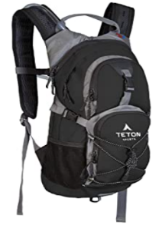
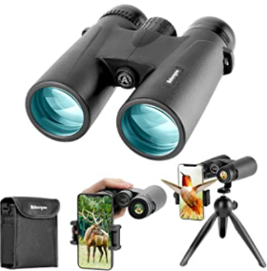
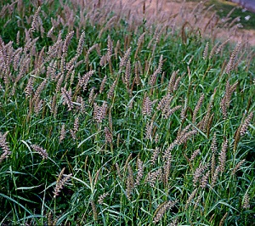




- Buffelgrass Sampling Blitz
- The event was hosted by Katherine Hovanes, a Postdoc in the Gornish Lab
- This was in effort to measure buffelgrass abundance in various neighborhoods in Tucson
- Took place on 4/16 and 4/17
- For those who participated, thank you gifts were provided
  - Snake gaiters
  - Hydration pack
  - Binoculars
  - iPhone microscope
- The event went fantastic! Everyone had lots of fun.



- Job Opportunities
- Check to see if some of these job opportunities are still available because they have short application periods
- USA Jobs
  - Rangeland Management Specialist
    - Utah, Oregon, Kansas, California, Idaho
  - Soil Conservationist
    - Kanas, Rhode Island
- Arizona Trail Association (ATA)
  - https://aztrail.org/the-ata/employment-opportunities/
- BIO5 Internship
  - https://bit.ly/B5Amb2022-23
- Earth Grant Internships
  - AZ DFFM, CBD, Pima County NRPR, SDCP, and more
    - https://environment.arizona.edu/earthgrant/2022-23-internships
- Please check the SRM listserv emails for summer positions!
  - Let us know if you are NOT on the SRM listserv
  - We will get you on it ASAP



- Trip to SRER
- Where: Florida Station at the Santa Rita Experimental Range
- When: 4/23/22 – 4/24/22
- Time: Arrive at 3pm Saturday, leave 2pm Sunday
- What: Opportunity to learn from range managers about the history and management objectives, also a chance to explore the range
- Space available: Up to 25 people
- Sign-up: https://forms.gle/qArkvKNKvRKPybiP9
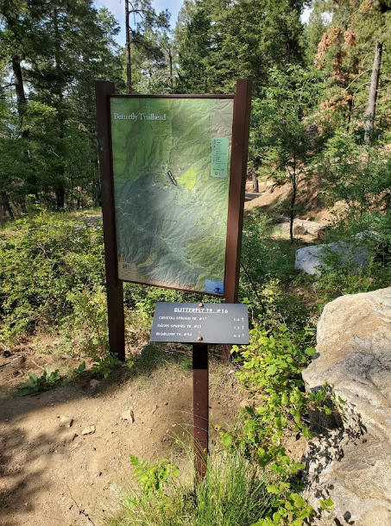
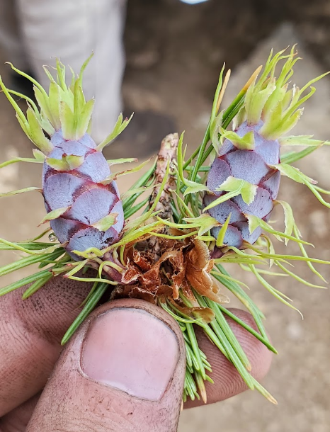
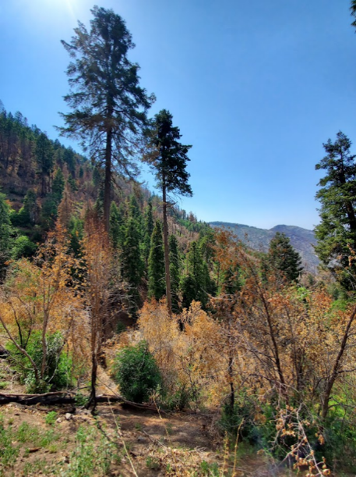

- Plant ID Hike Part Deux
- Where: Butterfly Trailhead @ Mt. Lemmon
- When: Sunday 5/1/22
  - Meet at the usual spot by BSE in the Chemical Science parking lot at 7am!
- What: Social hike, identify plants, develop plant list with pictures
- Sign-up here: https://docs.google.com/spreadsheets/d/1XwmcCXyscE9dD2x-jIvDbhJWoggEfB7kYolbj8QV9vs/edit?usp=sharing
- You can also scan this QR code to access the sign-up sheet!





- AZSRM Summer Meeting 2022
- When: August 3rd-5th (tentatively)
- Where: V Bar V Ranch (Rimrock, AZ)
- What: AZSRM membership meeting, auction, food, social
- Registration: Pending
- Tierra Seca has provided breakfast and lunch for over 15 years!



- Updates on miscellaneous items
- Tierra Seca club website
  - The team is starting to work on the club’s website
  - They would love to hear suggestions from other club members about what they think of how it is currently and how to improve it
  - You can find the current club website here
    - https://uofatierraseca.wixsite.com/website
- BSE club board
  - Printing 30-40 pictures, need help putting them up
  - This will most likely be done sometime next week
  - Let us know if you want to help out!



- Budget
- Checking: $5,067.76
- Club dues: $30/year (or $15/semester)





- 2022-2023 Officer Elections
- Nominees who ran
  - President
    - Dakota Badan
    - Parker Brown
  - Vice President
    - Dakota Badan
    - Parker Brown
    - Ashley Gomez
  - Secretary
    - Dakota Badan
    - Robin Bradley
    - Brain Muha
  - Treasurer
    - Bailie Wynbelt
- After counting all the ballots, here is your new officer team of 2022-2023!
  - President: Parker Brown
  - Vice president: Ashley Gomez
  - Secretary: Robin Bradley
  - Treasurer: Bailie Wynbelt
- Congrats to everyone! You will all do fantastic!


- Connect with us!
- Have any questions, comments, and/or concerns?
  - Email us at uofatierraseca@gmail.com
- Don’t want to send an email? We understand. Send us a message over on our GroupMe!
  - Tierra Seca GroupMe: https://groupme.com/join_group/38156015/nWJ5vk
- You can also join the GroupMe and Campus Groups by scanning the QR codes below!




Scan me to join the GroupMe! Scan me to join Campus Groups!



- Meeting Adjourned: 5:57 PM

- My Final Weekly Serotonin Drop
- As this is my last entry as secretary for this club, this will be the last meme you will officially receive from me
- So to make it extra special, it will be a non-rangeland meme
  - It will be a representation of me so that you all can remember me by
- May you all smile now and in the future!
Play me

