
Tierra Seca
University of Arizona Student Chapter
Society for Range Management

April 7th, 2022


- Meeting Called to order: 5:07 PM

- Tierra Seca Fall 2021 Club Meeting Schedule

~Biweekly meetings on Tuesdays at 5:00 PM at ENR2 in room N350
Month | Day
January | 25th
SRM Annual Meeting (February) | 7th-11th
February | 22nd
Spring Break (March) | 5th-13th
March | 22nd
April | 5th
April | 19th
May | 3rd

Attendance

Rakeen Abdali, Andrew Antaya, Flavie Audoin, Robin Bradley, Carter Blouin, Cameron Burleson, Violet Dasse, Isabel DiNardo, Elizabeth EbadiRad, Riley Gallagher, Gomez, Ava Hamstead, Dr. Aaron Lien, Eamonn Mazur, Brandon Mayer, Caleb Miller, Brain Muha, Sarah Noelle, Lia Ossanna, Austin Rutherford, Alex-Binford Walsh, Bailie Wynbelt

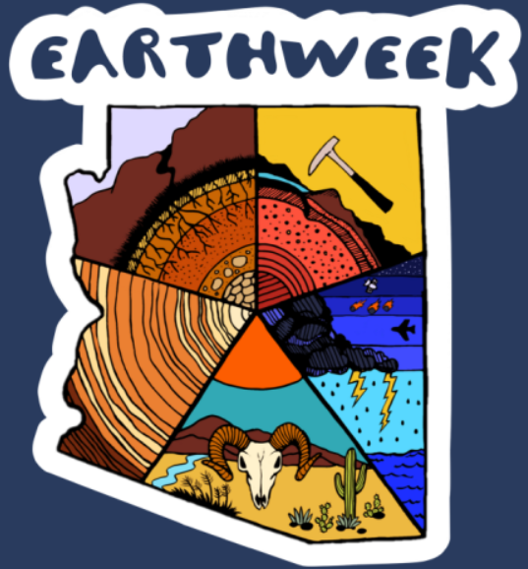

- Earth Week
- Tierra Seca participated in this year’s Earth Week trivia night
- Team name: Omniscient Cows
- Status: WINNERS
- Here’s some cool photos from that night!

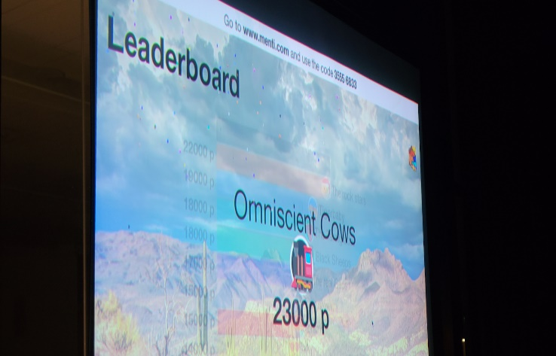
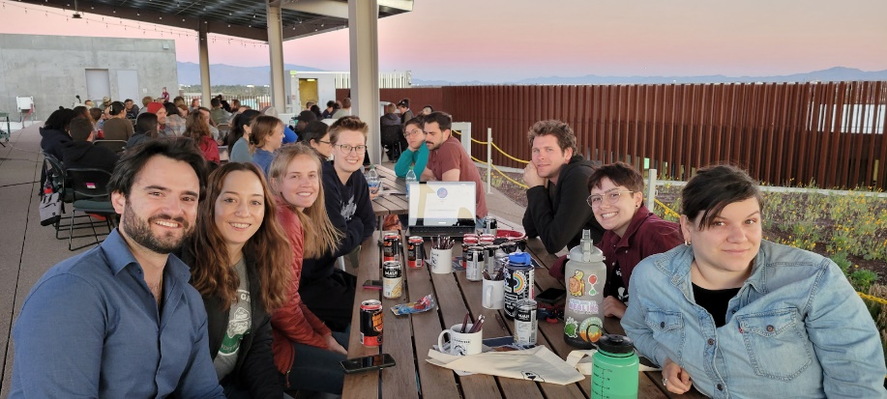
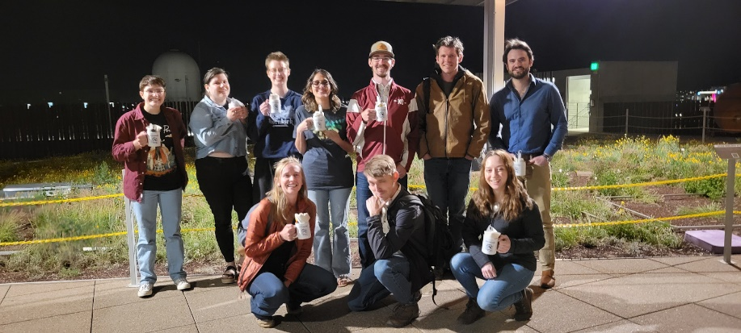

- Plant ID Hike
- This past weekend we had a plant ID hike over at the Starr Pass in the Tucson Mountains
- The hike happened over two days
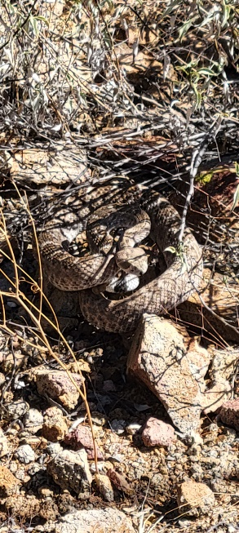
- Lots of people came and had a blast!
- Some neat pictures from those hikes
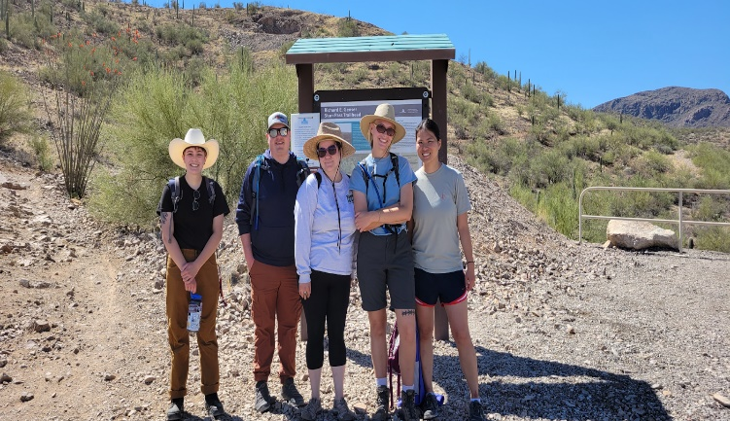
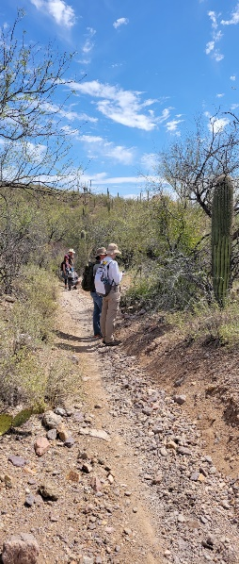
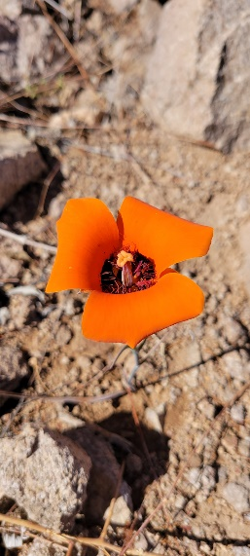

^ The coolest pic from the hikes imo



- Job Opportunities
- USA Jobs
  - Rangeland Management Specialist
    - Utah, Oregon, Kansas, California, Idaho
  - Soil Conservationist
    - Kanas, Rhode Island
- Arizona Trail Association (ATA)
  - https://aztrail.org/the-ata/employment-opportunities/
- BIO5 Internship
  - https://bit.ly/B5Amb2022-23
- Earth Grant Internships
  - AZ DFFM, CBD, Pima County NRPR, SDCP, and more
    - https://environment.arizona.edu/earthgrant/2022-23-internships
- Please check the SRM listserv emails for summer positions!
  - Let us know if you are NOT on the SRM listserv
  - We will get you on it ASAP



- Trip to SRER
- Where: Florida Station at the Santa Rita Experimental Range
- When: 4/23/22 – 4/24/22
- Time: Arrive at 3pm Saturday, leave 2pm Sunday
- What: Opportunity to learn from range managers about the history and management objectives, also a chance to explore the range
- Space available: Up to 25 people
- Sign-up: https://forms.gle/qArkvKNKvRKPybiP9


- OPM Crosswalk Workshop

- Goal: Justify official course lists for federal job requirements
- Why: Certain courses needed for federal jobs, good for non-federal jobs, and helps you use elective credits effectively
- Planned date: Tuesday, April 19th
- Check the club GroupMe for upcoming planning meeting times
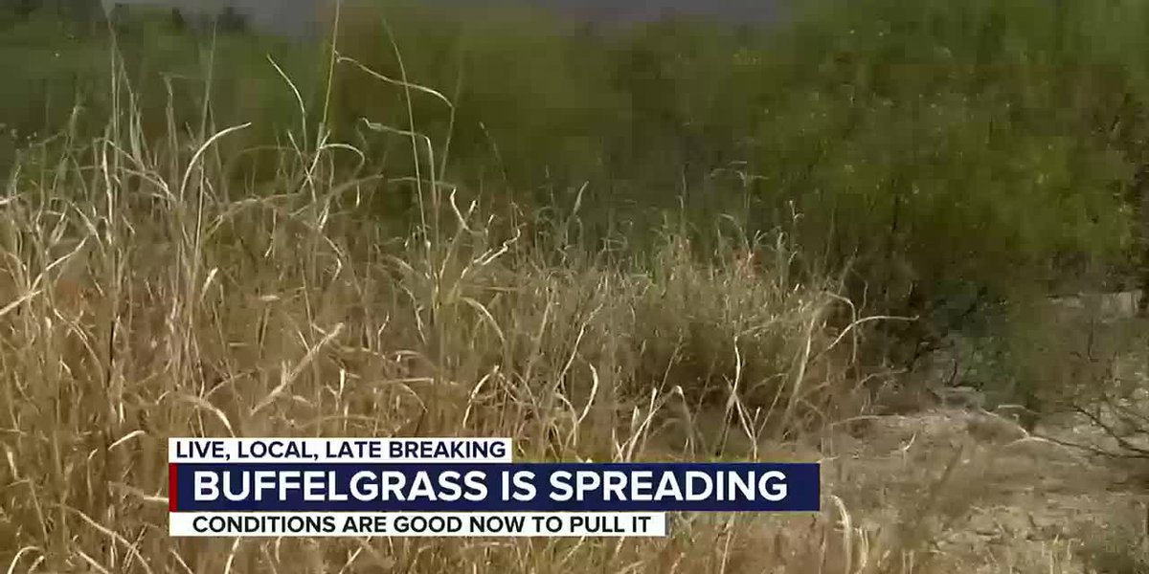

- Buffelgrass Sampling Blitz
- Who: Katherine Hovanes, Postdoc in Gornish Lab
- What: Measuring buffelgrass abundance
- Where: City of Tucson
- When: Saturday 4/16/22 and Sunday 4/17/2022
- Time: 9am – 4pm
- Snacks and water are provided
- Thank-you gifts will be given to those who volunteer
  - Snake gaiters
  - Hydration pack
  - Binoculars
  - iPhone microscope
    - Can only choose one item, even if volunteering for both days
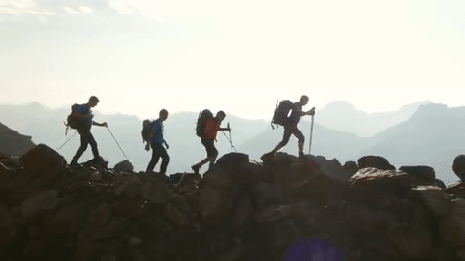

- More Hikes?
- Where do you all think we should hike next?
- Some ideas
  - Sabino Canyon
  - Mt. Lemmon
    - Butterfly trail, Marshall Gulch Trail, Box Camp Trail, and more
  - Mt. Wrightson
    - Longer hike
  - Possible beginner backpacking trip
    - Chiricahua NM, Hutch’s Pool, Saguaro NP, and others
      - This will be to help students gain basic backpacking experience that will boost their skills and their resumes in preparation for future jobs
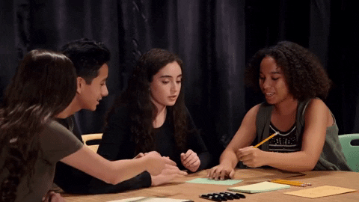

- Working Groups
- Club website
  - 2 people needed
  - Creating and fixing up the club’s website
  - Updating it after each event we do
  - Establishing a media presence for future rangeland students interested in the club
  - Also prepares for the website competition at SRM next year
- BSE photo-box
  - Cleaning up and organizing old photos
  - Obtaining access currently
    - Will get a group together next week over GroupMe


- Budget
- Checking: $5,094.10
- Club dues: $30/year (or $15/semester)



Scan me to pay dues!



- Officer Nominations
  - All positions are open!
  - Multiple people can run for the same position
  - Must have your nomination seconded by another club member
  - Next meeting will be the night of elections
    - Be there or be square!
  - Current team:
  - President: Eamonn Mazur
  - VP: Alex Binford-Walsh
  - Secretary: Elizabeth EbadiRad
  - Treasurer: Carter Blouin



- Connect with us!
- Have any questions, comments, and/or concerns?
  - Email us at uofatierraseca@gmail.com
- Don’t want to send an email? We understand. Send us a message over on our GroupMe!
  - Tierra Seca GroupMe: https://groupme.com/join_group/38156015/nWJ5vk




Scan me to join the GroupMe! Scan me to join Campus Groups!



- Meeting Adjourned: 5:41 PM

- Rangeland Meme of the Week
