
Tierra Seca
University of Arizona Student Chapter
Society for Range Management

March 22nd, 2022


- Meeting Called to order: 5:03 PM

- Tierra Seca Fall 2021 Club Meeting Schedule

~Biweekly meetings on Tuesdays at 5:00 PM at ENR2 in room N350
Month | Day
January | 25th
SRM Annual Meeting (February) | 7th-11th
February | 22nd
Spring Break (March) | 5th-13th
March | 22nd
April | 5th
April | 19th
May | 3rd

Attendance

Rakeen Abdali, Andrew Antaya, Robin Bradley, Carter Blouin, Cameron Burleson, Violet Dasse, Isabel DiNardo, Elizabeth EbadiRad, Ashley Gomez, Ava Hamstead, Justin Johnson, Eamonn Mazur, Brandon Mayer, Brain Muha, Sarah Noelle, Lia Ossanna, Austin Rutherford, Alex-Binford Walsh, Bailie Wynbelt



- Event Updates!
- FFA Day 2022
  - Set up tables and handed out supplies for the FFA exam for high school students
  - Spent time with Dr. Howery at and outside of the event
  - Had lots of fun!
  - Pictures were of course taken
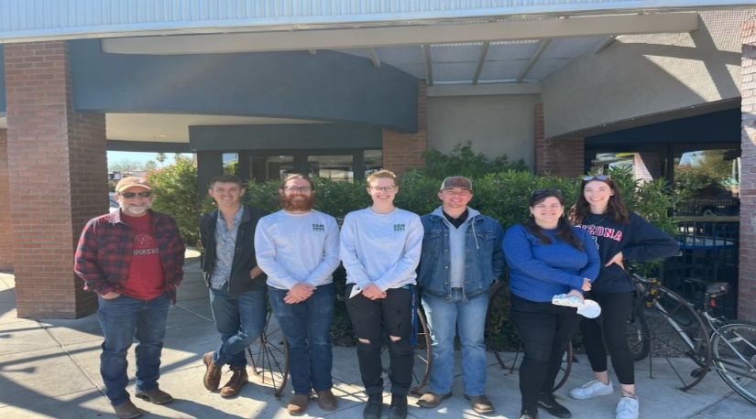
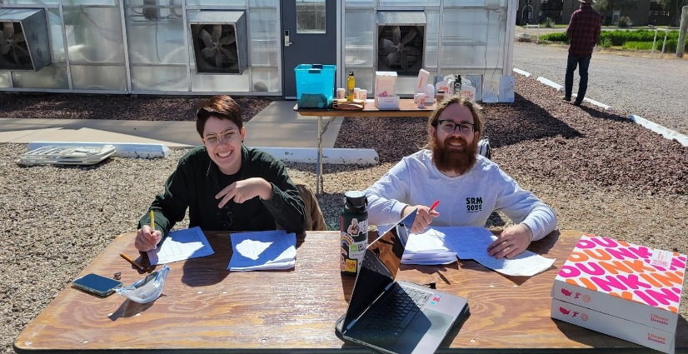
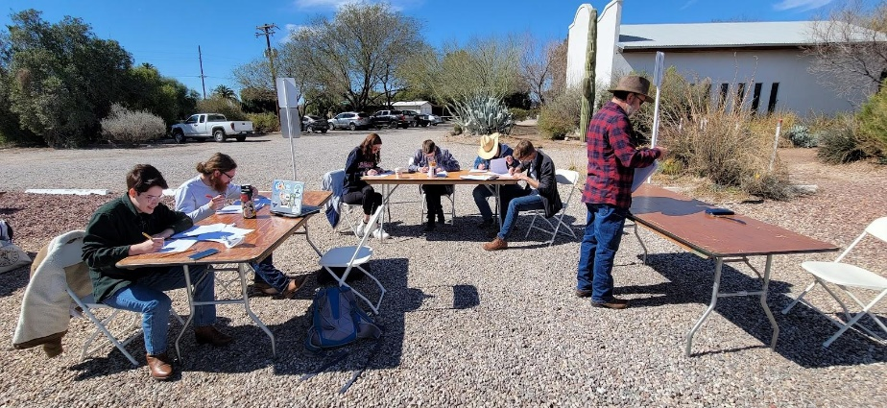
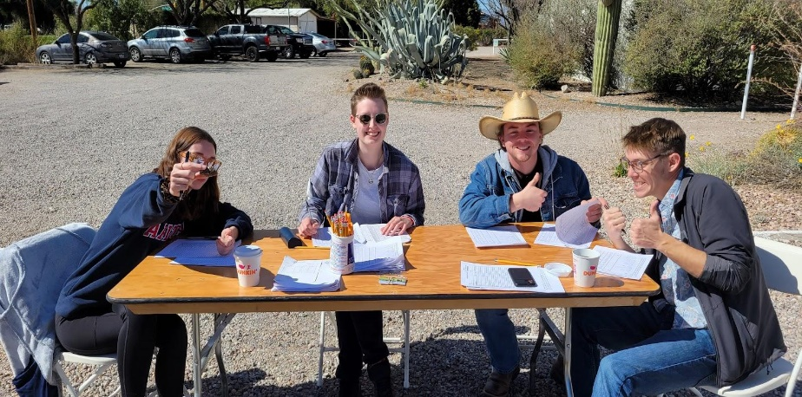

- Sheep Shearing 2022
  - Went to the 47 Ranch to help the sheep shearing event
  - Club members did not actually shear the sheep, but were provided a diversity of tasks to try out
    - Some included, but not limited to, picking out invasive weeds and their seeds from fleece, corralling sheep into the shearing placement pen, and cleaning sheep pens
  - Had lots of fun and gained a ton of experience
  - Pictures were taken, of course

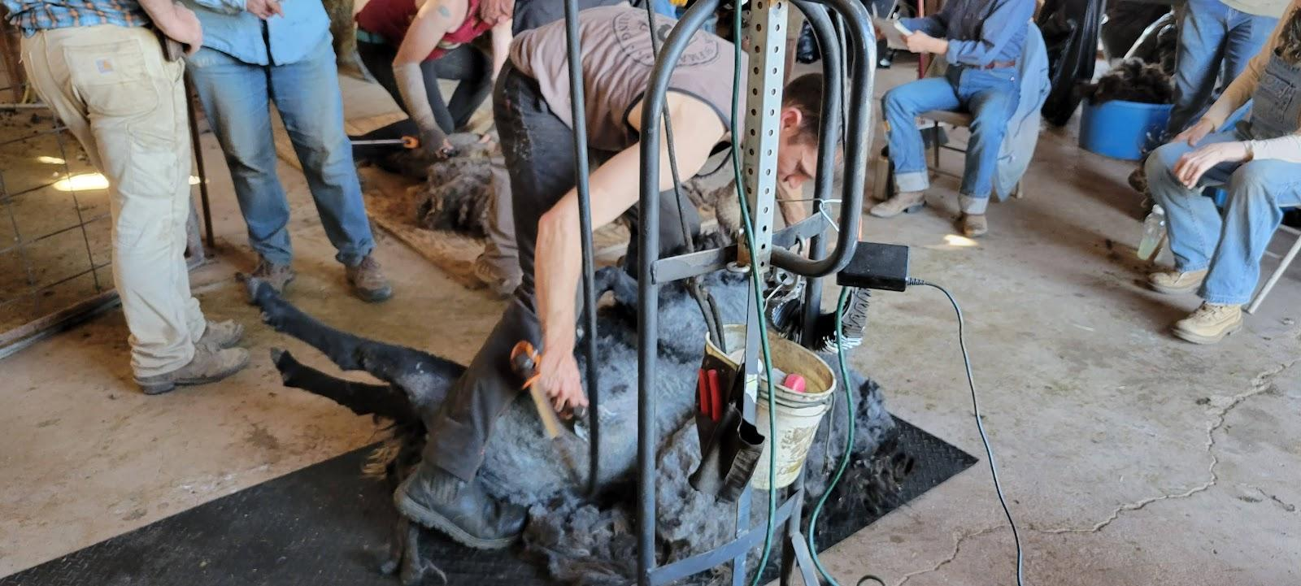
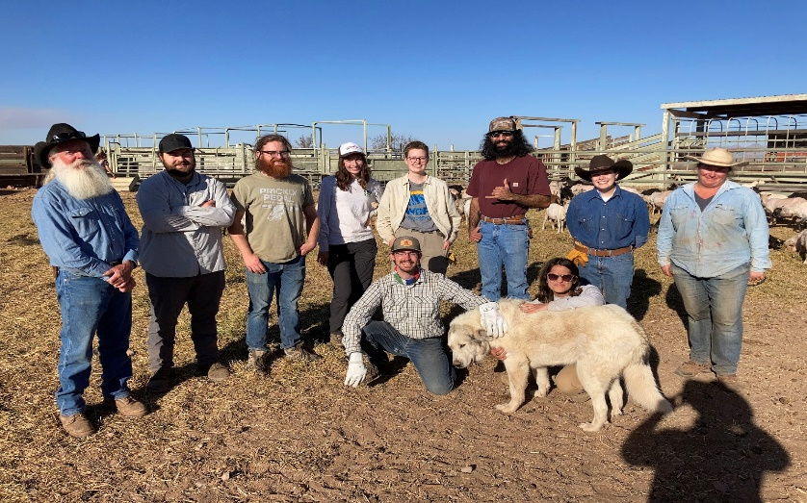
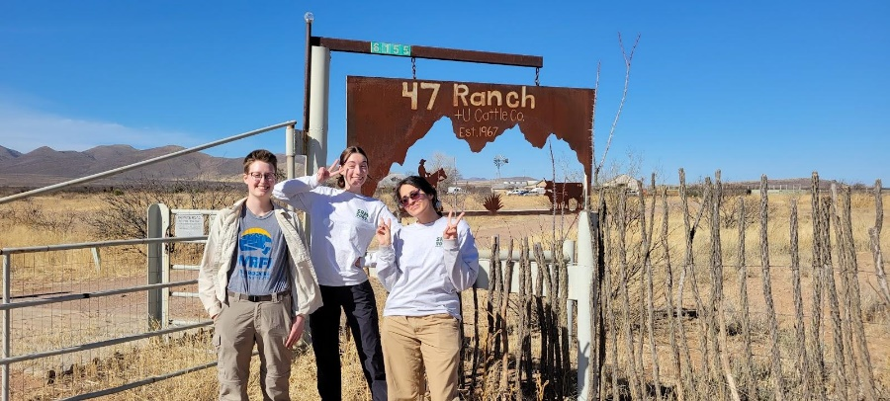
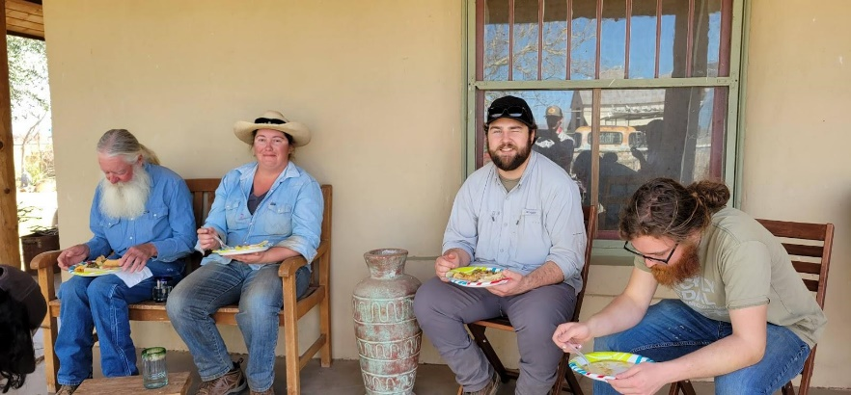



- Earth Week 2022
- SNRExpo Booth
  - When: Friday, 3/25/22 @ 11am-2pm
  - Where: ENR2 Courtyard
  - What: Setting-up booth, talking about the club, taking down the booth
- Trivia night
  - When: 03/23/22
  - Where: ENR2 Rooftop
  - What: Trivia!
  - Team name: The Omniscient Cows
    - WE WERE THE 1ST PLACE WINNERS!!



- Job Opportunities
- USA Jobs
  - Soil Conservationist
    - 17 new positions opened and will close soon!
  - Rangeland Management Specialist
    - 14 new positions opened and will close soon!
- Student Worker
  - For who: Austin Rutherford and Dr. Archer’s Lab
  - What: Help organize things in BSE and the Ag Center
  - Pay: $15/hour
- Ecophys
  - Lots of jobs and other cool opportunities on their website!
  - http://ecophys-jobs.org/positions.html
- Please check the SRM listserv emails for summer positions!
  - Let us know if you are NOT on the SRM listserv
  - We will get you on it ASAP

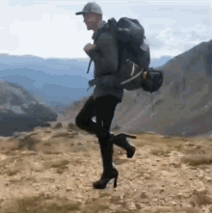

- Plant ID Hikes

- 1st hike of the semester
  - Where: Starr Pass Trailhead
  - When: Saturday, 4/2/22 @8am
  - What: Social hike, casual plant identification, create a plant list with some neat photos
  - Sign-up: Currently pending

- Future hikes (minimum 2 more)
  - Mt. Lemmon
  - Sabino Canyon
  - Madera Canyon
  - King’s Canyon
  - Any other ideas?



- Trip to SRER
- Where: Florida Station at the Santa Rita Experimental Range
- When: 4/23/22 – 4/24/22
- What: Opportunity to learn from range managers about the history and management objectives, also a chance to explore the range
- Sign-up: Currently pending
- Lodging facility can hold up to 25 people


- OPM Crosswalk Workshop

- Goal: Organize official course lists for federal job requirements
- Why: Certain courses needed for federal jobs, good for non-federal jobs, and helps you use elective credits effectively
- Planned date: Tuesday, April 19th
- Check the club GroupMe for upcoming planning meeting times

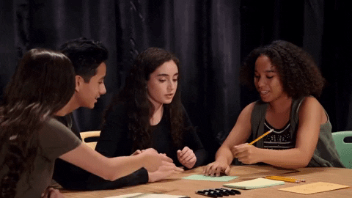

- Working Groups
- Club website
  - Creating and fixing up the club’s website
  - Updating it after each event we do
  - Establishing a media presence for future rangeland students interested in the club
  - Also prepares for the website competition at SRM next year
- BSE photo-box
  - Cleaning up and organizing old photos



- Budget

- Checking: $4,719.02
- Club dues: $30/year (or $15/semester)
- Steer raffle:
  - Venmo: $1,050
  - PayPal: $427.40
  - AZSRM website: $617
  - Cash/Check: $2,640
  - Total: $4,734.40



- Miscellaneous Items
- Plant ID Team
  - Starting up a plant ID team for next SRM
  - Finding a meeting date/time @BSE
- Club $wag
  - Products are coming soon!
- Officer nominations
  - All positions are open!
  - Multiple people can run for the same position
  - Must have your nomination seconded by another club member
  - Current team:
    - President: Eamonn Mazur
    - VP: Alex Binford-Walsh
    - Secretary: Elizabeth EbadiRad
    - Treasurer: Carter Blouin



- Connect with us!
- Have any questions, comments, and/or concerns?
  - Email us at uofatierraseca@gmail.com
- Don’t want to send an email? We understand. Send us a message over on our GroupMe!
  - Tierra Seca GroupMe: https://groupme.com/join_group/38156015/nWJ5vk




Scan me to join the GroupMe! Scan me to join Campus Groups!



- Meeting Adjourned: 5:38 PM

- Rangeland Meme of the Week

