
Tierra Seca
University of Arizona Student Chapter
Society for Range Management

February 22nd, 2022


- Meeting Called to order: 5:01 PM

- Tierra Seca Fall 2021 Club Meeting Schedule

~Biweekly meetings on Tuesdays at 5:00 PM at ENR2 in room N350
Month | Day
January | 25th
SRM Annual Meeting (February) | 7th-11th
February | 22nd
Spring Break (March) | 5th-13th
March | 22nd
April | 5th
April | 19th
May | 3rd

Attendance

Rakeen Abdali, Andrew Antaya, Flavie Audoin, Dakota Baden, Robin Bradley, Parker Brown, Carter Blouin, Cameron Burleson, Isabel DiNardo, Elizabeth EbadiRad, Ashley Gomez, Ava Hamstead, Dr. Aaron Lien, Eamonn Mazur, Brandon Mayer, Sarah Noelle, Caleb Miller, Brain Muha, Kaitlyn Tyler, Bailie Wynbelt, Alex-Binford Walsh



- Guest Speaker: Andrew Antaya
- Andrew came and practiced his speech he gave on 02/23/2022 in Yuma, Arizona
- Topic of the speech: Virtual Fencing
- Comments and questions were encouraged and appreciated
  - Whether it was about body language, content, visibility of the presentation, etc.



- SRM 2022 Congratulations!

- Congratulations to everyone who competed in this year’s SRM conference!
- Here are the teams that competed and their members
  - URME Team:
    - Dakota Baden
    - Bailie Wynbelt
    - Brian Muha
    - Parker Brown
    - Elizabeth EbadiRad
    - Eamonn Mazur
    - Rakeen Abdali
  - Plant ID Team:
    - Elizabeth EbadiRad
    - Eamonn Mazur
    - Ashley Gomez
    - Robin Bradley
    - Angie Shah
    - Kaitlyn Tyler
    - Brian Muha
    - Caleb Miller
    - Carter Blouin
  - Range Cup Team:
    - Parker Brown
    - Elizabeth EbadiRad
    - Bailie Wynbelt
  - Extempore Speaking:
    - Parker Brown
  - Graduate Awards:
    - 1st place – Austin Rutherford
    - 2nd place – Flavie Audoin
- Next step: Boise 2023!



- Volunteering Opportunities
- FFA Day (Dr. Howery)
  - When: 2/25/2022 @ 8am-12pm
  - Where: East of Campbell Ave and Roger Rd
  - What: Set-up tables and chairs, grade exams, enter results, etc.
  - Reward: Lunch with Dr. Howery

- Sheep Shearing Event (Flavie)
  - When: 3/1/2022 all day
  - Where: 47 Ranch, Cochise County, AZ
  - What: Sheep shearing
  - Watch this cool video made by Flavie and Co!
    - “Sheep shearing at the 47 Ranch”
    - https://www.youtube.com/watch?v=ptcvOdM5wBE

- Earth Week Booth
  - When: Friday, 3/25/2022 @11am – 2pm
  - Where: ENR2 courtyard
  - What: Set up booth, talk about the club, take down booth
    - UofA official social media people might be around to take pictures and ask us about our awesome club
  - Sign-up: https://docs.google.com/spreadsheets/d/1Lv-0NZ_JpT65EXJu-gZoGTPTdvd8Kh6c7XK54t9LeOw/edit?usp=sharing



- Job Opportunities
- Student ecohydrology summer position (Justin Johnson)
  - https://arizona.joinhandshake.com/stu/jobs/5886953
- Student database employee (UA Herbarium), Range Management Specialist (Halsey, Nebraska), Range Management Specialist, Soil Scientist, and Wildlife Biologist (Rio Grande NF, Colorado), and 7 USFS range jobs to be advertised at SRM 2022
  - https://drive.google.com/drive/folders/1kKOwPpP3chQW0PayunkouBvRSuPwa8SA?usp=sharing
- Also check out these cool websites for more information about jobs
  - SRM job postings
    - https://rangelands.org/job-listings/
  - USFS interns/trainees
    - https://www.usajobs.gov/
- Some of the deadlines for these jobs are coming up, so apply soon!

- Club $wag

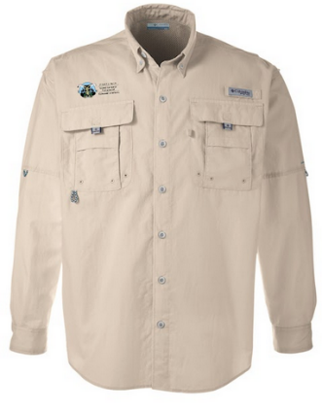
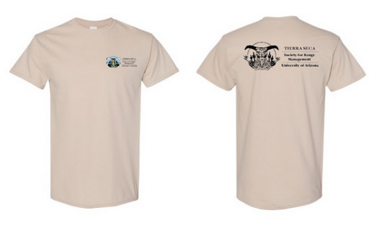
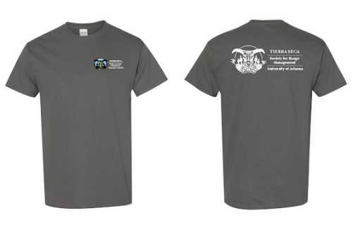
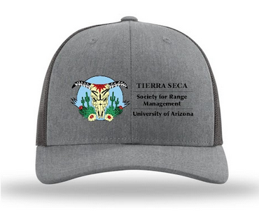
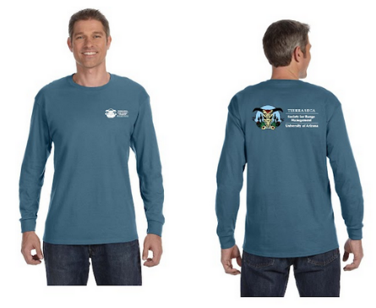
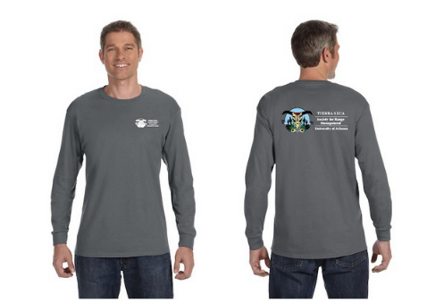

- Remember to fill out the Google Form to get some of these sweet club swag!
  - https://docs.google.com/forms/d/e/1FAIpQLSfivs__M4coXL-Rw86pAYxjbSFjjDS5zRlRezUrfbstRBWXCQ/viewform?usp=sf_link



- Connect with us!
- Have any questions, comments, and/or concerns?
  - Email us at uofatierraseca@gmail.com
- Don’t want to send an email? We understand. Send us a message over on our GroupMe!
  - Tierra Seca GroupMe: https://groupme.com/join_group/38156015/nWJ5vk



- Meeting Adjourned: 5:41 PM

- Rangeland Meme of the Week

