USDA Forest Service

Rocky Mountain Region

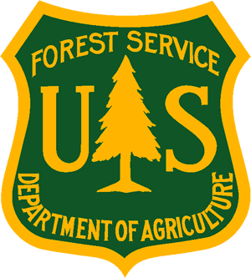
_________________________________________________Outreach Notice

Region 2

Medicine Bow-Routt National Forests

& Thunder Basin National Grassland

________________________________________________________________

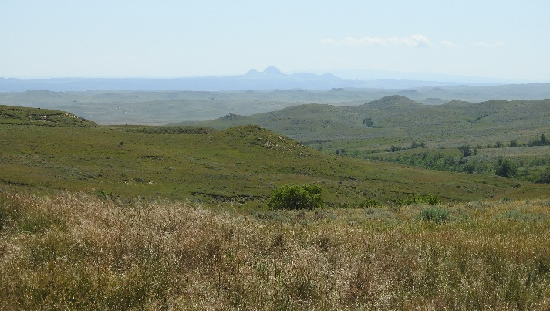 | 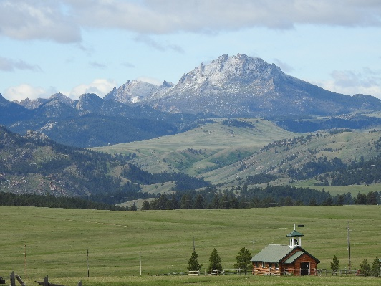 | 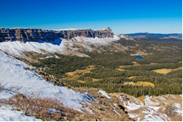

_________________________________________________

Rangeland Management Specialist, GS-0454-05/07/09, Permanent Appointment
SRM Hiring Event
Society for Range Management Convention (SRM) | US Forest Service (usda.gov)

Reply By: February 16, 2022

The Douglas, Laramie, and Parks (Waldon, CO) ranger districts on the Medicine Bow-Routt National Forests and Thunder Basin National Grassland, are conducting an outreach to assess interest in GS-0454-05/07/09 Rangeland Management Specialists with duty stations in Laramie and Douglas, WY and Waldon, CO. These positions may be filled at the GS 05 or GS 07 level with promotional potential to the GS 09 level. Please see the “Contact Information” section at the bottom of this notice for information on how to express interest in the position.

*This position is being advertised through the upcoming Society of Range Management (SRM) hiring event and will be open to apply on USAJOBS from February 18-28, 2022. This outreach notice will be updated and respondents will be provided with the vacancy announcement number as soon as it becomes available.

* THE DOUGLAS POSITION *
Major Duties: This position would be supervised by the District Program Rangeland Management Specialist. The incumbent has responsibility for the administration of grazing permits on the Laramie Peak Unit and grazing agreements on the Thunder Basin National Grassland for the Douglas Ranger District. The position will be one of four GS-9 Rangeland Management Specialists that work as part of the Rangeland Management Program. The Laramie Peak Unit has 33 direct permits and 43 allotments. The Thunder Basin National Grassland has three grazing associations with a total of 155 members and 179 allotments. Other duties of this position include leading efforts for long term and short term monitoring, supporting the noxious weed program, help in fostering and maintaining partnerships to aid in the management of highly intermingled land ownership within the boundaries of the Forest and Grassland, and provide support for other programs within the District.

Field Work: The selected individual will schedule field work that may include permit administration, monitoring, improvement inspections and other duties as assigned. They will assist in the treatment and inventory of noxious weeds. They will be expected to utilize 4x4 pickups, ATV/UTV, horses, and hiking as means of access.

Data Management: We are seeking applicants with strong verbal and written communication skills. Experience with all Microsoft programs, ArcGIS, Avenza, VGS, and GPS is desired.

Supervision: This position is non-supervisory but will be responsible for day-to-day guidance to seasonal field crews.

* THE LARAMIE POSITION *
Major Duties: This position would be supervised by the District Program Rangeland Management Specialist. The incumbent has responsibility for the administration of grazing permits on the Laramie Ranger District. The Laramie District range program consists of 22 direct permits and 20 allotments. Other duties of this position include leading efforts for long term and short term monitoring, supporting the noxious weed program, help in fostering and maintaining partnerships and provide support for other programs within the District.

Field Work: The selected individual will schedule field work that may include permit administration, monitoring, improvement inspections and other duties as assigned. They will assist in the treatment and inventory of noxious weeds. They will be expected to utilize 4x4 pickups, ATV/UTV, horses, and hiking as means of access.

Data Management: We are seeking applicants with strong verbal and written communication skills. Experience with all Microsoft programs, ArcGIS, Avenza, VGS, and GPS is desired.

Supervision: This position is non-supervisory but will be responsible for day-to-day guidance to seasonal field crews.

* THE PARKS POSITION *
Major Duties: This position would be supervised by the District Program Rangeland Management Specialist. The incumbent has responsibility for the administration of grazing permits on the Parks Ranger District (Walden, CO). The district range program consists of 14 direct permits and 31 allotments and covers 399,415 acres. Other duties of this position include leading efforts for long term and short term monitoring, supporting the noxious weed program, help in fostering and maintaining partnerships and provide support for other programs within the District.

Field Work: The selected individual will schedule field work that may include permit administration, monitoring, improvement inspections and other duties as assigned. They will assist in the treatment and inventory of noxious weeds. They will be expected to utilize 4x4 pickups, stock trailers and flatbed trailers (gooseneck and bumper pull), ATV/UTV, horses, and hiking as means of access. Horses are used quite a bit in the roadless and wilderness areas; horse experience and knowledge are not required but preferred.

Data Management: We are seeking applicants with strong verbal and written communication skills. Experience with all Microsoft programs, ArcGIS, Avenza, VGS, and GPS is desired.

Supervision: This position is non-supervisory but will be responsible for day-to-day guidance to seasonal field crews.

MEDICINE BOW-ROUTT NATIONAL FORESTS
& THUNDER BASIN NATIONAL GRASSLAND
The Medicine Bow National Forest dates back to May 22, 1902, with the establishment of the Medicine Bow Forest Reserve by President Theodore Roosevelt. The Medicine Bow contains 1,665,721 acres of National Forest System land within its boundaries. It consists of three Ranger districts: Brush Creek/Hayden at Saratoga, Laramie District at Laramie, and the Douglas District / Thunder Basin National Grassland at Douglas.

The Routt National Forest is located in northern Colorado. It was established by President Theodore Roosevelt in 1905 as the Park Range Forest Reserve, and then the name changed to the Routt National Forest in honor of Colonel John N. Routt, the last territorial and the first State Governor of Colorado. The Routt includes 1,126,650 acres of National Forest System land within its boundaries. It now consists of three Ranger Districts: Hahn’s Peak-Bears Ears at Steamboat Springs, Parks at Walden, and Yampa at Yampa. The former Middle Park District at Kremmling is part of the Arapaho National Forest but is administered as part of the Routt, and as a part of the Parks District. It includes 232,846 acres of National Forest.

The Forest has been heavily impacted by a mountain pine beetle epidemic which has affected more than 1.2 million acres of lodge pole pine. The large number of dead trees has increased the potential for large fires and the need for fire and fuels management.

The topography varies greatly within the national forests. Elevation ranges from 5,500 to 12,940 feet. The climate ranges from semi-arid at low elevations to colder and less arid in the high country. Vegetation varies from sage brush-grasslands at the lower elevations to mixed conifer forests of pine, spruce, fir and aspen in the upper elevations. Wildlife is abundant, with antelope, elk, moose, mule deer, and white-tailed deer being the most common larger species.

The Thunder Basin National Grassland is located in northeastern Wyoming in the Powder River Basin between the Big Horn Mountains and the Black Hills. The 550,000 acre Grassland ranges in elevation from 3,600 feet to 5,200 feet and the climate is semi-arid. Land patterns are very complex due to the intermingled federal, state, and private lands. The Grassland abounds with wildlife, provides forage for livestock, provides unique opportunities for recreation, and is underlain by vast mineral resources.

Major resource programs on the Forest include fire and fuel management, range, timber and other vegetation management, wildlife, minerals and recreation.

Elevations on the Forest range from about 5,000 feet to over 12,000 feet. Vegetation varies from sage brush-grasslands at the lower elevations to mixed conifer forests of pine, spruce, fir and aspen in the upper elevations. Wildlife is abundant, with antelope, elk, moose, mule deer, and white-tailed deer being the most common larger species.

ABOUT THE DUTY LOCATIONS
Douglas, WY:
The Douglas District office is located in Douglas, Wyoming, a full service community of 6,350 people. Services include 2 supermarkets, a movie theatre, dental and medical facilities, a sports medicine clinic, a modern hospital, 7 motels, a limited-service airport, a weekly newspaper, and churches of many denominations.
Douglas is located along the North Platte River, just off I-25. Casper, the Second largest city in Wyoming, is 45 miles west of Douglas. Casper provides a wide range of services. The Denver metropolitan area is approximately a 4 hr. drive. Cheyenne is the state capitol and largest city in Wyoming. It takes approximately 2+ hours to drive to Cheyenne. https://www.cityofdouglas.org/

Laramie, WY:
The Laramie Ranger District is located in the scenic Snowy Range and the Medicine Bow mountains in southeast Wyoming, just a short distance from several major metropolitan areas. With approximately 400,000 acres of public land, the ranger district offers a wide array of multiple-use management activities. Favorite local activities include fishing, camping, rafting, and hunting in the summer and fall. Winter brings ample opportunities for skiing, snowmobiling, ice fishing etc…

Educational opportunities are plentiful in Laramie. Private schools are offered K-6 and public schools K-12; junior college courses are offered locally through the Laramie County Community College in both Laramie and Cheyenne, Wyoming. The University of Wyoming is the only four-year institution in the state, serving the widespread population through modern technology and offering over 140 different academic programs.
https://laramie.org/

Walden, CO:
The town of Walden is located within Jackson County Colorado, 65 miles south of Laramie, WY. The area is generally considered northwestern Colorado and is approximately three hours from Denver, CO. Several premier ski areas are from 60-150 miles away. The town sits at approximately 8099’ mean sea level and originated as a small ranching and agricultural community with a classic western heritage. It is situated in the center of a large open valley called North Park. Jackson County offers a wide range of outdoor recreation opportunities in a spectacular mountain setting. North Park boasts of its hunting and fishing opportunities whether it is fly fishing or on one of the many lakes in the county. The primary industry is agriculture followed closely by recreation and timber with some oil and gas. Make no mistake this is a small town with the closest “chain or big box” stores being over 60 miles away. We do have a grocery store, bank, a bar, three gas stations, several hotels, a wonderful BBQ place and even a bowling alley. We have a medical clinic with our own home-grown doctor who grew up here on her family ranch went off to medical school and came back to raise her family on the same ranch. Public schools are K-12. Winters here can be long, but the summers are wonderful! Small town rodeos and county fair to boot! http://www.colorado.com/cities-and-towns/Walden
Extra Items to Consider
Wyoming has a sales tax; however, there is no personal income tax.

CONTACT INFORMATION
DOUGLAS RANGER DISTRICT – Michelle Buzalsky, 307-349-4640 or michelle.buzalsky@usda.gov
LARAMIE RANGER DISTRICT- Jackie Roaque, 307-745-2340 or jacquilyn.roaque@usda.gov
PARKS RANGER DISTRICT (WALDEN)- Marie Stiles, 970-873-3002 or marie.stiles@usda.gov

OUTREACH RESPONSE FORM
Rangeland Management Specialist, GS-0454-05/07/09
Please submit outreach response to Geri Proctor at geri.proctor@usda.gov
On or before February 16, 2022

NAME:

E-MAIL ADDRESS:

MAILING ADDRESS:

TELEPHONE NUMBER:
 | {USFS |  | {BLM |  | {OTHER

AGENCY EMPLOYED WITH:

 | {PERMANENT |  | {TEMPORARY |  | {TERM
TYPE OF APPOINTMENT:

 | {VRA |  | {PWD |  | {OTHER

 | {REGION |  | {FOREST

CURRENT:
{DISTRICT

 | {SERIES |  | {GRADE

CURRENT:
{POSITION TITLE

CURRENT:

HOW DID YOU FIND OUT ABOUT THIS OUTREACH NOTICE?

IF NOT A CURRENT PERMANENT (CAREER OR CAREER CONDITIONAL) EMPLOYEE
ARE YOU ELIGIBLE TO BE HIRED UNDER ANY OF THE FOLLOWING SPECIAL AUTHORITIES:

PERSON WITH DISABILITIES

VETERANS RECRUITMENT ACT

DISABLED VETERANS W/30% COMPENSABLE DISABILITY

VETERANS EMPLOYMENT OPPORTUNITIES ACT OF 1998

FORMER PEACE CORPS VOLUNTEER

PATHWAYS PROGRAM

Thank you for your interest in our Vacancy!

The U.S. Department of Agriculture (USDA) prohibits discrimination on all its programs and activities on the basis of race, color, national origin, gender, religion, age, disability, political beliefs, sexual orientation, and marital or family status. (Not all prohibited bases apply to all programs.) Persons with disabilities who require alternative means for communication of program information (Braille, large print, audiotape, etc.) should contact USDA's TARGET Center at (202) 720-2600 (voice and TDD). To file a complaint of discrimination, write USDA, Director, Office of Civil Rights, Room 326-W, Whitten Building, 14th and Independence Avenue, SW, Washington, DC 20250-9410 or call (202) 720-5964 (voice and TDD). USDA is an equal opportunity provider and employer.

