USDA Forest Service

Rocky Mountain Region

________________________________________________________

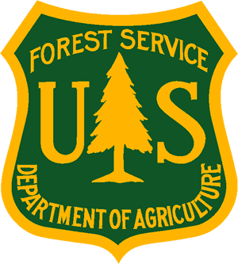
Outreach Notice

Region 2

Medicine Bow-Routt National Forests

& Thunder Basin National Grassland

________________________________________________________________

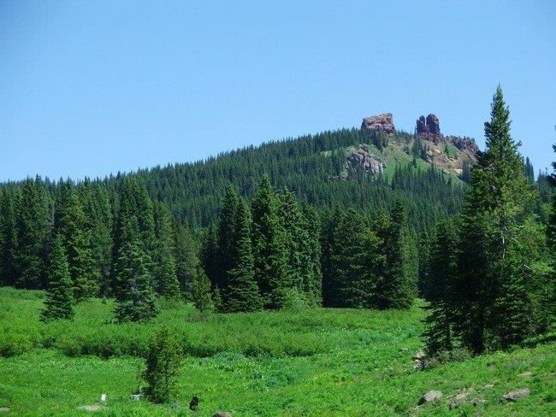 | 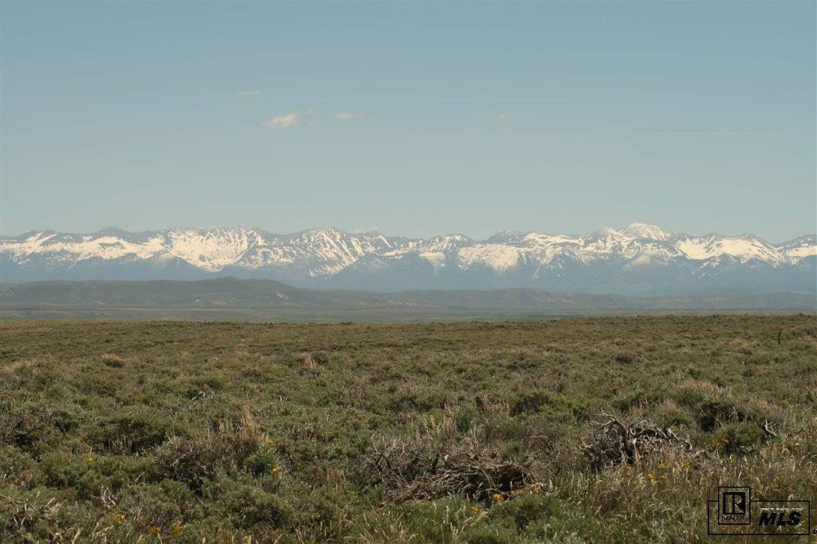 | 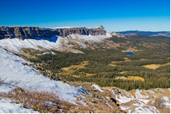

_________________________________________________

Range Technician, GS-0455-04/05/06/07, Permanent Appointment
SRM Hiring Event
Society for Range Management Convention (SRM) | US Forest Service (usda.gov)

Reply By: February 16, 2022

Various districts, on the Medicine Bow-Routt National Forests and Thunder Basin National Grassland, are conducting an outreach to assess interest in GS-0455-04/05/06/07 Range Technicians with duty stations in Laramie and Saratoga, WY and Walden, Steamboat, and Yampa CO. These positions may be filled at the GS 04 or GS 05 level with promotional potential to the GS 07 level. Please see the “Contact Information” section at the bottom of this notice for information on how to express interest in the position.

*This position is being advertised through the upcoming Society of Range Management (SRM) hiring event and will be open to apply on USAJOBS from February 18-28, 2022. This outreach noticed will be updated and respondents will be provided with the vacancy announcement number as soon as it becomes available.

* THE POSITION *
Major Duties: This position would be supervised by the District Rangeland Management Specialist. Duties include lead for the district weeds crew for day-to-day tasks. Plan and monitor weed treatments across district and work with partners/contractors to ensure completion of weed treatments. Check range allotments to assess appropriate time to graze, compliance with management plans and operating instructions, number of livestock, herding procedures, salting, range improvement, maintenance, and the need for additional range improvements such as fences or water development. Inspects and documents allotments before and after grazing. Contacts range users to explain needed maintenance work and reports noncompliance to supervisor. Inspects structural improvements and notifies supervisor of needed maintenance. May lead small crews in construction and/or maintenance of range improvements. Extensive hiking, horse/mule riding and ATV/UTV use is necessary for completion of duties. In order to accomplish major duties, incumbent will be expected to attain a Colorado or Wyoming Commercial Pesticide Applicator’s License.

Field Work: The selected individual will schedule project work for structural and non-structural infrastructure and assist crews in the installation of improvements. They will manage weed crews for treatments and inventory of noxious weeds. They will measure range condition by gathering required information concerning range readiness, utilization, and livestock distribution. Actual use data will be collected from the permittees for data entry.

Data Management: Additional responsibilities include collecting spatial data using a Global Positioning System (GPS) and ensuring that newly acquired field information is stored in a geodatabase format. The incumbent will manage the GIS data and ensure that all data is properly reported. The individual will conduct range studies relating to trend, condition, and utilization. They will summarize and enter the data. We are seeking applicants with strong verbal and written communication skills. Experience with all Microsoft programs, ArcMap, and GPS is desired.

Supervision: This position is non-supervisory but will be responsible for day-to-day guidance to field crews.

MEDICINE BOW-ROUTT NATIONAL FORESTS
& THUNDER BASIN NATIONAL GRASSLAND
The Medicine Bow National Forest dates back to May 22, 1902, with the establishment of the Medicine Bow Forest Reserve by President Theodore Roosevelt. The Medicine Bow contains 1,665,721 acres of National Forest System land within its boundaries. It consists of three Ranger districts: Brush Creek/Hayden at Saratoga, Laramie District at Laramie, and the Douglas District / Thunder Basin National Grassland at Douglas.

The Routt National Forest is located in northern Colorado. It was established by President Theodore Roosevelt in 1905 as the Park Range Forest Reserve, and then the name changed to the Routt National Forest in honor of Colonel John N. Routt, the last territorial and the first State Governor of Colorado. The Routt includes 1,126,650 acres of National Forest System land within its boundaries. It now consists of three Ranger Districts: Hahn’s Peak-Bears Ears at Steamboat Springs, Parks at Walden, and Yampa at Yampa. The former Middle Park District at Kremmling is part of the Arapaho National Forest but is administered as part of the Routt, and as a part of the Parks District. It includes 232,846 acres of National Forest.

The Forest has been heavily impacted by a mountain pine beetle epidemic which has affected more than 1.2 million acres of lodge pole pine. The large number of dead trees has increased the potential for large fires and the need for fire and fuels management.

The topography varies greatly within the national forests. Elevation ranges from 5,500 to 12,940 feet. The climate ranges from semi-arid at low elevations to colder and less arid in the high country. Vegetation varies from sage brush-grasslands at the lower elevations to mixed conifer forests of pine, spruce, fir and aspen in the upper elevations. Wildlife is abundant, with antelope, elk, moose, mule deer, and white-tailed deer being the most common larger species.

The Thunder Basin National Grassland is located in northeastern Wyoming in the Powder River Basin between the Big Horn Mountains and the Black Hills. The 550,000 acre Grassland ranges in elevation from 3,600 feet to 5,200 feet and the climate is semi-arid. Land patterns are very complex due to the intermingled federal, state, and private lands. The Grassland abounds with wildlife, provides forage for livestock, provides unique opportunities for recreation, and is underlain by vast mineral resources.

Major resource programs on the Forest include fire and fuel management, range, timber and other vegetation management, wildlife, minerals and recreation.

Elevations on the Forest range from about 5,000 feet to over 12,000 feet. Vegetation varies from sage brush-grasslands at the lower elevations to mixed conifer forests of pine, spruce, fir and aspen in the upper elevations. Wildlife is abundant, with antelope, elk, moose, mule deer, and white-tailed deer being the most common larger species.

ABOUT THE DUTY LOCATIONS
Steamboat Springs, CO
Steamboat Springs, Colorado is a full service year-round resort community located in northwestern Colorado at an elevation of 6,700 feet.
Community: Steamboat Springs is located 122 miles southwest of Laramie, WY, where the headquarters for the Forest is located. Denver is 160 miles southeast of town, and Fort Collins is 160 miles to the northeast. Year-round air service is provided at the Yampa Valley Regional Airport in Hayden.

The year-round population for Steamboat is about 12,000, which can swell up to 30,000 during the ski season. It is the county seat and largest community in Routt County. Other surrounding incorporated communities include Hayden (22 miles west, population 2,000), Oak Creek (23 miles south, population 1000), and Yampa (30 miles south, population 500).

Recreation: Recreation is unlimited in and around Steamboat Springs throughout the year. Summer and fall activities include hiking, horseback riding, fishing, hunting, kayaking, golfing, mountain biking and many other activities.
http://www.colorado.com/cities-and-towns/steamboat-springs

Walden, CO
The town of Walden is located within Jackson County Colorado, 65 miles south of Laramie, WY. The area is generally considered northwestern Colorado and is approximately three hours from Denver, CO. The town sits at approximately 8099’ mean sea level and originated as a small ranching and agricultural community with a classic western heritage. It is situated in the center of a large open valley called North Park. Jackson County offers a wide range of outdoor recreation opportunities in spectacular mountain settings.
http://www.colorado.com/cities-and-towns/Walden

Yampa, CO
Yampa is located at 7,881’ in elevation and currently has a population of approximately 500 people. It is a small ranching and agriculture community that offers year round recreation opportunities just minutes from town. It is situated at the southern end of the Yampa Valley in Routt County and surrounded by the Flat Tops to the west and Gore Range to the east. The closest larger city is Steamboat Springs, 30 miles to the north, which offers a full array of amenities. Year-round air service is provided at the Yampa Valley Regional Airport in Hayden, CO which is approximately 37 miles away.
http://www.colorado.com/cities-and-towns/Yampa

Saratoga, WY:
The Brush Creek/Hayden District of the Medicine Bow NF sits in the heart of the Rocky Mountains in south central Wyoming. About 30 permanent employees work at the Forest Service Office, and a varying number of seasonal hires, work in recreation, forestry, wildlife, fisheries, range, fire, engineering, planning, and hydrology. The District Office is in Saratoga, a friendly town of about 1800 people. Local and federal governments, plus traditional and renewable energy industries, are among the area’s largest employers. There is an interesting variety of restaurants, hotels, shops, hardware stores, farm and ranch stores, a brewpub, grocery, pharmacy, laundromat, gas/service stations, and 2 banks. A gorgeous community center complex serves as host to local theater, meetings and other events, and indoor recreation. There are also numerous local festivals, sporting events, and hands-on museums for every interest. Saratoga often places high on “best places to live/recreate lists” and was named the 2012 Outdoor Life Magazine 10th best hunting and fishing town in America.
http://www.saratoga.govoffice2.com/

Laramie, WY:
The Laramie Ranger District is located in the scenic Snowy Range and the Medicine Bow mountains in southeast Wyoming, just a short distance from several major metropolitan areas. With approximately 400,000 acres of public land, the ranger district offers a wide array of multiple-use management activities. Favorite local activities include fishing, camping, rafting, and hunting in the summer and fall. Winter brings ample opportunities for skiing, snowmobiling, ice fishing etc…

Educational opportunities are plentiful in Laramie. Private schools are offered K-6 and public schools K-12; junior college courses are offered locally through the Laramie County Community College in both Laramie and Cheyenne, Wyoming. The University of Wyoming is the only four-year institution in the state, serving the widespread population through modern technology and offering over 140 different academic programs.
https://laramie.org/

Extra Items to Consider
Wyoming has a sales tax; however, there is no personal income tax.

CONTACT INFORMATION
HAHN’S PEAK/BEARS EARS RANGER DISTRICT (STEAMBOAT)- Kristina Wood, 307-369-3518 or kristina.wood@usda.gov
PARKS RANGER DISTRICT (WALDEN)- Marie Stiles, 307-710-5990 or marie.stiles@usda.gov
YAMPA RANGER DISTRCT- Douglas Myhre, 970-819-6467 or douglas.myhre@usda.gov
LARAMIE RANGER DISTRICT- Jackie Roaque, 307-399-3038 or jackie.roaque@usda.gov
BRUSH CREEK/HAYDEN RANGER DISTRICT (SARATOGA)- Brad Weatherd, 307-329-9672 or bradley.weatherd@usda.gov

OUTREACH RESPONSE FORM
Range Technician, GS-0455-04/05/07
Please submit outreach response to Geri Proctor at geri.proctor@usda.gov
On or before February 16, 2022

NAME:

E-MAIL ADDRESS:

MAILING ADDRESS:

TELEPHONE NUMBER:
 | {USFS |  | {BLM |  | {OTHER

AGENCY EMPLOYED WITH:

 | {PERMANENT |  | {TEMPORARY |  | {TERM
TYPE OF APPOINTMENT:

 | {VRA |  | {PWD |  | {OTHER

 | {REGION |  | {FOREST

CURRENT:
{DISTRICT

 | {SERIES |  | {GRADE

CURRENT:
{POSITION TITLE

CURRENT:

HOW DID YOU FIND OUT ABOUT THIS OUTREACH NOTICE?

IF NOT A CURRENT PERMANENT (CAREER OR CAREER CONDITIONAL) EMPLOYEE
ARE YOU ELIGIBLE TO BE HIRED UNDER ANY OF THE FOLLOWING SPECIAL AUTHORITIES:

PERSON WITH DISABILITIES

VETERANS RECRUITMENT ACT

DISABLED VETERANS W/30% COMPENSABLE DISABILITY

VETERANS EMPLOYMENT OPPORTUNITIES ACT OF 1998

FORMER PEACE CORPS VOLUNTEER

PATHWAYS PROGRAM

Thank you for your interest in our Vacancy!

The U.S. Department of Agriculture (USDA) prohibits discrimination on all its programs and activities on the basis of race, color, national origin, gender, religion, age, disability, political beliefs, sexual orientation, and marital or family status. (Not all prohibited bases apply to all programs.) Persons with disabilities who require alternative means for communication of program information (Braille, large print, audiotape, etc.) should contact USDA's TARGET Center at (202) 720-2600 (voice and TDD). To file a complaint of discrimination, write USDA, Director, Office of Civil Rights, Room 326-W, Whitten Building, 14th and Independence Avenue, SW, Washington, DC 20250-9410 or call (202) 720-5964 (voice and TDD). USDA is an equal opportunity provider and employer.

