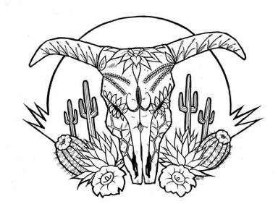
Tierra Seca
University of Arizona Student Chapter
Society for Range Management

January 25th, 2022


- Meeting Called to order: 5:05 PM

- Tierra Seca Fall 2021 Club Meeting Schedule

~Biweekly meetings on Tuesdays at 5:00 PM at ENR2 in room N350
Month | Day
January | 25th
SRM Annual Meeting (February) | 7th-11th
February | 22nd
Spring Break (March) | 5th-13th
March | 22nd
April | 5th
April | 19th
May | 3rd

Attendance

Rakeen Abdali, Andrew Antaya, Flavie Audoin, Dakota Baden, Robin Bradley, Parker Brown, Cameron Burleson, Elizabeth EbadiRad, Dr. Jeffery Fehmi, Ashley Gomez, Ava Hamstead, Dr. Larry Howery, Dr. Aaron Lien, Eamonn Mazur, Brandon Mayer, Sarah Noelle, Caleb Miller, Brain Muha, Austin Rutherford, Kaitlyn Tyler, Bailie Wynbelt, Alex-Binford Walsh



- Steer Raffle Updates
- The steer has already been slaughtered and will be ready to go!
- Raffle drawing will happen February 1st
  - Last tickets and money can be handed in the same day
- So far, we have made approximately $2,000 dollars
- AZSRM is another place for people to buy their tickets
  - https://azrangelands.org/store
  - It is the first thing listed under the name “Beef Raffle”
- People can still pay for tickets through PayPal and Venmo
  - PayPal: uofatierraseca@gmail.com
  - Venmo: @tierra_seca_steer_raffle
- Thank you everyone who sold or bought tickets!



- SRM 2022: Communication
- To make communication among members attending the SRM Conference this year much easier and safer, please join the Tierra Seca SRM GroupMe Chat
- You can join by scanning the QR code or by clicking this link: https://groupme.com/join_group/84830467/a3oVzQ5I





- SRM 2022 Schedule
- Important dates and times:
  - Saturday 2/5 @12pm – Depart from UA
  - Sunday 2/6 @6pm – Student Conclave Social
  - Monday 2/7 afternoon – URME
  - Tuesday 2/8 morning – Plant ID
  - Tuesday 2/8 evening – Bridging the Gap and University Socials
  - Wednesday 2/9 morning – Undergraduate Paper Session
  - Wednesday 2/9 afternoon – SRM Business Meeting and Awards
  - Friday 2/11 morning – Depart from ABQ
- Tentative schedule: https://docs.google.com/document/d/1HmC5hHjdPUNlUMzHG8Fma_ZqIk0dVxd3/edit?usp=sharing&ouid=107600990208785680093&rtpof=true&sd=true
- SRM 2022 website: http://annualmeeting.rangelands.org/schedule/



- SRM 2022 Volunteer Sign-Ups
- Find volunteer slots that don’t conflict with your competition!
  - URME – Monday 2/7 afternoon
  - Plant ID – Tuesday 2/8 morning
  - Range Cup – Variable
- Volunteer sign-up sheet here:
  - https://docs.google.com/spreadsheets/d/1jDF75P_JSEIl1Wy9r3k5WE04Hiw0Ncz7LVCPL9NTgUY/edit?usp=sharing

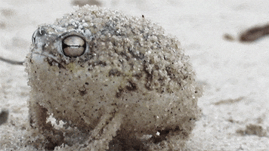

- SRM 2022 Optional Meeting
- When: Tuesday 2/1/2022 @ 6PM
- Where: ENR2, room N375
- What: Answer any last-minutes questions, clear up any confusion, hand out Dean’s Excuses



- Volunteering Opportunities
- FFA Day (Dr. Howery)
  - When: 2/25/2022 @7am-12pm
  - Where: East of Campbell Ave and Roger Rd
  - What: Set-up tables and chairs, grade exams, enter results, etc.
  - Reward: Lunch with Dr. Howery
- Sheep Shearing Event (Flavie)!
  - When: 3/1/2022 all day
  - Where: 47 Ranch, Cochise County, AZ
  - What: Sheep shearing
  - Watch this cool video made by Flavie and Co!
    - “Sheep shearing at the 47 Ranch”
      - https://www.youtube.com/watch?v=ptcvOdM5wBE



- Job Opportunities
- Student ecohydrology summer position (Justin Johnson)
  - https://arizona.joinhandshake.com/stu/jobs/5886953
- Student database employee (UA Herbarium), Range Management Specialist (Halsey, Nebraska), Range Management Specialist, Soil Scientist, and Wildlife Biologist (Rio Grande NF, Colorado), and 7 USFS range jobs to be advertised at SRM 2022
  - https://drive.google.com/drive/folders/1kKOwPpP3chQW0PayunkouBvRSuPwa8SA?usp=sharing

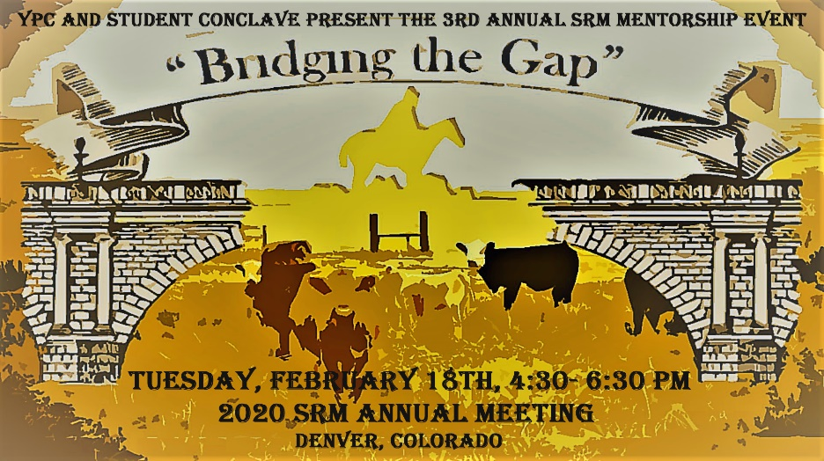

- “Bridging The Gap” event
- Hosted by SRM YPC (Young Professionals Conclave)
- When: Thursday 1/27/2022 @ 7PM
- Where: Online (Zoom)
- What: “build more connections between the student/young professional membership of SRM and established professionals. Mentees and mentors will hear a keynote presentation in professional communication and participate in a semi-structured activity to facilitate discussion and networking, with the intent of helping mentees navigate career opportunities in rangeland science and management.”
- Price: FREE!!
- Register here: https://www.eventbrite.com/e/2022-bridging-the-gap-tickets-25095817164



- Connect with us!
- Have any questions, comments, and/or concerns?
  - Email us at uofatierraseca@gmail.com
- Don’t want to send an email? We understand. Send us a message over on our GroupMe!
  - Tierra Seca GroupMe: https://groupme.com/join_group/38156015/nWJ5vk



- Meeting Adjourned: 5:50 PM

- Rangeland Meme of the Week
