
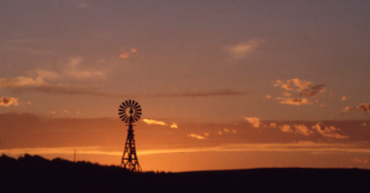
USDA Forest Service | Region 2
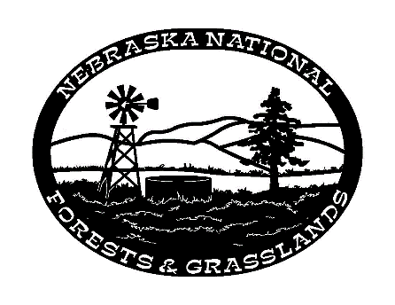
Nebraska national

Forests and Grasslands

http://www.fs.usda.gov/nebraska

OUTREACH NOTICE
Range Technician GS 0455–04/05, Permanent Appointment

The Fall River Ranger District, Buffalo Gap National Grassland, Nebraska National Forests and Grasslands, is seeking a candidate for a Range Technician, GS 0455-04/05, with promotion potential to a GS-07 level. This is a permanent, part-time position with a guarantee of 18 pay periods (approximately 8 months) located in Hot Springs, SD. The purpose of this Outreach Notice is to assess interest and inform prospective applicants of this upcoming opportunity.
This position is being advertised through the upcoming Society of Range Management (SRM) hiring event and will be open to apply on USAJOBS (www.usajobs.gov) from February 8-17, 2022, through Recent Graduate/Merit job announcements. This outreach noticed will be updated and respondents will be provided with the vacancy announcement number as soon as it becomes available.
Description of Duties:
This position serves as support to the District Rangeland Management Specialist implementing an overall ecosystem-based rangeland management program, utilizing resource management plan goals, objectives and decisions, and rangeland project decisions as necessary to implement actions that help achieve land management plan goals and objectives on the Fall River Ranger District. The position will review rangeland conditions to identify and develop solutions to manage rangelands. The Fall River Ranger District has a complex range program with over 70 grazing allotments and over 75 permittees (32 direct permittees and 3 grazing association).
Primary duties include monitoring permittee compliance, inspecting range allotments for compliance with management plans, and annual operating instructions for number of livestock, forage utilization, riparian impacts, range improvement maintenance, and the need for additional range improvements such as fences or water developments. Keep accurate records on the results of inspections, transects, and samples and updates required databases. Responsibilities also include assisting with the district noxious weed program. The position may participate in controlling weeds using chemical, biological, and/or mechanical methods. Duties may include construction and re-construction of fences and water developments. Other duties may include assisting with the district recreation and wildlife programs.
For additional information about the position or the Forest, please contact Clint Phillips, Rangeland Management Specialist, at (605) 745-4107 or at clint.phillips@usda.gov or Julie Wheeler, District Ranger, at (605) 745-8202, julie.wheeler@usda.gov.
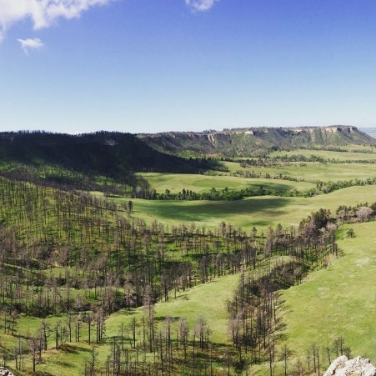
About the Nebraska National Forests and Grasslands:
The NNFG encompasses over 1.1 million acres of land in both Nebraska and South Dakota, including five Ranger Districts and one Nursery. The Pine Ridge Ranger District includes part of the Nebraska National Forest and all of the Oglala National Grassland in the northwest corner of the state. The Bessey Ranger District includes a portion of the Nebraska National Forest in west-central and the McKelvie National Forest in north-central NE. The Bessey Nursery is co-located with the Bessey Ranger District at Halsey, NE. The Fall River Ranger District and Wall Ranger District share management of the Buffalo Gap National Grassland across southwestern South Dakota. The Ft. Pierre National Grassland is managed by the Ft. Pierre Ranger District and is situated in south-central South Dakota.
The Supervisor’s Office is located in Chadron, Nebraska and is co-located with the Pine Ridge Ranger District. The Pine Ridge Job Corps Center is located 10 miles south of Chadron and is a close partner with the Nebraska National Forests and Grasslands.
Quick facts about the Fall River Ranger District, Buffalo Gap National Grassland:
- Responsible for the management of approximately 322,000 acres.
- Railroad Buttes OHV recreation area includes 1745 acres of “open ride area”.
- 170 miles of trails.
- Rockhounding for those interested in rocks, minerals, specifically Fairburn agates.
- Red Shirt Recommended for Wilderness Area.

Community and Surrounding Area:
Hot Springs, SD
The Fall River Ranger District, located in Hot Springs, South Dakota, which is known as the Southern Gateway to the Black Hills! Hot Springs has been well known for many years for its large, natural, warm water springs. With easy access to great attractions; soothing, natural, warm water springs; great year-round weather; distinctive sandstone architecture; and multiple opportunities for outdoor activities and experiences.
Hot Springs has a population of approximately 3,700. It is the county seat of Fall River County and is located at the southern end of the Black Hills about 50 miles south of Rapid City. Hot Springs is situated at an elevation of 3,500 feet and enjoys a four-season climate with an average January temperature of 31 degrees and a July average of 75 degrees. The average annual rainfall is 14 inches and annual snowfall is 27 inches. The community of Hot Springs offers 16 churches, 14 motels, 4 banks, a Veterans Administration Medical Center, the South Dakota State Veteran’s Home, a full-service hospital, a public library, a golf course, a tennis court, a health club, a natural warm water indoor pool, 7 parks, ball fields, a bowling alley, a movie theater, and a weekly newspaper. Emergency services for the community include a full-time police department and sheriff’s department, a volunteer fire department, and an ambulance service. Basic economic activities of Hot Springs include tourism, retail sales, medical services, farming, and ranching.
More information on the Hot Springs area can be found at: www.hotsprings-sd.com.

Tips on writing a Federal resume and applying for Federal jobs can be found on the USAJobs Channel.

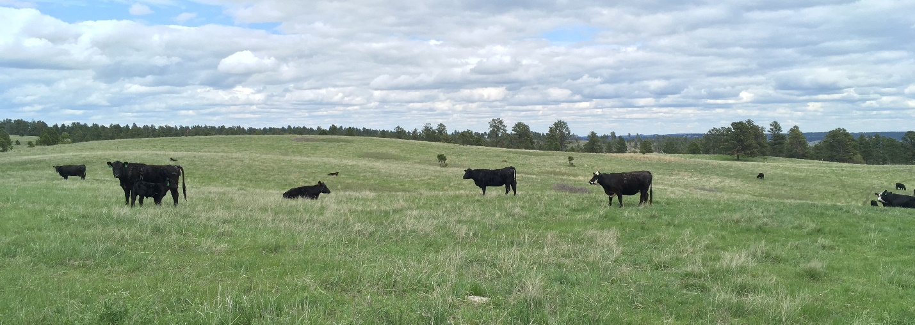

OUTREACH RESPONSE FORM
Range Technician, GS-0455-04/05
Please submit outreach response to Julie Wheeler at julie.wheeler@usda.gov,
On or before February 7, 2022

NAME:

E-MAIL ADDRESS:

MAILING ADDRESS:

TELEPHONE NUMBER:
 | {USFS |  | {BLM |  | {OTHER

AGENCY EMPLOYED WITH:

 | {PERMANENT |  | {TEMPORARY |  | {TERM
TYPE OF APPOINTMENT:

 | {VRA |  | {PWD |  | {OTHER

 | {REGION |  | {FOREST

CURRENT:
{DISTRICT

 | {SERIES |  | {GRADE

CURRENT:
{POSITION TITLE

CURRENT:

HOW DID YOU FIND OUT ABOUT THIS OUTREACH NOTICE?

IF NOT A CURRENT PERMANENT (CAREER OR CAREER CONDITIONAL) EMPLOYEE
ARE YOU ELIGIBLE TO BE HIRED UNDER ANY OF THE FOLLOWING SPECIAL AUTHORITIES:

PERSON WITH DISABILITIES

VETERANS RECRUITMENT ACT

DISABLED VETERANS W/30% COMPENSABLE DISABILITY

VETERANS EMPLOYMENT OPPORTUNITIES ACT OF 1998

FORMER PEACE CORPS VOLUNTEER

PATHWAYS PROGRAM

Thank you for your interest in our Vacancy!
The U.S. Department of Agriculture (USDA) prohibits discrimination on all its programs and activities on the basis of race, color, national origin, gender, religion, age, disability, political beliefs, sexual orientation, and marital or family status. (Not all prohibited bases apply to all programs.) Persons with disabilities who require alternative means for communication of program information (Braille, large print, audiotape, etc.) should contact USDA's TARGET Center at (202) 720-2600 (voice and TDD). To file a complaint of discrimination, write USDA, Director, Office of Civil Rights, Room 326-W, Whitten Building, 14th and Independence Avenue, SW, Washington, DC 20250-9410 or call (202) 720-5964 (voice and TDD). USDA is an equal opportunity provider and employer.

