Rio Grande National Forest Outreach Notice
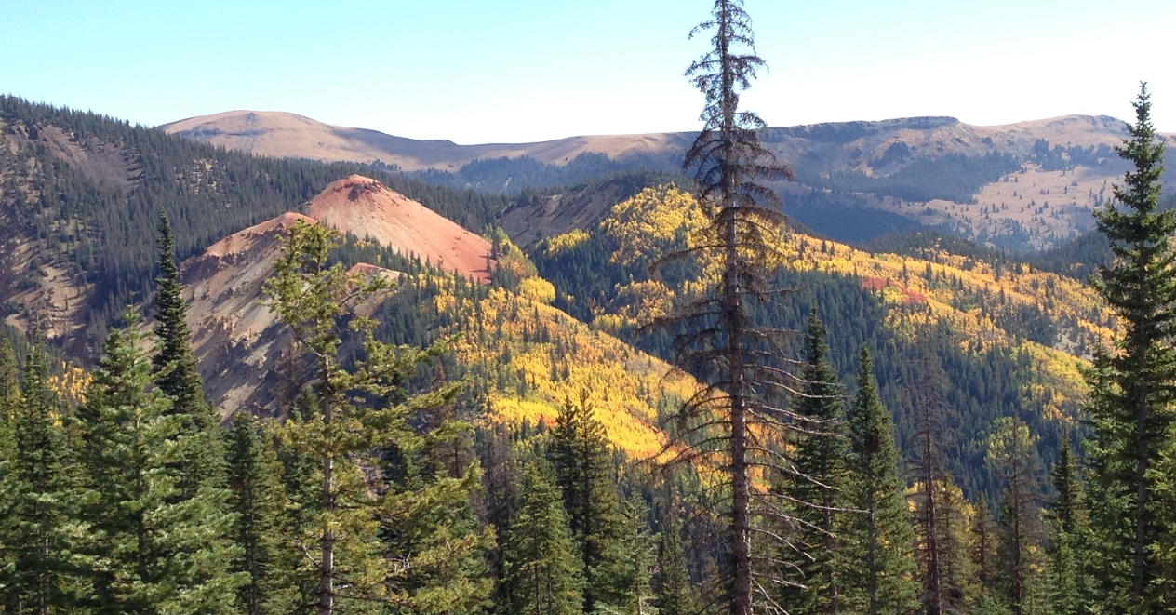

Permanent Full-Time Multiple Positions
Rio Grande National Forest – multiple duty stations
Respond by February 4, 2022

The Rio Grande National Forest is currently seeking candidates for three permanent full-time positions. The purpose of this outreach notice is to inform prospective applicants of this upcoming opportunities. These positions will be filled through the upcoming Society of Range Management (SRM) Conference, which will be held both virtually and in-person from February 6-10, 2022. Interested applicants do not need to attend the conference to apply. All positions will be filled through Recent Graduate or Merit Promotion job announcements, which will be available on USAJOBS (www.usajobs.gov) from February 8-17, 2022. The positions the forest plans to fill are listed below:

Rangeland Management Specialist, GS-0454-05/07
This is a career-ladder position starting at the GS-0454-05 or 07 level with the promotion potential to GS-09. The position provides professional and technical expertise to a complex Rangeland Management program. This position will be located at on of three districts: Del Norte, CO, Saguache, CO or La Jara, CO, and the incumbent would provide forest wide support. The incumbent is responsible for:
- Makes observations and gathers information for evaluating the need of control programs for poisonous or noxious plants
- Maintains plant surveys and monitoring records in appropriate data base files, in addition to collection and preparation of voucher specimens for plants
- Makes on-the-ground investigations of complex ecological and botanical conditions of the effects of specific activities relating to invasive noxious weeds and on the long-term survival of rare plant species, providing recommendations for action in specific cases.

- Assists unit personnel or contract personnel in conducting botanical research and studies
- Conducting short- and long-term monitoring of plant communities and their trends; grazing impacts, precipitation, soil erosion hazards and riparian condition.
- Conducts studies of range conditions, trends, and utilization.
- Carrying out ecosystem-based rangeland surveys and inventories.
- Gathering and assembling data concerning rangeland health, trends, ecological status of vegetation communities, site potential and desired plant community.
- Makes recommendations for improved rangeland and livestock administration and provides input into the development of subsequent rangeland and livestock management decisions.
- Maintains continuing working relationship with permittees and others to ensure compliance with agreed upon plans and desired quality of work, and to advise rangeland users of various activities affecting their use of specific rangeland areas. Prepares and revises annual rangeland user instructions. Prepares or initiates action on cooperative agreements for rangeland improvements.
- Assists in the administration of grazing permits by consulting, coordinating, and cooperating with permittees and other rangeland users. Determines permittee compliance with permits and makes recommendations to correct discrepancies.
- Determines rangeland readiness for various rangeland uses, inspects rangeland uses for compliance with permits, and monitors the results of the rangeland uses that are permitted or allowed. Prepares rangeland improvement maintenance schedules and keeps records of existing and proposed improvements, maintenance needs, and accomplishments.
- Conducts range allotment inspections, compiles actual use information, and prepares allotment management plans. Determines proper stocking and rotation schemes.
- The incumbent will spend approximately 60% of their time in the field, and may travel on foot, horseback, ATV, and 4x4 vehicle.
- It is desirable for applicants to have some of the following skills: the ability to navigate using a topographic map and GPS; experience around horses and riding; a strong background in the principles of rangeland management; comfort working alone or in small groups; plant identification skills with an emphasis on grass species; good writing and oral communication skills and the ability to utilize computers for writing, analysis, and data input.
- A valid driver’s license is required.

For more information on the Rangeland Management Specialist position, please contact Tristram Post, District Ranger, at tristram.post@usda.gov or 719-850-2358/

Soil Scientist, GS-470-05/07
This is a career-ladder position starting at the GS-470-05 or 07 level with the promotion potential to GS-09. This position performs professional work in the field of soil science and has responsibility to conduct and interpret soil surveys and analysis, as well as provide technical guidance within the framework of multiple-use management of forest and range lands. This position works Forest wide out of the Supervisors Office.
Major duties include:
- Assists in the development of land management planning related to soil condition.
- Prepares management prescriptions to protect and enhance the soil resource.
- Serves on interdisciplinary teams as a project proponent and/or as an interdisciplinary team member to complete NFMA and NEPA efforts.
- Interprets soils data for input to environmental reports.
- Evaluates impacts of land management (timber, grazing, fuels, mining, and special use permits) to soil resources.
- Assists in the weekly collection of precipitation samples for the National Atmospheric Depositional Program.
- Provides support to other projects.
- Provides support for watershed as needed.
- Assists with planning and evaluation of BMPs for the National BMP Monitoring Program.
- Manage data and create maps using ArcMap/ArcPro.
- Share and use data in AGOL Online and associated mobile apps.
- Will navigate using a topographic map and GPS.
- A valid driver’s license is required.

For more information on the Soil Scientist position, please contact Daryl Kohut, Forest Hydrologist at: email daryl.kohut@usda.gov; phone 719-852-6216.

Wildlife Biologist, GS-0486-05/07
This is a career-ladder position starting at the GS-0486-05 or 07 level with the promotion potential to GS-09. This position has a duty station of Del Norte, Colorado. Duties of the position include:
- Gathering, compiling, entering, and analyzing data to determine habitat requirements and management needs;
- Assessing habitat quality and quantity, interpreting biological requirements for species and their habitat;
- Inventorying and monitoring habitat and in some cases populations;
- Determining the need for and recommending habitat restoration, enhancement, or improvement projects; and
- Studying and recommending solutions to special coordination problems involving habitat protection.
- Prepares wildlife and fisheries management input for the interdisciplinary team. Gathers information to be used in environmental analyses affecting wildlife and fish resources.
- Develops biological evaluations for review by journey-level biologists.
- Known locations of any species of concern are documented and maintained in a GIS database, which is updated each year under direction of the biologists.
- A basic knowledge of plant identification is not required but is an asset.
- A valid driver’s license is required.

For more information on the Wildlife Biologist position, please contact David Topolewski, Wildlife Biologist, at David.Topolewski@udsa.gov or 719-274-6304.

The Rio Grande National Forest
The Rio Grande NF is 1.82 million acres located in south-central Colorado. The Forest embraces the San Luis Valley, a large rural agricultural valley. The Forest presents a myriad of ecosystems, from the 7,600-ft. alpine desert floor to over 14,300-ft. mountains in the Sangre de Cristo Wilderness on the eastern side. The Continental Divide runs for 236 miles along most of the western border of the Forest. The Rio Grande NF offers a wide range of recreational settings and opportunities. Portions of four Wilderness Areas (South San Juan, Weminuche, La Garita and Sangre de Cristo) and the headwaters of the Rio Grande River fall within the Forest. Recreational opportunities abound to include Wolf Creek Ski Area, over 1,300 miles of trails, mountain biking systems, premier fishing and hunting opportunities as well as scenic byways and a national scenic trail.
Visit the Rio Grande National Forest: https://www.fs.usda.gov/main/riogrande/home.
The San Luis Valley
Larger than the state of Rhode Island, the San Luis Valley (SLV) is the largest and highest agricultural alpine valley in the world. The “Valley” floor rests at 7600'. To the west of the SLV is the San Juan Mountains ecosystem, the headwaters of the Rio Grande River and the Continental Divide. To the east, the majestic Sangre de Cristo mountain range, complete with multiple “14'ers”, stands guard over this incredibly beautiful, very rural and isolated area. Denver, CO is 4-hours north and Albuquerque, NM is 4-hours south. While there are some excellent shopping opportunities locally, when you get the itch to experience some hustle and bustle, Durango, Pueblo, and Colorado Springs are 2-3 hours away. Long summer days in the 80's transition through a colorful and crisp fall. Winters can be somewhat extreme, with temperatures dipping well below zero and, in some years, frequent snows. However, the low mountain humidity and abundance of sunshine help mitigate the affect. The San Luis Valley is home to Adams State University as well as the Alamosa Campus for Trinidad State Junior College. Medical, dental, and vision clinics are located in many of the Valley communities as well as hospitals in the towns of Del Norte, Alamosa, and La Jara.
Del Norte, Colorado
Del Norte, now in its second century, has a population of 1,600 with an additional 300 people in the surrounding farm and ranch area. Its economy is geared to a modern diversification of recreation, travel, farming, ranching, logging, mining, fishing, and hunting. Being the county seat of Rio Grande County, it hosts a mayor and town council. There are schools to accommodate an education for children K-12. There are various stores located in Del Norte to accommodate most shopping needs, including grocery, hardware, clothing, craft, and auto parts. There is also a library, and hospital. Some say Del Norte is the gateway to the sportsman's paradise with many four-season activities just a short drive away. Winter sports include skiing at nearby Wolf Creek Pass, snowmobiling, and hunting to name a few. Summers are ideal for fishing, hiking, and camping. Fall brings out those who love to watch the changing colors on the mountains and spring brings out new color and new life. The opportunities are only limited by one's imagination.
La Jara, Colorado
La Jara is a small community with a population of around 896 located in the San Luis Valley of Southern Colorado. It is 14 miles south of Alamosa on Highway 285 and 20 miles north of the New Mexico border. It is bordered on the east by the Sangre de Cristo Mountain Range and on the west by the San Juan Mountain Range. La Jara has a hospital, doctor's clinic, nursing home, and retirement housing, as well as, a library, police and fire department, post office, various grocery stores, a pharmacy, and a fertilizer and potato plant. Schools are also available for K-12, with a 4-year college (Adams State), Trinidad Junior College, and the San Luis Valley Vocational School located in Alamosa. There is a variety of housing available both to rent and to buy either in town or on small farms or ranches in the outlying areas. The elevation is approximately 7,600 feet lending itself to cold winters with frequent, light snow falls and summers of "cool" sunshine (low’s in the 40’s and high's in the mid 80's).
Saguache, Colorado
Saguache has it all, from ghost towns in the west to the Sand Dunes National Park and Reserve in the east. The La Garita and Sangre De Cristo Wilderness Areas are known for their outdoor opportunities, their lakes, and their mountain streams. Saguache is a small, limited service community of approximately 600 people located at the north end of the San Luis Valley and is the county seat for Saguache County. Saguache is located on the junction of Highways 285 and 114. Gunnison is approximately 70 miles west of Saguache, Salida is approximately 45 miles north of Saguache and Monte Vista (location of Forest Supervisor’s office) is approximately 35 miles south of Saguache. The center of commerce for the San Luis Valley, Alamosa, is 58 miles south and east of Saguache. Saguache has a rural, agricultural and outdoor lifestyle with abundant opportunities for the outdoor enthusiast. Saguache offers a K-12 school system (with a brand new state of the art campus), doctor’s clinic, grocery stores, weekly newspaper, library, police and volunteer fire departments, volunteer ambulance, post office, and a unique variety of small businesses such as galleries and pottery shops. Housing can be limited with rentals starting around $1,000 per month and homes for sale starting around $200,000. There are several real estate businesses to accommodate your needs. Generally, Saguache receives only light snowfall. This is a high mountain desert valley with the town elevation around 7,800 feet.

Rio Grande National Forest Outreach Response Form
GS-0454-5/7 Rangeland Management Specialist
GS-0470-5/7 Soil Scientist
GS-0486-5/7 Wildlife Biologist
Please submit the outreach response to the contact listed above under each position description. Please indicate in the subject line of your response which position(s) you are interested in.
Please reply by February 4, 2022

Name: Click or tap here to enter text.
Email Address: Click or tap here to enter text.
Phone Number: Click or tap here to enter text. Work ☐ Home ☐ Mobile ☐
Current Employer: Click or tap here to enter text.
Current Employment Tour: Permanent ☐ Temporary ☐ Contractor ☐ Student/Intern ☐ Other ☐
Current Position Title: Click or tap here to enter text.
Series/grade if Federal Employee: Click or tap here to enter text.
How did you hear about this position?
Agency Contact Click or tap here to enter text. Other Click or tap here to enter text.
If not a current permanent employee, are you eligible to be hired under any of the following special authorities?
☐ Schedule A (Person with Disabilities)
☐ Veterans Recruitment Act
☐ Veterans w/30% Compensable Disability
☐ Veterans Employment Opportunities Act Of 1998
☐ Former Peace Corps Volunteer
☐ Student Intern Program (Students and Recent Graduates)
☐ Other (Please specify) Click or tap here to enter text.

