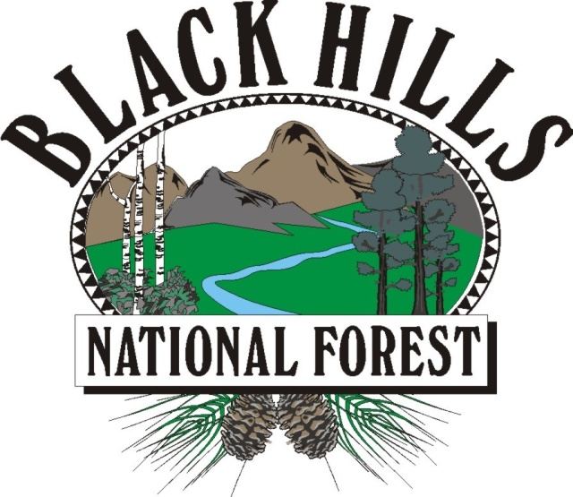
OUTREACH NOTICE
Botanist, GS-0430-05/07, Permanent Appointment
Black Hills National Forest, Newcastle, Wyoming or Custer, South Dakota

Reply By: January 25, 2022

The Hell Canyon Ranger District located on the Black Hills National Forest is conducting an outreach to assess interest in a District Botanist, GS 0430-05/07 with promotional potential to a GS-09. This is a district level, full time position with a duty station of either Newcastle, Wyoming or Custer, South Dakota. Please see the Contact Information section at the bottom of this notice for information on how to express interest in this position.

*This position is being advertised through the upcoming Society of Range Management (SRM) hiring event on February 6 – 10, 2022.

* THE POSITION *
Serves as a district specialist with an emphasis in botany. Responsible for developing, evaluating, and monitoring threatened, endangered and sensitive plant species and plant community and vegetation management programs.
Participates on interdisciplinary teams to provide the documentation and coordination necessary for the effective management of threatened, endangered and sensitive plant species.
Develops and/or modifies established procedures for recording plant survey information in order to meet environmental assessment requirements, botanical baseline data requirements, and for maintaining plants. Assists others in plant identification, as well as conducts training to help assigned field personnel recognize, identify, and locate plant species.
Conducts and oversees vegetation inventories, population, and community monitoring in compliance with selected protocols to contribute to the project's baseline data for botanical resources and coordinating surveys for special status plants and noxious weeds.
Maintains plant surveys and monitoring records in appropriate data base files, in addition to collection and preparation of voucher specimens for plants. Is responsible for the analysis and interpretation of population trend and community composition monitoring data and the preparation of summary reports. Assists unit personnel or contract personnel in conducting botanical research and studies.
Assists in the development and implementation of management plans for the protection and enhancement of habitat for special status plants, and the control of noxious weeds or other invasive species. Performs assignments which may include collaborating with other resources specialists in the preparation of prescribed fire, pesticide use and NEPA compliance documents for a variety of vegetation management and restoration actions. Assists in project planning, identifying suitable plants for restoration projects and participates in rangeland vegetation monitoring and analysis.

This position would also oversee the districts noxious weed management program. Duties would include design criteria for project planning, coordination of treatments and reporting.

BLACK HILLS NATIONAL FOREST
The Black Hills National Forest employs 275 full-time permanent employees on four ranger districts and at the Forest Supervisor’s Office. Offices are located in Sundance and Newcastle, Wyoming and Custer, Rapid City and Spearfish, South Dakota. The Black Hills National Forest is the largest forest in the Rocky Mountain Region in terms of budget, workforce, timber production, and fire and fuels management.

The Black Hills has 1.2 million acres of forested hills and mountains. It is 110 miles long and 70 miles wide, approximately 87 percent in South Dakota and 13 percent in Wyoming. The Black Hills rise from the adjacent grasslands into a ponderosa pine forest to 7,246 feet at Harney Peak Lookout in the Black Elk Wilderness. It is described as an “Island in the Plains” with the diversity of wildlife and plants reaching from the eastern forests to the western plains. The Forest boasts a good balance of multiple use between timber production and grazing to hiking, camping, mountain biking, horse back riding, rock climbing, mining and wildlife veiwing. Big game hunting opportunities include deer, elk, mountain lion and antelope.

The Black Hills area consistently rates as one of the top five tourist destinations in the nation. Four National Park System destinations lie within the Black Hills proper: Mount Rushmore National Memorial, Jewel Cave National Monument, Wind Cave National Park, and Devils Tower National Monument. Custer State Park, the nation’s second largest state park, is within five minutes of Custer. Historic Deadwood/Lead offers an interesting look at the Wild West, and features exciting gaming opportunities. Several beautiful mountain lakes and blue-ribbon trout streams attract thousands of recreation users to the Black Hills each year.

Hell Canyon Ranger District
The Hell Canyon Ranger District encompasses approximately 440,000 acres in the Southern part of the Black Hills. Most of the district is located in South Dakota with smaller portions located in Wyoming. Timber harvest and related silvicultural activities is currently the largest resource program on the district. Average annual timber offer has been about 20 million board feet. The district also has very active lands, minerals, wildlife, recreation, cultural resources, and livestock grazing programs. The district’s Rangeland Management Program is the largest on the forest with over 9,500 hd. of cattle permitted. Game species on the district include white-tailed deer, mule deer, Rocky Mountain elk, Merriam's turkey and ruffed grouse. The current elk population on the forest is estimated to be between 7,500 – 8,500 hd., with a majority of these animals inhabiting the Hell Canyon Ranger District.
COMMUNITY of Custer, SD
Custer, South Dakota, population approximately 1800. Facilities in Custer include two grocery stores, five gas stations, a small hospital, a clinic, and two dentists. Churches include Baptist, Catholic, Lutheran, Seventh Day Adventist, Wesleyan, Church of Christ, and Non-Denominational. The community also offers one library, nine-hole golf course, one weekly newspaper, a post office, volunteer fire department, ambulance service, city offices, county offices and several local retail businesses. The school system is on a four-day school week and has an average graduating class of near 75. One elementary school (others are also located in Hermosa and Spring Creek), one middle school, and one high school are located in Custer.
The summers in Custer (Elevation 5300’) are moderate with moderate rainfall and temperatures generally range from
60-90 degrees. Winters are mild with moderate snowfall and temperatures generally ranging from 0-40 degrees, with occasional below zero temperatures. Housing is available for purchase in Custer with prices starting at $120,000 in town and $200,000+ out of town. Rentals are limited with prices ranging from $600 - $1,000 per month.
Tourism is a main industry in Custer and support services such as motels and restaurants are abundant. Nearby lakes offer boating and fishing, hunting, hiking, and rock climbing are some recreational opportunities offered in the surrounding area.
Rapid City is the nearest larger town with a population of 60,000. It is located 45 miles north of Custer and includes Rushmore Plaza Civic Center, shopping malls, South Dakota School of Mines & Technology, a regional hospital and all other typical services found in a larger city.
You can also contact the Custer Chamber of Commerce at 615 Washington, Custer, SD 57730 or (605) 673-8844 or visit their web site at www.custersd.com/
Community of Newcastle, WY
Newcastle is located 87 miles southwest of Rapid City, SD, on the western edge of the Black Hills National Forest. The elevation is 4,334 feet above sea level. The average annual temperature is 50.5° with the average winter temperature of 25° and summer average of 76.0°. The annual average rainfall is 13.6 inches and annual snowfall is 36 inches. The climate is mild with less wind than many other parts of Wyoming. The population of Newcastle is 3,065 and Weston County is 6,644. Newcastle is the county seat.
The community of Newcastle offers one library, seventeen churches, one hospital, one clinic, three doctors and two physicans assistants, three dentists, fourteen motels, three campgrounds, one radio station, one weekly newspaper, a post office, combination Law Enforcement Center, volunteer fire department, ambulance service, city offices, county offices and several local retail businesses. The Newcastle School District has one elementary school, one middle school (6th through 8th grades) and one high school. Newcastle also has one Christian school.
The nearest commercial airport is Rapid City Regional Airport. Public recreation in Newcastle includes three baseball fields, three soccer fields, one indoor swimming pool, one 9-hole golf course, and three parks. Recreation opportunities in the immediate vicinity include fishing, hunting, hiking, rock climbing, caving, camping, cross country skiing, alpine skiing, and snowmobiling.
The main industries in Newcastle are oil refining, natural gas and oil well drilling, coal mining, ranching, and trucking. Major employers are Weston County School District #1, Par Pacific Refinery, and Weston County Hospital and Nursing Home.
Community information may be obtained from the Newcastle Chamber of Commerce at (307) 746-2739.

Additional Information
If you are interested in applying for this position and would like more information, contact Justin McConkey, District Rangeland Management Staff at (307) 746-2782, or email at justin.mcconkey@usda.gov

Botanist, GS-0430-05/07, Permanent Appointment
Hell Canyon Ranger District
Black Hills National Forest
Please respond by completing this form and submitting a resume by January 25, 2022 to:
Justin McConkey, (307) 746-2782, justin.mcconkey@usda.gov

Name: ______________________________________________________________________
Email Address: _________________________________________
Phone Number: __________________________ Work, Home or Mobile?

Employer: FS Unit________________________ Other ________________________________
Location: ____________________________________________________________________
Tour: Permanent ____ Temporary____ Student/Intern____ Contractor____ Other_____
Current Position Title: __________________________________________________________
Series/grade if Federal Employee: __________________________

How did you hear about this position? _____________________________________________
Agency Contact_____________________________ Other_____________________________

If not a current permanent employee, are you eligible to be hired under any of the following special authorities?
_____ Schedule A (Person with Disabilities)
_____ Veterans Recruitment Act
_____ Veterans w/30% Compensable Disability
_____ Veterans Employment Opportunities Act Of 1998
_____ Former Peace Corps Volunteer
_____ Pathways Program (Students and Recent Graduates)
_____ Other ________________________________________________

Submission of this form is voluntary ----- Thank you for your interest.

