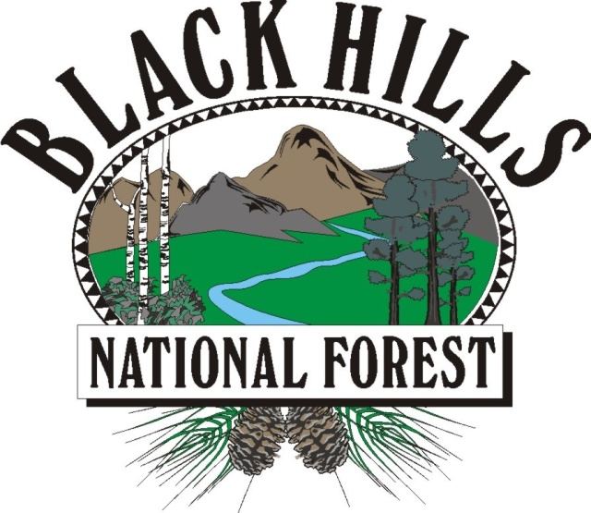
BLACK HILLS

NATIONAL FOREST
___________________________

OUTREACH NOTICE / VACANCY ANNOUNCEMENT

BLACK HILLS NATIONAL FOREST
Rapid City, South Dakota
_______________________________ ____

Range Technician, GS-0455-04/05, Permanent Appointment
Reply By: January 28, 2022

The Mystic Ranger District, on the Black Hills National Forest, is conducting an outreach to assess interest in a GS-0455-04/05 Range Technician with a duty station in Rapid City, South Dakota. This position will be filled at the GS 04 or GS 05 level with promotional potential to the GS 07 level. Please see the “Contact Information” section at the bottom of this notice for information on how to express interest in the position.

*This position is being advertised through the upcoming Society of Range Management (SRM) hiring event and will be open to apply on USAJOBS from February 8-17, 2022. This outreach noticed will be updated and respondents will be provided with the vacancy announcement number as soon as it becomes available.

* THE POSITION *
Major Duties: This position would be supervised by the District Rangeland Management Specialist. Duties include assisting in planning rangeland management projects that are without clear precedents or guides. Lead the district weeds crew with day-to-day tasks. Checks range allotments to assess appropriate time to graze, compliance with management plans and operating instructions, number of livestock, herding procedures, salting, range improvement, maintenance, and the need for additional range improvements such as fences or water development. Inspects allotments before and after grazing. Contacts range users to explain needed maintenance work and reports noncompliance to supervisor. Inspects structural improvements and notifies supervisor of needed maintenance. Recommends the construction or abandonment of improvements such as fences, water developments, facilities etc. May lead small crews in construction and/or maintenance of range improvements.

Field Work: The selected individual will schedule project work for structural and non-structural infrastructure and assist crews in the installation of improvements. They will measure range condition by gathering required information concerning range readiness, utilization, and livestock distribution. Actual use data will be collected from the permittees for data entry.

Data Management: Additional responsibilities include collecting spatial data using a Trimble navigation system (GPS) and ensuring that newly acquired field information is stored in a geodatabase format. The incumbent will manage the GIS data and ensure that all data is properly reported. The individual will conduct range studies relating to trend, condition, and utilization. They will summarize and enter the data. We are seeking applicants with strong verbal and written communication skills. Experience with all Microsoft programs, ArcMap, and Pathfinder is desired.

Supervision: This position is non-supervisory but may give day to day guidance to field crews.

BLACK HILLS NATIONAL FOREST
The Black Hills National Forest employs 275 full-time permanent employees on four ranger districts and at the Forest Supervisor’s Office. Offices are located in Sundance and Newcastle, Wyoming and Custer, Rapid City and Spearfish, South Dakota. The Black Hills National Forest is the largest forest in the Rocky Mountain Region in terms of budget, workforce, timber production, and fire and fuels management.

The Black Hills has 1.2 million acres of forested hills and mountains. It is 110 miles long and 70 miles wide, approximately 87 percent in South Dakota and 13 percent in Wyoming. The Black Hills rise from the adjacent grasslands into a ponderosa pine forest to 7,246 feet at Harney Peak Lookout in the Black Elk Wilderness. It is described as an “Island in the Plains” with the diversity of wildlife and plants reaching from the eastern forests to the western plains. The Forest boasts a good balance of multiple use between timber production and grazing to hiking, camping, mountain biking, horse back riding, rock climbing, mining and wildlife veiwing. Big game hunting opportunities include deer, elk, mountain lion and antelope.

The Black Hills area consistently rates as one of the top five tourist destinations in the nation. Four National Park System destinations lie within the Black Hills proper: Mount Rushmore National Memorial, Jewel Cave National Monument, Wind Cave National Park, and Devils Tower National Monument. Custer State Park, the nation’s second largest state park, is within five minutes of Custer. Historic Deadwood/Lead offers an interesting look at the Wild West, and features exciting gaming opportunities. Several beautiful mountain lakes and blue-ribbon trout streams attract thousands of recreation users to the Black Hills each year.

MYSTIC RANGER DISTRICT

The Mystic Ranger District is a high-traffic, high-visibility office, serving thousands of visitors and customers each year, and is responsible for 55% of the forest product sales for the Black Hills National Forest annually. It employs 65 permanent and 20 seasonal employees. The District covers approximately 356,000 acres, of which 311,000 acres are National Forest System lands.

Interested applicants desiring further information regarding this position and duties may contact Patrick Champa at (605) 569-3133 or patrick.champa@usda.gov .

COMMUNITY
Rapid City, at an elevation of 3,200 feet, lies along the eastern edge of the Black Hills. It is the major population and retail center for the region. Rapid City has a population of over 70,000 and is a rapidly growing and vibrant community. This modern city offers a Regional Hospital, the Regional Eye Clinic, Neurology Center and Sleep Clinic, 27 parks with many connected by a 20 mile city bike path, Ellsworth Air Force Base, the South Dakota School of Mines and Technology, National American University, scores of local and national chain restaurants, 90 churches, two public high schools/four middle schools/17 elementary schools, and several shopping malls.

Rapid City, bisected by Interstate I-90, serves as the hub for dozens of tourist destinations in the Black Hills and is a popular stopping point for visitors passing through on their way to Yellowstone National Park, Wyoming and Montana. Three major airlines serve the Rapid City Regional Airport.

The climate is great– sunny, low humidity with summer daytime highs in the 80’s and winter daytime highs in the 30’s. Rainfall averages 17 inches per year and snowfall 32 inches.

Housing is available for purchase or rent in Rapid City and the surrounding communities. The median price for a home in Rapid City is about $275,000. Apartment rentals start at $800/month. Interested applicants should check the web sites of the local realtors for more information. There are several web sites with information on Rapid City and the Black Hills. A few are listed below:

http://rapidcity.areaguides.net
www.rcgov.org
www.rcas.org

OUTREACH RESPONSE FORM
Range Technician, GS-0455-04/05
Please submit outreach response to Patrick Champa at patrick.champa@usda.gov,
On or before January 28, 2022

NAME:

E-MAIL ADDRESS:

MAILING ADDRESS:

TELEPHONE NUMBER:
 | {USFS |  | {BLM |  | {OTHER

AGENCY EMPLOYED WITH:

 | {PERMANENT |  | {TEMPORARY |  | {TERM
TYPE OF APPOINTMENT:

 | {VRA |  | {PWD |  | {OTHER

 | {REGION |  | {FOREST

CURRENT:
{DISTRICT

 | {SERIES |  | {GRADE

CURRENT:
{POSITION TITLE

CURRENT:

HOW DID YOU FIND OUT ABOUT THIS OUTREACH NOTICE?

IF NOT A CURRENT PERMANENT (CAREER OR CAREER CONDITIONAL) EMPLOYEE
ARE YOU ELIGIBLE TO BE HIRED UNDER ANY OF THE FOLLOWING SPECIAL AUTHORITIES:

PERSON WITH DISABILITIES

VETERANS RECRUITMENT ACT

DISABLED VETERANS W/30% COMPENSABLE DISABILITY

VETERANS EMPLOYMENT OPPORTUNITIES ACT OF 1998

FORMER PEACE CORPS VOLUNTEER

PATHWAYS PROGRAM

Thank you for your interest in our Vacancy!

The U.S. Department of Agriculture (USDA) prohibits discrimination on all its programs and activities on the basis of race, color, national origin, gender, religion, age, disability, political beliefs, sexual orientation, and marital or family status. (Not all prohibited bases apply to all programs.) Persons with disabilities who require alternative means for communication of program information (Braille, large print, audiotape, etc.) should contact USDA's TARGET Center at (202) 720-2600 (voice and TDD). To file a complaint of discrimination, write USDA, Director, Office of Civil Rights, Room 326-W, Whitten Building, 14th and Independence Avenue, SW, Washington, DC 20250-9410 or call (202) 720-5964 (voice and TDD). USDA is an equal opportunity provider and employer.

