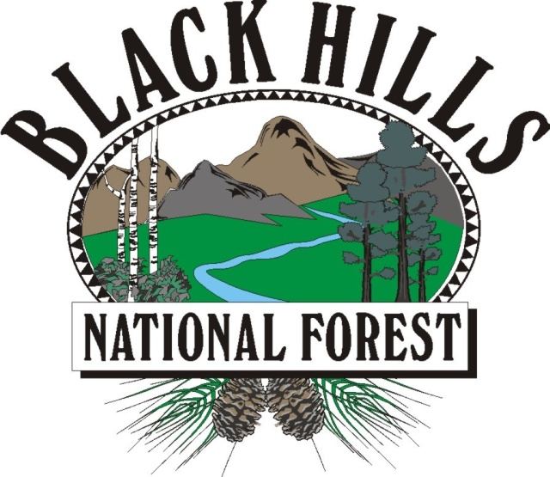
BLACK HILLS

NATIONAL FOREST
___________________________

OUTREACH NOTICE / VACANCY ANNOUNCEMENT

BLACK HILLS NATIONAL FOREST
Rapid City, South Dakota
_______________________________ ____

Hydrologist, GS-1315-05/07, with planned
conversion to GS-1315-09
Permanent Appointment

The Mystic Ranger District located on the Black Hills National Forest is conducting an outreach to assess interest in permanent vacancy for a GS-1315-05/07 (with planned conversion to GS-1315-09) Hydrologist position. This is a district level, full time position with a duty station in Rapid City, South Dakota.
*This position is being advertised through the upcoming Society of Range Management (SRM) hiring event and will be open to apply on USAJOBS from February 8-17, 2022. This outreach noticed will be updated and respondents will be provided with the vacancy announcement number as soon as it becomes available.
Position Description
This position performs professional work in the field of hydrology and has responsibility to conduct and interpret hydrologic surveys and analysis, watershed rehabilitation and management planning, and providing technical guidance within the framework of multiple-use management of forest and range lands.
- Assists in the development of land management planning related to hydrological evaluation.
- Prepares hydrological management prescriptions to protect and enhance water resource.
- Evaluates impacts of land management in correlation with water resources.
- Conducts water resource inventories to assist in land management planning procedures.
- Analyzes hydrologic data to determine apparent reasons for data anomalies.
- Interprets watershed data for input to environmental reports.

* BLACK HILLS NATIONAL FOREST *
The Black Hills National Forest employs 275 full-time permanent employees on four ranger districts and at the Forest Supervisor’s Office. Offices are located in Sundance and Newcastle, Wyoming and Custer, Rapid City and Spearfish, South Dakota. The Black Hills National Forest is the largest forest in the Rocky Mountain Region in terms of budget, workforce, timber production, and fire and fuels management.
The Black Hills has 1.2 million acres of forested hills and mountains. It is 110 miles long and 70 miles wide, approximately 87 percent in South Dakota and 13 percent in Wyoming. The Black Hills rise from the adjacent grasslands into a ponderosa pine forest to 7,246 feet at Harney Peak Lookout in the Black Elk Wilderness. It is described as an “Island in the Plains” with the diversity of wildlife and plants reaching from the eastern forests to the western plains. The Forest boasts a good balance of multiple uses, such as timber production, grazing, hiking, camping, mountain biking, horseback riding, rock climbing, mining and wildlife viewing. Big game hunting opportunities include deer, elk, mountain lion and antelope.
Four National Park System destinations lie within the Black Hills proper: Mount Rushmore National Memorial, Jewel Cave National Monument, Wind Cave National Park, and Devils Tower National Monument. Custer State Park, the nation’s second largest state park, is within five minutes of Custer. Historic Deadwood/Lead offers an interesting look at the Wild West, and features exciting gaming opportunities. Several beautiful mountain lakes and blue-ribbon trout streams attract thousands of recreation users to the Black Hills each year.
Memorial, Jewel Cave National Monument, Wind Cave National Park, and the nation’s second largest state park, Custer State Park. Water activities, fishing, boating are available in the small reservoirs, climbing opportunities attract thousands world-wide, as does the Peter Norbeck National Scenic Byway with tunnels and “pig-tail bridges”. Crazy Horse Memorial provides a Native Arts and Education Center. There are two District Offices; Custer SD and Newcastle WY with approximately 50 permanent employees and approximately 20 temporary summer employees. Besides the significant recreation and wilderness program there is a strong range and weeds program, land adjustments and special uses program, fuels treatment and fire.

*MYSTIC RANGER DISTRICT & COMMUNITY of RAPID CITY, SD*
The Mystic Ranger District is a high-traffic, high-visibility office, serving thousands of visitors and customers each year, and is responsible for 55% of the forest product sales for the Black Hills National Forest annually. It employs 65 permanent and 20 seasonal employees. The District covers approximately 356,000 acres, of which 311,000 acres are National Forest System lands.

Rapid City, at an elevation of 3,200 feet, lies along the eastern edge of the Black Hills. It is the major population and retail center for the region. Rapid City has a population of over 70,000 and is a rapidly growing and vibrant community. This modern city offers a Regional Hospital, the Regional Eye Clinic, Neurology Center and Sleep Clinic, 27 parks with many connected by a 20 mile city bike path, Ellsworth Air Force Base, the South Dakota School of Mines and Technology, National American University, scores of local and national chain restaurants, 90 churches, two public high schools/four middle schools/17 elementary schools, and several shopping malls.

Rapid City, bisected by Interstate I-90, serves as the hub for dozens of tourist destinations in the Black Hills and is a popular stopping point for visitors passing through on their way to Yellowstone National Park, Wyoming and Montana. Three major airlines serve the Rapid City Regional Airport.

The climate is great– sunny, low humidity with summer daytime highs in the 80’s and winter daytime highs in the 30’s. Rainfall averages 17 inches per year and snowfall 32 inches.

Housing is available for purchase or rent in Rapid City and the surrounding communities. The median price for a home in Rapid City is about $275,000. Apartment rentals start at $800/month. Interested applicants should check the web sites of the local realtors for more information. There are several web sites with information on Rapid City and the Black Hills. A few are listed below:

http://rapidcity.areaguides.net
www.rcgov.org
www.rcas.org

OUTREACH RESPONSE FORM
Hydrologist, GS-1315-05/07, with planned conversion to GS-1315-09
Please submit outreach response to Jessica Eggers at jessica.eggers@usda.gov,
On or before January 28, 2022

NAME:

E-MAIL ADDRESS:

MAILING ADDRESS:

TELEPHONE NUMBER:
 | {USFS |  | {BLM |  | {OTHER

AGENCY EMPLOYED WITH:

 | {PERMANENT |  | {TEMPORARY |  | {TERM
TYPE OF APPOINTMENT:

 | {VRA |  | {PWD |  | {OTHER

 | {REGION |  | {FOREST

CURRENT:
{DISTRICT

 | {SERIES |  | {GRADE

CURRENT:
{POSITION TITLE

CURRENT:

HOW DID YOU FIND OUT ABOUT THIS OUTREACH NOTICE?

IF NOT A CURRENT PERMANENT (CAREER OR CAREER CONDITIONAL) EMPLOYEE
ARE YOU ELIGIBLE TO BE HIRED UNDER ANY OF THE FOLLOWING SPECIAL AUTHORITIES:

PERSON WITH DISABILITIES

VETERANS RECRUITMENT ACT

DISABLED VETERANS W/30% COMPENSABLE DISABILITY

VETERANS EMPLOYMENT OPPORTUNITIES ACT OF 1998

FORMER PEACE CORPS VOLUNTEER

PATHWAYS PROGRAM

Thank you for your interest in our Vacancy!

The U.S. Department of Agriculture (USDA) prohibits discrimination on all its programs and activities on the basis of race, color, national origin, gender, religion, age, disability, political beliefs, sexual orientation, and marital or family status. (Not all prohibited bases apply to all programs.) Persons with disabilities who require alternative means for communication of program information (Braille, large print, audiotape, etc.) should contact USDA's TARGET Center at (202) 720-2600 (voice and TDD). To file a complaint of discrimination, write USDA, Director, Office of Civil Rights, Room 326-W, Whitten Building, 14th and Independence Avenue, SW, Washington, DC 20250-9410 or call (202) 720-5964 (voice and TDD). USDA is an equal opportunity provider and employer.

