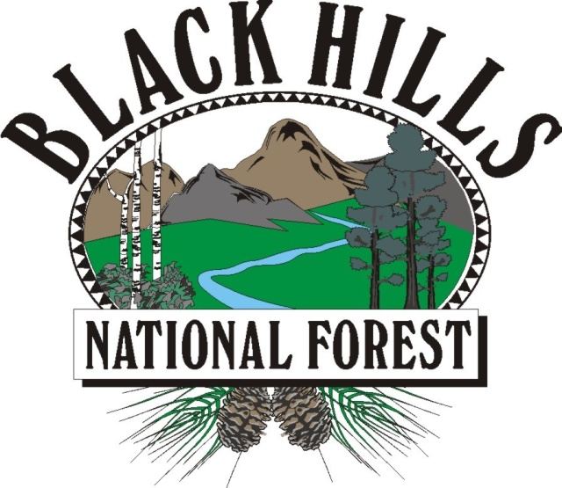
BLACK HILLS

NATIONAL FOREST
___________________________

OUTREACH NOTICE / VACANCY ANNOUNCEMENT

BLACK HILLS NATIONAL FOREST
Rapid City, South Dakota
_______________________________ ____

Botanist, GS-0430-05/07, Permanent Appointment
Reply By: January 28, 2022

The Mystic Ranger District located on the Black Hills National Forest is conducting an outreach to assess interest in a GS-0430-05/07 District Botanist position. This position has promotional potential to the GS-09 level. This is a district level, full time position with a duty station in Rapid City, South Dakota. Please see the Contact Information section at the bottom of this notice for information on how to express interest in this position.

*This position is being advertised through the upcoming Society of Range Management (SRM) hiring event and will be open to apply on USAJOBS from February 8-17, 2022. This outreach noticed will be updated and respondents will be provided with the vacancy announcement number as soon as it becomes available.

* THE POSITION *
Serves as a district specialist with an emphasis in botany. Responsible for developing, evaluating, and monitoring threatened, endangered and sensitive plant species and plant community and vegetation management programs.
Participates on interdisciplinary teams to provide the documentation and coordination necessary for the effective management of threatened, endangered and sensitive plant species.
Develops and/or modifies established procedures for recording plant survey information in order to meet environmental assessment requirements, botanical baseline data requirements, and for maintaining plants. Assists others in plant identification, as well as conducts training to help assigned field personnel recognize, identify, and locate plant species.
Conducts and oversees vegetation inventories, population, and community monitoring in compliance with selected protocols to contribute to the project's baseline data for botanical resources and coordinating surveys for special status plants and noxious weeds.
Maintains plant surveys and monitoring records in appropriate data base files, in addition to collection and preparation of voucher specimens for plants. Is responsible for the analysis and interpretation of population trend and community composition monitoring data and the preparation of summary reports. Assists unit personnel or contract personnel in conducting botanical research and studies.
Assists in the development and implementation of management plans for the protection and enhancement of habitat for special status plants, and the control of noxious weeds or other invasive species. Performs assignments which may include collaborating with other resources specialists in the preparation of prescribed fire, pesticide use and NEPA compliance documents for a variety of vegetation management and restoration actions. Assists in project planning and identifying suitable plants for restoration projects.

Responsible for day to day supervision of two seasonal noxious weed technicians and for reporting noxious weed treatment data.

BLACK HILLS NATIONAL FOREST
The Black Hills National Forest employs 275 full-time permanent employees on four ranger districts and at the Forest Supervisor’s Office. Offices are located in Sundance and Newcastle, Wyoming and Custer, Rapid City and Spearfish, South Dakota. The Black Hills National Forest is the largest forest in the Rocky Mountain Region in terms of budget, workforce, timber production, and fire and fuels management.

The Black Hills has 1.2 million acres of forested hills and mountains. It is 110 miles long and 70 miles wide, approximately 87 percent in South Dakota and 13 percent in Wyoming. The Black Hills rise from the adjacent grasslands into a ponderosa pine forest to 7,246 feet at Harney Peak Lookout in the Black Elk Wilderness. It is described as an “Island in the Plains” with the diversity of wildlife and plants reaching from the eastern forests to the western plains. The Forest boasts a good balance of multiple use between timber production and grazing to hiking, camping, mountain biking, horse back riding, rock climbing, mining and wildlife veiwing. Big game hunting opportunities include deer, elk, mountain lion and antelope.

The Black Hills area consistently rates as one of the top five tourist destinations in the nation. Four National Park System destinations lie within the Black Hills proper: Mount Rushmore National Memorial, Jewel Cave National Monument, Wind Cave National Park, and Devils Tower National Monument. Custer State Park, the nation’s second largest state park, is within five minutes of Custer. Historic Deadwood/Lead offers an interesting look at the Wild West, and features exciting gaming opportunities. Several beautiful mountain lakes and blue-ribbon trout streams attract thousands of recreation users to the Black Hills each year.

MYSTIC RANGER DISTRICT

The Mystic Ranger District is a high-traffic, high-visibility office, serving thousands of visitors and customers each year, and is responsible for 55% of the forest product sales for the Black Hills National Forest annually. It employs 65 permanent and 20 seasonal employees. The District covers approximately 356,000 acres, of which 311,000 acres are National Forest System lands.

Interested applicants desiring further information regarding this position and duties may contact Patrick Champa at (605) 569-3133 or patrick.champa@usda.gov .

COMMUNITY
Rapid City, at an elevation of 3,200 feet, lies along the eastern edge of the Black Hills. It is the major population and retail center for the region. Rapid City has a population of over 70,000 and is a rapidly growing and vibrant community. This modern city offers a Regional Hospital, the Regional Eye Clinic, Neurology Center and Sleep Clinic, 27 parks with many connected by a 20 mile city bike path, Ellsworth Air Force Base, the South Dakota School of Mines and Technology, National American University, scores of local and national chain restaurants, 90 churches, two public high schools/four middle schools/17 elementary schools, and several shopping malls.

Rapid City, bisected by Interstate I-90, serves as the hub for dozens of tourist destinations in the Black Hills and is a popular stopping point for visitors passing through on their way to Yellowstone National Park, Wyoming and Montana. Three major airlines serve the Rapid City Regional Airport.

The climate is great– sunny, low humidity with summer daytime highs in the 80’s and winter daytime highs in the 30’s. Rainfall averages 17 inches per year and snowfall 32 inches.

Housing is available for purchase or rent in Rapid City and the surrounding communities. The median price for a home in Rapid City is about $275,000. Apartment rentals start at $800/month. Interested applicants should check the web sites of the local realtors for more information. There are several web sites with information on Rapid City and the Black Hills. A few are listed below:

http://rapidcity.areaguides.net
www.rcgov.org
www.rcas.org

OUTREACH RESPONSE FORM
Botanist, GS-0430-05/07
Please submit outreach response to Patrick Champa at patrick.champa@usda.gov,
On or before January 28, 2022

NAME:

E-MAIL ADDRESS:

MAILING ADDRESS:

TELEPHONE NUMBER:
 | {USFS |  | {BLM |  | {OTHER

AGENCY EMPLOYED WITH:

 | {PERMANENT |  | {TEMPORARY |  | {TERM
TYPE OF APPOINTMENT:

 | {VRA |  | {PWD |  | {OTHER

 | {REGION |  | {FOREST

CURRENT:
{DISTRICT

 | {SERIES |  | {GRADE

CURRENT:
{POSITION TITLE

CURRENT:

HOW DID YOU FIND OUT ABOUT THIS OUTREACH NOTICE?

IF NOT A CURRENT PERMANENT (CAREER OR CAREER CONDITIONAL) EMPLOYEE
ARE YOU ELIGIBLE TO BE HIRED UNDER ANY OF THE FOLLOWING SPECIAL AUTHORITIES:

PERSON WITH DISABILITIES

VETERANS RECRUITMENT ACT

DISABLED VETERANS W/30% COMPENSABLE DISABILITY

VETERANS EMPLOYMENT OPPORTUNITIES ACT OF 1998

FORMER PEACE CORPS VOLUNTEER

PATHWAYS PROGRAM

Thank you for your interest in our Vacancy!

The U.S. Department of Agriculture (USDA) prohibits discrimination on all its programs and activities on the basis of race, color, national origin, gender, religion, age, disability, political beliefs, sexual orientation, and marital or family status. (Not all prohibited bases apply to all programs.) Persons with disabilities who require alternative means for communication of program information (Braille, large print, audiotape, etc.) should contact USDA's TARGET Center at (202) 720-2600 (voice and TDD). To file a complaint of discrimination, write USDA, Director, Office of Civil Rights, Room 326-W, Whitten Building, 14th and Independence Avenue, SW, Washington, DC 20250-9410 or call (202) 720-5964 (voice and TDD). USDA is an equal opportunity provider and employer.

