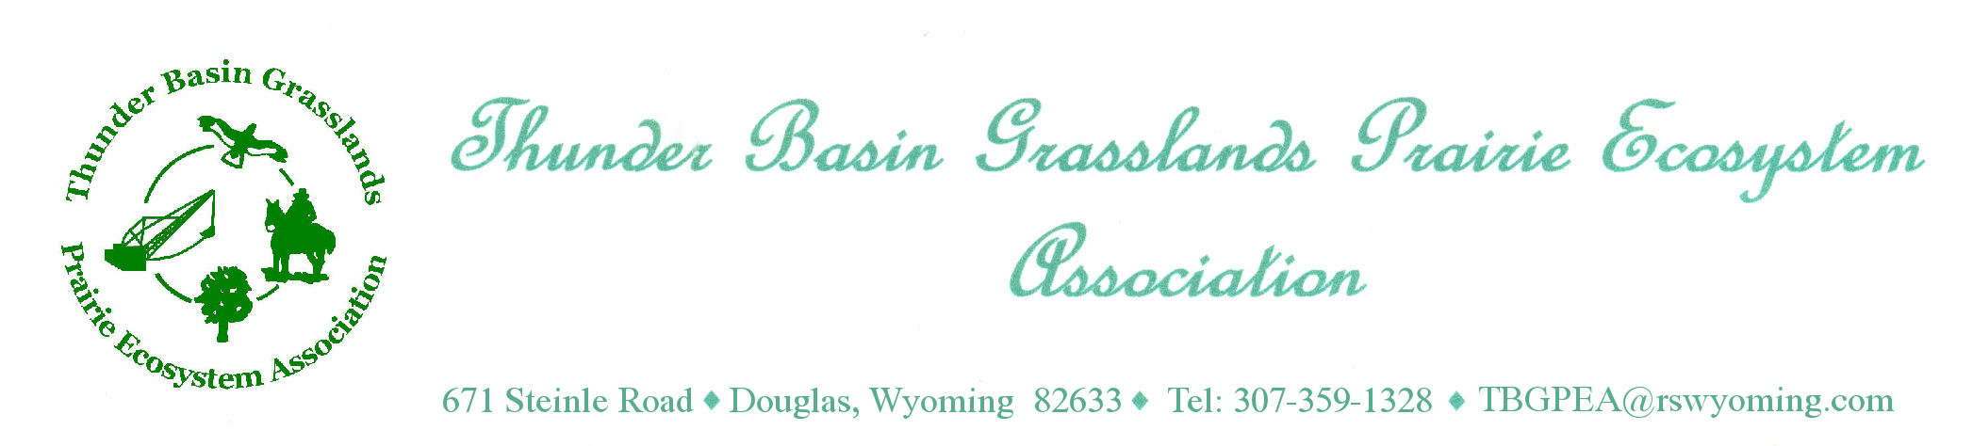

Research assistant

Location of work: Thunder Basin National Grassland, Bill, WY

Hours of work: 40 hours per week (4 x 10 hour days per week)

Salary: $2470 per month. On-site housing is provided. Three days of PTO and two holidays included.

Dates: May 23 - August 19, 2022 (13 weeks; start and end times may be flexible)

Please submit applications by January 28, 2022 for full consideration.

Send application materials (cover letter, resume, references, and college transcript) and/or questions to:

Dave Pellatz
Executive Director
Thunder Basin Grasslands Prairie Ecosystem Association
671 Steinle Rd
Douglas, WY 82633
307-359-1328
dave@rswyoming.com

Lauren Porensky
Research Ecologist
Rangeland Resources Systems Research Unit
USDA-ARS
1701 Centre Ave.
Fort Collins, CO 80526 USA
970.492.7139
lauren.porensky@usda.gov

General Job Description
Research assistant for the Thunder Basin Prairie Ecosystem Association (TBGPEA). TBGPEA is a non-profit organization established to provide private landowner leadership in developing a responsible, science-based approach to long-term management of the lands of its members. Over the last ten years the Association has focused its efforts on developing ecosystem-based conservation measures. These measures are designed to address the habitat needs of species of concern in northeastern Wyoming in balance with the need for sustainable economic and social activities and preservation of cultural values.

TBGPEA is collaborating with the USDA-ARS Rangeland Resources Systems Research Unit (RRSRU) in Fort Collins, Colorado to develop new knowledge about ecological processes in Thunder Basin and apply this knowledge to improved management for production and conservation objectives. The Research Assistant will be supervised by the Board of TBGPEA with input from RRSRU scientists. The Assistant will be responsible for collecting scientific data from field experiments to evaluate how climate, fire, soils, grazing management, and global change affect ecological phases, states, transitions and thresholds in semi-arid rangeland ecosystems. If time permits, the Assistant may help evaluate Association member’s property as part of the Candidate Conservation Agreement with Assurances implementation.

Major Duties
Collects soil and vegetation data and is responsible for quality assurance/quality control of data collected. Keeps exact, detailed records of experimental data. Provides data in an appropriate format for incorporation into computer spreadsheets. Makes and records observations of unusual happenings, phenomena or trends that might influence interpretation of plot or field data.

Manages fieldwork program semi-autonomously; takes responsibility for solving problems and adapting to current conditions and events without constant supervision.

Operates, maintains, cleans, repairs and constructs equipment used in plot and field experiments including, but not limited to, vehicles and field equipment.

If time permits, the Assistant may participate in the development of livestock grazing management plans and may also collect ornithological or small mammal data.

Ensures that all safety and environmental concerns are addressed to provide a safe work environment, and that activities in support of research in the Thunder Basin do not pose an environmental threat.

Knowledge requirements
Technical knowledge of plant identification, structure and function of plant communities, and theory and practice of rangeland management, and a familiarity with the methods of biological sciences such as biology, chemistry, botany, etc., in order to participate responsibly in most phases of the experimental process.

Experience with bird and/or small mammal wildlife survey techniques is beneficial.

Ability to do efficient and high-quality work without direct supervision. Ability to proactively solve problems and manage tasks adaptively in order to get the job done on time.

Skill in the use of personal computers to utilize software packages such as: word processing, data entry and manipulation in spreadsheets (e.g., Excel).

Communication skills necessary to follow directions precisely and produce positive interactions with scientists, research personnel, and the general public.

Knowledge of range science, soil science, general biology and ecology.

Practical knowledge of general vehicle maintenance and repair. Knowledge of safe operating procedures when using equipment or vehicles. Knowledge of UTV operation and safety is beneficial.

Practical knowledge of livestock management and nutrition for use in development of livestock grazing management plans.

Communication contacts
Personal contacts are broad including TBGPEA members; scientists, technicians and graduate students from other institutions or other federal agencies; action agencies; non-governmental organizations; vendors and contractors; state or local government entities; visitors and the general public.

Personal contacts within the RRSRU involve support and assistance to scientists and support staff. The purpose of personal contacts is to mutually accomplish technical and support work; assist in planning and coordinating work efforts; discuss technical requirements of equipment with manufacturers and resolve problems concerning the work or the peculiar needs of the organization; coordinate help with other research projects; exchange information about research techniques; obtain supplies and equipment.

Physical demands
The work requires standing, walking, bending and lifting of objects weighing as much as 50 pounds. Certain phases of the work require extended (such as most of a work day) periods of standing or sitting while accomplishing detailed experimental procedures. Some procedures require stamina and endurance. Need to have the physical capability to perform required duties without hazard to self or others when working with machinery, cattle, horses, fire or chemicals.

Work Environment
The job is located in a remote part of NE Wyoming. Weekend transportation to and from Fort Collins, CO is available. The work environment is about 85% in the field and 15% in the shop or office. The work involves regular and recurring moderate risks or discomforts which require special safety precautions, e.g., working outdoors. Throughout the year, the person may encounter belligerent livestock, insects, dust and extremes of weather. The person is required to wear protective clothing (e.g., coats, boots, goggles, gloves, and respirator) as conditions warrant.

