
Tierra Seca
University of Arizona Student Chapter
Society for Range Management

November 30th, 2021


- Meeting Called to order: 5:02 PM

- Tierra Seca Fall 2021 Club Meeting Schedule

~Biweekly meetings on Tuesdays at 5:00 PM at ENR2 in room N350

Month | Day
September | 7th
September | 21st
October | 5th
October | 19th
November | 2nd
November | 16th
November | 30th

- Attendance
Rakeen Abdali, Andrew Antaya, Flavie Audoin, Dakota Baden, Claire Bigelow-Ludin, Carter Blouin, Robin Bradely, Parker Brown, Cameron Burleson, Elizabeth EbadiRad, Eamonn Mazur, Caleb Miller, Clara Miller Brian Muha, Sarah Noelle, Taylor Portman, Austin Rutherford, Alex-Binford Walsh



- RISE Symposium
- Got $200 in donations
- Cameron, Eamonn, Austin, and Robin set up breakfast in the morning
- Congratulations!!
  - Robin (1st place undergraduate)
  - Austin (tied for 2nd place graduate)
  - Link to posters: https://www.tucson.ars.ag.gov/rise/index.htm

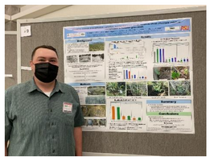
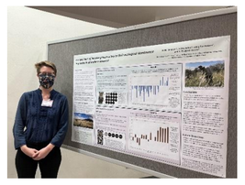

Robin Austin



- Call for a Range Cup Team!
- What is the Range Cup?
  - The Rangeland Cup team problem solving competition is an activity to promote critical thinking and cooperative, collaborative work on current topics and/or topics of historical importance to rangeland ecology and management.
- Who can join?
  - Up to 4 students (max. 1 graduate student).
- What’s the final product?
  - Each team will present their approach/solution in poster format during a poster session at the SRM meeting.

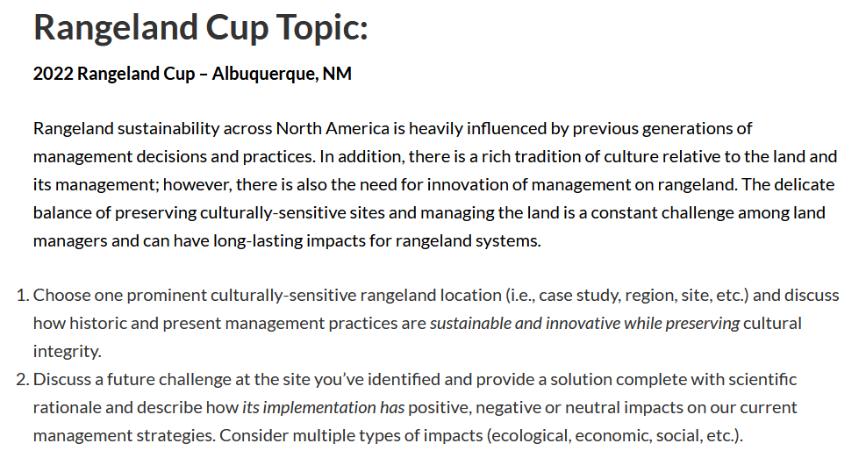



- Volunteer opportunities

NRCS Earth Team volunteering
- Allows students to work directly with NRCS employees
- If any student wants to shadow an employee for a day to see what they do and get more experience, contact the Tucson office to coordinate!
  - Alisha Phipps (Rangeland Management Specialist): alisha.phipps@usda.gov
  - Brett Myers (Rangeland Management Specialist): brett.myers@usda.gov
- Check out their volunteer portal here: https://www.nrcs.usda.gov/wps/portal/nrcs/main/national/people/volunteers/



- Scholarship opportunities
- $2,000 Natural Resources Management Today 2022 scholarship:
  - Apply here: https://nrmtoday.com/scholarship.html
  - Deadline: November 30, 2021
  - Who: Students enrolled in 2022 in undergraduate and master’s in natural resources degree programs
  - Looks good on a resume!



- Steer raffle details
- Ends February 1st
  - Winner will be contacted that day
- $20 per ticket or $100 for 6 tickets
- Minimum number of tickets to sell is 150
  - This will help fund for going to SRM
- Tickets will be ordered soon!

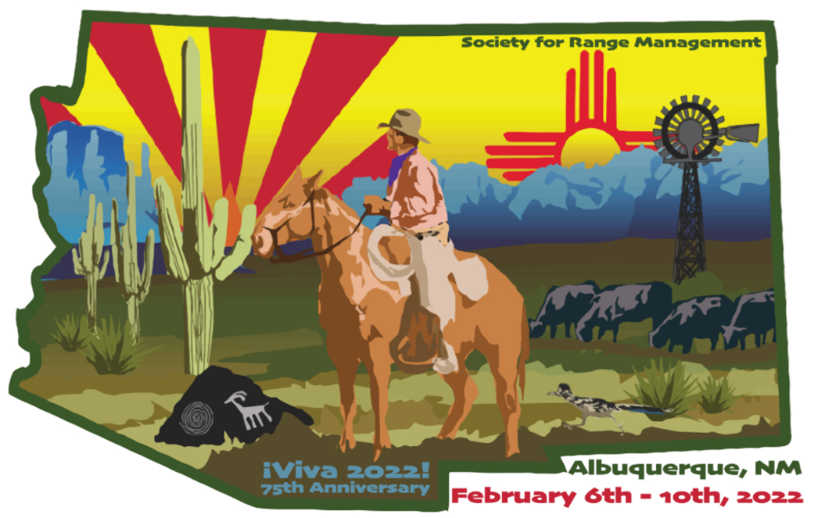

- SRM Albuquerque 2022 details
- Register Tierra Seca as a block for the 16 people attending SRM to get student fees paid for
- Working out the fine details with ASUA for funding
- AZSRM might give us $1,000 if we need it
- Might get approximately $4,000 from ASUA
- SRM planning committee want to give volunteers t-shirts as conference swag to show they volunteered



- Congrats, Bigs!!
  - Read the article here:https://documentcloud.adobe.com/link/review?uri=urn:aaid:scds:US:1fd0bc4f-7cdb-400a-b2a1-d79280895978
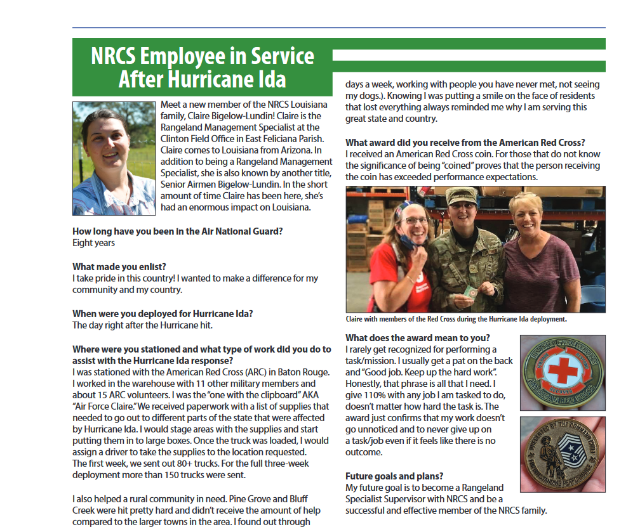



- Budget
- Total: $3,220.26 (checking account)

- Tierra Seca PayPal
- Use for paying dues!
- Scan our cool QR code to make your payment

- Dues: $30 for the year



- Connect with us!
- Join the Tierra Seca GroupMe
  - GroupMe link: https://groupme.com/join_group/38156015/nWJ5vk

  - GroupMe QR Code:



- Join Tierra Seca on Campus Groups
  - Campus Groups QR Code:



- Have any questions, comments, and/or concerns?
  - Email us at uofatierraseca@gmail.com

- Meeting Adjourned: 5:47 PM

- Rangeland Meme of the Week



