
Tierra Seca
University of Arizona Student Chapter
Society for Range Management

November 2nd, 2021



- Meeting Called to order: 5:02 PM

- Tierra Seca Fall 2021 Club Meeting Schedule

~Biweekly meetings on Tuesdays at 5:00 PM at ENR2 in room N350

Month | Day
September | 7th
September | 21st
October | 5th
October | 19th
November | 2nd
November | 16th
November | 30th
- Attendance
Rakeen Abdali, Andrew Antaya, Flavie Audoin, Dakota Baden, Carter Blouin, Cameron Burleson, Elizabeth EbadiRad, Caleb Fetveit, Dr. Aaron Lein, Brandon Mayer, Eamonn Mazur, Caleb Miller, Brain Muha, Sarah Noelle, Austin Rutherford, Mano Tainatongo, Bailie Wynbelt, Alex-Binford Walsh


- Elkhorn/Las Delicias Monitoring
- Had an amazing time
- Thank you, Mary and Julia, from AVCA!



- Volunteer opportunities

NRCS Earth Team volunteering
- Allows students to work directly with NRCS employees
- If any student wants to shadow an employee for a day to see what they do and get more experience, contact the Tucson office to coordinate!
  - Alisha Phipps (Rangeland Management Specialist): alisha.phipps@usda.gov
  - Brett Myers (Rangeland Management Specialist): brett.myers@usda.gov
- Check out their volunteer portal here: https://www.nrcs.usda.gov/wps/portal/nrcs/main/national/people/volunteers/

RISE Symposium
- What: Recent research at the USDA-ARS Walnut Gulch Experimental Watershed (WGEW) and the University of Arizona Santa Rita Experimental Range (SRER)
  - We will have a table where we’ll serve coffee and a small breakfast for attendees
- Where: University of Arizona, Marley Building, Rm. 230
- When: Saturday, November 20, 8:30am-3pm
- Sign-up here: https://docs.google.com/spreadsheets/d/1Z-Gxa9e4mrjA_gzMKKE8ZLcdwVEIYWy4g5-0IjGLlSY/edit?usp=sharing


- Job opportunities
- USA Jobs
  - Lots of new announcements up! (about 45)
  - Many application windows close between 11/2 - 11/5
  - Jobs for recent graduates
  - Summer 2022 internships (Pathways) w/ NRCS
    - https://www.usajobs.gov/Search/Results?a=AG99&a=AG16&a=AGFA&a=AG08&show=hp&show=ag&hp=student&hp=graduates&p=1
    - Ex. rangeland management, soil conservation, soil science, natural resource management, agronomy



- Scholarship opportunities
- $2,000 Natural Resources Management Today 2022 scholarship:
  - Apply here: https://nrmtoday.com/scholarship.html
  - Deadline: November 30, 2021
  - Who: Students enrolled in 2022 in undergraduate and master’s in natural resources degree programs
  - Looks good on a resume!

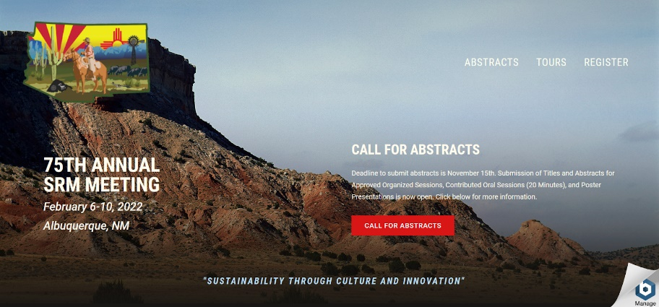

- SRM 2021
- The conference will be in-person this year!
- Check out the meeting website here: http://annualmeeting.rangelands.org/
- Sign-up here if you would like to go to the conference:
https://docs.google.com/spreadsheets/d/1jyg-zge9w7nEkq4FCmv2amRcYLZy6-ZjwNuwmRSO8L0/edit?usp=sharing



- Club Schwag
- Button-down shirts?
  - Maybe nice field shirts?
- Hats w/mesh backs?
- Long-sleeves?
  - Maybe pockets?
- Short-sleeves?
  - Maybe pockets?
- Beanies?
- Car decals?
- We will decide what to get and purchase by the end of November to have some neat club schwag for next semester



- Budget
- Total: $3,606.00 (checking account)

- Tierra Seca PayPal
- Use for paying dues!
- Scan our cool QR code to make your payment
- Dues: $30 for the year




- Connect with us!
- Join the Tierra Seca GroupMe
  - GroupMe link: https://groupme.com/join_group/38156015/nWJ5vk
  - GroupMe QR Code:


- Join Tierra Seca on Campus Groups
  - Campus Groups QR Code:



- Have any questions, comments, and/or concerns?
  - Email us at uofatierraseca@gmail.com



- Meeting Adjourned: 5:35 PM

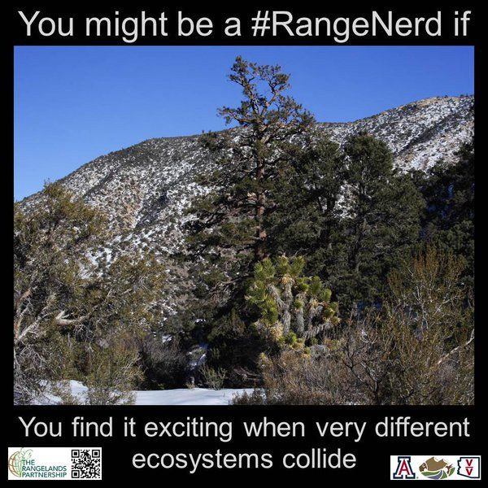
- Rangeland Meme of the Week

