REGION 3 GILA NATIONAL FOREST
Outreach Notice

RANGE PROGRAM MANAGER GS-0454-11/12
Silver City, New Mexico

Permanent Vacancy Interest
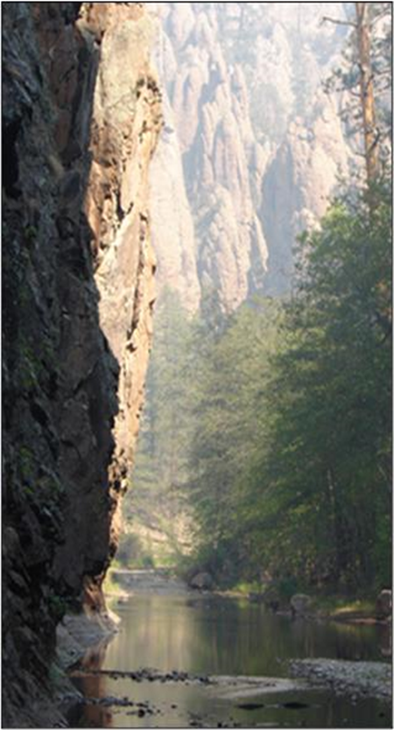
The Gila National Forest in southwestern New Mexico is conducting a Single Vacancy announcement outreach for a highly skilled and qualified candidate to fill a vacant GS-0454-11/12 Forest Range Program Manager position. This is a permanent, fulltime position with a duty station in Silver City, NM. This notification is being circulated to inform prospective applicants of the opportunity and to determine interest in the position.

The vacancy announcement for this position will soon be posted on the U.S. Government's official website for employment opportunities: https://www.usajobs.gov/

Those responding to this outreach will be directly notified when the announcement is posted.

If you have questions or interest in the position, you are encouraged to contact:

Jeff Shearer – Natural Resources Staff Officer
jeffrey.shearer@usda.gov
(575) 388-8417

VACANCY OUTREACH
The Gila National Forest is looking for experienced leadership for the Forest Range Program Manager position. The range program in southern New Mexico is complex and challenging with ample opportunities to try creative solutions and for collaboration across multiple partners. A successful range manager will be comfortable with rural cultures, a skilled permit administrator, work closely with district range staff, experienced with litigation, a competent communicator, and have a long-term vision for range management that integrates multiple resource areas.

Major duties and work emphasis of this position will include overall range program administration, grazing permit administration, allotment management planning, and National Environmental Policy Act (NEPA) analysis. A background in NEPA, threatened and endangered species, soils, watershed resources, and monitoring is useful, as well as knowledge of native plants and noxious/invasive weeds. The incumbent will be expected to participate on interdisciplinary teams.

Partnering and collaboration skills are also critical to the position. Partnering is integral to accomplishing the forest plan of work with both internal and external partners. The Forest works towards forest wide objectives and employees work across district boundaries. The district rangers work closely together to cooperate and support each other in achieving objectives.

If you are interested, please respond to the attached outreach form by November 10, 2021.

SILVER CITY AND THE LOCAL AREA
Silver City (www.townofsilvercity.org) and the surrounding communities of Bayard, Santa Clara, Tyrone and Hurley are located in southwest New Mexico. Main access to Silver City is via Highway 180 north from Interstate 10 at Deming, NM. The elevation is 5,900 feet above sea level. Silver City boasts four gentle seasons. The average annual temperature is 54 degrees. May is the driest month of the year while July is the wettest. The annual average precipitation is 15 inches. The population of Silver City is approximately 9,600 and Grant County is about 29,000. Silver City was recently selected as one of the healthiest places to live. It placed in the top 1% of over 3,000 communities our size or larger. Downtown Silver City is undergoing a revitalization effort and features many locally owned shops and galleries.

The community has two libraries, churches of all denominations, a Regional hospital http://www.grmc.org/, several medical clinics, ambulance service, an emergency care clinic, physicians in all specialty areas, dentists, and nursing homes. There are two newspapers, motels, radio stations, city and county offices and local retail businesses. Recreation facilities include baseball and soccer fields, all-weather track, tennis courts, health and fitness clubs, an indoor and outdoor swimming pool, an 18-hole golf course, a bowling center, and parks. Organized youth and adult sports activities are numerous. In the immediate vicinity are trout fishing, hunting, hiking, horseback riding, bicycling, and camping. The main industries are tourism, mining, logging, and ranching. The nearest commercial airports are in El Paso, TX (2 hours), Tucson, AZ (2 hours) and Albuquerque, NM (4 hours). Grant County airport also provides some services.

Grant County has two public school districts, Silver Consolidated and Cobre Consolidated School Districts. There are several private schools and alternative schools. Western New Mexico University www.wnmu.edu/ offers four-year programs and two-year technical programs in areas such as education, nursing, basic arts and sciences and several graduate programs.

Rental homes and apartments range from $350-$1,000 per month for an average three-bedroom home/apartment. The price of single-family homes ranges from $85,000 and up.

To find more information about the Gila National Forest and Silver City, visit our website at https://www.fs.usda.gov/gila .

Gila National Forest

Forest Range Program Manager

Position Title/Series/Grade: Range Program Manager, GS-0454-11/12
Duty Station: Silver City, NM
Please submit the outreach form located below to jeffrey.shearer@usda.gov

PERSONAL INFORMATION:
Name: Date:
Address: Phone:
Email:

(e.g., Career, Career-Conditional, Excepted-ANILCA, Excepted VRA, etc.)
Are you currently a Federal employee: ( ) YES or ( ) NO
Briefly describe your qualifications/interest in this position (type answer into box, which will expand as needed):

