
Tierra Seca
University of Arizona Student Chapter
Society for Range Management

October 19th, 2020



- Meeting Called to order: 5:03 PM

- Tierra Seca Fall 2021 Club Meeting Schedule

~Biweekly meetings on Tuesdays at 5:00 PM at ENR2 in room N350

Month | Day
September | 7th
September | 21st
October | 5th
October | 19th
November | 2nd
November | 16th
November | 30th

Attendance

Rakeen Abdali, Brandon Mayer, Dakota Baden, Carter Blouin, Robin Bradley, Parker Brown, Cameron Burleson, Elizabeth EbadiRad, Caleb Fetveit, Eamonn Mazur, Caleb Miller, Brain Muha, Austin Rutherford, Alex-Binford Walsh



- Volunteer opportunities
- Elkhorn/Las Delicias Monitoring:
  - When: Friday, Oct 29 @8:30am-about 4pm
    - If you need a Dean’s excuse to attend, please let us know by October 13th!
  - Where: Elkhorn Ranch in the Altar Valley
  - What: Assist the Altar Valley Conservation Alliance in completing the 10th year of monitoring at the Elkhorn/Las Delicias Demonstration Site. This project is intended to restore incised channels, increase vegetation growth, and promote biodiversity in an area where ecosystem function and forage production were threatened by erosion. You will work with NRCS and AVCA staff to identify the frequency of vegetation present at established monitoring points within treated and non-treated channels at the demonstration site.
  - Sign-up here: https://docs.google.com/spreadsheets/d/1G9EKlRzMA5EWhoCqrlGUoQuAnH3Eyr1gELuAkxuxbgw/edit?usp=sharing


- Job opportunities
- USA Jobs
  - Ecologist (Recent Graduate):

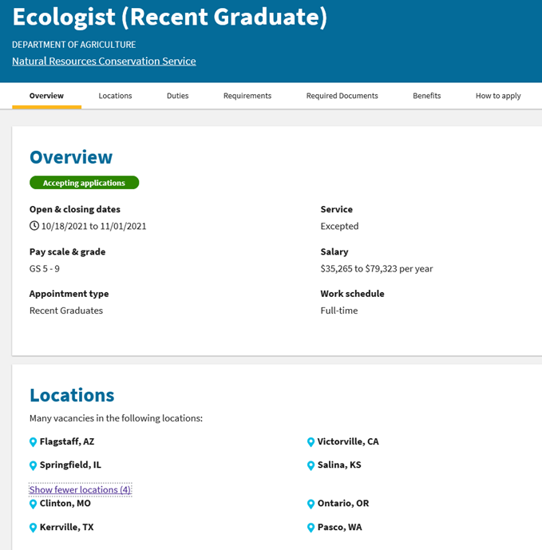

Apply here: https://www.usajobs.gov/GetJob/ViewDetails/617499100#

  - Rangeland Management Specialist (Recent Graduate):
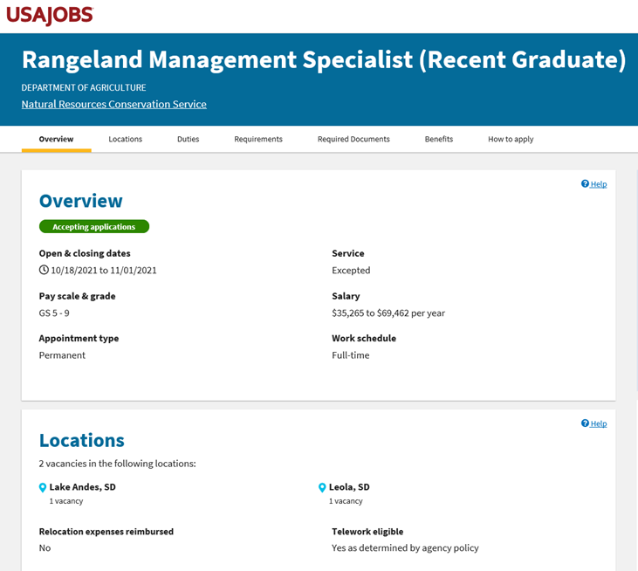

Apply here: https://www.usajobs.gov/GetJob/ViewDetails/617491700

- Apache Sitgreaves National Forests Summer 2022 Temporary Seasonal Job Interest:
  - Fill out the form below if you have any interest!
  - “Seeking individuals interested in Wildland fire/Rangeland management/Wildlife/Recreation/Heritage-archaeological/Timber jobs for the 2022 field season.”

- Sign the form here: https://forms.office.com/Pages/ResponsePage.aspx?id=5zZb7e4BvE6GfuA8-g1Gl9raPhj97stKt519nC9xCg5UQzBJVjNBMEJTSFUyTjhJQkNSNjRYRFNKOC4u<https://gcc02.safelinks.protection.outlook.com/?url=https%3A%2F%2Fforms.office.com%2FPages%2FResponsePage.aspx%3Fid%3D5zZb7e4BvE6GfuA8-g1Gl9raPhj97stKt519nC9xCg5UQzBJVjNBMEJTSFUyTjhJQkNSNjRYRFNKOC4u&data=04%7C01%7C%7C0902cbb0b8a740b5a4c308d98f33fad4%7Ced5b36e701ee4ebc867ee03cfa0d4697%7C0%7C0%7C637698275759243594%7CUnknown%7CTWFpbGZsb3d8eyJWIjoiMC4wLjAwMDAiLCJQIjoiV2luMzIiLCJBTiI6Ik1haWwiLCJXVCI6Mn0%3D%7C1000&sdata=yqkb%2B95IOKbGbm11GYMrjpqi7FDGCUzl2rXtpn6iAzM%3D&reserved=0>



- Scholarship opportunities
- $2,000 Natural Resources Management Today 2022 scholarship:
  - Apply here: https://nrmtoday.com/scholarship.html
  - Deadline: November 30, 2021
  - Who: Students enrolled in 2022 in undergraduate and master’s in natural resources degree programs
  - Looks really good on a resume!



- Budget
- Total: $3,627.45 (checking account)


- Connect with us!
- Have any questions, comments, and/or concerns?
  - Email us at uofatierraseca@gmail.com
- Don’t want to send an email? We understand. Send us a message over on our GroupMe!
  - Tierra Seca GroupMe: https://groupme.com/join_group/38156015/nWJ5vk


- Meeting Adjourned: 5:15 PM

- Rangeland Meme of the Week
