
Tierra Seca
University of Arizona Student Chapter
Society for Range Management

September 7th, 2020



- Meeting Called to order: 5:04 PM

- Tierra Seca Fall 2021 Club Meeting Schedule

~Biweekly meetings on Tuesdays at 5:00 PM at ENR2 in room N350

Month | Day
September | 7th
September | 21st
October | 5th
October | 19th
November | 2nd
November | 16th
November | 30th


- Welcome Back!

  - Last Tuesday (August 31st) was a social meeting
    - Talked about a variety of topics
      - Classes
      - What are rangelands
      - Etc.

  - Today is the first official Tierra Seca meeting of the semester



- Officer Introductions

- Eamonn Mazur—President
- Alex Binford-Walsh—Vice President
- Elizabeth EbadiRad—Secretary
- Carter Blouin—Treasurer

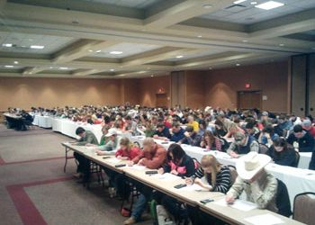

- URME Meetings

- Undergraduate Range Management Exam
- Administered at Society of Range Management (SRM) conference
- Goal: opportunity for undergraduates to apply rangeland knowledge
- Open to all undergraduates
  - Top 10% move towards becoming Certified Professional in Rangeland Management
  - Eligible for 2 credits (RNR 496B with Dr. Howery)
- Meet-up on Fridays from 4:00 PM to 6:00 PM on Zoom (link will be provided)

- Coaches:
  - Dr. Howery (lhowery@ag.arizona.edu)
  - Cameron Burleson (cameronburleson@email.arizona.edu)
  - Elena Dosamantes (edosamantes@email.arizona.edu)
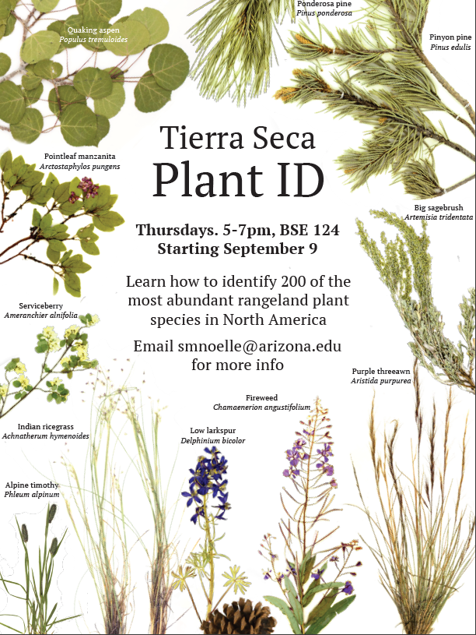

- Plant ID Meetings

- Learn to ID 200 of most abundant rangeland plant species in North America
- Thursdays from 5:00 PM to 7:00 PM in Biosciences East (BSE) room #124

- Coaches:
  - Sarah Noelle (smnoelle@arizona.edu)
  - Brandon Mayer (butterzs@arizona.edu)

- 2022 SRM Conference in Albuquerque

- Arizona Section of SRM co-hosting with NM section
- Network with professionals, employers, professors, ranchers, and other students
  - Internships, jobs, graduate school
- Club goal: pay for all students to attend conference
  - Active club member
  - Contract to sign to make sure you can attend
- Gonna be a good time



- Fundraising

- Received $250 from Mary Nichols (past AZSRM president) for lawn work
  - Thanks, Elizabeth and Eamonn!
- Potential steer auction with Dennis Moroney



- Job Opportunities

- Vanessa Prileson (Rangeland Program Coordinator with Pima County Natural Resources, Parks & Recreation):
  - The Range Program within the Pima County Natural Resources, Parks and Recreation department is currently advertising two positions, a 5-6 month Ranch Internship at the County’s Bar V Ranch, and a full-time position as a Ranch Liaison serving the Altar Valley and Upper Santa Cruz zones:

  - 2211 - Laborer (Bar V Ranch Intern) | Job Details tab | Career Pages (governmentjobs.com) – recommended for those wishing to gain hands-on experience on a cattle ranch. This will be a revolving opportunity, so if this time around doesn’t work for folks to apply, there will be more opportunities in the future!

  - 7020 - Special Staff Assistant - Unclassified (Southwest Ranch Liaison) | Job Details tab | Career Pages (governmentjobs.com) – recommended for recent graduates in Range/natural resources, trades, or related field or for experienced individuals who enjoy working outside in remote locations, performing hands-on maintenance of ranch and farm infrastructure, coordinating projects with ranchers, participate in vegetation management and monitoring.

- Katie Matthiesen (field technician for National Ecological Observatory Network, NEON):
  - 9/18 or 9/24 - field trip to Santa Rita Experimental Range (SRER)
  - Plant protocols (plant diversity, herbaceous biomass, phenology, etc.) or fauna protocols (beetle/mosquito sampling, small mammal handling)
  - “SRER is more green and incredible than I have seen in my 5+ years at NEON!” (Katie)


- Future Meetings

- Potential OPM (Federal Office of Personnel Management) workshop
  - Work through federal requirements with rangeland professors
- Guest speaker sources:
  - NRCS (Natural Resources Conservation Service)
  - USFS (U.S. Forest Service)
  - TNC (The Nature Conservancy)
  - USFWS (U.S. Fish & Wildlife Service)
  - BLM (Bureau of Land Management)
  - AZSRM Board of Directors


- Budget

- Total: $3,713.74 (checking account)
  - Does not include the $250 from Mary Nichols


- Connect with us!

- Have any questions, comments, and/or concerns?
  - Email us at uofatierraseca@gmail.com

- Don’t want to send an email? We understand. Send us a message over on our GroupMe!
  - Tierra Seca GroupMe: https://groupme.com/join_group/68106119/Sv4d4C9Q


- Meeting Adjourned: 5:43 PM

- Rangeland Meme of the Week
