Discovery Friday’s
University of Arizona
Santa Rita Experimental Range
Lecture 4: 30 April 2021, 10:00-11:00AM (MST)
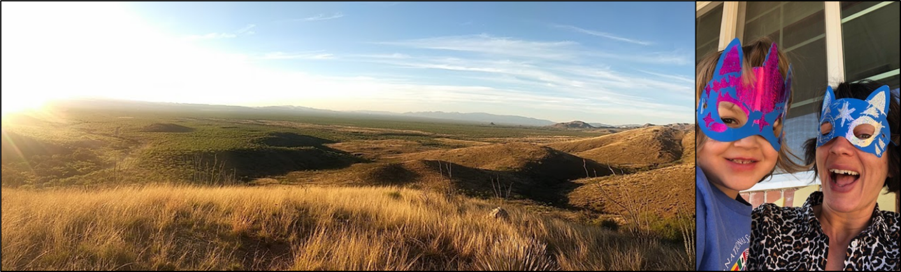
Unexpected Drivers of Vegetation Change at the Santa Rita Experimental Range
Dr. Elise Gornish is a Cooperative Extension Specialist in Ecological Restoration at the University of Arizona. Her research and outreach program largely focuses on identifying strategies for successful restoration in arid land systems and integration of restoration approaches into weed management. Originally from New York, Dr. Gornish received her MS and PhD from Florida State University in 2013. She then completed two years of a post doc at the University of California, Davis followed by two years as a Cooperative Extension Specialist in Ecological restoration at UC Davis. Dr. Gornish is an early career leader in the fields of arid land restoration and weed management and has published over 50 papers and has presented over 180 times at various venues. In addition to vegetation management, Dr. Gornish is passionate about STEM inclusion and in 2018 become the Director of UA GALS (Girls on outdoor Adventure for Leadership and Science). This new program focuses on providing science learning and leadership opportunities to traditionally underserved female high school students through backcountry programming.
Please use the link below to join the webinar:
https://arizona.zoom.us/j/87271045950
or dial in
US: +1.602.753.0140
SRER Discovery Friday’s 2021 Webinar Calendar
29 January- Brett Blum: SRER: Past, Present and Future
26 February- Allie Burnett: Walk a Mile in Their Shoes: shrub encroachment through the eyes of prey
26 March- Drs. Ashlee and Matthew Rowe: Why is a bark scorpion sting both painful and potentially deadly?
30 April- Dr. Elise Gornish:Unexpected Drivers of Vegetation Change at the Santa Rita Experimental Range



