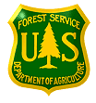
Outreach
Humboldt-Toiyabe National Forest
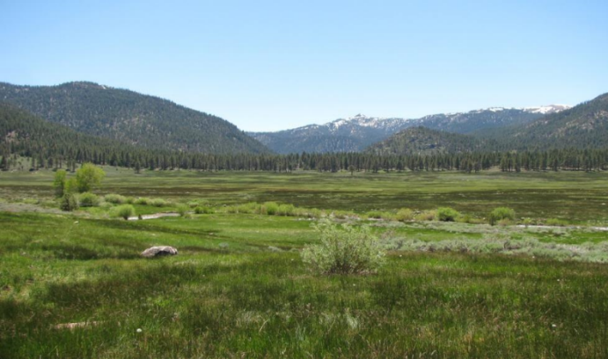
Ecologist – 1 Position
Outreach: GS-0408-12
Duty Station: Multiple Locations

Contact Information:
Kendal Young, Natural Resources and Planning Staff Officer
Telephone: (775) 276-4659
E-Mail: Kendal.young@usda.gov

Job Opportunity -- The Humboldt-Toiyabe National Forest is looking to fill up an Ecologist position, GS-0408 -12. To express interest in the position please submit the Outreach Response Form attached below and a current resume by April 14, 2021 to the contact information listed above. Announcement date is yet to be determined but will be updated with the announcement date and number when known.

QUALIFICATION REQUIREMENTS -- Those who are interested must meet the qualification requirements for the GS-0408 series covered by the U.S. Office of Personnel Management (OPM) Qualification Standards for General Schedule Positions which can be found on the internet at:
https://www.opm.gov/policy-data-oversight/classification-qualifications/general-schedule-qualification-standards/0400/ecology-series-0408/ and
https://www.opm.gov/policy-data-oversight/classification-qualifications/general-schedule-qualification-standards/

About the Position(s):
The duty station for this position may be located in one of the following locations: Winnemucca, Elko, or Wells, Austin, Tonopah, Carson City, Las Vegas, or Sparks, NV. This outreach will help inform interest in duty station locations; please indicate any preference on the outreach form attached.

Duties Include:
Performs the most complex ecological projects or studies, which cover the full range of ecological work within a forest or several forests (e.g., vegetation, soil, aquatic, fishery and wildlife resources, terrestrial ecology, endangered species, water resource development, silviculture, range management, fire, environmental impact, environmental characteristics, planning, etc.), as they relate to Forest projects, and/or environmental activities. Plans forest or zone projects or environmental activities, coordinating with the Forest; Federal, State, territorial and local government agencies; special interest groups; and the public.
Develops and formulates plans for conducting investigations and analyses of complex projects, which require intensive field sampling, mapping, and sophisticated computerized data analysis. Initiates, coordinates and conducts environmental impact assessments, background analyses, and surveys/site investigations, which cover designs, studies, and plans to provide specific information, usually in the form of plans of study, scope of work, and cost estimates for studies to be performed in-house or by contracts; evaluation of alternative plans; and assessment of probable impact related to zone or forest projects. Recommends priorities for ecological investigations through consideration of local land management needs, concern for resources, and special problems and situations that may arise.
Makes reconnaissance surveys of proposed projects, prepares environmental inventories and environmental impact statements, and analyzes the impact of specific plans prepared by others. Reviews and prepares responses to comments from other Forest disciplines; Federal, State, and territorial governmental agencies; special interest groups; and the public with regard to the environment. Maps distribution of ecological resources (natural and existing vegetation) and develops preliminary alternative plans for management, conservation, and/or mitigation of impacts to the environment. Investigates on-the-ground ecological situations and occurrences posing particular land management problems. Monitors long term ecological studies generally dealing with changes in vegetation over time. Evaluates quality of ecological studies of vegetation, soil, and environmental characteristics from which ecological classifications are produced containing useful land management and planning information. Based on these investigations, develops and recommends solutions, which can be successfully implemented by the land manager.
Serves as the senior ecological specialist. Performs Supervisory duties (20%). Is responsible for ensuring the completion and accuracy of the ecological projects or studies assigned to lower graded ecologists. Ensures the successful accomplishment of study objectives, solves complex and comprehensive problems, assesses situations to determine the most cost effective and technically correct solutions, reviews team members work for errors and completeness, reviews reports for thoroughness, and ensures that completed work provides all required data. Has full review and approval authority over the work of the team.
About the Humboldt-Toiyabe National Forest:
The Humboldt-Toiyabe National Forest, in the Intermountain Region, has 6.3 million acres of mountains and valleys, ranging in elevation from 2,000 to nearly 13,000 feet. It is the largest National Forest in the contiguous United States. The Forest consists of four distinct geographic areas, the Sierra Nevada, Great Basin, Northeastern Nevada, and the Spring Mountains (Las Vegas). The Forest administers 5.3 million acres in 12 of Nevada's 17 counties, and 1 million acres in 7 California counties. The H-T is the only Region 4 National Forest containing NFS land within the State of California.
For more information about the Humboldt-Toiyabe National Forest please visit the following website: http://www.fs.usda.gov/htnf/

OUTREACH RESPONSE FORM
Humboldt-Toiyabe National Forest
Ecologist GS-0408-12
Respond by April 14, 2021 and Include Resume

NAME:

E-MAIL ADDRESS:

MAILING ADDRESS:

TELEPHNE NUMBER:
 | {USFS |  | {BLM |  | {OTHER

AGENCY EMPLOYED WITH:

 | {PERMANENT |  | {TEMPORARY |  | {TERM
TYPE OF APPOINTMENT:

 | {VRA |  | {PWD |  | {OTHER

 | {REGION |  | {FOREST

CURRENT:
{DISTRICT

 | {SERIES |  | {GRADE

CURRENT:
{POSITION TITLE

CURRENT:

HOW DID YOU FIND OUT ABOUT THIS OUTREACH NOTICE?

PLEASE INDICATE INTEREST IN WHICH POSITIONS(S) AND POSSIBLE DUTY LOCATIONS:

IF NOT A CURRENT PERMANENT (CAREER OR CAREER CONDITIONAL) EMPLOYEE
ARE YOU ELIGIBLE TO BE HIRED UNDER ANY OF THE FOLLOWING SPECIAL AUTHORITIES:

PERSON WITH DISABILITIES

VETERANS READJUSTMENT

DISABLED VETERANS W/30% COMPENSABLE DISABILITY

VETERANS EMPLOYMENT OPPORTUNITIES ACT OF 1998

FORMER PEACE CORPS VOLUNTEER

STUDENT CAREER EXPERIENCE PROGRAM

Contact Information:
Kendal Young, Natural Resource and Planning Staff Officer
Telephone: (775) 276-4659, E-Mail: kendal.young@usda.gov
The U.S. Department of Agriculture (USDA) prohibits discrimination in all its programs and activities on the basis of race, color, national origin, age, disability, and where applicable, sex, marital status, familial status, parental status, religion, sexual orientation, genetic information, political beliefs, reprisal, or because all or part of an individual’s income is derived from any public assistance program. (Not all prohibited bases apply to all programs.) Persons with disabilities who require alternative means for communication of program information (Braille, large print, audiotape, etc.) should contact USDA’s TARGET Center at (202) 720-2600 (voice and TDD). To file a complaint of discrimination, write to USDA, Director, Office of Civil Rights, 1400 Independence Avenue, S.W., Washington, DC 20250-9410, or call (800) 795-3272 (voice) or (202) 720-6382 (TDD). USDA is an equal opportunity provider and employer.

