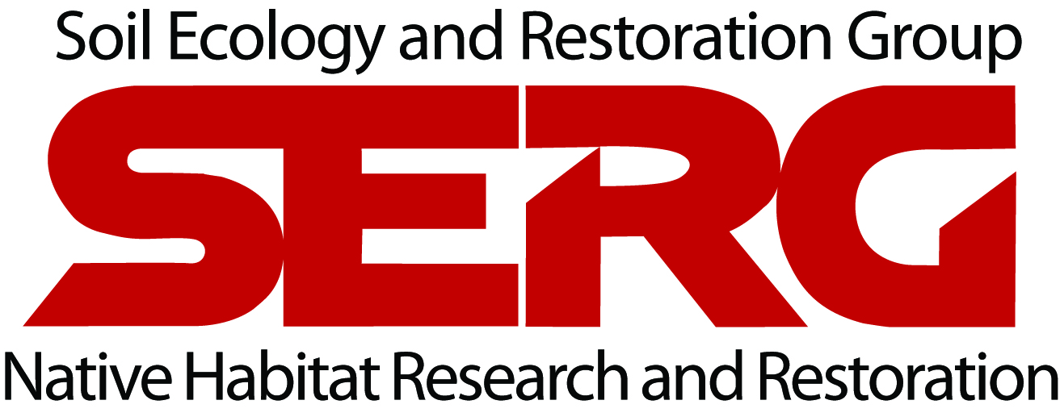 | Job Title: SCI Restoration Technician  Supervisor: Betty Lee  Effective: April 1, 2021

SERG MISSION STATEMENT
SERG is a non-profit organization under the umbrella of the San Diego State University Research Foundation and is committed to restoring and preserving California’s sensitive vegetation communities for the benefit of the environment and the preservation of the ecosystem services they offer.

PURPOSE OF THE POSITION
We seek a Restoration Technician for habitat restoration projects on San Clemente Island, a Naval installation on the southern-most of California’s Channel Islands. The Restoration Technician position requires arduous manual labor, working outdoors in all weather, heavy lifting and carrying, and working on rugged terrain. This is a full-time, hourly position with full benefits. Compensation will be $15.00/hour plus a full benefits package. Room and board are provided while working on San Clemente Island. Work schedule will be 10 days on-island and 4 days off-island. Food reimbursement will be provided at $15/day for crew members while on-island. Transportation to and from the island is provided by means of a twin engine 19-seater plane. Relocation benefits will not be offered.

All work will be conducted on San Clemente Island, which is owned and operated by the U.S. Navy as an active training site. San Clemente Island has a particularly unique flora, hosting 15 plants that are known from nowhere else in the world, and an additional 48 plants that are only known from the Channel Islands as a whole. The island is home to endemic and rare plant and animal species, with an extensive community of biologists, archaeologists, and researchers. Applicants should enjoy living as part of a small and remote community, and be able to maintain a professional, positive attitude at all times.

SPECIFIC DUTIES
The following information is intended to be representative of the work performed by incumbents in this position and is not all-inclusive. The omission of a specific duty or responsibility will not preclude it from the position if the work is similar, related, or a logical extension of position responsibilities.

- Collect native plant propagules
- Grow native plants
- Install, maintain, and monitor native species out-plantings
- Remove/control non-native plant species manually, mechanically, or chemically
- Monitor rare plant populations
- Monitor vegetation cover
- Wildland fire mapping and assessment
- Fuel moisture sampling
- Monitoring and maintenance of Remote Automated Weather Stations
- Use of GPS in the field and GIS software
- Data entry and database maintenance
- Install erosion control materials

QUALIFICATIONS AND SPECIAL SKILLS
SERG is looking to hire someone with the following qualifications and professional skills.

- Bachelor’s degree in botany, ecology, biology, or related discipline
- Passion for Southern California flora
- Capacity to follow work rules and procedures
- Willingness and ability to apply herbicide safely and effectively
- Experience performing strenuous labor with a high level of physical endurance under a variety of weather and work conditions
- Ability to repeatedly lift loads of up to 45 lbs. throughout the workday and to safely navigate and work off-trail on steep, rocky, cactus-covered terrain
- Highly motivated individual with a high energy level and strong interpersonal skills.
- Possess good judgment and common sense.
- Ability to respectfully, clearly, and accurately communicate with other staff, contractors, and military commands
- Ability to pass a background check to obtain clearance for military base access
- Valid driver’s license, good driving record, and ability to drive 4-wheel-drive vehicles
- Legal working status in the US

PREFERRED QUALIFICATIONS AND SPECIAL SKILLS
- Previous experience in habitat restoration
- Experience with GIS and habitat modeling strongly preferred
- Familiarity with Southern California flora
- Experience maintaining and repairing small engines
- Experience safely operating and maintaining mechanical equipment, hand tools, herbicide application equipment, and GPS units
- Valid California Qualified Applicator Certificate strongly preferred

Please send resume, cover letter, and contact information for three professional references in one PDF document to Julie Lambert at jlambert@sdsu.edu and Betty Lee at blee6@sdsu.edu

