PLUMAS NATIONAL FOREST
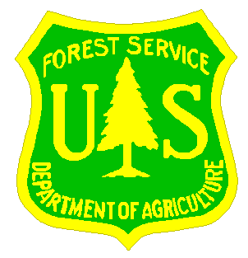
_______________________________

OUTREACH NOTICE

PLUMAS NATIONAL FOREST

Beckwourth Ranger District
___________________________________

The Plumas National Forest, Beckwourth Ranger District is seeking interested candidates in filling the following detail and permanent position:

Not-to-exceed 120-day temporary promotion/detail beginning in March 2021
Title/Series/Grade:
Forest Range Staff, GS-0454-11

Permanent position
Title/Series/Grade:
Forest Range Staff, GS-0454-11 (The permanent opportunity may be GS-0454-12)

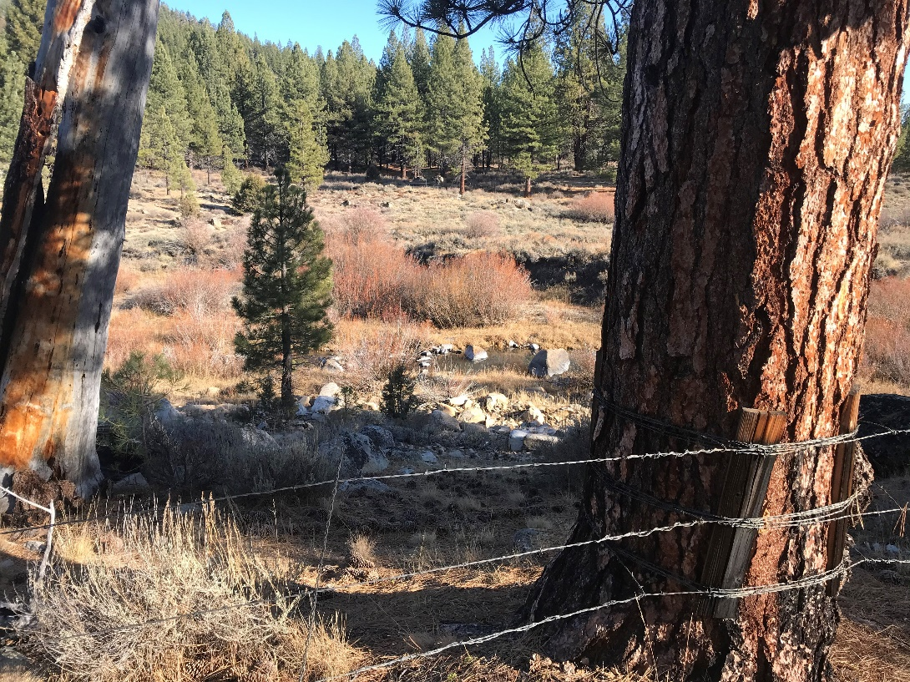

The duty station will be the Plumas National Forest, Beckwourth Ranger Station in Blairsden, CA, located at 23 Mohawk Highway Road, Blairsden, CA 96103.

Outreach begins February 1, 2021 and ends February 16, 2021.

Description of the duties associated with this position:

This is a Forest-wide Forest Range Staff position. The Plumas has 65 allotments, 45 which are active, and 24 permittees. There are two active sheep allotments. There is a FS horse trailer at the Beckwourth Ranger Station. Use of personal horses are authorized under the 2017 Stock Management Plan. The Plumas National Forest is a beautiful Forest to work on. The east side consists of East Side Pine, Sierra Mixed Conifer, and sage brush steppe, with large sedge meadows. The other two districts are predominately red fir forest.

The Plumas has an active before/during/after grazing season monitoring program at 165 designated monitoring areas to evaluate stream bank alteration, meadow utilization, and riparian shrub use. Assessments are conducted for meadow seral stage and stream/spring/fen habitat to determine proper functioning condition. The only threatened and endangered habitat currently affecting range program are two Sierra Nevada yellow-legged frog exclosures. A focus of the Plumas National Forest is vegetation restoration and fuels reduction projects. There are three allotments left on the Recessions Act Schedule.

The position is based out of the Beckwourth Ranger Station, on the east side of the Forest where most of the grazing occurs. The position is supervised by the Forest Ecosystem Staff Officer based in the Forest Supervisor’s Office in Quincy, CA. There are three districts on the Plumas National Forest: Beckwourth Ranger Station on the east; Mount Hough Ranger Station in the center; and Feather River Ranger Station on the west. This Forest Range Staff position supervises one GS-0454-9 Forest Rangeland Management Specialist, a GS-0455-7 Range Crew Leader, and a GS-0455-5 Range Crew Member.

The Plumas National Forest is a hidden gem in the Sierra with undiscovered recreational potential only 65 miles from the closest big city (Reno, NV). Forest staff and range permittees are kind and work well together.

Area description:
The Plumas National Forest encompasses over a million acres of tree-covered mountains, filled with hundreds of high alpine lakes and thousands of miles of clear running streams. Elevations range from 3,000 to 8,000 feet. The area has four seasons with warm to hot days and warm to cool nights in the summer, and periodic snowstorms in the winter. Average annual precipitation is about 35-40 inches a year. Within a half day or less drive are Lake Tahoe, Reno, Sacramento, Susanville, San Francisco, Redding, Chico, California coast, Lake Shasta, Lassen Volcanic National Park and a vast variety of activities and opportunities. Popular outdoor activities within the Plumas National Forest include bicycling, boating, camping, cross country skiing, driving for pleasure, fishing, hiking, hunting, snowmobiling, white water rafting, and wildlife viewing.

For further information about this position contact: Scott Lusk (530) 927-7593 scott.lusk@usda.gov

Non-discrimination Statement

In accordance with Federal civil rights law and U.S. Department of Agriculture (USDA) civil rights regulations and policies, the USDA, its Agencies, offices, and employees, and institutions participating in or administering USDA programs are prohibited from discriminating based on race, color, national origin, religion, sex, gender identity (including gender expression), sexual orientation, disability, age, marital status, family/parental status, income derived from a public assistance program, political beliefs, or reprisal or retaliation for prior civil rights activity, in any program or activity conducted or funded by USDA (not all bases apply to all programs). Remedies and complaint filing deadlines vary by program or incident.

Persons with disabilities who require alternative means of communication for program information (e.g., Braille, large print, audiotape, American Sign Language, etc.) should contact the responsible Agency or USDA’s TARGET Center at (202) 720-2600 (voice and TTY) or contact USDA through the Federal Relay Service at (800) 877-8339.

To file a program discrimination complaint, complete the USDA Program Discrimination Complaint Form, AD-3027, found online at http://www.ascr.usda.gov/complaint_filing_cust.html and at any USDA office or write a letter addressed to USDA and provide in the letter all of the information requested in the form. To request a copy of the complaint form, call (866) 632-9992. Submit your completed form or letter to USDA by: (1) mail: U.S. Department of Agriculture, Office of the Assistant Secretary for Civil Rights, 1400 Independence Avenue, SW, Washington, D.C. 20250-9410; (2) fax: (202) 690-7442; or (3) email: program.intake@usda.gov .

USDA is an equal opportunity provider, employer, and lender.

Plumas National Forest, Beckwourth Ranger Station
Forest Range Staff, GS-0454-11
Please return to Scott Lusk scott.lusk@usda.gov
Outreach begins February 1, 2021 and ends February 16, 2021

NAME:

E-MAIL ADDRESS:

MAILING ADDRESS:

TELEPHONE NUMBER:
 | {USFS |  | {BLM |  | {OTHER

AGENCY EMPLOYED WITH:

 | {PERMANENT |  | {TEMPORARY |  | {TERM
TYPE OF APPOINTMENT:

 | {VRA |  | {PWD |  | {OTHER

 | {REGION |  | {FOREST

CURRENT:
{DISTRICT

 | {SERIES |  | {GRADE

CURRENT:
{POSITION TITLE

CURRENT:

HOW DID YOU FIND OUT ABOUT THIS OUTREACH NOTICE?

IF NOT A CURRENT PERMANENT (CAREER OR CAREER CONDITIONAL) EMPLOYEE
ARE YOU ELIGIBLE TO BE HIRED UNDER ANY OF THE FOLLOWING SPECIAL AUTHORITIES:

PERSON WITH DISABILITIES

VETERANS RECRUITMENT ACT

DISABLED VETERANS W/30% COMPENSABLE DISABILITY

VETERANS EMPLOYMENT OPPORTUNITIES ACT OF 1998

FORMER PEACE CORPS VOLUNTEER

STUDENT INTERN AND RECENT GRADUATES PROGRAM

Thank you for your interest in our vacancy. When responding, please send a current resume and indicate if you are interested in the Not-To-Exceed 120-day detail/temporary promotion and/or permanent opportunity.

