Tierra Seca meeting
November 4, 2020

MINUTES

Present (Zoom): Carter Blouin, Jacob Brown, Cameron Burleson, Larry Howery, Grace Nykol, Austin Rutherford, James Bradley, Flavie Audoin, Thomas Koppy, Tzirel Leiser

- Grace shared new Tierra Seca logo designs. The favorite logo is in the first graphic below. Our old logo is in the second image. T-shirt options - burgundy red short-sleeved shirts with the new logo, and long-sleeved forest green with the old logo. They are $10 each. Email Grace ASAP if interested (gracenykol@email.arizona.edu).
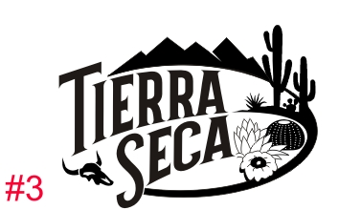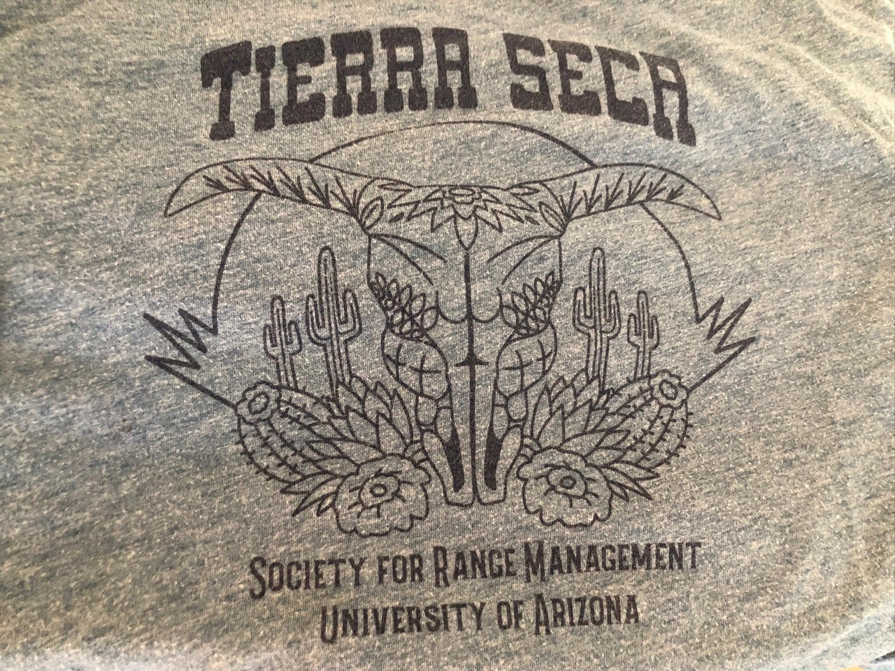

- SRM contract - There is a new Tierra Seca contract for the SRM conference. If you plan to go (and have registration covered by the club), please return the form to a Tierra Seca Officer (Jacob Brown- jacobbrown64@email.arizona.edu, Grace Nykol- gracenykol@email.arizona.edu, Alex Binford-Walsh- abinfordwalsh@email.arizona.edu, or James Bradley- abinfordwalsh@email.arizona.edu).

- Johnsen Book Donation
  - Jacob has 46 books that were donated. Tierra Seca members can claim specific books if interested – go to the following spreadsheet and enter your ‘claims’: https://docs.google.com/spreadsheets/d/1ZzQBEY4m2TFRvLNmnljdRdvYXPHFUJORHVOoym8hLMg/edit?usp=sharing

- Elk Horn Monitoring (Altar Valley Conservation Alliance) – November 6
  - We will meet off of Elkhorn Ranch Road at 8:30 AM (directions below). We will be conducting photo monitoring (not transects) in the same drainages that have been studied throughout the project. Photo monitoring usually takes a few hours, so expect to finish around 1-2PM.
  - Due to the COVID-19 pandemic, we will follow these guidelines:
- Remain 6 feet from others
- Wear a face covering
- Bring your own food and water
- Sanitize your hands before using shared equipment
  - Directions to the meeting place on Elkhorn Ranch Road (approx. 75 mins from Tucson):
  - Travel west on 86/Ajo Way to Three Points. Turn left (south) onto Highway 286/Sasabe Road. Drive about 20 miles through the Border Patrol checkpoint. Immediately afterward, you will see the Elkhorn Ranch sign ahead to the right. Turn right at the sign and continue 5-10 minutes down Elkhorn Ranch road over two cattle guards. You will see cars parked on your right near a barbed wire fence at the meeting location.

- Help is needed to move cans from Altar Valley to Jacob's house. On a separate day, help will be needed to move cans from Jacob's house to a recycling center. Please email Jacob at Jacobbrown64@email.arizona.edu

- We have $3279.96 in our checking account. $604.75 in our Venmo account.

- SRM Range Program Reaccreditation – We are one of the 13 Accredited Range Programs at Universities around the world. This year Dr. Howery and others are working to get our program reaccredited for the next 10 years. On November 16th there will be a virtual talk with the accreditation team from 5-6pm (Zoom). Students who are interested in the Range program (EMRR) or Tierra Seca are invited and encouraged to attend. It will be a group conversation. Dr. Howery will send out meeting info. If you plan to attend please add your information to the following spreadsheet: https://docs.google.com/spreadsheets/d/1LhZ61Qeu1g14tISpQE4QoYoFK2QcgJU-ZSclQ9aU7eY/edit?usp=sharing

- Pay dues! $30/semester. Venmo @tierraseca

- Tierra Seca meetings are bi-weekly on Wednesdays from 5:30-6:30. The next meeting will be on Wednesday, November 18.
o Zoom Link: https://us02web.zoom.us/j/88960375768?pwd=WDlmakxRNjd6cXp5Y3hWTVBOL0c2UT09
Meeting ID: 889 6037 5768
Passcode: Grazed

- URME practice – Thursdays 5-7pm. https://arizona.zoom.us/j/94144782659

- Plant ID – Mondays 6-7:30 pm. https://arizona.zoom.us/j/93054030609 (Password: Plants)
Brush Treatment Monitoring with Altar Valley Conservation Alliance
(contact: Julia Sittig, julia@altarvalleyconservation.org)

- Timing - First week of December - contact Julia with your availability if you're interested. With driving, plan on spending about 6-8 hours total.
- Activity - In 2019, the AVCA implemented an herbicide treatment using a helicopter on multiple ranches in the Valley to restore native grasslands. The AVCA is monitoring the response of mesquite and other vegetation, and needs 4-6 volunteers to help take photopoints and read/record transects.
- Compensation - AVCA can compensate you for your driving mileage to the sites.

