OUTREACH NOTICE: Detail/Temporary Promotion/Permannt Full Time (PFT)

Rangeland Management Specialist

GS-0454-7/9

Region 2, San Juan National Forest

Columbine Ranger Districts

Respond by: August 21st, 2020

The San Juan National Forest is conducting an outreach to identify interest for one GS-0454-07/09 Rangeland Management Specialist position located on the Columbine Ranger District. The duty station of this position is Bayfield Colorado. Livestock grazing in the area has occurred on public lands since the late 1870’s and has been an integral component of the communities in Southwest Colorado for generations. The Columbine Ranger District administers 33 active grazing allotments on over 400,000 acres including both cattle and sheep.
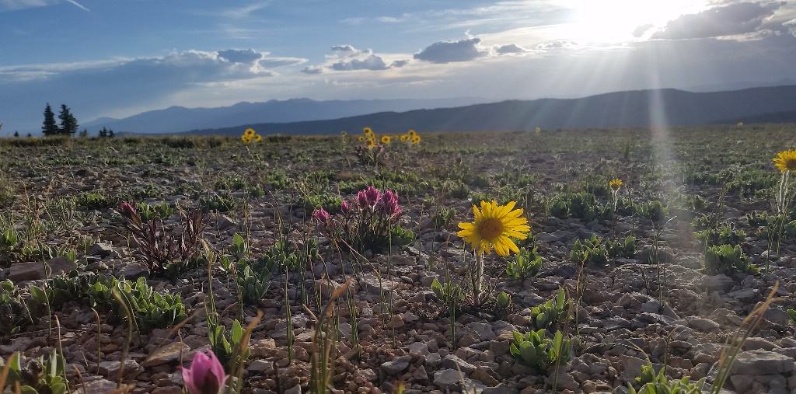

MAJOR DUTIES
Due to the time of year that this detail is being advertised, the primary focus will be field observations regarding end of season grazing compliance and range infrastructure documentation, specifically:
- Conducts short and long term monitoring of plant community change, trends, and grazing impacts.
- Participates by monitoring, gathering, analyzing, interpreting and evaluating data to determine if land management, economic, and social goals and objectives identified for the land involved are being achieved.
- Compiles material and supply estimates for construction and maintenance of rangeland projects
- Makes recommendations for improved rangeland and livestock administration and provides input into the development of subsequent rangeland and livestock management decisions.
- Maintains continuing liaison with permittee, affected groups and others to ensure compliance with agreed upon plans and desired quality of work, and to advise rangeland users of various activities affecting their use of specific rangeland areas. Prepares and/or revises annual rangeland user instructions.
- Maintains range allotment inspection books, livestock management strategies/practices, and compiles actual use information for various grazing areas.
Horseback and ATV/UTV riding skills are preferable.
QUALIFICATION REQUIREMENTS
Those who are interested must meet the qualification requirements for the 0454 series that is covered by the U.S. Office of Personnel Management (OPM) Qualification Standards for General Schedule Positions -- GS-0454 Rangeland Management Specialist. The OPM Qualification Standards Handbook Manual is available for review on the Internet at Qualifications for the 0454 series can be found here: https://www.opm.gov/policy-data-oversight/classification-qualifications/classifying-general-schedule-positions/occupationalhandbook.pdf.

SAN JUAN NATIONAL FOREST
The San Juan National Forest covers 1.8 million acres in the southwestern corner of Colorado. The Forest Headquarters Office is located in Durango, Colorado, with district offices in Bayfield, Dolores and Pagosa Springs. The forest is a recreation mecca for those seeking backcountry outdoor experiences whether by motorized or non-motorized means. Over 140 developed recreation sites are also available to forest visitors. All or part of four wilderness areas are located within the forest, adding up to nearly 500,000 acres, and the forest also contains and manages the recently designated Chimney Rock National Monument and Hermosa Creek Special Management Area. Primary management activities include recreation, forest health, range, fisheries, water quality, and heritage and cultural resources. For more information about the San Juan National Forest visit: https://www.fs.usda.gov/sanjuan/.

BAYFIELD, COLORADO
The Town of Bayfield (elev 6900’), located in La Plata County, is in the southwest corner of Colorado. The population of Bayfield is approximately 3,000, and nearby Durango (19 miles) is about 17,500. La Plata County is known as an outdoor recreation epicenter, with rafting, skiing, hunting, fishing, mountain biking, and horseback riding, to name a few activities. Durango is also known as home to world class mountain biking opportunities. We are within an hour of the Purgatory ski area and within 0.5-4 hours of Mesa Verde, Chaco Canyon, the Alpine Loop, Arches and Canyonlands National Parks and Lake Powell National Recreation Area.
If you are interested in being considered for this opportunity, complete the outreach response form below along with a resume and send to James Simino, james.simino@usda.gov by August 21st, 2020. For additional information on this position, please contact James.

OUTREACH RESPONSE FORM
Rangeland Management Specialist
GS-0454-7/9
Region 2, San Juan National Forest, Columbine Ranger District
Respond by 8/21/2020 to James Simino
james.simino@usda.gov, 970-884-1438
Include Resume with outreach response

NAME:__________________________________________________

EMAIL ADDRESS:__________________________________________

MAILING ADDRESS:_________________________________________

TELEPHONE NUMBER:______________________________________

Are you currently a Federal Employee? _____Yes _____No

If yes, what is your current appointment type?
_____Permanent _____Temporary _____Term
_____Veterans Readjustment Appointment _____Persons with Disabilities _____Other (identify)

If with USFS, current Region/Forest/District:_________________________

Current Series and Grade:________________________________

Current Position Title:____________________________________

If not a current permanent (career or career-conditional) employee, are you eligible to be rehired under any of the following special authorities?
_____Persons with disabilities
_____Veterans readjustment
_____Disabled veterans with 30% compensable disability
_____Veterans employment opportunities act of 1998
_____Former peace corps volunteer
_____Other (please provide brief description)

COMMENTS:

