
Coronado National Forest
Outreach Notice

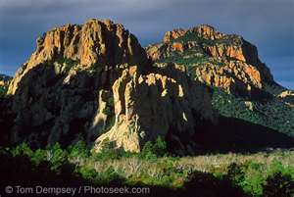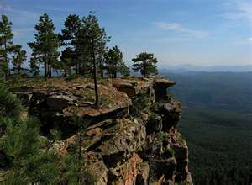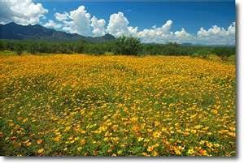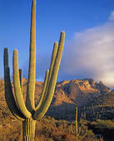
Join our team on the Coronado National Forest!
Pre-Announcement
DISTRICT RANGELAND MANAGEMENT SPECIALIST
GS-0454-05/07/09

The Coronado National Forest (CNF) in southern Arizona will soon be advertising a GS-0454-05/07/09 District Rangeland Management Specialist position located at the Douglas Ranger District in Douglas, Arizona.

Salary: $34,916 - $67,013
Work Schedule: Full-time
Duty Station: Douglas Ranger District in Douglas, Arizona

We are a multifaceted Forest with a host of challenges and opportunities that bring national attention. We are seeking a dynamic, innovative, and motivated individual willing and able to continue our efforts in being an employer of choice.

PRE-ANNOUNCEMENT OUTREACH
To express interest in the position, please complete and submit the attached outreach form, as well as a resume, by May 8, 2020 via email to Joseph Harris, District Range and Watershed Staff at the Douglas Ranger District, at joseph.e.harris@usda.gov. When completing your resume please indicate your education and/or your work experience that ensures qualification for this position. All responses to this outreach must be received by May 8, 2020.

The vacancy announcement for this position will be posted on the U.S. Government’s official website for employment opportunities at www.usajobs.gov. Anyone who expresses interest in the position will be notified when the announcement opens.

OPM QUALIFICATION STANDARD
The Qualification requirements for the GS-0454 series covered by the U.S. Office of Personnel Management (OPM) Qualification Standards for General Schedule Positions -- GS-0454: Rangeland Management Series, can be found in any Federal Human Resources Office or on the internet at the following hyperlink:
http://www.opm.gov/policy-data-oversight/classification-qualifications/general-schedule-qualification-standards/0400/rangeland-management-series-0454/

MAJOR DUTIES
The position provides professional and technical expertise to a complex Range and Watershed program. The incumbent is responsible for:
- Conducting short and long term monitoring of plant communities and their trends; grazing impacts, precipitation, soil erosion hazards and riparian condition.
- Conducts studies of range conditions, trends and utilization
- Carrying out ecosystem based rangeland surveys and inventories.
- Gathering and assembling data concerning rangeland health, trends, ecological status of vegetation communities, site potential and desired plant community.
- Compiles material and supply estimates and/or oversees the construction and/or maintenance of rangeland projects.
- Makes recommendations for improved rangeland and livestock administration and provides input into the development of subsequent rangeland and livestock management decisions.
- Prepares livestock management plans, determines location and proper stocking and locates, prescribes, designs, and schedules rangeland improvement projects such as fences, pipelines, cattleguards, plant community changes, or prescribed burning.
- Maintains continuing working relationship with permittees and others to ensure compliance with agreed upon plans and desired quality of work, and to advise rangeland users of various activities affecting their use of specific rangeland areas. Prepares and/or revises annual rangeland user instructions. Prepares or initiates action on cooperative agreements for rangeland improvements.
- Assists in the administration of grazing permits by consulting, coordinating and cooperating with permittees and other rangeland users. Determines permittee compliance with permits and makes recommendations to correct discrepancies.
- Determines rangeland readiness for various rangeland uses, inspects rangeland uses for compliance with permits, and monitors the results of the rangeland uses that are permitted or allowed. Prepares rangeland improvement maintenance schedules and keeps records of existing and proposed improvements, maintenance needs, and accomplishments.
- Conducts range allotment inspections, compiles actual use information, and prepares allotment management plans. Determines proper stocking and rotation schemes.
- Performs other duties as assigned.

The incumbent will spend approximately 60% of their time in the field, and will travel on foot, horseback, ATV, and 4x4 vehicle. Arduous travel to remote work locations is a regular occurrence. It is desirable for applicants to have some of the following skills: the ability to navigate using a topographic map and GPS; experience around horses and riding in rough or broken country; a strong background in the principles of rangeland management; comfort working alone or in small groups in remote locations; plant identification skills with an emphasis on grass species; good writing and oral communication skills and the ability to utilize computers for writing and analysis.

ABOUT THE CORONADO NATIONAL FOREST
The twelve mountain range units of the Coronado National Forest total 1.7 million acres of public land, and offer an unusual range of vegetative types and climates. In only one hour, a visitor can drive from the hot, arid desert to the cool pines. The forest is exceptionally rich in diversity of flora and fauna.

The Coronado National Forest is made up of five Ranger Districts serving urban and rural populations. The Forest works hard to collaborate with these communities and share critical resources across boundaries.

Employer of Choice
The Coronado National Forest is also dedicated to nurturing and supporting the development of our employees. The Forest does this by encouraging participation in some or all of the following programs:
- Commuter Benefit Program: If you ride your bike to work, or use public transportation, the Forest can help you with the cost of commuting.
- Employee Wellness Program: Do you like to work out? With this program you can choose to be paid to work out up to three hours a week, or be reimbursed for half of your gym membership.
- Aglearn Rosetta Stone: The Coronado National Forest will pay for you to learn a new language! With your supervisor’s permission, you will be able to develop your linguistic skills.
- Mentoring: We all have skills to share, as well as something to learn. Our mentoring program encourages you to develop new skills and to teach the ones you already have.
- Healthy Awards: This program promotes a healthy work/life balance and rewards you for taking care of yourself. When you complete items on the list, you get points. At the end of the year, you redeem the points you’ve earned for either time off or spot award.

ABOUT THE DOUGLAS RANGER DISTRICT
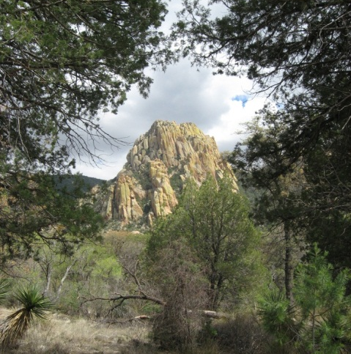
The Douglas Ranger District, one of the five districts of the Coronado National Forest, encompasses three mountain ranges: the Chiricahua Mountains (291,496 acres), the Dragoon Mountains (54,211 acres) and the Peloncillo (Pel-un-see-yo) Mountains (87,986 acres). These mountain ranges are part of the Coronado National Forest “Sky Island” landscape with some of the most diverse wildlife and plant life in Arizona. The District is located in the southeastern corner of Arizona and southwest New Mexico. As the heartland of the Chiricahua Apache, the Douglas District is the custodian of many unique historic and pre-historic cultural resource sites.
Ecological types range from Sonoran and Chihuahuan deserts to spruce-fir forests, as elevations rise from about 4500 feet to over 9700 feet. The Chiricahua Mountains alone contain 47 designated hiking trails both inside and outside of the 87,700 acre Chiricahua Wilderness.The monsoon (rainy) season is a very important part of the ecosystem. Running from July through September, the monsoon provides about nine inches of precipitation on average with the remaining 7 inches generally in the winter. Temperatures range from an average low in the low-twenties in winter to average highs in the high-90’s for summer.
During the summer season, the District employs an average of 30 people. There are 20 full time staff, including the fire, range/watershed, wildlife, zoned recreation and law enforcement organizations.
The Douglas Ranger District currently manages 45 grazing allotments with approximately one half of them authorized to graze yearlong and the other half is authorized during the winter. The district authorizes approximately 60,000 Animal Unit Months (AUMs) of cattle and horses each year. The Range program takes pride in maintaining a respectful, good-natured working relationship with their permittees while producing livestock products in an ecologically sustainable manner.

Douglas, AZ Community Information
Douglas, Arizona, is located 118 miles southeast of Tucson (population 486,700) on the US-Mexico border with a population of approximately 15,000. The City of Douglas, as part of the southern Arizona region, has been listed as one of the 100 top places to live in America according to a recent study conducted by Bizjournal.com. Serving as Arizona’s gateway to Mexico, Douglas is full of history, architecture, minerals, artifacts, and fossils.
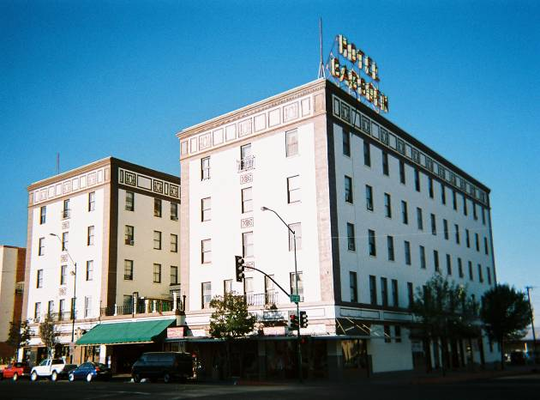
We have five elementary schools, two middle schools and one high school. Douglas also has Charter Schools open for enrollment. Located just 10 minutes outside of town, Cochise Community College has its Douglas Campus. Additionally, The University of Arizona South Facility is co-located at Cochise College Campus. The Southeast Arizona Medical Center is located 3 miles west of town, and the city boasts a new dialysis center. Private physicians and medical clinics are available in town. Douglas has a full complement of religious congregations, including Roman Catholic, Methodist, Baptist, Lutheran, LDS, Church of Christ, Church of God, and Jehovah Witness. The Elks Lodge, Lions Club, VFW Post and the Bushmasters Club are all active and visible in the community.

Bisbee, AZ Community Information
Bisbee, AZ is located about 20 miles northwest of Douglas and is a popular place to live because of its small town charm and cooler climate (elev. 5,500ft). Bisbee, a once booming copper mining town of over 20,000 people, has transformered itself into a quiet tourist community (pop. 5,600) offering many opportunities to stroll the sidewalks and enjoy the art galleries, restaurants, coffee shops, and local breweries. Today Bisbee is better known for its relaxed quality of life and uncommon blend of creativity, friendliness, and style.
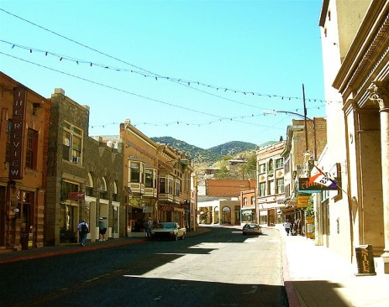

To find more information about the Coronado National Forest and the Douglas Ranger District, visit our website at http://www.fs.usda.gov/coronado/
Coronado National Forest
Douglas Ranger District
District Rangeland Management
GS– 0454-05/07/09
Please respond by May 8th, 2020

Please indicate your interest in this detail by completing and submitting this form and a current resume by email to Joseph Harris, District Range and Watershed Staff at joseph.e.harris@usda.gov. Thank you.

Personal Information

Name: __________________________________________ Date: _______________
E-mail Address: ______________________________________________________________
Telephone Numbers: _________________________________________________________

Work History
Are you a current federal employee? Yes_____ No_____
Agency Employed with: USFS _____ BLM _____ Other ______________________
Type of appointment: Permanent ____Temporary ____ Term ____VRA ___ PWD ____ Other _____
Current Region/Forest/District: ______________________________________________________________
Current Position/Title/Series/Grade: __________________________________________________________

Eligiblities
Are you eligible for hire under a special hiring authority? Yes______No______
If so which one? ____________________________________________________________________

Briefly describe why you will be a strong candidate for this position.

THANK YOU FOR YOUR INTEREST IN THIS OPPORTUNITY!

