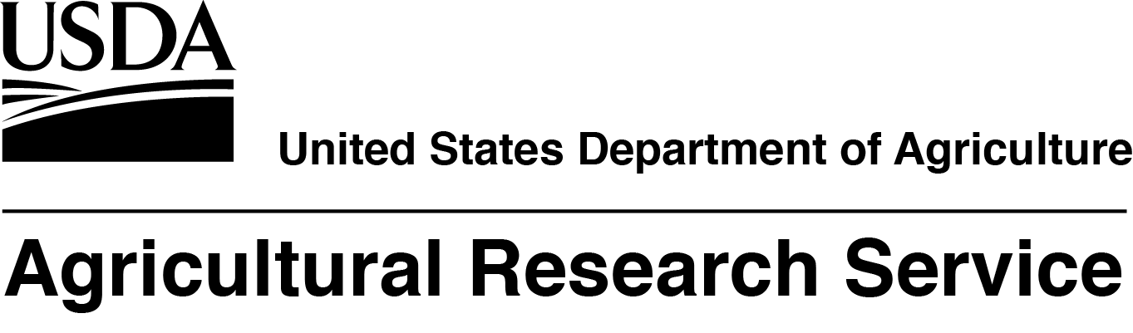
The USDA, Agricultural Research Service, National Soil Erosion Research Laboratory (NSERL), is seeking a full time, permanent, Research Soil Scientist/Agricultural Engineer/Hydrologist to join their multi-disciplinary program. The mission of the NSERL is to quantify the dynamics and transport processes affecting environmental quality and agricultural sustainability and to develop tools for land users to conserve soil and water resources. The incumbent’s research has the general objective of elucidating the interactions among soil physical and chemical processes, hydrology, and soil quality at the basic level, ultimately to help quantify potential benefits of soil quality on water quality, greenhouse gas emission, crop yield, economics, ecosystem service, and resiliency. The salary for this position is at the GS-12/13 level, $74,596.00 - $115,313.00 per year. This announcement will open 8/29/19 and will close on 9/19/19. U.S. Citizenship is required. USDA/ARS is an equal opportunity provider and employer.

If you have any questions regarding the additional duties of this position, please contact Dr. Chi-hua Huang at (765) 494-6134 or chi-hua.huang@usda.gov.

If you have any questions regarding the application process for this position, please contact
Heather Lee, Human Resources Specialist, at 301-504-1410 or heather.lee@ars.usda.gov.

To view additional details about this position and complete application instructions, go to the USAJobs Web site: https://www.usajobs.gov/ and refer to announcement number ARS-D19MWA-10577467-HCL.

Please note that the announcement number will not be accessible until 8/29/19.

YOUR REQUEST TO USE THE ABOVE ADVERTISEMENT IS APPROVED.

Heather Lee 8/16/19
___________________________________________________________________
Human Resources Specialist Date

