
OUTREACH NOTICE

USDA FOREST SERVICE
Tonto National Forest – Duty Location: Scottsdale, AZ
GS-0454-11 Zone Rangeland Management Specialist
NTE 120 day Detail/Temp Promotion and Permanent - Full-time positions
Respond by August 13th, 2019

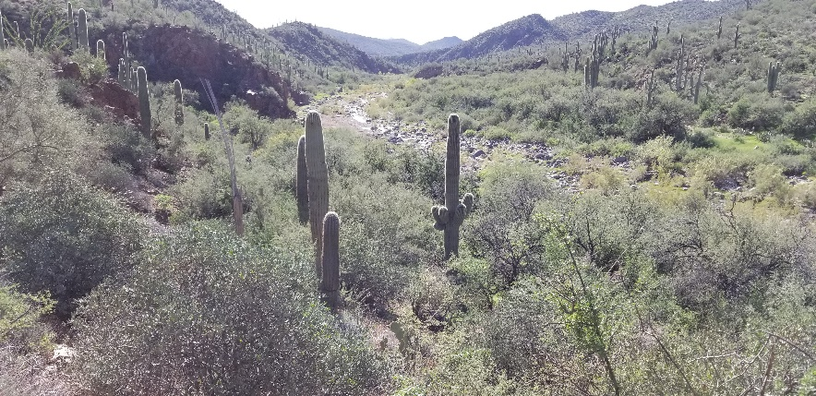
Positions to be Advertised/Duty Station:
Sonoran Desert Ecosystems - South Zone, Tonto NF

The Tonto National Forest is currently recruiting to fill a GS-11, Zone Rangeland Management Specialist (Range Staff) position with a duty station of the Cave Creek Ranger District in Scottsdale, AZ.

The purpose of this Outreach Notice is to select a candidate to fill an NTE 120-day detail/temporary promotion and to determine the potential applicant pool for filling the permanent full-time position in FY2020.

A selection for an NTE 120 day detail/temporary promotion will be made from those respondents who indicate interest in the detail on the attached response form. Expected effective date for the detail will be September 15th, 2019.

This outreach will also help hiring officials determine the appropriate recruitment method for filling the permanent full-time position. Please review the information below and, if interested in applying for the detail and/or permanent position, fill out the candidate response form and e-mail it to Micah Grondin District Ranger, at mgrondin@fs.fed.us.

You are encouraged to include a resume or brief summary of your education and work experience. Notification of availability of the application will follow when the vacancy announcement is posted in USAJobs. For more information on the application process in USAJobs, visit https://www.usajobs.gov/.

Duties of the Position

The Zone Rangeland Management Specialist will report to the Cave Creek and Mesa District Rangers and will be responsible for implmenting a comprehensive Range Management program across the two districts; specifcally:

Developing an overall ecosystem based rangeland management program utilizing resource management plan goals, objectives and decisions and rangeland project decisions to implement actions that help achieve land management plan goals and objectives.

Preparing long and short-range plans based on rangeland resource needs/health/capability, available work force, equipment and budget, and public demands for rangeland resource uses.

Consulting and coordinating with all affected users, interested publics, and private interests including various environmental groups and resolving differences among diverse groups with competing goals. Serves as an advisor to landowners and land lessees on principles of rangeland management and the laws, regulations, and policies governing management of range resources. Serves as principal contact and negotiator for the District on rangeland resources and activities.

Completing inventories and annual monitoring of rangeland resource and activities to document degree of impacts occurring, plant community changes and trend of ecological status or diversity that results. Planning and implementing rangeland improvement projects.

Monitoring and analyzing rangeland resource health and determines the effectiveness of on-going management actions and possible alternatives or planned management practices or changes which will help achieve land management goals and objectives more effectively.

Evaluating competition between wildlife and livestock grazing on specific rangeland areas, initiating the necessary decision processes that will resolve conflicts that are identified, and implementing decisions that are made as a result of that process.

Serving on interdisciplinary teams, evaluating rangeland resource and ecosystem impacts, identified alternatives, and trade-offs or results of various rangeland project proposals. Preparation and review of Environmental Analysis Reports and reviews applications for rangeland use permits or other rangeland use agreements.
Inspecting grazing allotments for compliance with livestock grazing strategies and management practices that are part of the grazing permit. Completes necessary action on rangeland use permit changes or modifications, and ensures compliance by permittees/rangeland users.
Preparing decisions, processes protests, and appeals, and researching/preparing records to suport hearings and appears as expert witness when necessary.

The position is non-supervisory, though coordination, direction and oversight of seasonal field/range monitoring crews will be required. Important skills required for the job include knowledge of range management principles, hiking, horseback riding, all-terrain vehicle use, and trailering of equipment. The ideal candidate will be familiar with NEPA and have experience working through issues with threatened and endangered species, cultural resources, soils, and watershed impacts/restoration. Communication and coordination skills are critical for success in this position.
About the Tonto National Forest

The Tonto National Forest is directly adjacent to the Phoenix Metropolitan Area and is one of the most heavily visited in the nation. From the desert to the tall timber, the Tonto National Forest contains a spectacular 2.9 million acres of cactus, chaparral, ponderosa pine, and mixed conifer country north and east of Phoenix right up to the edge of the Mogollon Rim. The Forest is the fifth largest in the United States and has six ranger districts operating in a complex, politically-sensitive atmosphere. The Forest receives national attention concerning such issues as recreation, range management, prescribed fire, road management, and a host of issues related to the wildland urban interface with the growing Phoenix Metropolitan Area. This is an outstanding opportunity for professional development, community involvement and program leadership.

Cave Creek Ranger District and Range Management Program

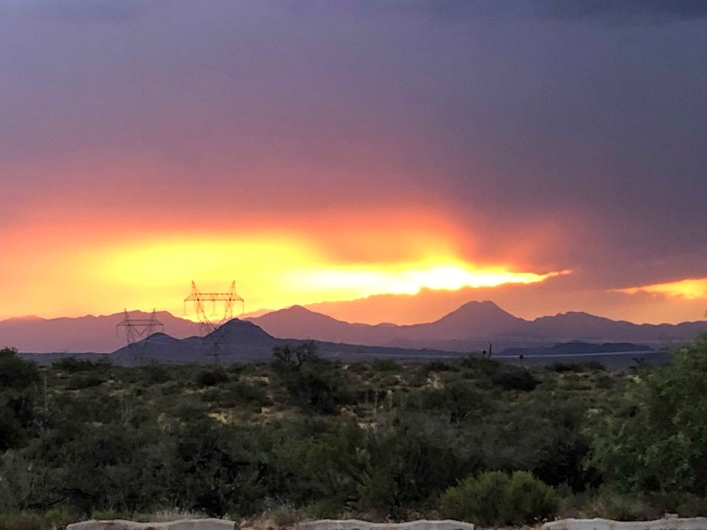
The Cave Creek Ranger District spans over 611,000 acres of Desert, Semi-Desert Grassland, Chaparral and Pinyon-Juniper ecosystems. The Verde River flows through the district, filling Horseshoe and Bartlett reservoirs just outside the metropolitan area. It includes a mixed urban interface in North Scottsdale and the communities of Carefree and Cave Creek with luxury homes, historic sites and scattered developments. The District also experiences high levels of recreation activity along the Verde River and associated reservoirs. Additionally, the rugged terrain in the vast back country of the Cave Creek Ranger District includes a portion of the Mazatzal and Pine Mountain Wilderness areas as well as lands accessible by backcountry visitors via “jeep” trails, with hiking, horseback riding, camping and other recreation opportunities. Topography varies from 1590 feet at Needle Rock @ the Verde River to 7873 feet on Mazatzal Peak.

The Cave Creek District Range program consists of 11 grazing allotments total, 7 of which are actively grazed. Most of the allotments are year-long grazing. Permitted use for the allotments is approximately 3,000 head of cattle plus yearlings on over 450,000 acres. The District has allotments in the Sonoran Desert and many threatened and endangered species, adding complexities for allotment management. A large part of the district is remote and requires up to 3 hours of primitive dirt road driving to reach. Due to new species being listed, many of the allotments on the river are vacant pending allotment NEPA. The Tonto National Forest was also completely destocked from grazing in the early 2000’s which caused many ranchers to shrink their herds or go out of business. As a result, many of the range improvements and water developments have not been maintained which poses challenges for management on the ground; especially in drought years.
A July sunrise on the Cave Creek RD

The forest is currently in the process of zoning the Cave Creek Range program with the adjacent Mesa Ranger District program. The Permanent Zone Range Staff will be responsible for range management on both Districts. (To avoid multiple changes with permittees, this will not apply during the NTE 120 day detail).

The Mesa Ranger District also lays predominately in lower Sonoran Desert with a few areas of higher elevation. The range program on the Mesa Ranger District consist of 8 grazing allotments, 4 of which are actively grazed. Two of these allotments will be managed by the permanent Zone Range Staff: Sunflower, Cross F and Diamond Allotments. The remaining allotments will continue to be managed by Globe Ranger District. A sheep driveway travels through this district, but is managed by the Apache-Sitgreaves National Forest; it crosses Sunflower, Cross F and Diamond Allotments. The four allotments consist of 213,000 acres with permitted livestock numbers of 900 head. All allotments have some level of grazing occurring. All allotments are year-long grazing.

Cross F and Diamond allotments are managed by the same permittee, with two separate herds. The permittee is working to increase the herd, and as of 2019 is running 75% of their permitted numbers.

Sunflower allotment is managed by one permittee, and will have separate herds in each Unit. An AMP outlines management with an MOU for each separate Unit. Currently Dos S Unit is grazing 100% of their permitted numbers. Cottonwood East Unit will likely authorize livestock in 2019. MOUs for Cline and Cottonwood West are in the planning stages. Allotment has not been grazed since early 2000s, and many improvements need repair before livestock grazing, per the AMP.

About the community

Scottsdale is one of the many suburbs of the Phoenix metropolitan area offering all amenities of a large city. The towns of Cave Creek and Carefree also neighbor the district office.

The Phoenix metropolitan area is a full service community of nearly 4 million people located in the heart of Maricopa County. Various municipalities including Phoenix, Mesa, Scottsdale, Tempe and Peoria makeup “The Valley” and are within a reasonable drive of the District office. There is a wide variety of schools, hospitals (including many specialty clinics), universities and community colleges, trade schools and religious institutions available throughout the city.

The primary administrative site for the Cave Creek Ranger District is located at 40202 N Cave Creek Road, Scottsdale, AZ 85262. It lays approximately 30 miles northeast of downtown Scottsdale at the intersection of Cave Creek Road and Bartlett Dam Road (Forest Road 19). The neighborhoods and housing developments in the immediate area are very expensive with homes starting in the $500,000 range and extending into the millions. As such, most Cave Creek Ranger District employees reside in the cities closer to the metropolitan area (see above) where housing options are numerous. On average, Cave Creek RD employees commute 30-40 minutes to the office each day. Phoenix area freeways experience heavy traffic typical of a large city which can add to the commute time at peak rush hour. Reviewing the duty station location, and potential housing and commuting options is encouraged.

The growing Phoenix metro area offers a vast number of housing options. Homes are reasonably priced with modest housing starting around $180,000-$200,000. Rental rates for 2 bedroom apartments start around $850 per month. Overall cost of living is slightly above the National Average.

The Phoenix area is the home to the Phoenix Suns basketball team, Arizona Cardinals football team, Arizona Diamondbacks baseball team and Phoenix Coyotes hockey team. Many baseball teams reside here during spring training allowing many opportunities to watch professional ball games at reasonable rates. There are numerous museums, concert and theatre venues available as well as NASCAR, Grand Prix and Professional Motocross racing events. The Phoenix Metro Area has numerous Regional Malls and Shopping Centers as well as Outlet Malls and other specialty stores. Other National Forest and National Parks are within a half-day drive from Phoenix including the Grand Canyon.

Climate

Like most of Arizona, the Tonto National Forest enjoys abundant sunshine and low relative humidity much of the year. Winter temperatures are very mild and pleasant in the desert areas, with periodic rainfall occurring throughout the season. While desert elevations rarely receive snow, the higher mountain regions can receive heavy snowfall along with cooler temperatures. Summers in the desert areas can be quite hot, with daytime temperatures often exceeding 100 degrees from May thru September. July has the highest average daily temperature of 104.3 degrees and January the lowest at 64.9 degrees. Average rainfall for the District is about 8 inches. The Greater Phoenix Area receives more than 300 days of sunshine a year.

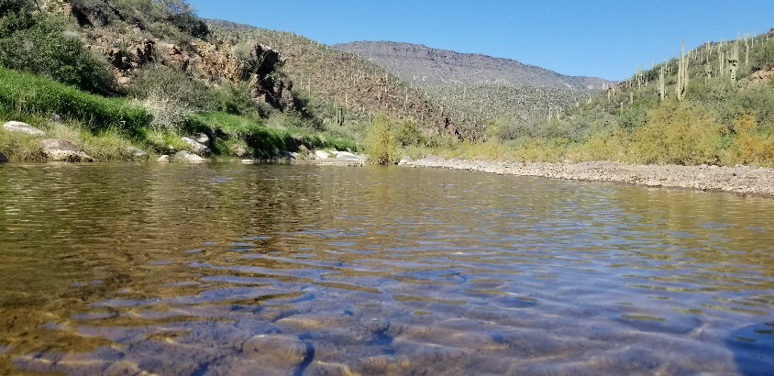
The higher mountain regions generally enjoy daytime temperatures 25-30 degrees cooler than the deserts. Each year the summer "monsoon" season arrives on the Tonto in early July and typically remains through mid-September. During this period, an influx of tropical moisture brings higher humidity and afternoon thunderstorms that can be quite spectacular. In the desert regions, much of the total annual precipitation falls during these "monsoon" thunderstorms.

There are many outdoor and indoor recreational opportunities in the surrounding areas. There are numerous opportunities near Scottsdale, Cave Creek and Carefree for hiking, mountain biking, walking paths, equestrian trails and more. The area also provides many areas for indoor sports for youth and adults.
Cave Creek during winter/spring

Government provided housing and day care facilities are not available.

For more information, please visit our website at www.fs.fed.us/r3/tonto

If you are interested in this position, please respond by August 13th, 2019; completed forms can be mailed to:
Micah Grondin, Cave Creek District Ranger at mgrondin@fs.fed.us

If you do not have access to electronic mail, please complete the form and mail or fax to: Attn: Micah Grondin, Tonto National Forest, Cave Creek RD, 40202 N Cave Creek Rd, Scottsdale AZ 85262 or fax 602-595-3346.

Would you be interested in applying for (check one or both):

___Detail/Temp Promotion ___Permanent Full-Time

Candidate Profile

NAME: _____________________________________________________________________________

ADDRESS: __________________________________________________________________________

PHONE: EMAIL: ___________________________________________

Are you currently a Federal Employee? YES NO

If yes, current agency: ________________________________________________________________

Current title/series/grade: ______________________________________________________________

Duty Station Location: _________________________________________________________________

Type of Appointment you are currently under: _____________________________________________ (e.g., Career, Career-Conditional, Permanent, Term, Temporary, Excepted-ANILCA, Excepted VRA, etc.):

Duty Location: _______________________________________________________________________

Years in Grade: ______________________________________________________________________

If No, Current Agency/Company/Organization: _____________________________________________
Position/Title: __________________________________________________________________
Brief Description of duties: _______________________________________________________
Educational Background: _______________________________________________________________
If you are not currently a permanent employee, are you eligible to be hired under any of the following special authorities (see below for more information)?

☐ | Persons with Severe Disabilities | ☐ | Disabled Veterans with 30% Compensable Disability
☐ | Veterans Recruitment Act (VRA) or Veterans Employment Opportunities Act of 1998 | ☐ | Peace Corp Alumni
☐ | Pathways Program  (Intern NTE, Intern Indefinite or Seasonal 1039) | ☐ | Reinstatement Eligibility or Other (please describe)

USDA Non-Discrimination Statement
Revised 6/8/2005
“The U.S. Department of Agriculture (USDA) prohibits discrimination in all its programs and activities on the basis of race, color, national origin, age, disability, and where applicable, sex, marital status, familial status, parental status, religion, sexual orientation, genetic information, political beliefs, reprisal, or because all or part of an individual’s income is derived from any public assistance program. (Not all prohibited bases apply to all programs.) Persons with disabilities who require alternative means for communication of program information (Braille, large print, audiotape, etc.) should contact USDA’s TARGET Center at (202)720-2600 (voice and TDD). To file a complaint of discrimination, write to USDA, Director, Office of Civil Rights, 1400 Independence Avenue, S.W., Washington, DC 20250-9410, or call (800) 795-3272 (voice) or (202) 720-6382 (TDD). USDA is an equal opportunity provider and employer.”

TYPE OF APPOINTMENTS

https://www.opm.gov/policy-data-oversight/hiring-information/hiring-authorities/

If you are not a current permanent (career or career conditional) employee, are you eligible for appointment under any of the following special authorities?

VRA – Veterans Recruitment Appointment Authority (Disabled veterans, veterans who served in a declared war, or in a campaign for which a campaign badge has been authorized, or awarded a Armed Forces Service Medal, and separated from active duty in the past 3 years).
Military Spouse Hiring Authority (Military spouses eligible under Non-competitive Appointment of Certain Military Spouses do not have a hiring preference; however, this appointing authority does provide for non-competitive entry into the competitive service. There are three categories that determine eligibility: those who are relocating with their service-member spouse as a result of permanent change of station (PCS) orders, spouses of service members who incurred a 100% disability because of the service member's active duty service, and spouses of service members killed while on active duty).
VEOA – Veterans Employment Opportunity Authority (Allows eligible veterans to apply for merit promotion vacancies otherwise not open to external candidates without career status).
Prior AmeriCorps/VISTA (Persons are granted a one-year period to be non-competitively appointed to a normally competitive Federal position after leaving the Peace Corps or AmeriCorps VISTA with a certification of eligibility).
30% Disabled Veterans Appointing Authority (Disabled veterans who were retired from active military service with a 30% or more disability rating; disabled veterans rated by the Veterans Affairs as having a compensable service-connected disability of 30% or more).
Prior Peace Corps (Former Peace Corps volunteers who have satisfactorily completed 3 years of continuous service into career or career-conditional permanent positions).
Schedule A Disabled Persons Hiring Authority (Persons with physical or mental disabilities certified by the Veterans Administration or a State Rehabilitation Agency as eligible).
Reinstatement Rights (Agencies may reappoint people previously employed under a career or career-conditional appointment by reinstatement to a competitive service position).
Pathways Student Hiring Authority (Internship Program: current students in an accredited high school, college [including 4-year colleges/universities, community colleges, and junior colleges]; professional, technical, vocational, and trade school; advanced degree programs; or other qualifying educational institution pursuing a qualifying degree or certificate; Recent Grads Program: recent graduates who have completed, within the previous two years, a qualifying associates, bachelors, masters, professional, doctorate, vocational or technical degree or certificate from a qualifying educational institution).
Public Lands Corp (A non-competitive authority for hiring current and former Public Lands Corps members who have satisfactorily served a minimum of 640 hours on an appropriate conservation project that included at least 120 hours through the Public Lands Corps. Current or former PLC members are eligible for noncompetitive hiring up to a 120days after completion of the program).
Land Management Workforce Flexibility Act (The purpose of the Land Management Workforce Flexibility Act is to allow certain current and former land management agency employees who are serving (or who have served) under a time-limited appointment to compete for any permanent position in the competitive service at a Land Management Agency, or any other agency, under “internal” merit promotion procedures).

