

Tierra Seca
University of Arizona Student Chapter
Society for Range Management
College of Agriculture and Life Sciences
School of Natural Resources and the Environment

April 24th, 2019

- Call to order: 5:03 PM

  - Members in attendance: Flavie Audoin, Josephine Profy, Clara Miller, Will Gray, Cameron Burleson, TZ Leiser, Brian Koppy, Mitchell Zieglgansberger, Corwin Carroll, Justin Johnson, James Bradley, Amanda Sacek
  - Faculty in attendance: Mitch McClaran, Sarah Noelle
  - Graduates: Josephine Profy, Trevor Kerin, Clara Miller, Jodi Poole
  - If you are a graduating member this year and you don’t see you name on the above list, please email us as soon as possible. This way you can receive your congratulatory gift from Tierra Seca.

- Introductions

- President’s Report

- Spring Meeting Schedule ~ Biweekly meetings on Wednesdays at 5:00PM
- January 16, 2019- Spring Semester Introductory Meeting
- January 30, 2019- 2019 SRM Meeting Logistics
- February 27, 2019- Annual SRM Recap
- March 13, 2019- Organizational Meeting
- March 27, 2019- Alisha Phipps (Range Specialist – NRCS)/New Officer Nominations
- April 10, 2019- Flavie Audoin Presentation/New Officer Elections
- April 24, 2019- New Officer Lead Meeting *Brainstorming Day/Emilio Corella USFS Presentation
  - Recreation Technician for the USFS
  - Many degrees do not prepare you for technical aspects of the job
  - Lots of physical work and manual labor
  - Volunteer opportunities for the summer and fall: Provide hands-on experience, earn a park pass (250 hours), get documented volunteer hours for OPM, set resume apart
  - Related certifications such as wildlands chainsaws. hazard tree removal, trails maintenance, and off-trail vehicles
- Next meeting in the fall TBD

Transfer of Position: This marks the first meeting with the new elects for this coming year of 2019-2020 with Brian Koppy as President, Cameron Burleson as Vice President, TZ Leiser as Secretary, and Mitchell Zieglgansberger as Treasurer.

Banking/Treasurer: To add to this, we need to remove the old officers Josephine Profy, Clara Miller, and William Gray from the Tierra Seca banking account at the OneAZ Credit Union Bank in Tucson, AZ. We need to add the new officers of Brian Koppy as President, Mitchell Zieglgansberger as Treasurer, and Cameron Burleson as Vice President onto the Tierra Seca banking account for the upcoming year of 2019-20 starting now. Talk with Advisor on this.

- Past Events Report

- SNRE Awards Ceremony: April 22nd
-Flavie won the raffle!
-$819 collected by TS and $802 by FWS (We beat Wildlife!)
-Awards: Josie (Student Leadership and EMRR Senior), Clara (EMRR Senior), Cameron (Outstanding Student Assistant), Will (EMRR Scholarly Achievement), Professor McClaran (Outstanding Course) Professor Fehmi (Outstanding Faculty Member) and Sarah Noelle (EMRR Faculty Involvement and Coaching).
-Mitch presented gift as outgoing advisor after 23 years of service to Tierra Seca

- Upcoming Events Report

- Ceremony Banquet in Tombstone, April 26th (Friday)
-What: High school FFA awards event for recruiting/visibility with younger students
-When: 5:00 PM -
-Where: Tombstone High School
-Who: Brian Koppy, Cameron Burleson, Dr. Howery

- Aluminum Can Collection at Elkhorn Ranch: April 27th (Sat)
-What: Another fundraiser collecting aluminum cans at Elkhorn ranch to get some $$
-When: 7:00AM-2:00PM
-Where: Meet on the SE corner of BSE
-Who: Clara, Josie, Amanda, Mitchell, Corwin (maybe)

- Target Practice: April 28th (Sunday)
-What: Social activity for members to learn about firearm safety and proper techniques for target shooting. If you do not have a firearm and would like to participate, please bring money or ammo!
-When: 8:00AM
-Where: Meet out front of the ENR2 building on the north side (Going to Rail X)
MOVE CAMPING EQUIPMENT IN BSE @ 3pm (move into 118)
Attending: Brian Koppy, Josie Profy, Amanda, Claire Bigelow, James Bradley

- End of School Year Potluck: May 1st (Wednesday)
-What: Come join us for a potluck as we celebrate the end of the school year! Open to club members (BOTH Grads & Undergrads) and friends alike!
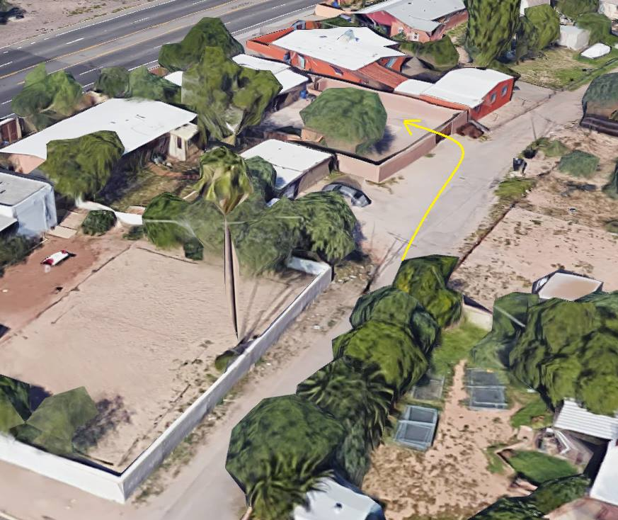
-When: 5:00PM
-Where: 2218 N Euclid Ave, Tucson, AZ 85719- 2972, United States

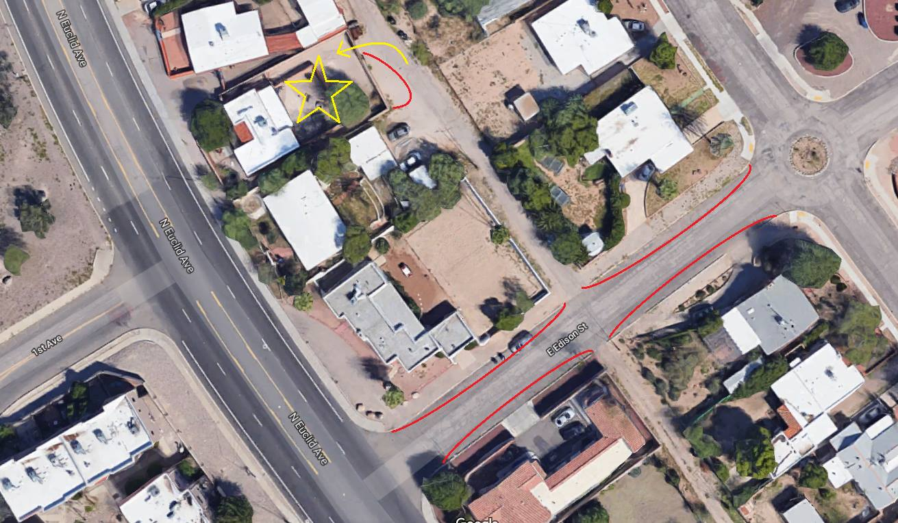

Google sheet for who is bringing what:
https://docs.google.com/spreadsheets/d/1MeuTR21xy_d_bxG3CxCgknVz7BngVpTrPJMsWbPDoeA/edit?usp=sharing

- Commencement Ceremony Parking Day: May 10th (Friday)
-What: Help TS fundraise by parking cars for the UA 2019 Commencement Ceremony!
-When: 3:00PM-8:00PM
-Where: Meet at Parking and Transportation Building (SE corner 6th St Garage)
-Who: Amanda, William, TZ, Cameron, Brian, (possibly James)

- AZSRM summer meeting: August 14th-16th
-What: A VERY important event with Arizona Section of the Society for Range Management. Tierra Seca is responsible for cooking breakfast for the members in attendance. It would be amazing to have five or six students attend and help with breakfast!
-Where: Show Low, AZ
-Who: James, Sarah, William, Amanda (possible), Justin, Cameron

- Vice President’s Report
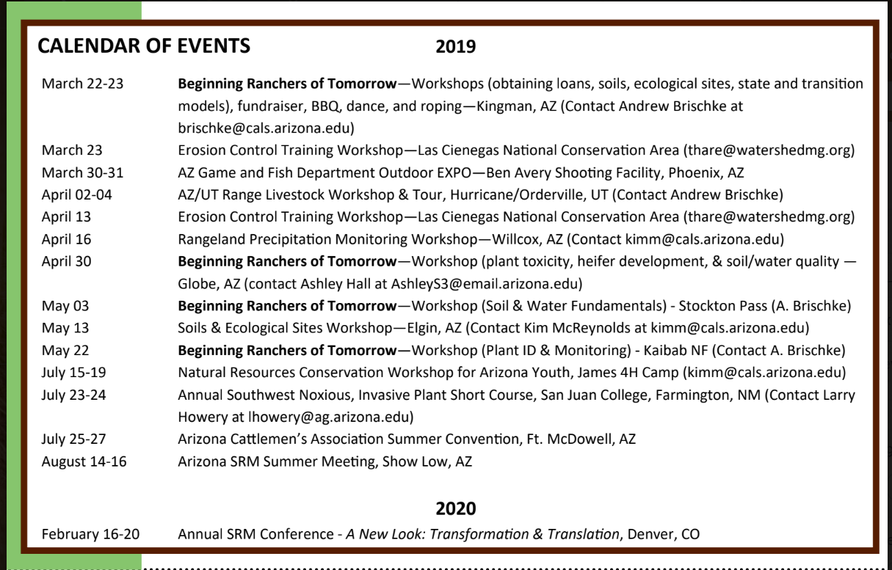

- Treasurer’s Report

- Dues ($30 per semester)
- Paid dues Spring 2019: Amanda Sacek, Brandon Mayor, Austin Gonzales, Mitchell Zieglgansberger, Cameron Burleson, Josephine Profy, Corwin Carroll, Claire Bigelow, Mitch McClaran, TZ Leiser, Brian Koppy, William Gray, James Bradley, Sarah Noelle, Justin Johnson, Flavie Audoin, Austin Rutherford
- Account balances (Now accepting all credit cards):
- Checking: $1,903.92
- Savings: $396.16
- Cash: $421.00
- Running total = $2,721.08
***$1,000+ reimbursed from Southwest Airlines to be used for next SRM flight tickets(:
- VENMO - @TierraSeca
- PAYPAL - Need to get still

- Miscellaneous

- GroupMe – Easy way to communicate, join and we tend to send notification about events.
- Using InvolveUA link as storage for all club information

Link to InvolveUA: https://arizona.collegiatelink.net/organization/tierraseca

- Swag
  - Design approval held up in bookstore, hats and shirts coming

- Any Other Business?
- Fall goals?
  - Focus on recruitment of freshman, sophomores, and high schools (replacement plus 3 min)
    - Speak in intro classes on campus. Mall club fairs
    - Emilio Corella willing to do class recruitment
    - Attend high school events (FFA, etc)
    - March for Science
  - Fundraising
  - Social Media - members upload pictures, etc
    - CALS take-over “Day in the Life of Range”
    - UPDATE WITH ITALY STUFF “This is Tierra Seca. We are Range”
    - Mascot (little cow)
  - Events: Another Wild Horse and Burro field trip
- Doodle poll to establish meetings for fall semester (potentially Tuesdays 5pm)
- Consider joining Plant I.D.!
- If traveling or doing field work or being anywhere around plants this summer, please consider grabbing these plants for the Plant ID team! Correctly identified, pressed, and mounted specimens are preferred.
  - Phalaris arundinacea
  - Bromus carinatus
  - Muhlenbergia porteri
  - Panicum hallii
  - Paspalum distichum
  - Festuca campestris
  - Nassella pulchra
  - Carex nebrascensis
  - Schoenoplectus acutus
  - Juncus balticus
  - Conium maculatum
  - Crepis acuminata
  - Ambrosia dumosa
  - Hymenoxys odorata
  - Wyethia mollis
  - Symphoricarpos occidentalis
  - Sarcobatus vermiculatus
  - Cornus sericea
  - Dalea purpurea
  - Ribes cereum
  - Pinus edulis
  - Penstemon glaber
  - Delphinium bicolor
  - Ceanothus cuneatus
  - Fallugia paradoxa
  - Salix exigua

- Adjournment: 5:59

Facebook club link: https://www.facebook.com/uofatierraseca
President: Brian Koppy bkoppy@email.arizona.edu
Vice President: Cameron Burleson cameronburleson@email.arizona.edu
Treasurer: Mitchell Zieglgansberger mzieglgansberger@email.arizona.edu
Secretary: TZ Leiser tzleiser@email.arizona.edu

