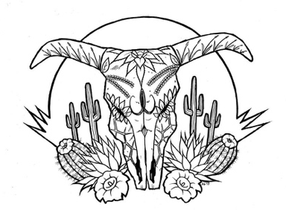
Tierra Seca
University of Arizona Student Chapter
Society for Range Management

College of Agriculture and Life Sciences
School of Natural Resources and the Environment

March 27th, 2019

- Call to order: 5p.m.

  - Members in attendance: Flavie, Clara, James, Josie, Austin, Corwin, Mitchell, Brian, Cameron, Claire, Sandy
  - Faculty in attendance: Mitch McClaran, Alisha Phipps (speaker non faculty)
  - Graduates: Josephine Profy, Trevor Kerin, Clara Miller, Jodi Poole
  - If you are a graduating member this year and you don’t see you name on the above list, please email us as soon as possible. This way you can receive your congratulatory gift from Tierra Seca.

- Introductions
  - Around the table- what is your name, major,

- President’s Report

- Spring Meeting Schedule ~ Biweekly meetings on Wednesdays at 5:00PM
- January 16, 2019- Spring Semester Introductory Meeting
- January 30, 2019- 2019 SRM Meeting Logistics
- February 27, 2019- Annual SRM Recap
- March 13, 2019- Organizational Meeting
- March 27, 2019- Alisha Phipps (Range Specialist – NRCS)/New Officer Nominations
  - Alisha.phipps@az.usda.gov
  - work cell: 520-305-1913
  - office: 520-989-5630
  - 3241 N. Romero Rd. Tucson AZ 85705
  - Nominations
    - President: Brian, Will, Austin,
    - VP: Will, Austin, Mitchell, Cameron, James
    - Secretary: Cameron, Claire, Corwin, Mitchell, TZ
    - Treasurer: Austin, James,
- April 10, 2019- Flavie Audoin Presentation/New Officer Elections
- April 24, 2019- New Officer Lead Meeting *Brainstorming Day?

- Past Events Report

- Wild Horse and Burro Facility Tour
- Tierra Seca vs. UA Fish and Wildlife Society Kickball Game

- Upcoming Events Report

- Country Dancing Night: March 29th
-What: Social Activity for anyone interested in going out this Friday!
-When: 8:00 or 9:00PM ??
-Where: The Wreck, 213 N Fourth Ave, Tucson, AZ

- UA Home Baseball game: April 6th
-What: UA vs. Washington
-When: 3:00PM
-Where: Hi Corbett Field by Reid Park Zoo
-Who: Austin Rutherford, Brian Koppy, Corwin Carrol, Mitchel Zieglgansberger, Mitch McClaran, James Bradley, Josephine Profy, Clara Miller, William Gray, Sarah Noelle, Claire Bigelow, Cameron Burleson, Justin Johnson

- March for Science Southern Arizona Rally for Science: April 13th
-What: Showcase the U of A’s range club and range program to people with our Tierra Seca booth
-When: 10:00AM-1:00PM
-Where: Georges DeMeester Outdoor Performance Center, Gene C. Reid Park, Tucson, Arizona
-Who: Austin Rutherford, Clara Miller, Mitchel Zieglgansberger, Josephine Profy, Brian Koppy

- Parking Day: April 14th
-What: Help TS fundraise by parking cars for the UA basketball game!
-When: 3:00PM-8:00PM
-Where: Parking and Transportation Center at 6th Street Garage
-Who: William Gray, Claire Bigelow, Amanda Sacek, Mitchell Zieglgansberger, Brian Koppy, TZ Leiser

- SNRE Awards Ceremony: April 22nd
-What: Join TS at the awards ceremony and enjoy food, raffle prizes, and great company! The winner to our fundraising 50/50 Raffle will be announced here as well!
-When: 2:30PM-4:30PM
-Where: ENR2 N350

- Aluminum Can Collection at Elkhorn Ranch: April 27th
-What: Another fundraiser collecting aluminum cans at Elkhorn ranch to get some $$
-When: 7:00AM-2:00PM
-Where: Meet on the SE corner of BSE

- Target Practice: April 28th
-What: Social activity for members to learn about firearm safety and proper techniques for target shooting. If you do not have a firearm and would like to participate, please bring money or ammo!
-When: 8:00AM
-Where: Meet out front of the ENR2 building on the north side
MOVE CAMPING EQUIPMENT IN BSE

- End of School Year Potluck: May 1st
-What: Come join us for a potluck as we celebrate the end of the school year! Open to club members (BOTH Grads & Undergrads) and friends alike!
*We will also be attaching a google excel sheet as a reference for who is bring what to the potluck.
-When: 5:00PM
-Where: Address will be added closer to date; Reference photos for parking will be attached closer to date.

- Commencement Ceremony Parking Day: May 10th
-What: Help TS fundraise by parking cars for the UA 2019 Commencement Ceremony!
-When: 8:00AM-4:00PM
-Where: TBD
-Who: Corwin Carroll, Mitchell Zieglgansberger, Amanda Sacek, William Gray, TZ Leiser

- Vice President’s Report

- Nominate Dr. Fehmi for SNRE Outstanding Faculty Award

- Treasurer’s Report

- Dues ($30 per semester)
- Paid dues: Amanda Sacek, Brandon Mayor, Austin Gonzales, Mitchell Zieglgansberger, Cameron Burleson, Josephine Profy, Corwin Carroll, Claire Bigelow, Mitch McClaran, TZ Leiser, Brian Koppy, William Gray, James Bradley, Sarah Noelle, Justin Johnson, Flavie Audoin, Austin Rutherford

- Account balances (Now accepting all credit cards):
- Checking:
- Savings:
- Cash:
- Running total =
***+1000 reimbursed from Southwest Airlines to be used for next SRM flight tickets(:
- VENMO - @TierraSeca
- PAYPAL - Need to get still

- Miscellaneous

- GroupMe – Easy way to communicate, join and we tend to send notification about events.
- Using InvolveUA link as storage for all club information

Link to InvolveUA: https://arizona.collegiatelink.net/organization/tierraseca

- Swag

  - New orders will be made now that we have an idea what everybody would like.

- Any Other Business?

  - 50/50 Raffle
-What: We will be selling tickets for a 50/50 Raffle for 1$ each. A portion of the proceeds go back to TS for fundraising. Every ticket counts so if you’d like to purchase some and/or sell a few, it will be greatly appreciated! The winner of the raffle will be announced at the SNRE Awards Ceremony on April 22nd (more details in the upcoming events report^).
-When: ends on April 22nd at the SNRE Awards Ceremony
-Where: purchase a ticket from any of our TS officers and members, if not sure who is who, go ahead and shoot us an email so you can get your tickets!
-Who: ANYONE and EVERYONE can participate or purchase these tickets and win!

- Adjournment: 5:58p.m.

Facebook club link: https://www.facebook.com/uofatierraseca
President: Josephine Profy jprofy@email.arizona.edu
Vice President: Clara Miller claramiller@email.arizona.edu
Treasurer: William Gray williamgray4@email.arizona.edu
Secretary: Amanda Sacek ajsacek@email.arizona.edu

Wild Horse and Burro Facility Tour

KICKBALL CHAMPIONS!

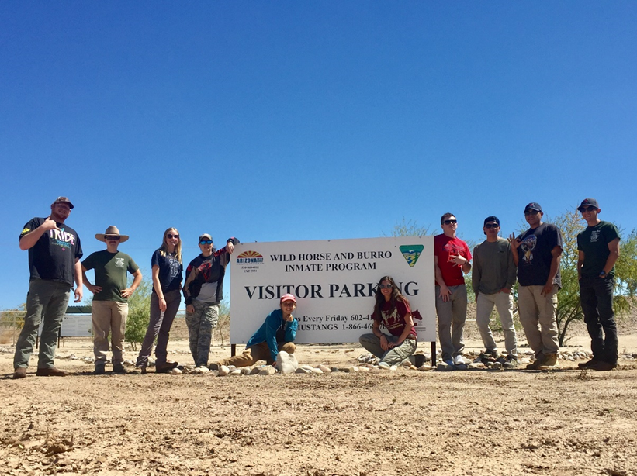
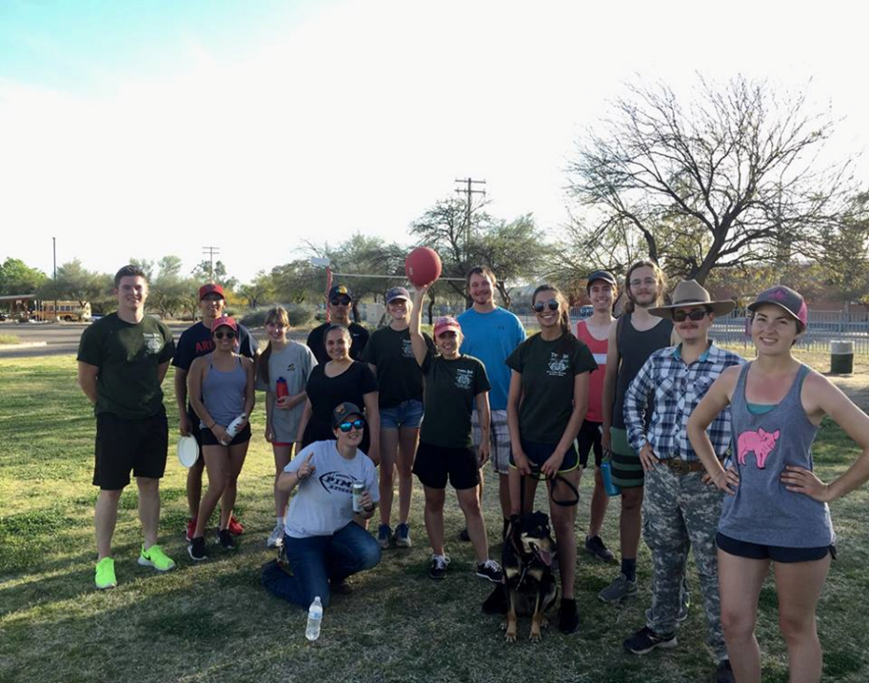

Wild Horse and Burro Facility Tour

